  - Altiris
Overview:

altiris IT management suite offers a variety of IT automation products starting from small businesses all the way to large enterprises, also among their solutions are: Server management suite, client management suite, endpoint protection suite, helpdesk suite, service and asset management suite, and deployment solution.[1]

Background:
Altiris IT management suite developed by altiris Inc, is a subsidiary of Symantec, altiris specializes in service-oriented management software which allows organizations to manage IT assets. They also provide software for web services, security, and systems management products. Established in 1998, Altiris is headquartered in Lyndon, Utah, United States. Altiris has over 20,000 customers managing more than 3 million servers and 60 million desktops and laptops. Altiris offers an array of it management products such as security, infrastructure operations, information risk and compliance, storage and business continuity.[2]
Functional Coverage:

Altiris management suite is a multiplatform solution, is fully compatible windows based machines, Mac OS, as well as Linux machines; it uses an agent to monitor and manage assets from a centralized location.

Grouping Managed Devices: : altiris management suite offers a handful of facilities that are uses to manage and control IT assets remotely and locally, if offers advanced filtering features that allow IT managers to group managed devices based on roles, operating system, and location

    - Remote Control and Help Desk

Altiris suite has a solution dedicated for remote control and helpdesk and ticketing, is called Altiris helpdesk solution, this solution covers most of the aspects related with ticketing and remote administration, for remote administration, it uses a proprietary solution built in onto the software, file transfer, and well as user status, and connectivity statistics. The helpdesk solution comes with a Built-in workflow to automatically assign and escalate tickets to the proper Helpdesk technicians, also it offers Web reports to ensure quality of service and efficient IT operations. .[3]
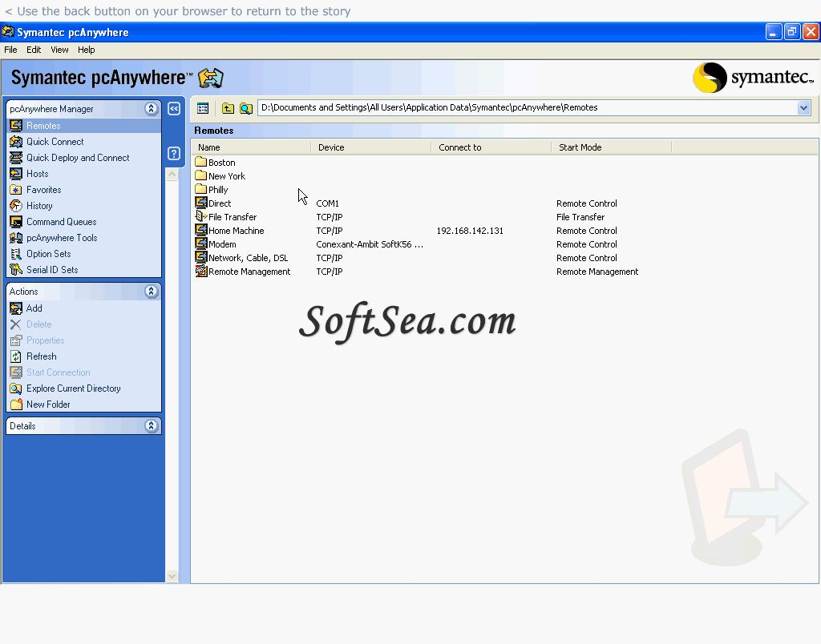

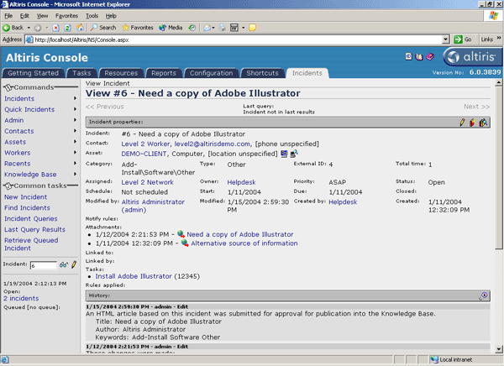

    - Auditing & Asset management

Altiris Management solution Actively track IT asset location, configuration, deployed versions, relationships, and historical information, also, the solution is able to track software and hardware usage for reallocation and contract negotiation, another highlight from this solution is the ability to capture detailed information about desktops, notebooks, and servers and determines how many copies of an application are installed on your users' systems. .[4]

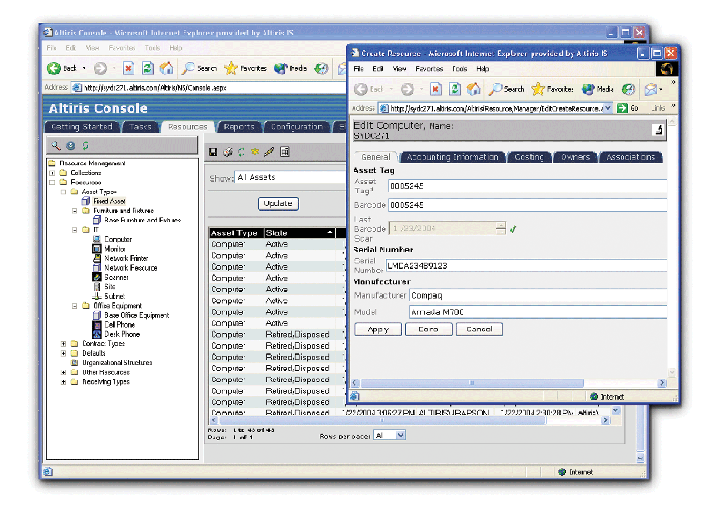

    - Monitoring

The Altiris Server Management Suite offers a dashboard used to organize servers into vital groups to provide a quick status of current health. It includes self-healing remediation tasks already configured, before critical events occur. The solution allows the analysis and resolves challenges faster with the flexible historical performance viewer. [5]

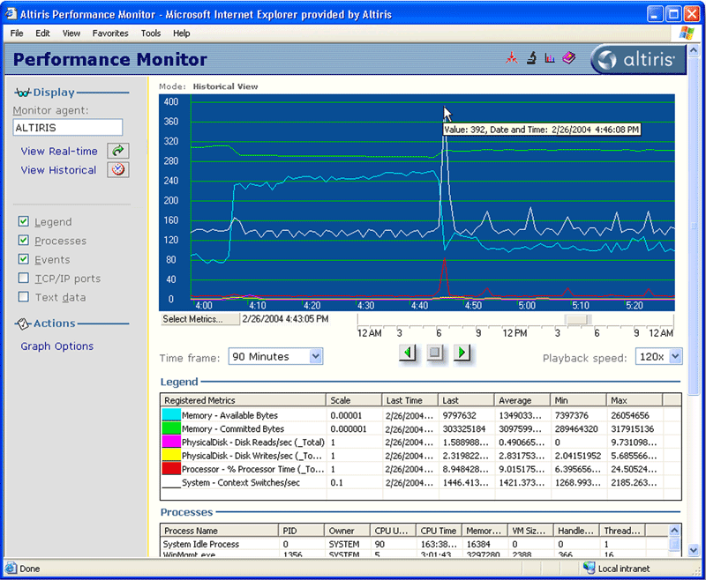

2.6.4 Patch Management

Patch management and deployments are handled to users via agents installed on client machines, also Provides a repository that includes information on each software bulletin, such as technical details, severity ratings, and number of updates, also, Discovers detailed information on the OS and applications, and inventories installed updates, finally it also includes detailed reports and alerts on patch updates and distribution status. [6]

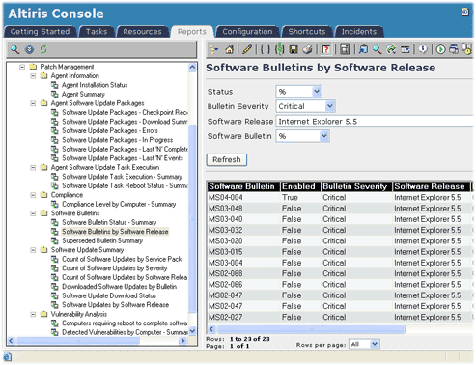

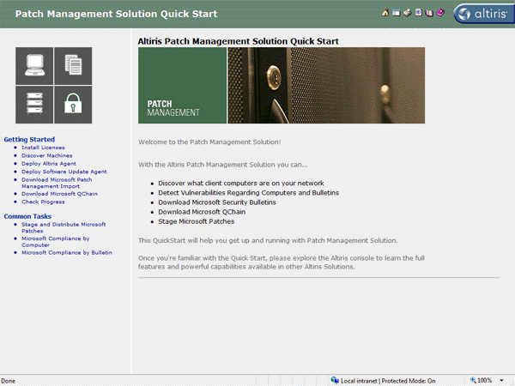

2.6.5 Backup & Disaster Recovery

Altiris management suite offers Recovery to completely dissimilar hardware, including differences in RAID types, disk types, processor types, NIC cards, entirely different system manufacturers; it supports several platforms within the windows server family, such as windows vista, windows 2008 server, 2003 server family and XP family. [7]

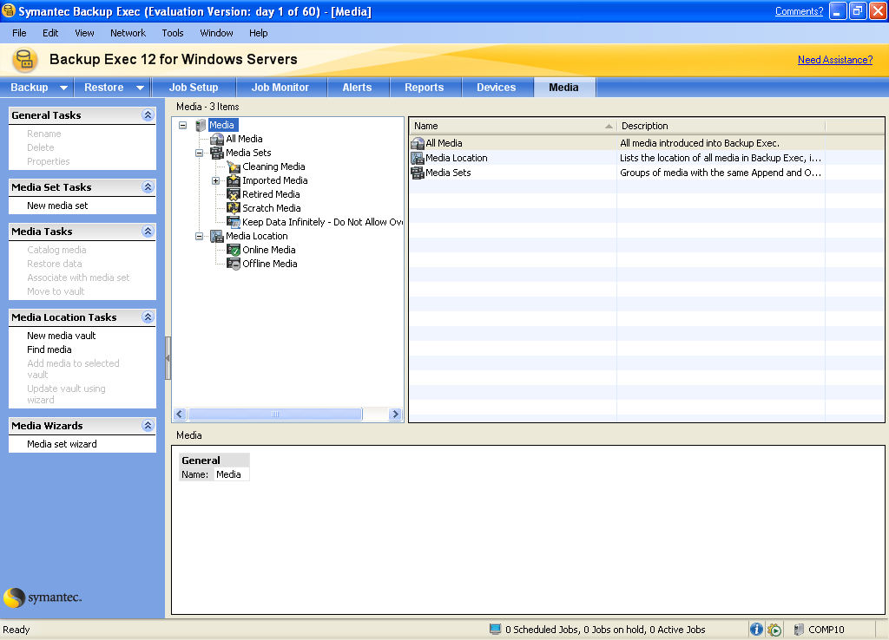

2.6.6 Endpoint Security

Altiris management suite offers an endpoint security solution with features that includes: the Creation variable security policies that automatically change based on user location. Also comes with advanced firewall protection that centralizes firewall settings, enforces trusted communications, and it can't be turned off by the end user. Protecting endpoints from the moment network traffic enters the computer, the driver-level firewall opens communication ports for authorized network traffic only, blocks all unwanted intrusions, and completely hides the endpoint from port scans and other attacks, blocking malicious hackers before they get started, preventing denial of service attacks, port-scans and protocol based attacks, in a way t hat optimizes security compliance and system performance. [8]
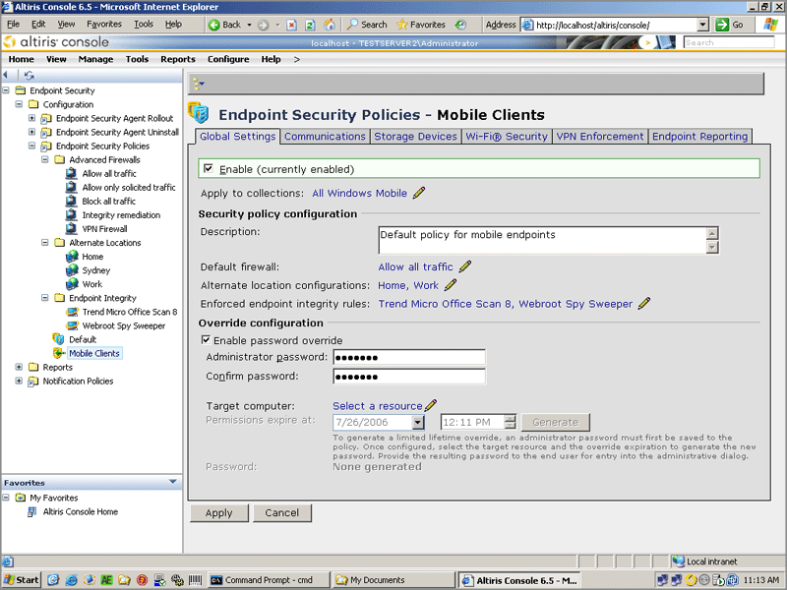

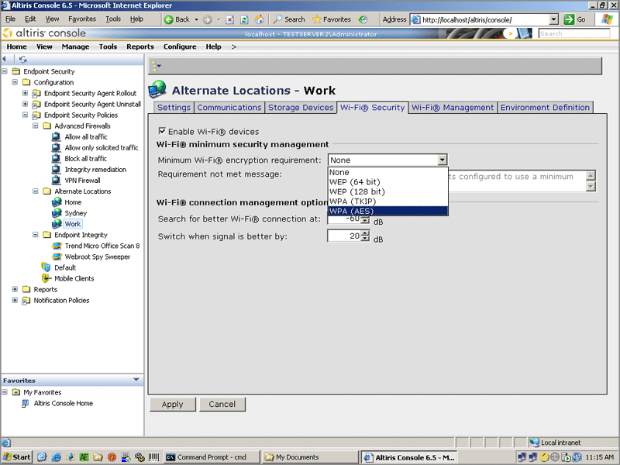

2.6.7 User State Management

Altiris management suite would meet the needs with its user state management. Altiris uses an agent that has the ability to track and monitor user state as well as machine status, the admin could easily setup permissions and policies according with user’s rights via web browser, so it gives the flexibility to manage and monitor the whole environment from virtually anywhere.

2.6.8 Usability

Altiris IT management suite definitely will meet the needs of any company or business, usability and ease to use is really a plus. Most already have server 2003 in their network so no interpretability issues will arise. For those who do not have server 2003 implemented, adding computers to the suite will not be a problem since the agent will take care of it only with a couple of clicks. Symantec has a lot of support on the Internet for its product line. Like mentioned above, you do not need to be a Symantec guru to handle your way around the server.

    - Reliability

Current system is very reliable and stable, system crashes are very rare, and downtime is only caused by outages in the area, reliable error reporting and extensive data replication capabilities make this solution a good reason to have a goodnight sleep.

    - Performance

With good processors and a good amount of memory, Alters solutions should perform very well. I would recommend having around 4 GB of memory installed for the best performance. Since the suite is not resource hungry, the servers won’t get overloaded, so crashes and system interruption won’t be a problem.

    - Supportability

Most to all companies and businesses today are mainly using Windows based equipment. Unfortunately Altiris management suite is only limited to windows server product line and can not at all support neither Linux nor Mac.

