2.5 Kaseya

Overview: Kaseya Professional Edition covers all major areas of IT such as:
Asset Management – With Kaseya, a simple automated scan of the network will identify any IP-enabled device to obtain an accurate picture of your IT assets. [3]
- Find misplaced or forgotten computers, printers and routers
- Gather basic inventory data or detailed hardware, software and OS configuration data
- Easy-to-use query tools help you analyze inventory data and group assets according to attributes
- Automated inventory scans help you understand what you have, without manually gathering data
Software and License Audit – Discover and inventory all software applications, license keys and duplicate licenses. [4]
- Prevent users from launching unauthorized software whether it is installed or not, even when not connected to the network
- Maintain a comprehensive view of software license use and easily respond to audits with extensive application usage, license compliance reporting, and license reporting features
- Powerful query and reporting capabilities let you quickly view, analyze and understand your IT environment
Performance Monitoring – with Kaseya, IT administrators can proactively monitor system and network devices to ensure maximum uptime and availability. With Kaseya performance monitoring, administrators can do the following: [5]
- Proactively monitor systems and devices to efficiently detect potential problems and automatically respond to defined conditions
- Implement best practices to identify and resolve network infrastructure and system problems
- Optimize the efficiency of the IT department
Help Desk – Kaseya provides an integrated help desk and trouble ticketing system that helps IT professionals easily manage users by providing IT support personnel with the tools they need to resolve issues quickly. Users and support personnel can interact in real time to report, diagnose and resolve issues without ever having to physically visit the desktop. [6]
- Deploy Service Desk / Help Desk capabilities in minutes
- Easy to use with no long training cycles or requirement for consultants
- Accessible from anywhere with no special servers or reconfiguration of your existing computing infrastructure
- Keep track of issues, resolve them quickly and increase customer satisfaction
Remote Control – Kaseya’s remote control capabilities provide easy, fast and secure remote desktop management of your entire computing infrastructure from anywhere. Using Kaseya, you’ll no longer have to struggle to find that laptop in the field or change your firewall settings in order to gain access to computers behind a NAT or gateway. [7]
Patch Management - From simple fully automated patch deployment to script based automation for a customized deployment, Kaseya delivers a secure and comprehensive enterprise class automated patch management solution to help keep security holes closed with a mouse click. [8] Kaseya Patch Management provides IT Administrators and service providers with the tools they need to be successful and keep the organization running.
Endpoint Security - The Kaseya Endpoint Security (KES) solution provides world class, enterprise level anti-virus, anti-spyware, and root kit protection for servers, workstations and mobile computers.
Backup and Disaster Recovery – administrators have the ability to deploy, configure, manage, monitor, secure, backup and restore distributed systems from a single management console. Kaseya backup and disaster recovery offers fast and easy recovery in a fully automated functionality.
Background: Kaseya Corporation is a privately held software company located in San Francisco, San Juan Capistrano (Orange County), Milpitas, CA, Bothell, WA, Miami, Washington, DC, London, Amsterdam, and Singapore. Kaseya was started in January 2000 to build a new type of IT services delivery solution. Kaseya’s product line is quickly becoming a standard in the IT services field. Kaseya’s IT Automation Framework allows IT professionals to proactively monitor, manage and maintain distributed IT infrastructure remotely, easily and efficiently with one integrated Web based platform. [9]
Company Highlights:
- Kaseya markets their products worldwide
- Annual revenue of $2.3 Million
- A global provider of IT automation software for IT Solution Providers and Public and Private Sector IT organizations
- Kaseya's technology is licensed on over three million machines worldwide
- Technology alliance partnerships with other IT solutions such as Autodesk, Catbird, ConnectWise, Tigerpaw, and Untangle

Functional Coverage:
Supported Operating Systems:
Microsoft Windows 98, Me, NT 4.0, 2000, XP, Vista, Server 2003
Macintosh OSX v10.3.9 and above, Intel and PowerPC editions
Linux support is coming soon.
In order to manage computers on the network, administrators install a software agent which communicates with the Kaseya server. The Kaseya agent supports both PC and Mac, and provides a non intrusive, non evasive and seamless OS service addition. This light-weight agent initiates all communications back to the server. Since the agent will not accept any inbound connections, it is impossible for a third-party application to attack the agent from the network. [9]
Grouping Managed Devices: Kaseya allows administrators to easily group any or all the devices on the network that has been imported into Kaseya. Administrators can use the default device group names or create their own based on the operating system, department or location.

2.5.1 Remote Control
Kaseya's remote control software provides the tools needed for secure remote access to all of your managed computers. Administrators have complete control over the remote control functions, including passwords, notification method, screen mode, and control level. In addition the remote control software allows administrators to grant end user access their machines remotely. Each end user also has the capability of optionally blocking remote control software access to their computer systems. Some key features in terms of remote control are as follows: [6]
- Firewall and NAT Friendly
- Access from Anywhere
- Configurable Client
- Secure FTP
- Secure Online Chat
- Video Streaming for Remote Training and Support
- Available to Administrators and End Users
- Maximum Security using 256 bit RC4 Encryption
Unlike other IT solutions, Kaseya has support for multiple remote control clients. These range from RAdmin to VNC. Below is a screenshot showing some other remote control clients such as PcAnywhere, K-VNC, and terminal server.
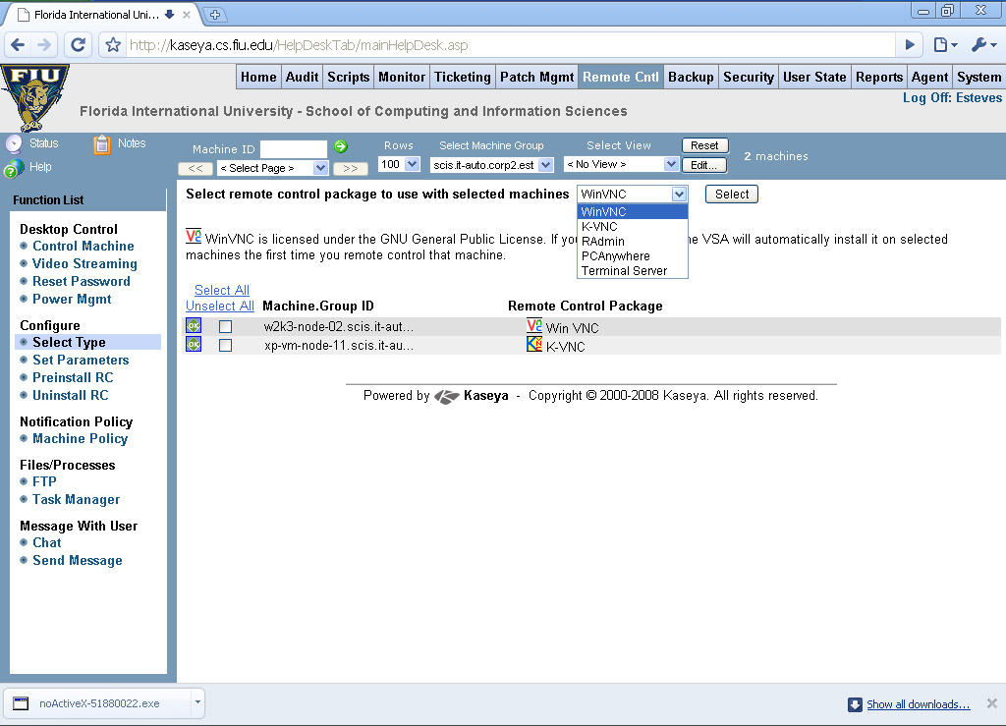
2.5.2 Auditing & Asset management (Rating: 4)
The Auditing and Asset Management features built into Kaseya are very easy to use and spaced out nicely. Once machines on the network have been discovered and they have agents installed those machine will show up in the machine group that is selected. There will be a list of machines to choose from on the left side. Here is a snap shot of what one machine looks like:
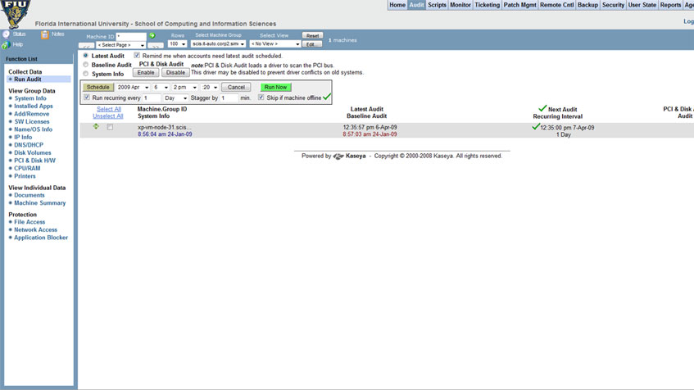
Figure 2.5.2a – Snapshot of Kaseya Audit Dashboard.
As you can see of the left side of this page there are a number of different data groups that are separated for administrators to choose from. Let’s say that an administrator would like to know what applications are installed on this machine. Instead of having to go to the machine or remotely login administrators can simply do to this section and click on the “Installed Apps” link, below is what they would see:
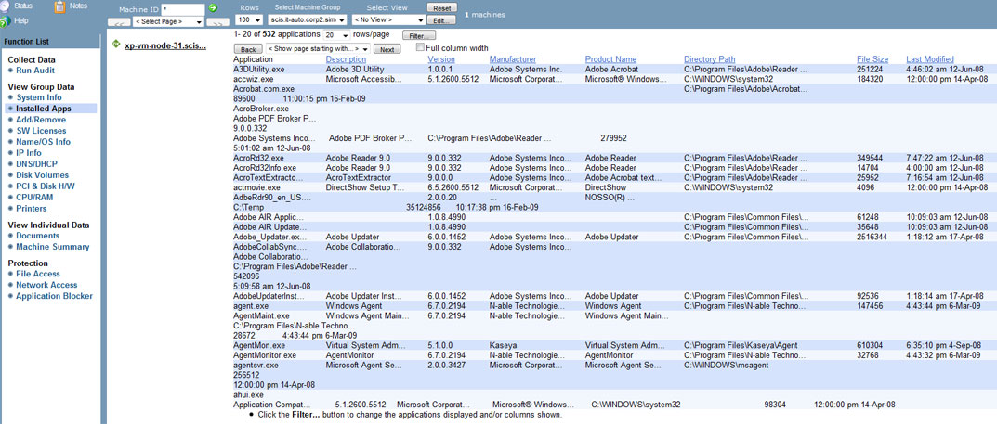
Figure 2.5.2b – Snapshot of Kaseya “Installed Apps” page in the audit section.
Administrators would see a list of the applications installed, version number, path it is installed in as well as the size and when it was last modified.
The Audit section also allows administrators to view entire machines system information in detail it needed. Below is another snapshot of the system information view of this particular machine:
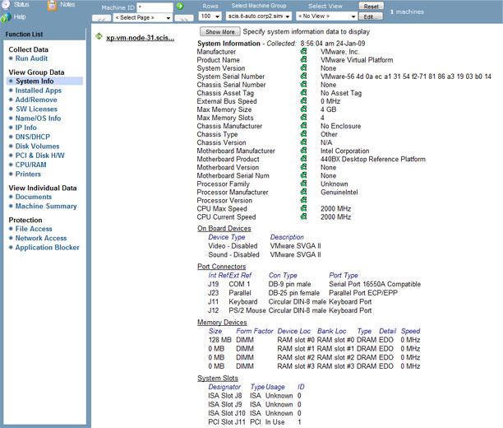
Figure 2.5.2c – Snapshot of Kaseya “System Info” section
In this system information view administrators can see specific information as far as how many memory slots are being used and are remaining to what types of ports are on the back of the machine.
2.5.3 Monitoring (Rating: 5)
Kaseya has a fantastic built-in monitoring system. This feature uses the agents installed on the machines to monitor different services and/or processes on individual machines. For devices that agents cannot be installed on administrators have the option to monitor these devices via SNMP. Devices such as printers for example would not be able to have agents installed but with the use of SNMP administrators can monitor page count and other printer spool services. Kaseya allows administrators to setup and configure monitor sets to easily organize different types of monitoring. For example, the printer spool monitor set allows administrators to monitor the printer queue to see if there are any job errors, or is the printer is out of paper. Below is a snapshot of the printer spool monitor set:
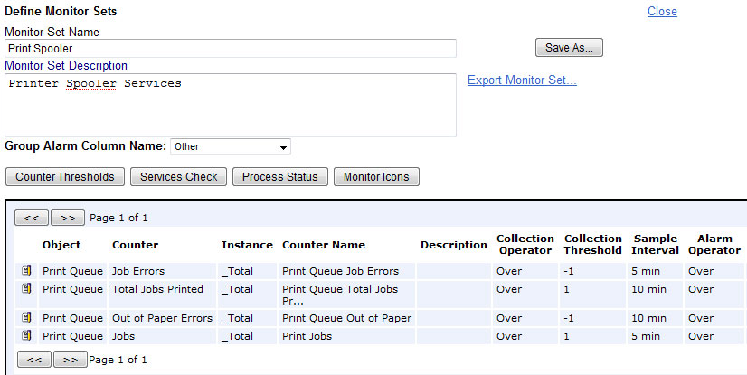
Figure 2.5.3a – Snapshot of Kaseya Printer Spool Monitor Set section
As you can see if there is a error during the print job whether is a out of paper error or any other related error administrators can be notified. Administrators also have the ability to set different thresholds. This can be useful if administrators know when there might be a spike in the printing jobs.
Administrators even have the ability to monitor the actual agents installed on the machines. If there is an issue with the agent itself administrators can be notified by email. Other useful alerts are also available to administrators. Alerts like low disk space, hardware changes, script file alerts, and many others.
2.5.4 Patch Management (Rating: 5)
One of Kaseya’s strengths has to be patch management. There is no need for an additional WSUS server in order to deploy patches. With Kaesya, administrators can see a list of all the machines on the network and simply select the machines they would like to scan for patches. Kaseya then shows administrators very clearly how many patches are installed, missing or denied. Below is a snapshot of what the Patch status page looks like for an individual machine:
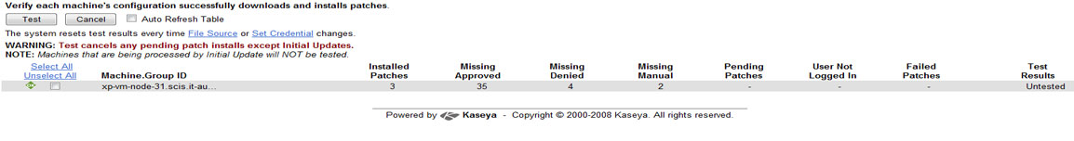
Figure 2.5.4a – Snapshot of Kaseya patch management status
In this view, after the patch scan has completed, administrators can easily see which patches have successfully installed, which patches are missing and approved and which ones have been denied. Kaseya allows administrators to manage which patches are approved or denied by their critical, recommended or optional status. Managing patches with Kaseya can cut administrators time with these built-in features. Below is a snapshot of Kaseya’s “Approval by Policy” page which allows administrators to select which patches should be approved or denied by default:
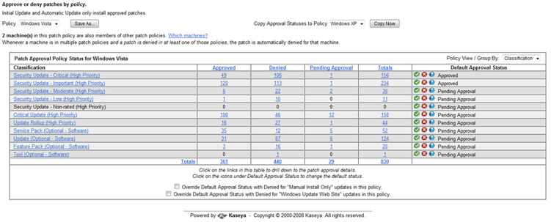
Administrators also have the ability to set a reboot action upon a successful patch or update. This can save the administrator’s time after the patches have been installed. Some patches do require a reboot and this section of Kaseya’s patch management section will allow administrators to configure this type of policy specifically.
2.5.5 Backup & Disaster Recovery
Kaseya’s backup & disaster recover solution is very powerful and the way it displays the status of the backups and the schedules is very user friendly and intuitive. It shows the administrators the status of each backup in progress, the status of backup sets like volumes backups or folders backups.

Through the interface the administrators can get a complete overview of all the backups, it shows them the number and percentage of cancelled backups, skipped backups, failed backups, unscheduled backups, in progress backups, and succeeded backups. It also separates the backups that are local and the ones that are offsite, that way administrators know that all their backup procedures are in place.

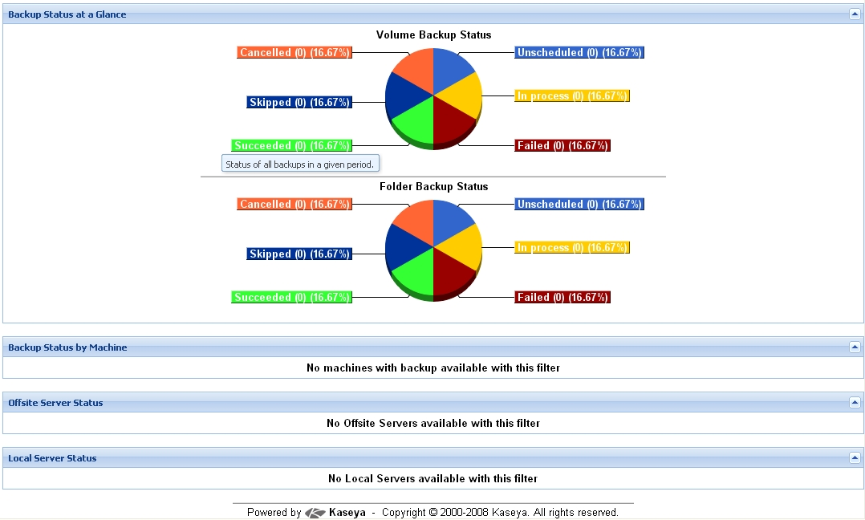
Figure 2.5.5a – Snapshot of Kaseya’s backup status at a glance

The backups itself are very well done, Kaseya offers all the typical types of backups like full backup, incremental backups, and differential backups. The recovery part is straight forward, the administrator select the image or folder to recover from either a local server or an offsite server and starts the recovery, or schedule it. Kaseya also offers backup alerts so that administrators don’t forget to do the backups or schedule them.

2.5.6 Endpoint Security
“Kaseya Endpoint Security (KES) provides security protection for managed machines, using fully integrated anti-malware technology from AVG Technologies. The term malware encompasses viruses, spyware, adware and other types of unwanted programs”. [1] Kaseya continuously monitors all the machines and servers where the endpoint security software is installed. Kaseya cleans and removes all infected files found and alarms can be set to alert administrators of security threats via email notifications, running scripts, and creating job tickets.

The interface status page gives administrators the current security status of all the machines. “This indicators include resident shield protection, mail protection, the number of unresolved threats detected, the number of threats in the virus vault and the version of security protection installed on each machine ID”. [2]

Administrators can also schedule scans for the best time possible and select a staggering time between scans so that scans on more than a set number of machines doesn’t happen at the same time. That way the load on the network can be distributed. Another great feature is setting up profiles for different machines, for example administrators can set up one profile for servers and another one for workstations and then assign different schedules and scans to those profiles.

2.5.7 HelpDesk
Kaseya’s helpdesk and ticketing solution provides a good way for end users to get help from administrators or other technical help people. Just by opening a ticket administrators can attend to a problem completely and keep in touch with the users if they need for information.

Once tickets are opened they are displayed in Kaseya’s interface for easy viewing and keeping track of the status. Tickets with notes entered in the last day will appear highlighted in red while tickets with notes entered in the last 7 days will be highlighted in yellow. Tickets can be search for by name or date or other keywords, as well as it can be filtered and sorted.

Administrators also have the ability of creating notification policies to be alerted when new tickets are created or when tickets change status. These notifications are usually sent out by email. There are many notification types including ticket creation, ticket modified, due date change, and others. Another great feature is the ability to archive old tickets and their solution for future reference. Common problems will happen in the future and having the answer to those problems right there it is a great advantage for administrators.

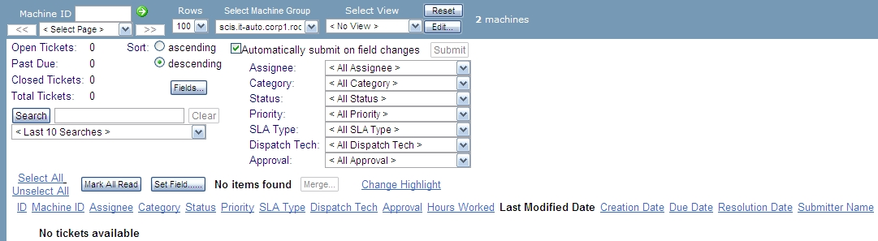
Figure 2.5.7a – Snapshot of Kaseya’s help desk status page

2.5.8 Usability

2.5.9 Reliability
2.5.10 Performance
2.5.11 Supportability (Rating: 5)
Kaseya has several avenues of support, from video how-to guides, phone support, and knowledge base systems.

Kaseya Knowledge Base
The knowledge base starts out with a simple page with several topics. These topics are listed below.
- Backup / Disaster Recovery (BU/DR)
- Core components
- Kaseya Endpoint Security (KES)
- Patch Management
- Server / Agent

Along with this there is a dynamic listing of both Hot Topics and Latest Articles.

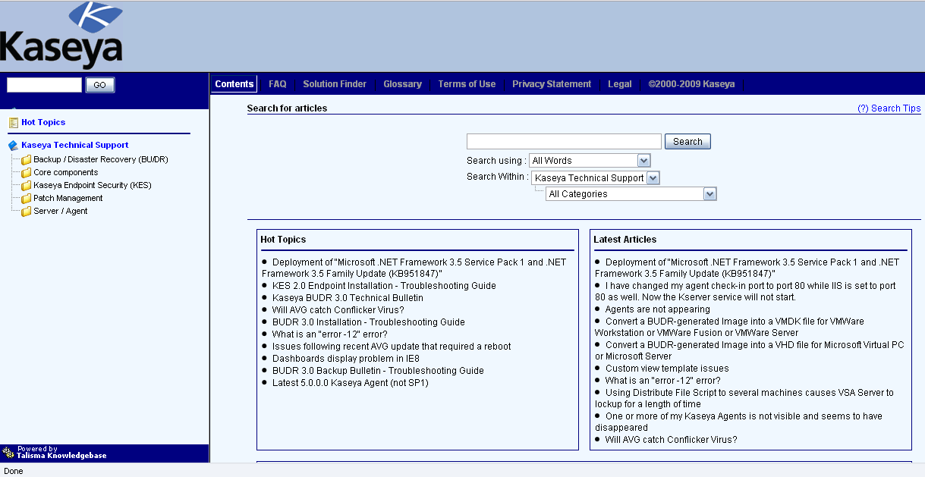
Figure 2.5.11a – Listing from the Kaseya site for the knowledgebase.

Kaseya Forum
There is a form for submitting Problems to Kaseya with the support forum along with a user community to help with issues and share ideas.

Kaseya Call Center
Kaseya has a call center that is available from 8:30AM to 7:00PM Eastern Standard Time from Monday through Friday. This is available for Kaseya customers to call for access to experts.

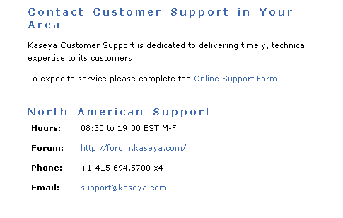
Figure 2.5.11b – Listing from the Kaseya site for support options.

