22.4 Zenith InfoTech
Zenith InfoTech offers a full IT Automation solution for the Small to Medium sized business.
About the Company
Zenith InfoTech Limited is an India-based company with offices in Pittsburgh Pennsylvania, California, and India. Zenith InfoTech provides managed service infrastructure and business continuity solution to information technology service firms worldwide. The Company has a Network Operations Center and fully managed disaster recovery solution supplies partners the essentials to deliver scalable managed service and Disaster Recovery offerings providing servers for customers and offering local network server solutions for clients that want local backups. The Company offers a range of managed services, such as Desktop Solutions, Server Solutions, Network Devices, Vulnerability Assessment Scans and Demonstrations. It also provides Backup and Disaster Recovery Solutions. Zenith InfoTech Services Sdn.Bhd (Malaysia) AND Zenith InfoTech (Singapore) Ltd are its wholly owned subsidiaries. The Company has a distribution network of over 1,500 resellers/channel partners to distribute and sell its services.
*Excerpt from Google Finance see references for listing
Zenith provides three separate and distinct services:
Managed Service Infrastructure
Zenith InfoTech offers a service and software solution that both give you the power to manage your IT infrastructure yourself or obtain the help you needs from Zenith InfoTech themselves. This gives the customer the flexibility to choose where manpower and Zenith InfoTech systems can help out in keeping the business aspect of the company running and reducing the overhead IT costs.
The main driving force of the Zenith InfoTech Managed Service Infrastructure is the SAAZ platform. This platform provides a comprehensive hosted environment with several tools that do the following:
- Desktop Management
- Server and Network Monitoring
- Advanced Scripting Engine
- Reporting Engine
- Ticketing System
The Managed Service Infrastructure also provides its own data center located in Fremont California, rated to be one of the top-ten collocation facilities. With this environment there is no need to add additional servers, they can host them at their facilities or bundle them with other Zenith InfoTech servers.
With the ability to provide management for customer networks from their 600 man Network Operations Center in Mumbai India, the Managed Service Infrastructure can provide 24/7 monitoring. The Network Operations Center has over 3 years of support experience and 15,000+ sites under their management.

Virtual Help Desk
Zenith InfoTech Systems provides a live help desk service from its Service Desk in Pittsburgh, Pennsylvania. The Service Desk is staffed with experienced Level 1 and Level 2 technicians who have 2+ years of work experiencing supporting end-users on server, desktop and network level issues. This service is delivered using a combination of phone and remote control tools that are a part of the SAAZ software. A flat fee per desktop per month is charged for this Service Desk service.
Business Continuity Solution
This solution focuses on a comprehensive backup and disaster recovery solution specifically designed for the small to medium sized business market. This package is often referred to as Backup and Data Recovery (BDR) by Zenith InfoTech Systems. This solution not only provides a software client application but it also provides a standby server merging both a software and hardware solution combined in one. The solution is also capable of near real-time backups pushing as much as every 15 minutes, capturing data as it changes. What sets this solution apart is that it includes a standby server which allows you to recover from server crashes or data loss in minutes, not hours or days. Full block level backups are done in minutes. Granular file, file folder, email, or email attachments can be restored in minutes as well. Zenith’s BDR models are Network Attached Storage (NAS) device installed with Business Continuity Software (BCS) that run on the Windows Storage Server 2003 platform.
One important feature that Zenith InfoTech Systems offers as part of their Business Continuity Software solution is the ability to virtually create a standby server with the backup image, backups are still maintained on the virtual server. The virtual server is run on the NAS device. This is a great feature that greatly limits costly downtime due to server hardware failures. This makes most server functions transparent to the clients that use them.

Technology Partners
To compliment the SAAZ Software & NOC Services Zenith partners with leading Information Technology Partners to offer you further options. You can choose to use the software and services from Zenith’s Technology Partners or deploy your own preferred alternatives for your end clients. Currently Zenith partners to provide: Antispyware Software, and Remote Control software.
The Antivirus offering has recently changed. Antivirus software is no longer offered directly as part of the SAAZ Platform or within Zenith’s Service Levels. You can select your own Antivirus solution or you can choose an Antivirus Vendor that has partnered with Zenith.
In addition Zenith also has setup with ConnectWise where you can view Asset and Inventory data collected by the SAAZ Software in ConnectWise. Also, if you use ConnectWise you can setup Ticketing synchronization between Zenith and ConnectWise to manage your ticketing in the ConnectWise system.
Antivirus Technology Partners
  AVG |   BitDefender |   VIPRE
Remote Connection Technology Partners

LogMeIn

Spyware Technology Partners    Spybot | Asset Management Partners    ConnectWise
2.4.1 Functional Coverage
The SAAZ infrastructure focuses primarily on Microsoft product line due to its abundance in the small to medium size businesses. Most of these companies operate on Microsoft products due to ease of use and prevalence of products.
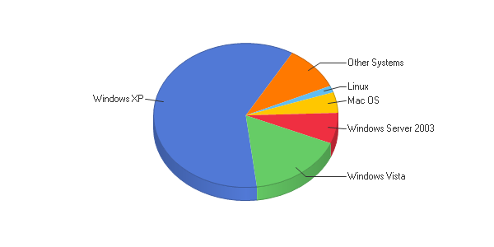
*from the website http://cru.cahe.wsu.edu/WebLog/cru/index.htm
Managed Service Infrastructure SAAZ client software supported Operating Systems
- Windows 2000
- Windows XP
- Windows Vista

Managed Service Infrastructure SAAZ server software supported Operating Systems
- Windows NT Server
- Windows 2000 Server
- Windows 2003 Server
- Windows 2008 Server
- POSIX compliant Hardware monitoring only

What can be Monitored and Managed by the SAAZ Client software for Workstations

- Antivirus definition checks for monitored vendors every 4 hours
- Temporary file and internet debris removal
- Microsoft Patch Assessment
- Disk Based Backup
- Logical Disk space checked for 200 MB free space
- Spyware quick scan during business week full scan weekend
- Microsoft Patch deployment of all or white listed security patches
- S.M.A.R.T. monitoring checking

What can be monitored and managed by the SAAZ client software for Servers

- Stuff about what can be monitored

SAAZ client software for Workstations

The SAAZ client software needs 35mb for the install. It syncs with a SAAZ server either provided by Zenith InfoTech’s datacenter or the customers own server. There is a process that the SAAZ client sets up when installed, this process is defined below. After the installation, the scheduled maintenance that is assigned runs on a schedule for optimum resources for the user, scheduled maintenance can also be run on-demand by the SAAZ server itself. Agents report on any errors to the SAAZ server. Anti-Virus definitions and software can also be deployed to the client using the SAAZ agent and the server. Advanced scripting can also be deployed by the SAAZ client on the workstation.

SAAZ client software for Servers

The SAAZ client software needs only 30mb of space instead of the 35mb for the workstation client. This also communicates to the SAAZ server and reports several things to the monitoring agent. The client software follows several steps when it is first installed. The first step it does is, apply the policy templates that have been assigned to the server. Device monitoring is also setup at this time. Once the agent is started and configured, the SAAZ client sends error codes and unavailability to the SAAZ server. The agent is also capable of mail transaction monitoring also.

2.4.1.1 Remote Control (Rating: 5)
SAAZ architecture uses a technology partner currently provided by LogMeIn. This shows a very flexible way of remote controlling and finding workstations and servers that is used through a web browser for maximum compatibility with administrators preferred workstations.
Brief overview of LogMeIn
LogMeIn is a leading provider of on-demand, remote-connectivity and support solutions to small businesses, IT service providers and consumers. Businesses and IT service providers use LogMeIn's solutions to deliver remote end-user support and to access and manage computers and other Internet-enabled devices more effectively and efficiently.
Advantages of LogMeIn
- Remote Sound Hear email notifications, check web based voice mail or listen to music and podcasts from your host computer
- Drag & Drop Seamlessly transfer files and folders between connected PCs
- Share files or photos instantly with others, even those too large for email
- Remote Printing Automatically print files from your remote PC to your local printer
- Direct Connect Save time and clicks by going directly from the My Computer's page into a remote control or file transfer session
- Mini Meeting Invite a colleague or friend to your PC for an online meeting; view only or full control
- File Transfer Move files quickly between PCs
- File Sync Synchronize files and folders on both PCs in seconds
- Drive Mapping Link your local drives to your target PC
- Quick Clips Short format how to video clips on LogMeIn features and functions

Typical Screenshot of LogMeIn software
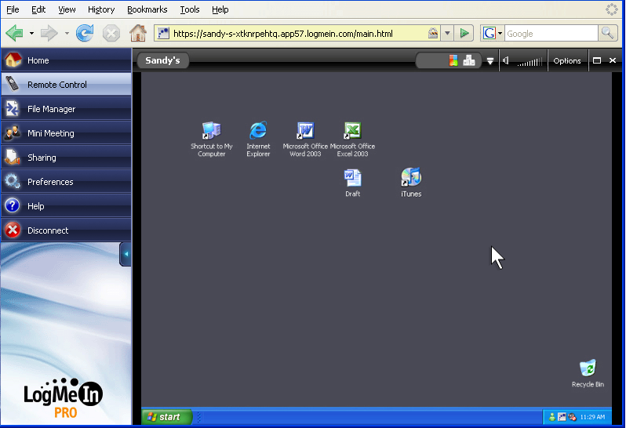
Figure 2.4.1.1a – Screenshot of the LogMeIn software.

Notice that it uses a web browser as its choice of communication and control.
2.4.1.2 Auditing & Asset management (Rating: 4)
With the SAAZ Agent installed system information is captured weekly or on-demand. This information is used for system monitoring but is also reported back to the asset database so you can review system information or run prefabricated asset reports or create your own custom asset report.
Features of the SAAZ Asset Management
- Prefabricated report templates
- Dynamic column and report sorting
- Multi-Site reporting
- Customized asset reporting
- Executive Summary Reports
- Export to Excel
- ConnectWise Asset Synchronization
- End users can review reports in the End Client Portal
- Patching, Spyware, Antivirus Reporting
- Asset Change Reporting
Individual Server Asset management is done through the main SAAZ Server portal as demonstrated below.
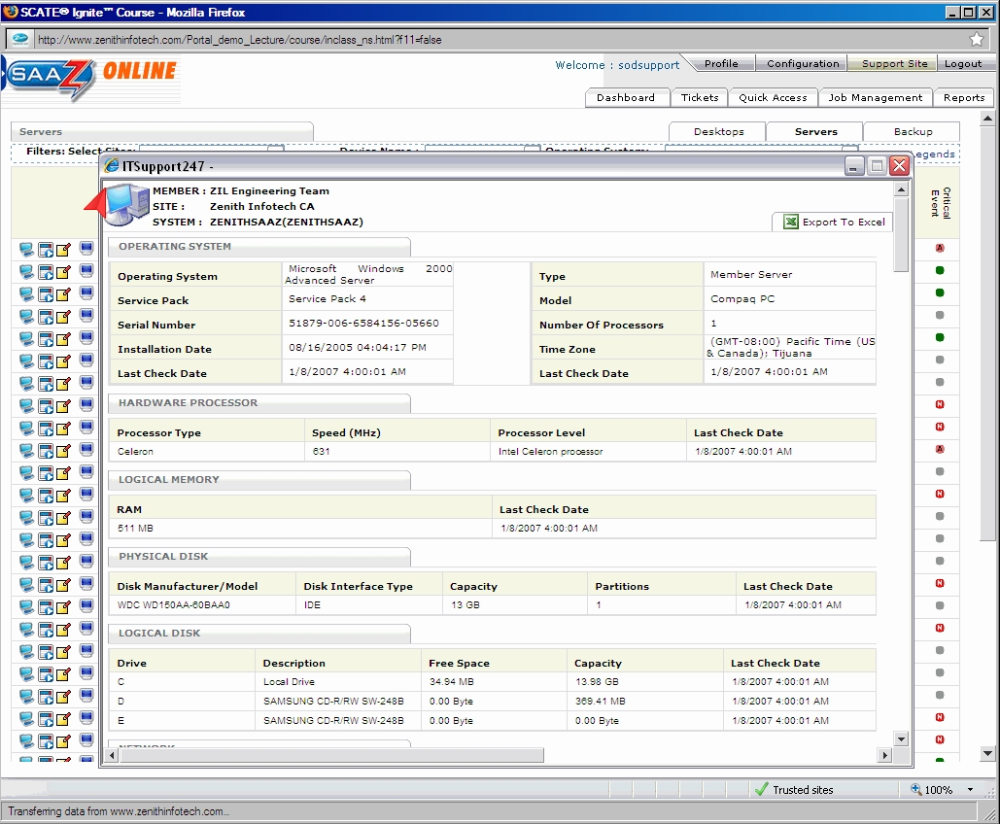
Figure 2.4.1.2a – Screenshot of the helpdesk SAAZ console.
We can see that all the physical assets are viewable below with more asset information that can easily be added. This can also be exported to Excel for further analysis.
2.4.1.3 Monitoring (Rating: 4)
There are 3 distinct management portals used by the SAAZ software solution. There are 2 primary management portals: ITS Portal and Partner Support Portal. The remaining Management Portal is intended for End Client usage. Below is an explanation for each one.
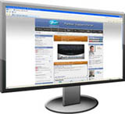  Support Site  - Training Documentation  - Product Videos  - Weekly Live Training  - Business Development Resources  - Marketing Campaign Resources  - MSPtv by Zenith Studios | 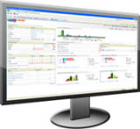  ITS Portal  - Centralized Management  - Portal Overview Dashboard  - Ticketing System  - Alert Overview Dashboard  - Simple Script Deployment Engine  - Patch Deployment Engine  - Prefabricated Reports  - Asset Report Builder
The final one is the one that gives the important monitoring information.
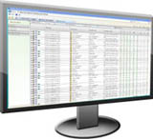

End Client Portal
- Desktop Reporting
- Server Reporting
- Desktop Remote Connections
- Server Remote Connections
- Veritas Reporting
- Business Continuity Reporting
We will be focusing on the End Client Portal which is the SAAZ Server. The interface uses a convenient web interface for true compatibility with most systems that administrators would use for monitoring.

This first window shows the main screen from the SAAZ Server site.

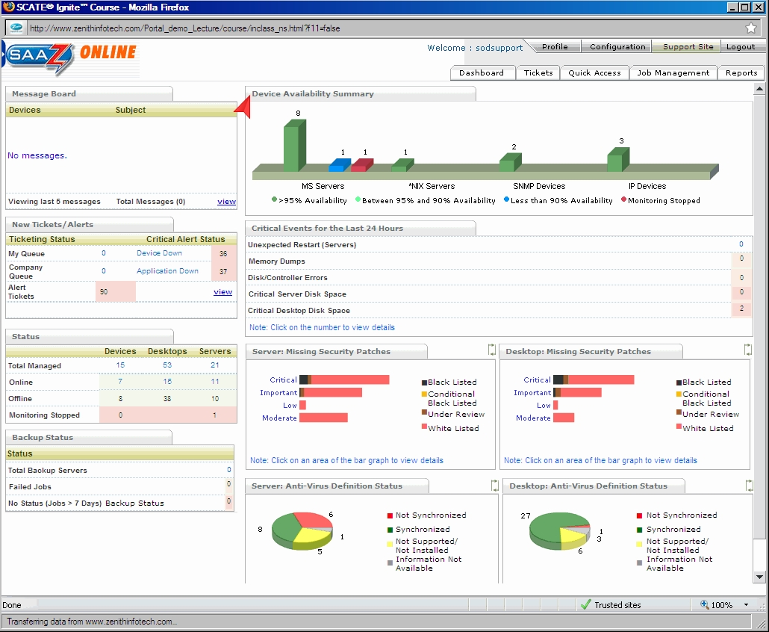
Figure 2.4.1.3a – Screenshot of the main SAAZ Dashboard console.

This is the summary page called the Dashboard and it gives the administrators a top down look at the network starting with the Device Availability Summary. We can see that you can also look at the Ticketing System, Quick Access, Job Management, and Reports. Monitoring is accomplished with the individual SAAZ agents installed on the devices both servers and workstations, these send agent alerts to the SAAZ server which in return displays these results above.

Individual monitoring of alerts can be seen with this example below.

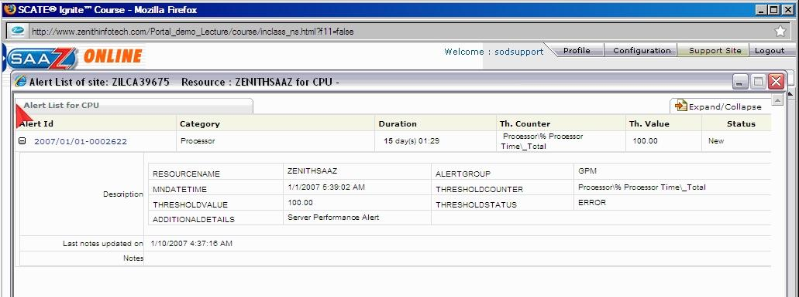
Figure 2.4.1.3b – Screenshot of the individual resource screen SAAZ console.

Of course an overall of all systems on the network can be seen using the Dashboard function as discussed earlier. This window is demonstrated in the next example.

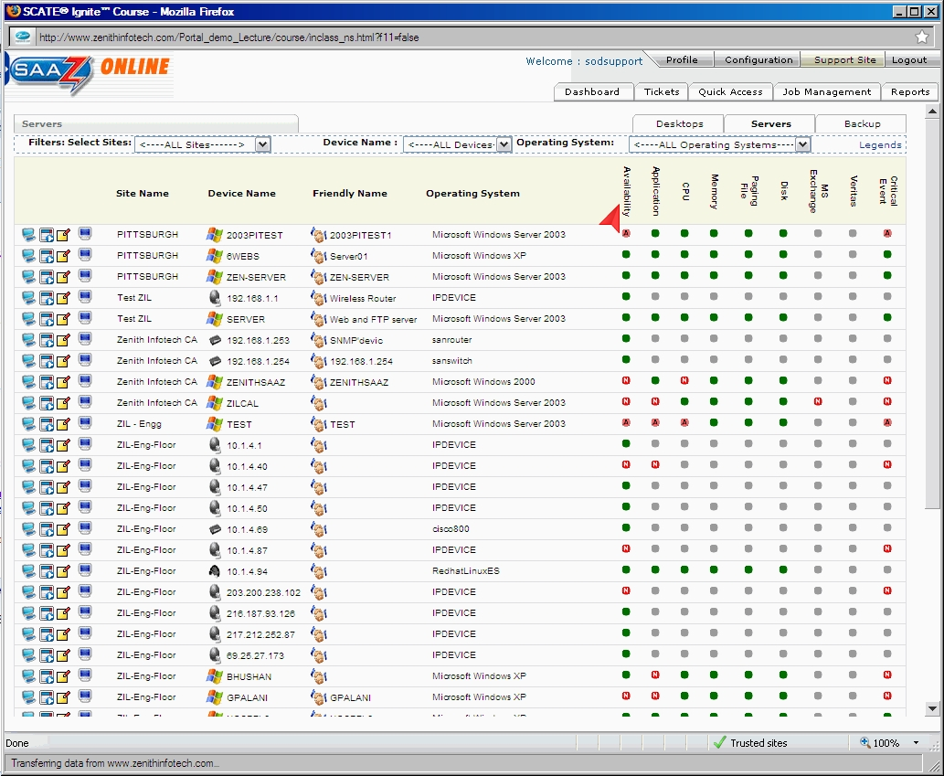
Figure 2.4.1.3c – Screenshot of the computer list SAAZ console.

2.4.1.4 Patch Management (Rating: 4)
Patch management is actually handled by the SAAZ Gateway Component, this component is usually installed locally to either a workstation or server (running windows 2000 or higher) on the local network and is used to download and distribute patches based on what the SAAZ server needs. This functions as a patch caching server so that bandwidth is conserved and new patches are downloaded to just this system from the internet. This component needs an embedded web server to be installed IIS 5.0 or above in order to function properly. Any SAAZ desktop agents installed on the workstations or servers will communicate to this device using standard HTTP and will receive the needed updates.
2.4.1.5 Backup & Disaster Recovery (Rating: 4)
Zenith InfoTech offers a Backup and Disaster Recovery solution that they call their Business Continuity Solution as we discussed earlier. They offer several solutions that include using their Servers to customers having their own server’s located onsite. This is both a hardware and software solution that also provides virtualization which can recreate a virtual server from the backup that it contains if the server were to go down, keeping mission critical servers up the whole time and leaving little downtime to the customers IT infrastructure. The main device is a Network Attached Storage with Zenith InfoTech’s own Business Continuity Software that runs on a Windows 2003 Storage Server platform. This can provide an almost real-time backup with intervals as small as 15 minutes. Backups can be both incremental and full providing flexibility to mission critical needs.

The first backup is called the Base Image and iti is an exact and complete copy of the currently used space on the server. This is a volume copy of each partition, after this all backups are incremental. Once this base image is created it must be shipped to the Zenith InfoTech’s co-location facility where the base image is copied to a server for usage in the Virtual Server backup option. This drive once the base image is copied is then returned to the customer. This creates and incremental forever methodology which they are basing their backup technology on. The customer chooses the backup frequency from the SAAZ server client portal. The incremental backups are stored locally on the customers installation of the NAS but then one incremental is stored offsite at Zenith InfoTech’s data center.

To keep the amount of stored incremental to a manageable size, the backup solution creates something they call Synthetic Incremental backups. This is done by making a larger incremental file from several smaller ones; the different types are listed below.

- Intra-day incremental collapse to a synthetic daily incremental
- Synthetic daily incremental backups collapse to a synthetic weekly
- Synthetic weekly incremental backups collapse to a synthetic monthly
- The synthetic Monthly incremental is currently the highest level back to the base image

Recovery Options

Recovering the files and folders needed is a very simple process where the entire partition is attached on the NAS device. The data can easily be copied to the destination location. The software can even restore SQL tables from a database, a really nice feature.

Instant Visualization Standby Server

The NAS device has the ability to create a virtual standby server using the image that was originally captured and updated through the incremental images. This unique ability is part of the larger Business Continuity Solution. The virtual server retains the same IP address so there is no loss of client productivity. Backups are still performed on the virtual server until the original “downed” server is corrected.

2.4.1.6 Endpoint Security (Rating: 3)
Password Vault feature
The SAAZ server interface has password auditing; this provides security through strong password selection. This password auditing feature uses Zenith InfoTech’s unique Password Vault Technology and provides a controlled process for accessing passwords.

Malware/Spyware Protection and Removal
The SAAZ package provides protection of Malware/Spyware by the usage of its technology partners and has features such as running in the background so that it is transparent to the users.

Anti Virus
The SAAZ server along with the client can track and verify integrity of well known anti-virus programs and combine it in the general alerting agent that the SAAZ server uses. Another Technology partner AVG works closely with Zenith Infotech to provide an Anti-Virus solution but not without its drawbacks as presented with a review below.

  - Review from Customer.

by David Schrag, 5/5/08
I sent the following note to my Zenith InfoTech account managers in February 2008, and I encourage(d) other ZI partners to do the same if they share similar concerns:
As an MSP who relies on Zenith InfoTech’s services for management of my clients’ antivirus software, I am writing to express my displeasure with several aspects of the current implementation of the AVG product line. These problems are listed in order of importance.
1) Having the NOC monitor whether or not AVG is installed and whether the definitions are current is inadequate. A centrally managed antivirus solution must include monitoring and remediation of infections as well. Both the NOC and the MSP should be able to view and report activity on both a client-by-client basis and across the MSP’s client base.
2) I frequently find myself being informed by end-users that their licenses have expired. This is embarrassing to me, not to mention time-consuming. Zenith InfoTech must find a way to ensure that licenses are kept current without intervention from me or my clients.
3) The default settings on AVG often lead to performance problems. For example, standalone machines are configured by default to do a complete scan every day at 8:00 am. If that scan is missed, it kicks off at the next user login. This leads to complaints from users that their computers run extremely slow in the morning. The installation needs to be scripted for so that full system scans are run during off hours, even if no user is logged on at the time of the scan.
4) The rollout of AVG is rather cumbersome, particularly for mobile computers that do not have a constant connection to an AVG ADMIN console. There needs to be a solution that takes less human intervention.
I understand that AVG is currently being offered at an extremely attractive price when bundled with the Zenith InfoTech product. However, saving a few dollars is not worth the risk of having infected machines go undetected and unrepaired or having to manually administer licenses and settings. If AVG is not technically able to provide a complete managed solution, I would prefer to see Zenith InfoTech switch to a different anti-virus vendor.
2.4.1.7 User State Management (Rating: 2)
From discussions with a representative of Zenith InfoTech, user state management is handled by Microsoft’s Active Directory services. There is no need for any additional software for this due to the small size that most of the small to medium size businesses provide. Due to this a rating of 2 is given because the other solutions demonstrate better options.
2.4.1.8 Help Desk (Rating: 5)
Trouble Ticketing System

By using another technology partner Connectwise, a comprehensive ticketing system is provided and integrated in the SAAZ architecture. This provides both trouble ticketing system and alert tracking.
Zenith InfoTech Systems provides a live help desk service from its Service Desk in Pittsburgh, Pennsylvania. The Service Desk is staffed with experienced Level 1 and Level 2 technicians who have 2+ years of work experiencing supporting end-users on server, desktop and network level issues. This service is delivered using a combination of phone and remote control tools that are a part of the SAAZ software. A flat fee per desktop per month is charged for this Service Desk service. The call center is available from 8:00AM till 10:00PM Monday through Friday. There is also premium afterhours support too. By using this you can now use their provided call center and save the massive cost of building a helpdesk infrastructure.
Virtual Help Desk supported operating systems and applications
- Windows 2000
- Windows XP
- Windows Vista
- Microsoft Office 2000/XP/2003/2007
- Microsoft Outlook 2000/XP/2003/2007
- Microsoft Outlook Express
- Lotus Notes 5 and above
- Internet Explorer 5 and above
- Mozilla Firefox
- Adobe Acrobat and Reader 6 and up
- Microsoft Visio 2000/XP/2003/2007

2.4.1.8 Usability (Rating: 5)
The SAAZ webpage interface is incredibly easy to navigate with many ways to get at key systems, cleanly linking everything together. The possibility to look up a system, see all the tickets assigned to it, along with the current status is really incredible. This system is mostly targeted for the small to medium sized business market so the dashboard has been geared toward that. With its top down focus on the network as a whole, it makes monitoring really easy.
2.4.1.8 Reliability (Rating: 4)
The most important fact about Reliability is the fact that Zenith InfoTech actually manages your monitoring servers in its own datacenter which is located in Freemont California, one of the top 10 datacenters out there. This means that extra overhead of managing a local server to act as the SAAZ server is not needed. The interface to the SAAZ server is through a web browser leaving little needed as far as installed software. The only biggest bottleneck is the internet connection itself, if this goes down, all other monitoring is stopped.
2.4.1.8 Performance (Rating: ?)
Due to the unavailability of the software and the server size nature of the product, I was not able to do a performance review.
2.4.1.8 Supportability (Rating: 5)
The massive helpdesk, online tutorials, and service both with hosting and client/server software available really put supportability to the fore front. The ability for the company to completely run your IT Automation software is also a great feature too if your IT department is limited in size.

