COP 4703 Loading Data Into SQL Server 2016

After you review the slides for Chapter 1, you will become more familiar with the sample data that you will work with in this course.
We will load this sample data inout our database in SQL Server.
To Load the sample data into your SQL Server, download the file SQL_Scripts8th.zip.
When you extract the document, you will see the following files:
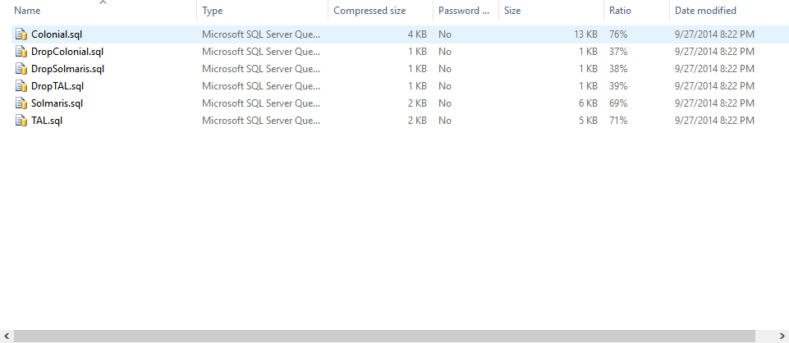
The SQL files have the commands necessary to create or remove data. We will focus on creating the data.
Ignoring the files that are precedeed with DROP, the you will have to execute the other scripts in their own database.
These scripts will 1) create the tables that hold the data and 2) insert the dummy data into the tables.

Creating a database
A SQL Server installation can have multiple databases created.
So for the script alone, you will need to create a database for:
- Colonial
- Solmaris
- TAL

To create a new database, launch Management Studio and connect to a SQL Server
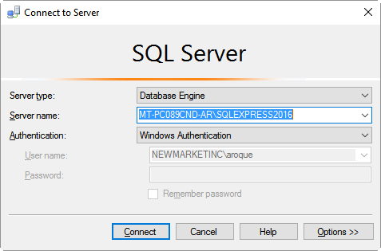

You can log into the SQL Server instance with your windows domain account or the SA account you had previously create. Once in, review the object explorer on your left.

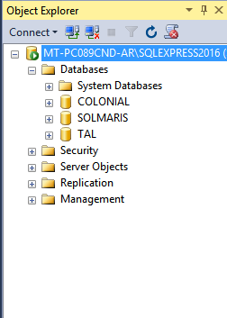

Right click on the Database folder and choose “New Database”
You will get the following screen. Give your database a name (“TAL” for example)
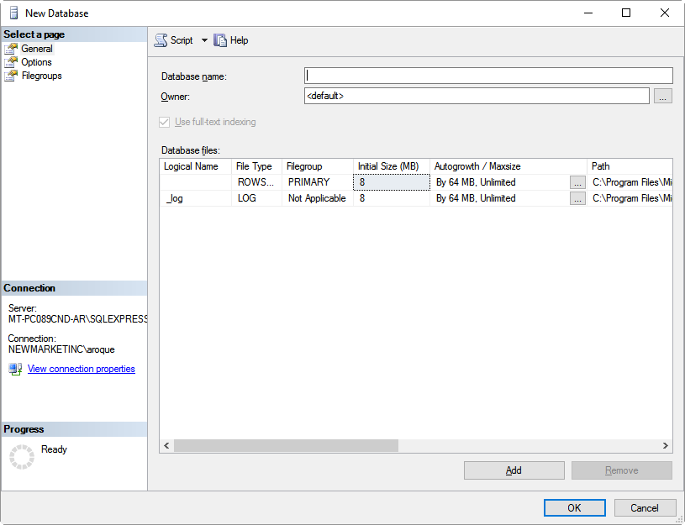

Hit OK, your Database should be created.
Make sure you create one database per each company.
At the End, you should have the following databases:

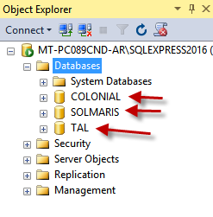
Once this is complete, you are ready to load the sample data.

Loading Sample Data
To load the data, we will need to run the scripts in their respective database.
In SQL Management Studio, perform a File -> Open -> File and open up the desired script:
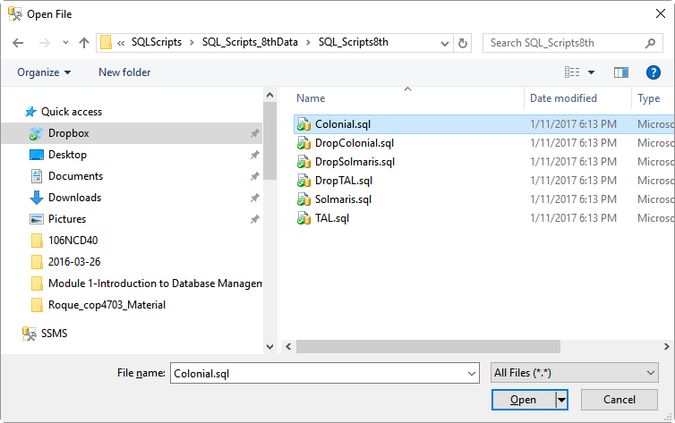

Once the script is opened, make sure you are in the right database and run the script.
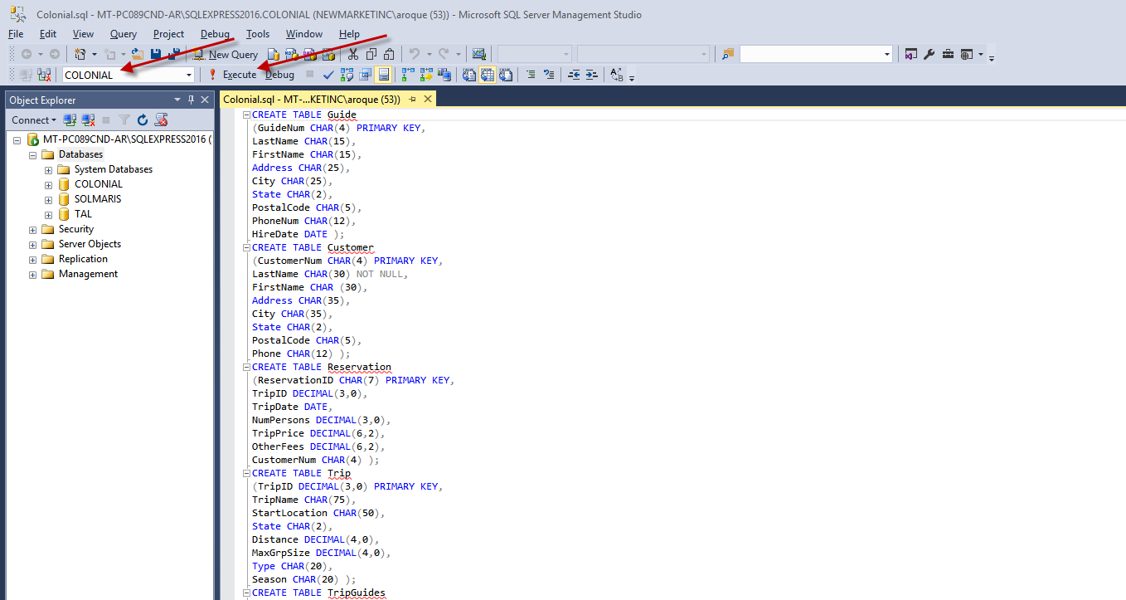

The script will create the tables that we are going to work with and isnert dummy data into those tables.
Once the script is executed, you cann open up the database in the object explorer and take a look at the tables:

We can verify that the tables have been created by right clicking on the tables and performing a
“select top 1000 rows”
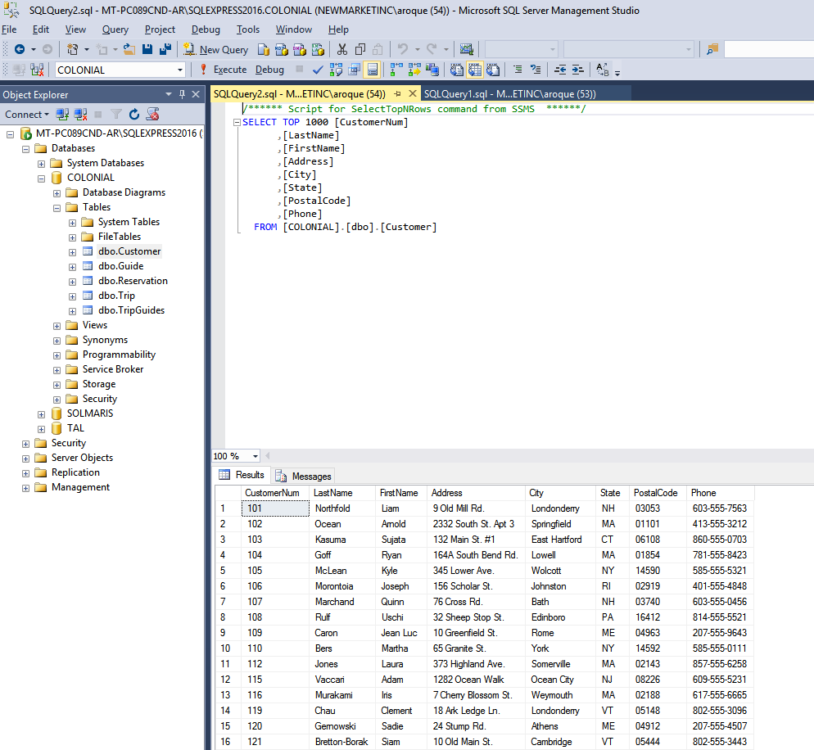

Remember to run the scripts in the 3 databases (colonial, solmaris and TAL).

