Running SQL Scripts in Management Studio

Once you have management studio installed, you will be able to run the Chapter SQL Scripts from each module to learn hands on how to work with SQL.
First, let’s open SQL Management Studio and open the SQL script we want to work with. To do this, go to management studio and connect to your SQL Server.
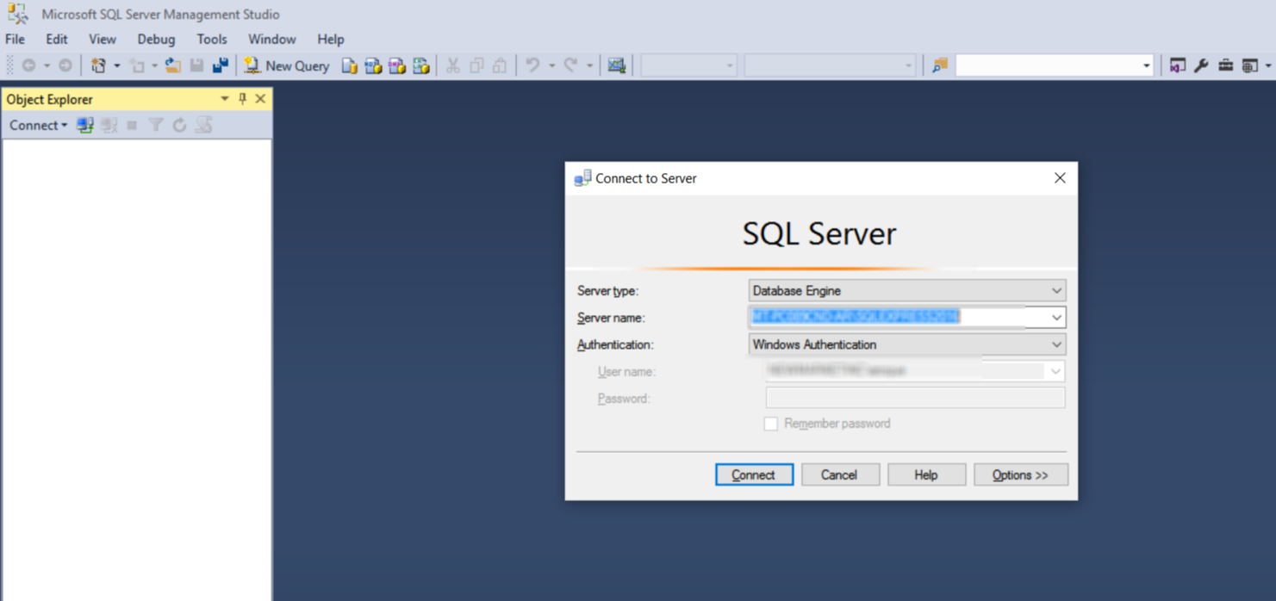
After you have connected, go to the menu and do a File - > Open and load the script that you will be working with. For example, for module 1, open the script Chapt2.sql
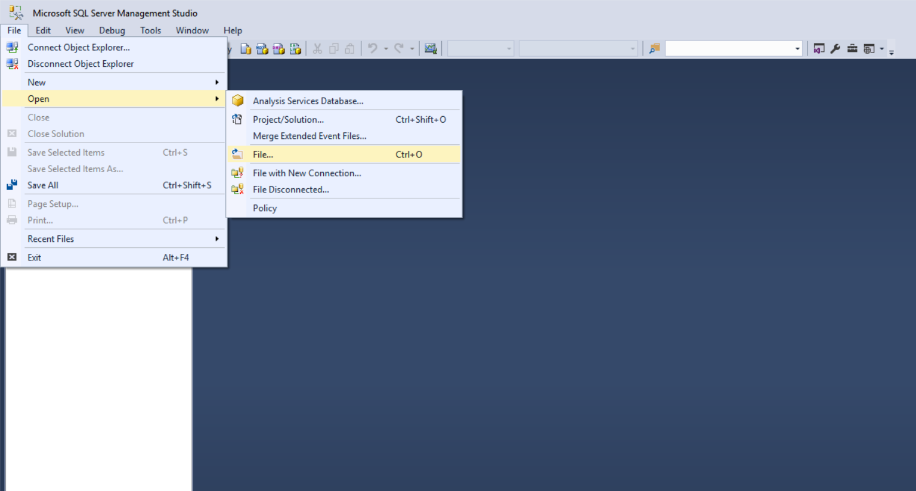
After you have opened the script, you need to make sure you are working in the correct database. You can change the database by changing the database dropdwon on the upper left:
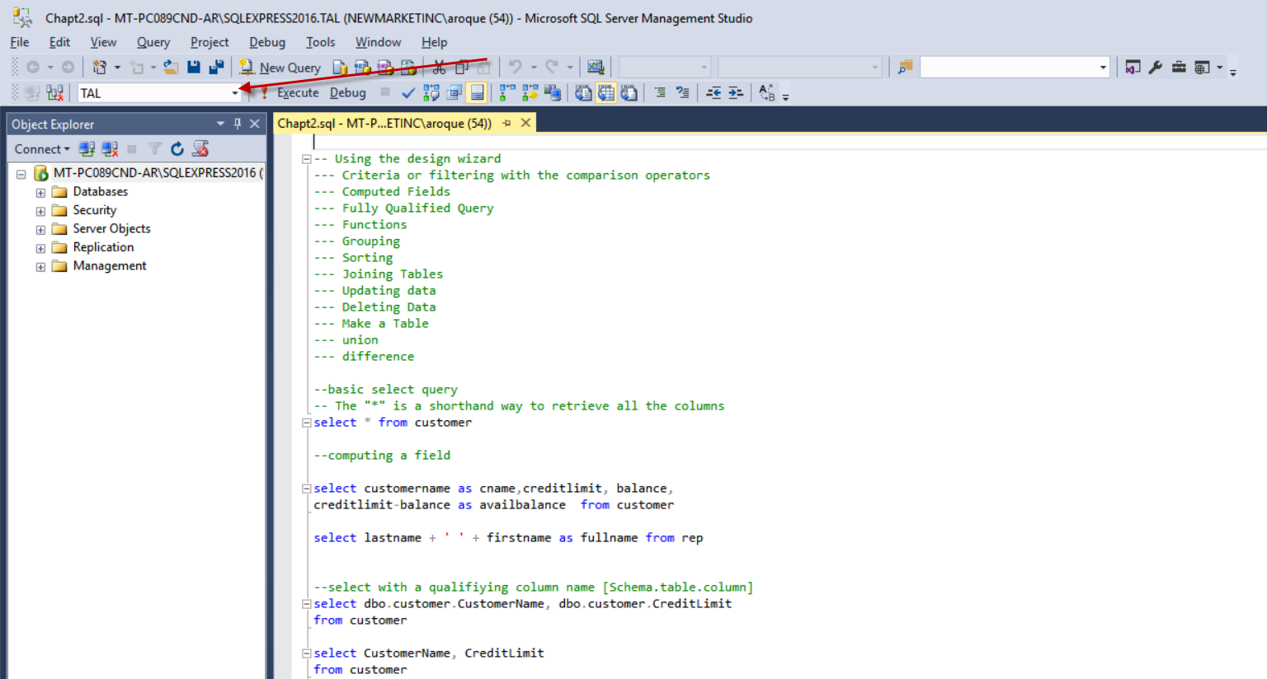

NOTE: The database to select depends on the tables we are working with. For Chapt2.sql, use the TAL database (which should have already been populated with data).
To work with the scripts, you select individual queries to run bu HIGHLIGHTING the desier query and clicking on the “Execute” button.
For Example, in the image below, I’ve highlighted the “select * from customer” query and this will be the only SQL code that will be executed once I click “Execute”.
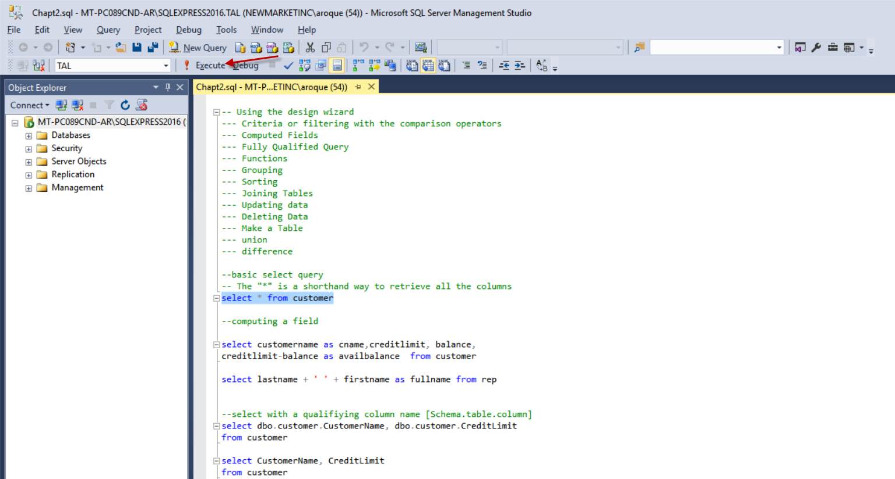

Once I click Execute, we will see the results of the SQL query in the results pane and any messages in the message pane.
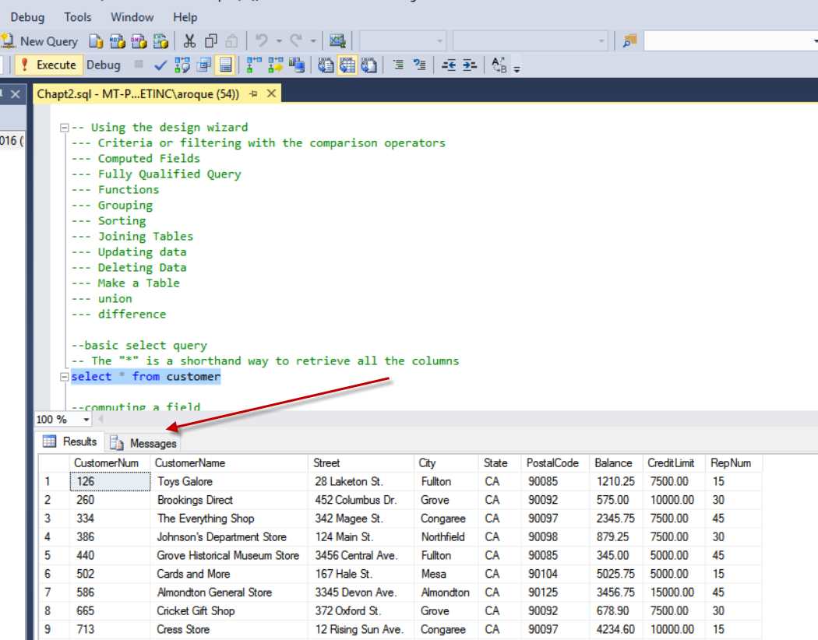

Alternatively, if you don’t select a particular line, it will try to execute the entire page. Please be mindful of this as you work with SQL.

