One you start the download, you will get a File executable to start.
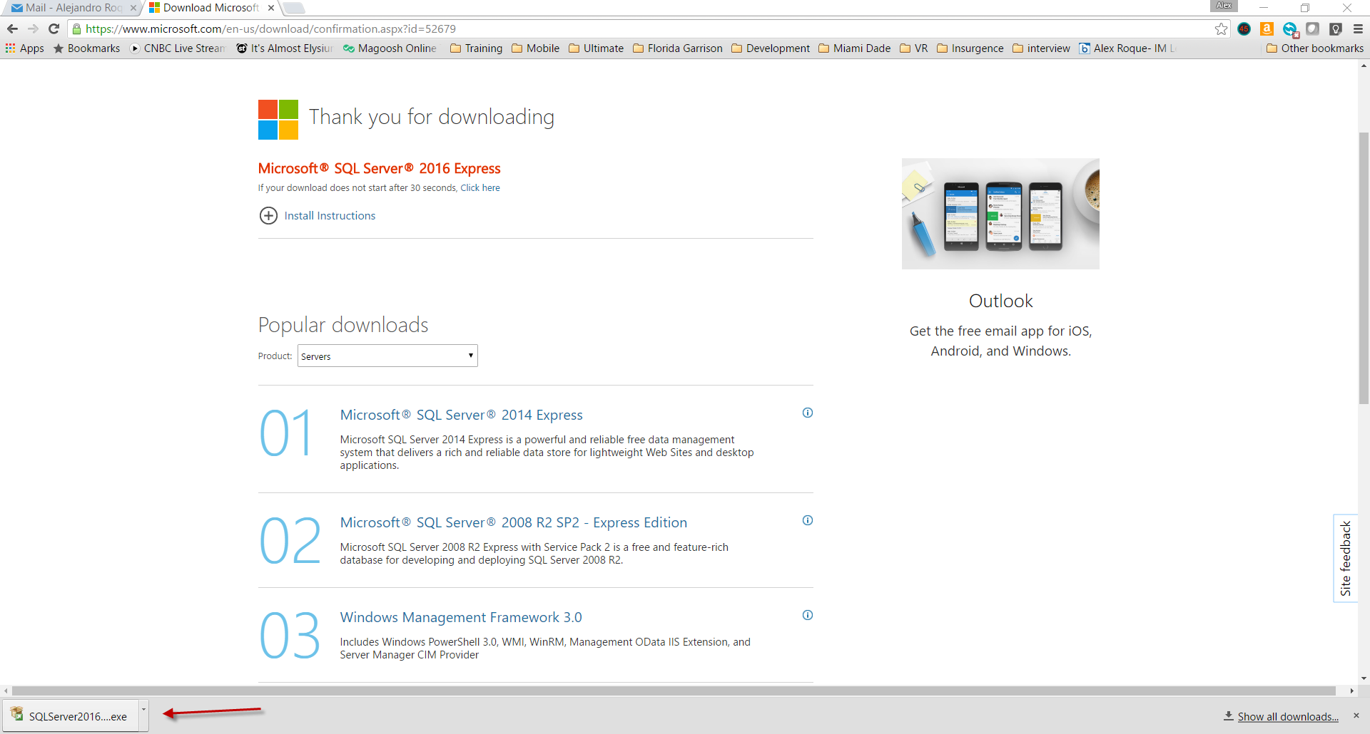
Select custom and it will extract the package to a directory and start the installation.

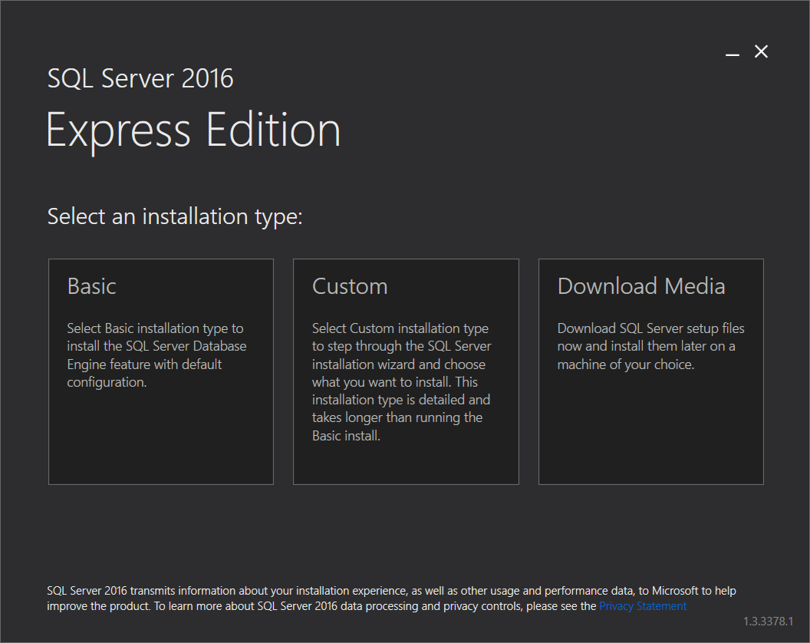
Next you will get the Installation Center. You need to install both the database service (new sql server stand-along installation) and Sql Server Management Tools
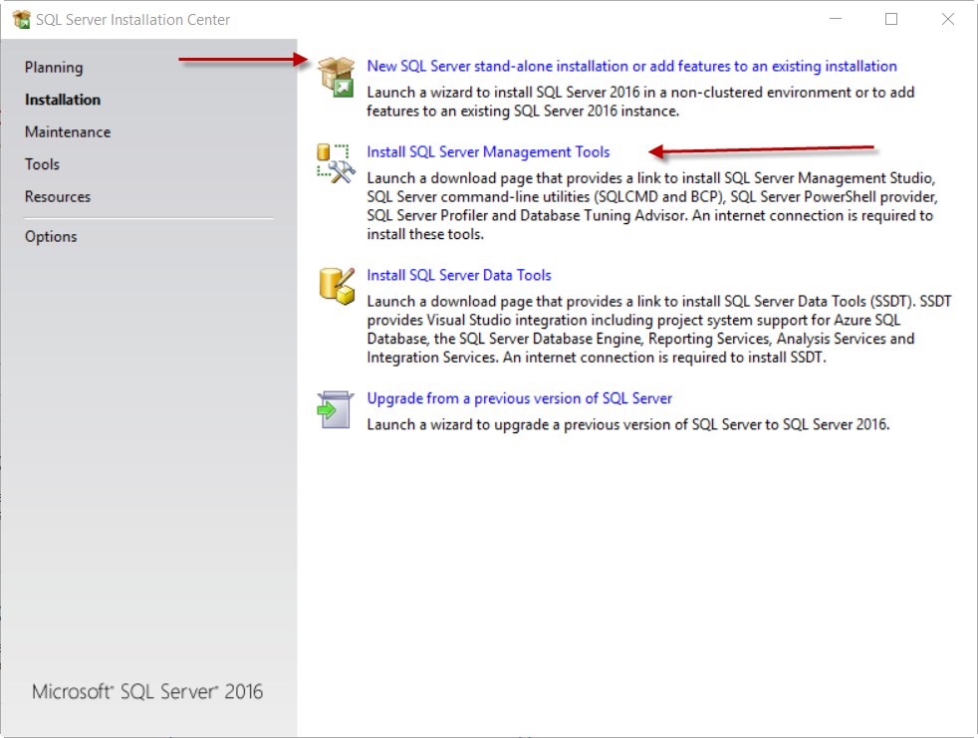
When installing the SQL Server installation, these are the components needed:
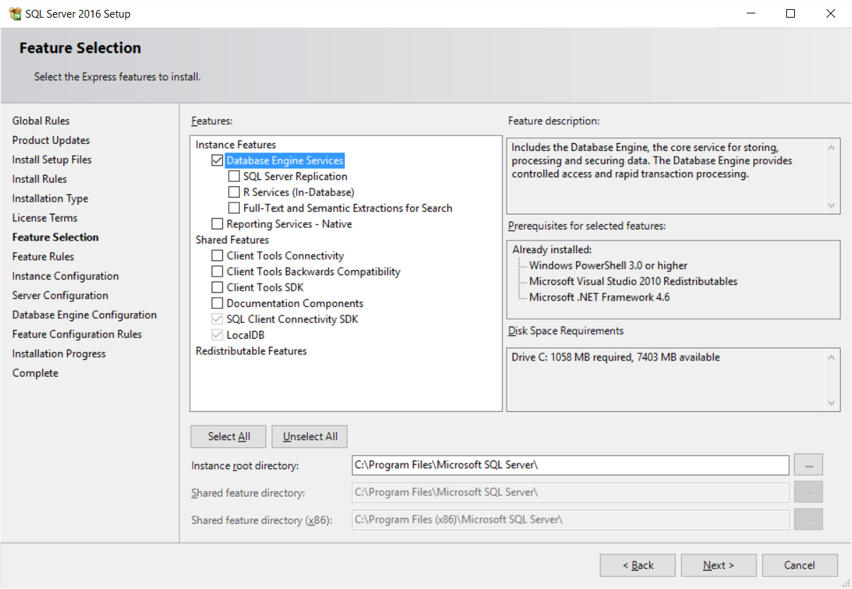
For Authentication Mode, used Mixed Mode and create a SQL server admin account (remember your password).
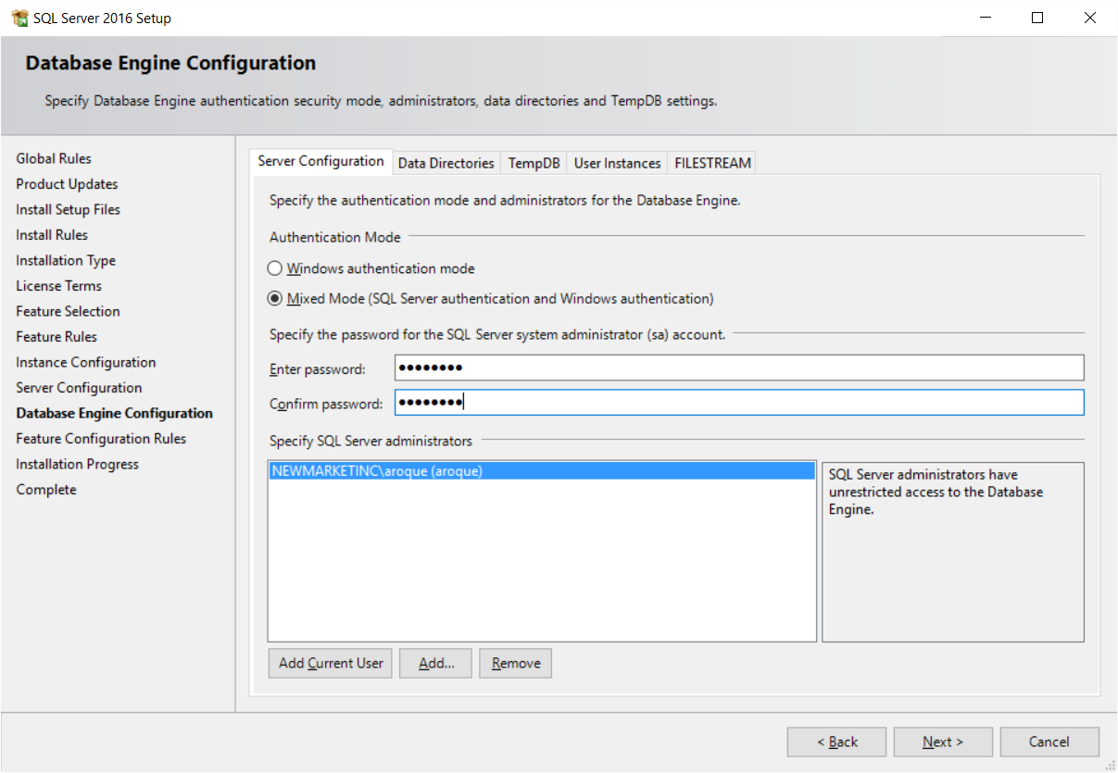
Done with the installation of the database.
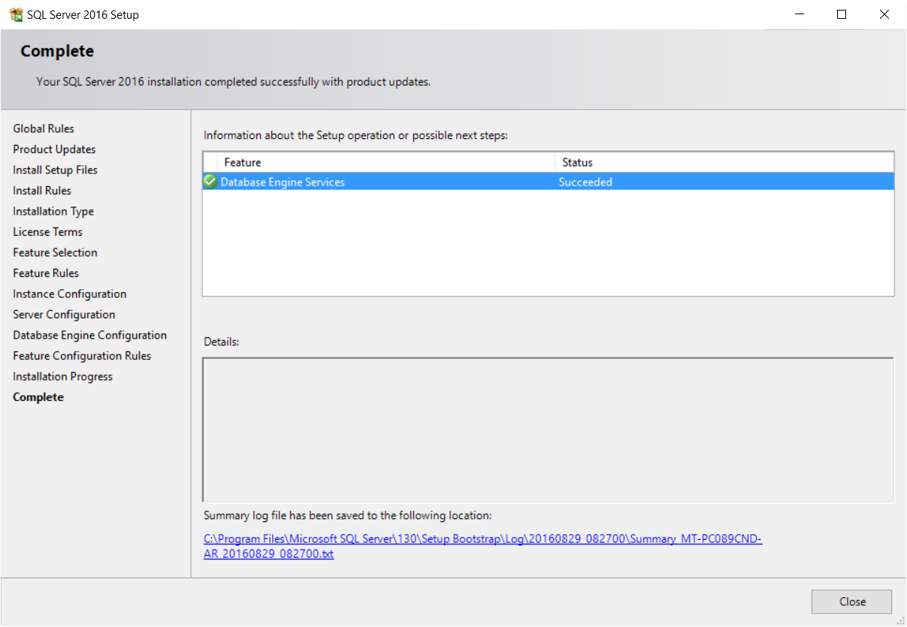
Now install SQL Server Management Studio Tools
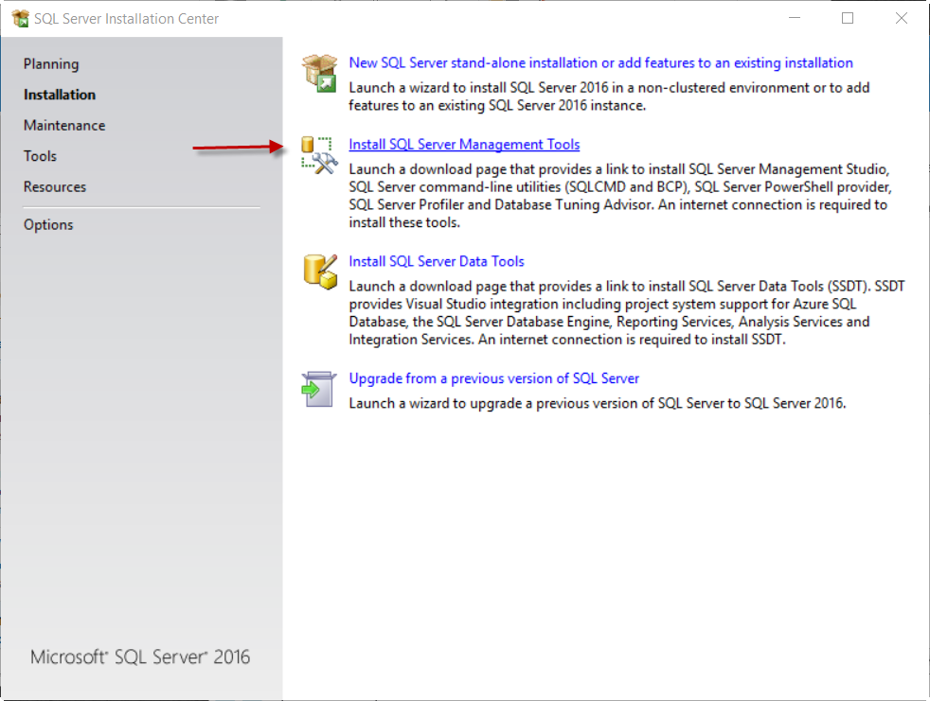
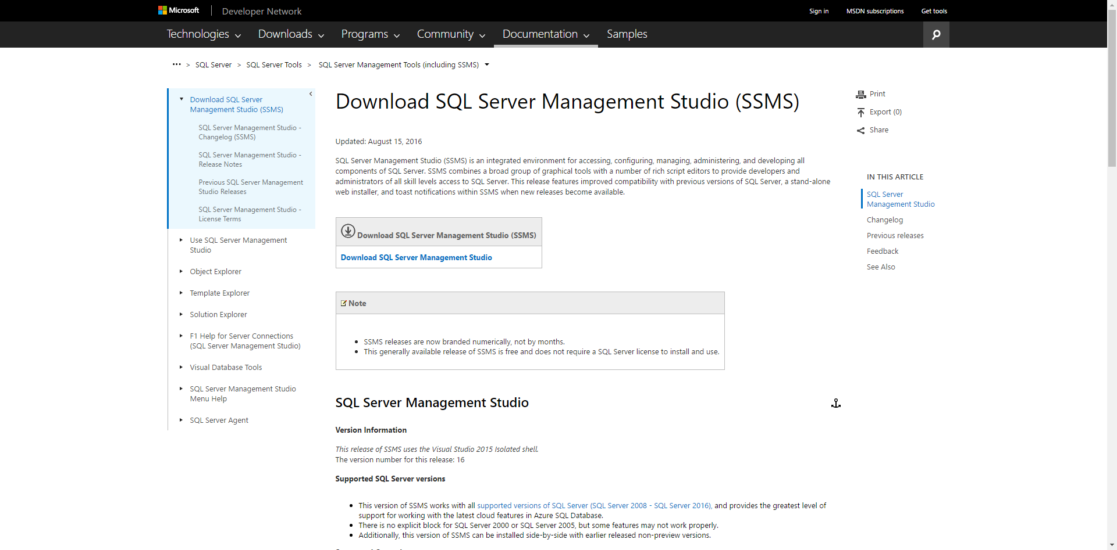
The Sql Server Management Studio (SSMS) is around 807 MB

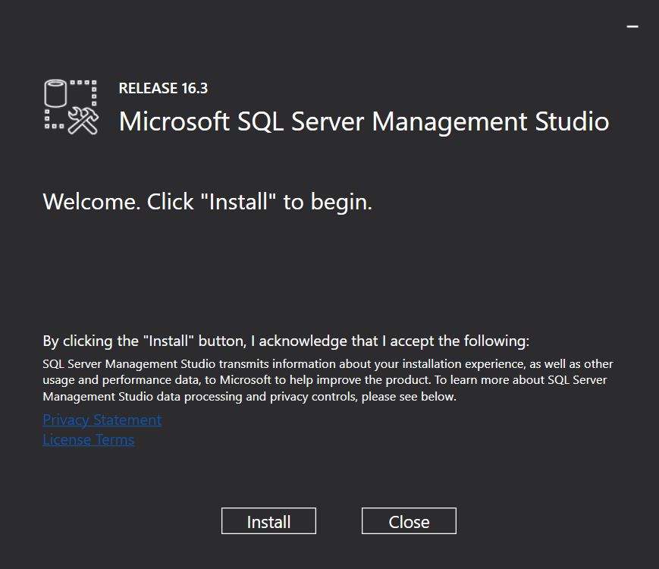

Once the installation completers, you should have a new folder named “Microsoft SQL Server 2016” under all apps. You can them launch Microsoft SQL Server Management Studio.
Once you launch management studio, you should see the Server name automatically populated. If you don’t, select “browse for more” and expand “database engine” and you should see the SQL Server instances which you have installed.

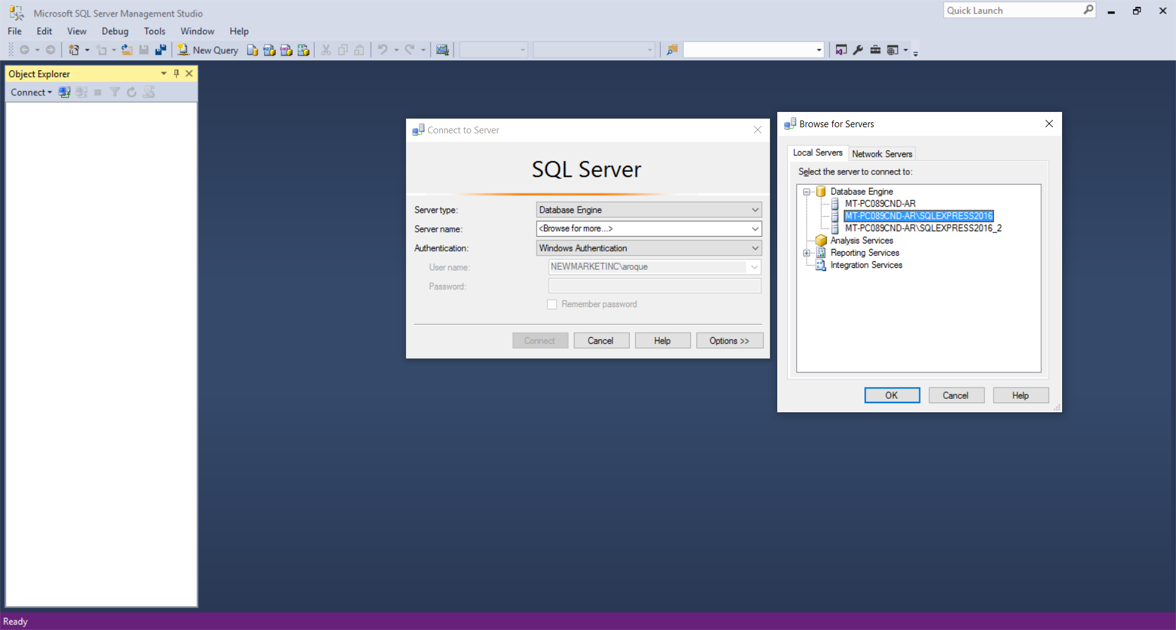

If you want to see the SQL Server instances and their state, you can go to the application “SQL Server Configuration Manager” under the Microsoft Sql Server 2016 folder in your apps menu.
Selecting “SQL Server Services” will show you database instances you have installed. The state of a database instance should be “running” and the start mode should be “automatic”. Otherwise, you will not be able to connect from management studio.
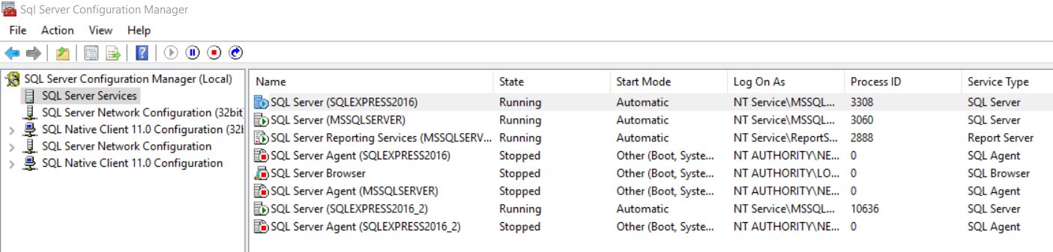
If you see that your database server is not running, try to start it. If there is an error, review the error. Sometimes antivirus programs do not allow the database server to start when you boot up the computer.

