This document is not intended to be a complete list of all requirements and is not a substitute for the Undergraduate Program Catalog. All students are presumed to have read the information in the Undergraduate Program Catalog, which is the final authority.
ELECTRONIC ACCESS TO UNDERGRADUATE PROGRAM INFORMATION
Information about the undergraduate program is available on the web at http://www.cis.fiu.edu/. If you have questions, please send them to either advising@cis.fiu.edu or info-undergrad@fiu.edu.

GENERAL DEGREE INFORMATION
The School of Computing and Information Sciences offers curricula leading to the following degrees:
The Bachelor of Science in Computer Science provides an introduction of the theoretical foundations of computer science. Graduates of this program often conduct research of work in industry as software developers.
The Bachelor of Science in Information Technology as a single major prepares students for entry-level jobs in support positions within companies, so they can manage company computer systems, networks, databases and web sites.
The Bachelor of Arts in Information Technology as a second major can be earned by a student who is either pursuing a major in another field or who has already earned a Bachelor's degree.
The Minor in Computer Science can be used to provide a minimal level of theoretical and practical computer science skills for students majoring in other fields.

ACCREDITATION
The Bachelor of Science program in Computer Science is accredited by:

Computing Accreditation Commission
ABET, 111 Market Place, Suite 1050
Baltimore, MD 21202-1012
Telephone 410-347-7700

SCHOOL OF COMPUTER SCIENCE RESEARCH INTERESTS
Database Systems: including database design, database management systems and applications, database theory and implementation, database machines, distributed databases, and information retrieval in heterogeneous databases.

Software Engineering: including large-scale software design, programming language environments, software development and maintenance methodologies, object-oriented techniques, software reuse, and software quality assurance.

Parallel and Distributed Systems: including formal specification methodologies, distributed file systems and operating systems, and parallel algorithms.

Theory: including data structures and analysis of algorithms, theory of computation, program verification, and logic.

Artificial Intelligence: including neural networks, expert systems, automated reasoning, term rewriting systems, intelligent tutoring systems.

Security: including stealthy malware detection and defense, runtime integrity of systems software, information flow security, and software security vulnerability mitigation

Networking: including simulation and modeling of large-scale computer networks, quality-of-service management, wireless networks, mobile computing, and high-performance routing

Bioinformatics: pattern discovery in sequences and structures, micro-array data analysis, primer design, probe design, phylogenetic analysis, image processing, image analysis

COMPUTING RESOURCES
The School of Computing and Information Sciences provides several computing labs to service the curriculum needs of our undergraduate students. For more information about the JCCL and our other undergraduate computing resources and services, please visit our website at: http://www.aul.fiu.edu.

The John C. Comfort Laboratory (JCCL, ECS 241) is an open learning facility for undergraduate students of the School of Computing and Information Science. This laboratory is equipped with 46 Intel Core2Duo, 2.4ghz class computers that run either Windows XP or Red Hat Linux. A recent addition to this lab includes two 42 inch flat panel displays available to students for collaboration or presentation assignments. This lab has been designed to give students a broad exposure to the Windows XP environment including programming using Microsoft Visual Studio, NetBeans, and Eclipse.

The Experimental Lab or ExLab, (located in ECS 281), can be employed to meet a variety of curriculum computing needs. It is used by undergraduates as an additional open lab, but is also scheduled for class meetings if there is a need for some "hands-on" work in a lab environment. Schedules are posted on the door.

The Instructional Lab (ILab, room ECS141) supports courses that have a programming lab component. The ILab is equipped with 47 Intel Core2Duo 3.0ghz class computers. The ILab is a closed lab and is only available to students for scheduled course meetings.

The IT Hardware Lab in ECS 237 is a closed lab designed to accommodate courses that require manipulation of computer components or networking technologies. This room contains 30 workstations, which students can "tear down" and rebuild in their course work. This room also houses the networking lab where students build and troubleshoot networks.

General Requirements

University Requirements
All students must complete the Academic Degree Requirements and Summer Enrollment Requirement as explained in the FIU catalog:
http://catalog.fiu.edu/index.php?id=2727&section=academicpolicies

All students must complete the University Core Curriculum, CLAS and Foreign Language Requirement as explained in the FIU catalog:
http://catalog.fiu.edu/index.php?id=2812&section=studentservices

College of Engineering Requirements
All students must complete the General Requirements for a Baccalaureate Degree in the College of Engineering as explained in the FIU catalog:
http://catalog.fiu.edu/index.php?id=2239&section=collegesandschools&college=1&parent=2239

SCIS Requirements
If a student takes a course at FIU and has already received transfer credit for an equivalent course at another institution, then the credits for the repeated course at FIU are not applicable toward graduation.

At least 50% of the upper division credits required for the degree must be taken at FIU.

A grade of "C" or better must be obtained in all courses required for the major.

Note: A "C-" is not an acceptable grade.

Additional Requirements
Additional Requirements for Computer Science majors in both tracks:

No computer-related courses in other departments (including CGS 3300) may be taken for elective credit by a CS major, unless specifically approved in writing by the student's advisor.

No credit for graduation will be given to CS majors for the following courses:
COP 3175, CGS 2060, CGS3300, STA 1013, STA 2023, STA 2122, STA 3123, MAC 2233, QMB 3200 and ESI 3161 unless the student took the course before declaring a CS major.

Most of the IT classes cannot be taken for credit for Computer Science majors. The only exceptions are CGS4825, CGS4854, COP4813 and COP4005.

Degrees Offered
Bachelor of Science in Computer Science, Computer Science Track
Bachelor of Science in Computer Science, Software Design Track
Bachelor of Arts in Information Technology
Bachelor of Science in Information Technology, Information Technology Major
Bachelor of Science in Information Technology, Software Major
Minor in Computer Science

Bachelor of Science in Computer Science

Computer Science Track

There are two tracks available in the upper division program for Computer Science. The Computer Science (CS) track should be followed by the student who intends to continue to graduate study in computer science. The Software Design and Development (SDD) track may be followed by the student who intends to pursue a software engineering career. This section explains the requirements for the Computer Science track.

Prerequisites
Students must complete Computer Programming in Java or C++ at an acceptable level, Calculus through infinite series (and including trigonometric functions), and Physics. For a student who has not completed these prerequisites, the courses at FIU that satisfy them are:

COP 2210 | Computer Programming I | PHY 2048 | Physics with Calculus I w/Lab
MAC 2311 | Calculus I | PHY 2049 | Physics with Calculus II w/Lab
MAC 2312 | Calculus II

CS Core Courses

CDA 4101 | Structured Computer Org. | COP 4338 | Computer Programming III
CEN 4010 | Software Engineering I | COP 4540 | Database Management
CGS 1920 | Introduction to Computing | COP 4555 | Principles of Prog. Languages
CGS 3092 | Ethics/Soc in CS | COP 4610 | Operating Systems Principles
CIS 4911 | Senior Project | COT 3420 | Logic for Computer Science
COM 3110 | Business Prof. Communications | ENC 3213 | Prof. and Technical Writing
COP 3337 | Computer Programming II | MAD 2104 | Discrete Mathematics
COP 3402 | Fundamentals of Computer Sys. | MAD 3512 | Intro to Theory of Algorithms
COP 3530 | Data Structures | STA 3033 | Intro to Prob. and Stat. for CS

CS Elective Courses
CS students must have three elective courses.

Choose two from this list:

CAP 4710 | Principles of Computer Graphics | CNT 4513 | Data Communications
CAP 4770 | Data Mining | COP 4225 | Advanced UNIX Programming
CDA 4400 | Computer Hardware Analysis | COP 4226 | Advanced Windows Programming
CEN 4021 | Software Engineering II | COP 4520 | Intro to Parallel Computing
Choose one from this list:

MAD 3305 | Graph Theory | MAD 4203 | Introduction to Combinatorics
MAD 3401 | Numerical Analysis | MHF 4302 | Mathematical Logic

CS Science Elective Courses
CS students are required to take two additional one-semester courses in science for science majors with strong emphasis on quantitative methods

AST 2003 | Solar System Astronomy | GLY 4450 | Exploration Geophysics w/lab
AST 2004 | Stellar Astronomy | MCB 2000 | Introductory Microbiology
BOT 1010 | Introductory Botany | OCB 2003 | Introductory Marine Biology
BSC 1010 | General Biology I | OCE 3014 | Oceanography
BSC 1011 | General Biology II | PCB 2061 | Introductory Genetics
CHM 1045 | General Chemistry I | PHY 3123 | Modern Physics I
CHM 1046 | General Chemistry II | PHY 3124 | Modern Physics II
GLY 3760C | Geological Map Analysis | PHY 3513 | Thermodynamics
GLY 3754 | Remote Sensing in Earth Sci. | PHY 4323 | Inter. Electromagnetism I
GLY 4400 | Structural Geology | PHY 4324 | Inter. Electromagnetism II

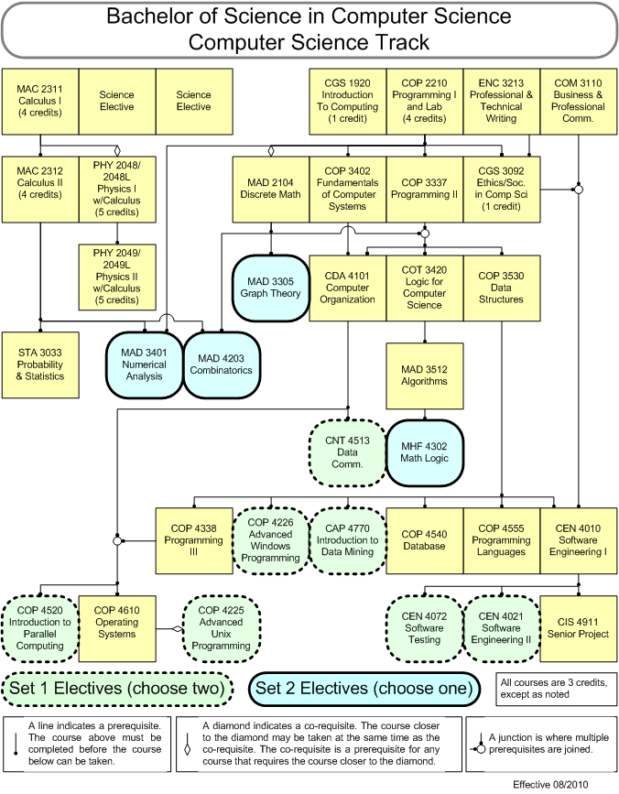

Bachelor of Science in Computer Science

Computer Science Track
Plan of Study

Freshman Year - 30 Credits
CGS 1920 - Introduction to Computing (1 credit)
MAC 2147 - Pre-calculus, if needed, or General Electives (3 credits)
MAC 2311 - Calculus I (4 credits)
MAC 2312 - Calculus II (4 credits)
CS Science Elective (3 credits)
UCC courses (15 credits)

Sophomore Year - 30 credits
COP 2210 - Computer Programming I (4 credits)
PHY 2048/PHY 2048L - Physics I w/Calculus (5 credits)
PHY 2048/PHY 2048L - Physics II w/ Calculus (5 credits)
MAD 2104 - Discrete Mathematics (3 credits)
UCC Life Science and Lab (4 credits) Choose from: BSC 1010, BOT 1010, MCB 2000, OCB 2003 and corresponding lab
UCC courses (6 credits)
General Electives (3 credits)

Junior Year - 30 credits
COP 3402 Fundamentals of Computer Systems (3 credits)
COP 3337 Computer Programming II (3 credits)
ENC 3213 - Professional and Technical Writing (3 credits)
COM 3110 Business and Professional Communications (3 credits)
STA 3033 - Introduction to Probability and Statistics for CS (3 credits)
CGS 3092 Professional Ethics and Social Issues in Computer Science (1 credit)
COP 3530 - Data Structures (3 credits)
COT 3420 - Logic for Computer Science (3 credits)
CDA 4101 - Structured Computer Organization (3 credits)
CS Elective (3 credits) General Electives (2 credits)

Senior Year - 30 credits
COP 4338 - Computer Programming III (3 credits)
MAD 3512 - Theory of Algorithms (3 credits)
CEN 4010 - Software Engineering (3 credits)
COP 4555 - Principles of Programming Languages (3 credits)
COP 4540 - Database (3 credits)
COP 4610 - Operating Systems Principles (3 credits)
CIS 4911 - Senior Project (3 credits)
CS Electives (6 credits)
General Electives (3 credits)

For students who are deficient in a foreign language, the general electives should include a two-semester sequence in one foreign language.

Students are required to earn at least nine credit hours prior to graduation by attending one or more summer semesters at FIU or any other University in the Florida State system.

Bachelor of Science in Computer Science

Software Development Track

There are two tracks available in the upper division program for Computer Science. The Computer Science (CS) track should be followed by the student who intends to continue to graduate study in computer science. The Software Design and Development (SDD) track may be followed by the student who intends to pursue a software engineering career. This section explains the requirements for the Software Design track.

Prerequisites
Students must complete Computer Programming in Java or C++ at an acceptable level, Calculus through infinite series (and including trigonometric functions), and Physics. For a student who has not completed these prerequisites, the courses at FIU that satisfy them are:

COP 2210 | Computer Programming I | PHY 2048 | Physics with Calculus I w/Lab
MAC 2311 | Calculus I | PHY 2049 | Physics with Calculus II w/Lab
MAC 2312 | Calculus II

SDD Core Courses

CDA 4101 | Structured Computer Org. | COP 3530 | Data Structures
CEN 4010 | Software Engineering I | COP 4338 | Computer Programming III
CEN 4021 | Software Engineering II | COP 4540 | Database Management
CEN 4072 | Software Testing | COP 4555 | Principles of Prog. Languages
CGS 1920 | Introduction to Computing | COP 4610 | Operating Systems Principles
CGS 3092 | Ethics/Soc in CS | COT 3420 | Logic for Computer Science
CIS 4911 | Senior Project | ENC 3213 | Prof. and Technical Writing
COM 3110 | Business Prof. Communications | MAD 2104 | Discrete Mathematics
COP 3337 | Computer Programming II | MAD 3512 | Intro to Theory of Algorithms
COP 3402 | Fundamentals of Computer Sys. | STA 3033 | Intro to Prob. and Stat. for CS

SDD Elective Courses
Choose one from this list:

CAP 4710 | Principles of Computer Graphics | COP 4225 | Advanced UNIX Programming
CAP 4770 | Data Mining | COP 4226 | Advanced Windows Programming
CDA 4400 | Computer Hardware Analysis | COP 4520 | Into to Parallel Computing
CNT 4513 | Data Communications

SDD Science Elective Courses
CS students are required to take two additional one-semester courses in science for science majors with strong emphasis on quantitative methods

AST 2003 | Solar System Astronomy | GLY 4400 | Structural Geology
AST 2004 | Stellar Astronomy | MCB 2000 | Introductory Microbiology
BOT 1010 | Introductory Botany | OCB 2003 | Introductory Marine Biology
BSC 1010 | General Biology I | OCE 3014 | Oceanography
BSC 1011 | General Biology II | PCB 2061 | Introductory Genetics
CHM 1045 | General Chemistry I | PHY 3123 | Modern Physics I
CHM 1046 | General Chemistry II | PHY 3124 | Modern Physics II
GLY 3760C | Geological Map Analysis | PHY 3513 | Thermodynamics
GLY 3754 | Remote Sensing in Earth Sci. | PHY 4323 | Inter. Electromagnetism I
GLY 4450 | Exploration Geophysics w/lab | PHY 4324 | Inter. Electromagnetism II

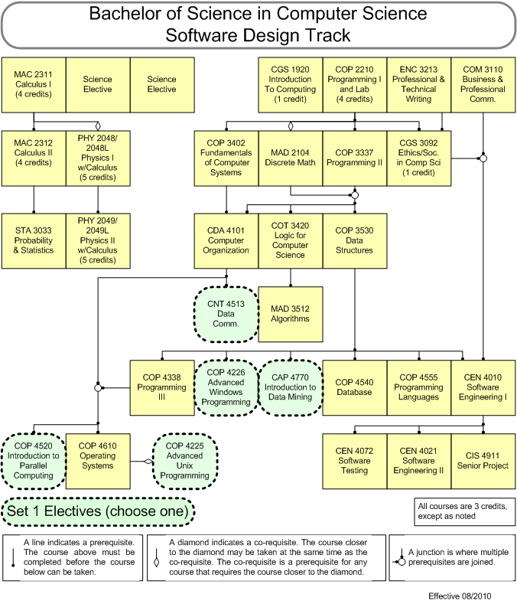

Bachelor of Science in Computer Science

Software Development Track
Plan of Study

Freshman Year - 30 Credits
CGS 1920 - Introduction to Computing (1 credit)
MAC 2147 - Pre-calculus, if needed, or General Electives (3 credits)
MAC 2311 - Calculus I (4 credits)
MAC 2312 - Calculus II (4 credits)
CS Science Elective (3 credits)
UCC courses (15 credits)

Sophomore Year - 30 credits
COP 2210 - Computer Programming I (4 credits)
PHY 2048/PHY 2048L - Physics I w/Calculus (5 credits)
PHY 2048/PHY 2048L - Physics II w/ Calculus (5 credits)
MAD 2104 - Discrete Mathematics (3 credits)
UCC Life Science and Lab (4 credits) Choose from: BSC 1010, BOT 1010, MCB 2000, OCB 2003 and corresponding lab
UCC courses (6 credits)
General Electives (3 credits)

Junior Year - 30 credits
COP 3402 - Fundamentals of Computer Systems (3 credits)
COP 3337 - Computer Programming II (3 credits)
ENC 3213 - Professional and Technical Writing (3 credits)
COM 3110 - Business and Professional Communications (3 credits)
STA 3033 - Introduction to Probability and Statistics for CS (3 credits
COP 3530 - Data Structures (3 credits)
COT 3420 - Logic for Computer Science (3 credits)
CDA 4101 - Structured Computer Organization (3 credits)
CGS 3092 - Professional Ethics and Social Issues in Computer Science (1 credit)
General Electives (5 credits)

Senior Year - 30 credits
COP 4338 - Computer Programming III (3 credits)
MAD 3512 - Theory of Algorithms (3 credits)
CEN 4010 - Software Engineering (3 credits)
COP 4540 - Database (3 credits)
COP 4555 - Principles of Programming Languages (3 credits)
COP 4610 - Operating Systems Principles (3 credits)
CEN 4021 - Software Engineering II (3 credits)
CEN 4072 - Software Testing (3 credits) CIS 4911 - Senior Project (3 credits)
CS Elective (3 credits)

For students who are deficient in a foreign language, the general electives should include a two-semester sequence in one foreign language.

Students are required to earn at least nine credit hours prior to graduation by attending one or more summer semesters at FIU or any other University in the Florida State system.

Minor in Computer Science

Required Courses
COP 2210 - Computer Programming I
COP 3402 - Fundamentals of Computer Systems
COP 3337 - Computer Programming II

Elective Courses
Two courses must be selected from the following list:
CAP 4710 - Principle Computer Graphics
CDA 4101 - Structured Computer Organization
CEN 4500 - Data Communications
COP 3175 - Programming in Visual Basic
COP 3530 - Data Structures
CGS 4825 - Website Construction and Management
COP 4338 - Computer Programming III
COP 4540 - Database Management

NOTE: Students from Engineering would choose COP 3530, and either COP 4338 or CDA 4101. Students from the School of Business would choose COP 3175 and CGS 4825. If one of the other options are selected, then the student should verify that he or she has the additional prerequisites necessary for the chosen course.

ALSO: Graduate courses can also be used to satisfy elective requirements. Please see advisor for approval. Graduate courses are subject to graduate fees.

Other Requirements
At least 9 of the 16 credits must be taken at F.I.U.

A grade of "C" or better must be obtained in all courses required for the minor.

NOTE: A "C-" is not an acceptable grade.

Bachelor of Arts in Information Technology

Second Major in Information Technology

The School of Computer Science offers a Bachelor of Arts degree Information Technology as a second major. This program is open to those students who are enrolled in and will be completing another Bachelor degree program or those who already have a Bachelor degree from an accredited institution. At this time Computer Science and Computer Engineering are not accepted as the primary major at this time.

Degree Requirements
Information Technology BA degree as a second major is intended to augment a student's primary degree.

As of the fall 2010 semester, the requirements for the degree have changed. Courses that are marked with * are for students who declared the major before fall 2010. Courses marked with + are for students who declare the major after the summer 2010 semester.

Courses marked with a * will only be offered as long as there are enough students to fill the classes. If you want to take these classes, take them as soon as possible.

Prerequisites
All students must have completed the following courses (or equivalent) prior to starting the BA in Information Technology program.

CGS 2518 | Computer Data Analysis | COP 2250 | Programming in Java
-or-  CGS 2060 | Intro to Microcomputers | CGS 3559 | Using the Internet or equivalent
-or-  CGS 2100 | Intro to Micro for Business | MAD 1100 | Math Concepts for IT

Core Courses
All students must complete all of the following courses:

CGS 3XXX+ | Human Computer Interaction + | CGS 4366 | Information Storage and Retrieval
CGS 3767 | Computer Operating Systems | COP 3643* | Microcomputer Organization *
CGS 4285 | Applied Computer Networking | COP 3804 | Intermediate Java
CGS 4854 | Web Site Construction and Mgmt

Elective Courses
All students must complete two elective courses from the following list:

CEN 4023 | Component Based Development | COP 4005 | Windows Programming for IT
CIS 4431 | IT Automation | COP 4813 | Web Application Programming
CIS 4930 | Network Administration | COP 4722 | DB Survey
CNT 4403 | Computer and Network Security | COP 4723 | DB Admin
CNT 4513 | Data Communications | CTS 4348 | Unix Admin
COP 3348* | Intro to Using Unix/Linux *

Cognate Elective Courses
All students must complete two additional elective courses. Students who are completing their first major concurrent with their IT degree must choose their cognate elective courses from a list of designated courses from the department of their primary major, with the approval of an IT adviser. Students who have received their first BA degree prior to enrolling in the IT program must instead choose an additional two courses from the list of IT elective courses.

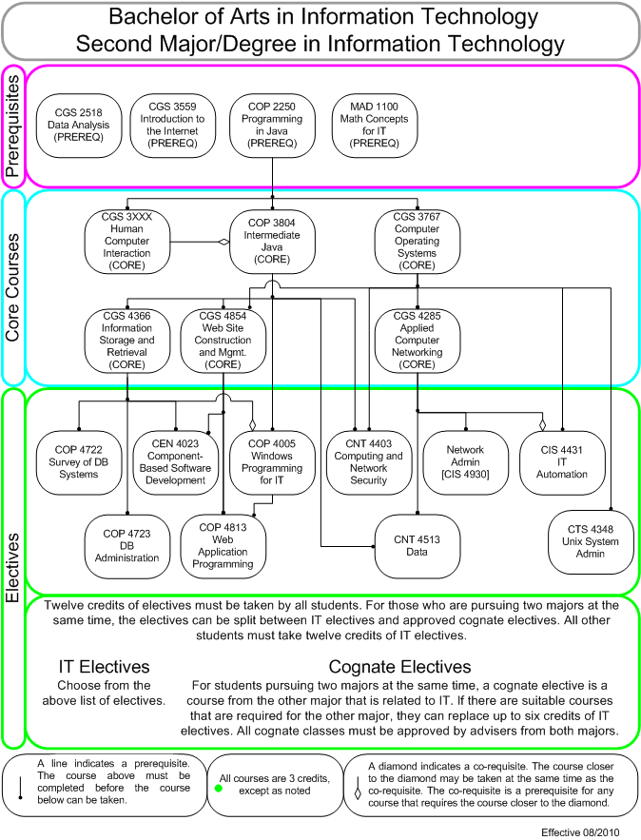

Bachelor of Arts in Information Technology

Second Major in Information Technology
Plan of Study

As of the fall 2010 semester, the requirements for the degree have changed. Courses that are marked with * are for students who declared the major before fall 2010. Courses marked with + are for students who declare the major after the summer 2010 semester.

Courses marked with a * will only be offered as long as there are enough students to fill the classes. If you want to take these classes, take them as soon as possible.

Freshman Year - 30 Credits
MAD 1100 - Math Concepts for IT (3 credits)
CGS 2060 - Introduction to Computers (3 credits)
UCC courses (15 credits)
General Electives (9 credits)

Sophomore Year - 30 credits
COP 2250 - Programming in Java (3 credits)
CGS 3559 - Introduction to the Internet (1 credit)
UCC courses (18 credits)
General Electives (8 credits)

Junior Year - 30 credits
COP 3804 - Intermediate Java (3 credits)
CGS 3767 - Computer Operating Systems (3 credits)
CGS 3XXX+ - Human Computer Interaction + (3 credits)
COP 3643* - Microcomputer Organization * (3 credits)
CGS 4285 - Applied Computer Networking (3 credits)
CGS 4366 - Info Storage and Retrieval (3 credits)
CGS 4854 - Website Construction and Management (3 credits)
First Major Courses and General Electives (12 credits)

Senior Year - 30 credits
2 IT Electives (6 credits)
2 Cognate Electives (6 credits)
First Major Courses and General Electives (18 credits)

For students who are deficient in a foreign language, the general electives should include a two-semester sequence in one foreign language.

Students are required to earn at least nine credit hours prior to graduation by attending one or more summer semesters at FIU or any other University in the Florida State system.

Bachelor of Science in Information Technology

Information Technology Major

The School of Computer Science offers a Bachelor of Science degree in Information Technology as a single major.

As of the fall 2010 semester, the requirements for the degree have changed. Courses that are marked with * are for students who declared the major before fall 2010. Courses marked with + are for students who declare the major after the summer 2010 semester.

Courses marked with a * will only be offered as long as there are enough students to fill the classes. If you want to take these classes, take them as soon as possible.

Prerequisites
All students must have completed the following courses (or equivalent) prior to starting the BS in Information Technology program.

CGS 2518 | Computer Data Analysis | CGS 3092 | Prof. Ethics and Social Issues
-or-  CGS 2060 | Intro to Microcomputers | MAC 2147 | Pre-calculus Mathematics
-or-  CGS 2100 | Intro to Micro for Business | MAC 1105 | Algebra and MAC 1114 Trig
COP 2250 | Programming in Java | MAD 1100 | Math Concepts for IT

Interdisciplinary Credits
Nine credits must be taken outside SCIS. These credits must be selected from the courses for a minor or certificate in another discipline. All nine credits must be taken from the same minor or certificate.

Students graduating under the requirements in effect prior to fall 2010 must take additional courses and complete a minor (not a certificate).

Core Courses
All students must complete all of the following courses:

CEN 4023+ | Component-Based Software Dev. + | CGS 4366 | Info Storage and Retrieval
CGS 1920 | Introduction to Computing | CNT 4403+ | Computing and Network Security +
CGS 3XXX+ | Human Computer Interaction + | COP 3643* | Microcomputer Organization *
CGS 3767 | Computer Operating Systems | COP 3804 | Intermediate Java
CGS 4285 | Applied Computer Networking | ENC 3213 | Professional & Technical Writing
CGS 4854 | Web Site Construction and Mgmt.

Elective Courses
All students must take 5 elective courses. Students must select two areas of concentration and take at least two courses in those two selected areas (4 courses). The fifth course may be selected from any area of concentration.

System Administration Area

COP 3348* | Intro to Unix/Linux * | CIS 4431 | IT Automation
CTS 4348 | Unix Admin

Network Administration Area

CIS 4930 | Network Administration | CNT 4513 | Data Communications

Application Development Area

COP 4005 | Windows Programming for IT | COP 4813 | Web Application Programming

Database Administration Area

COP 4722 | DB Survey | COP 4723 | DB Admin

Free Electives
All students must complete three additional general elective courses. Prerequisites can count as general electives.

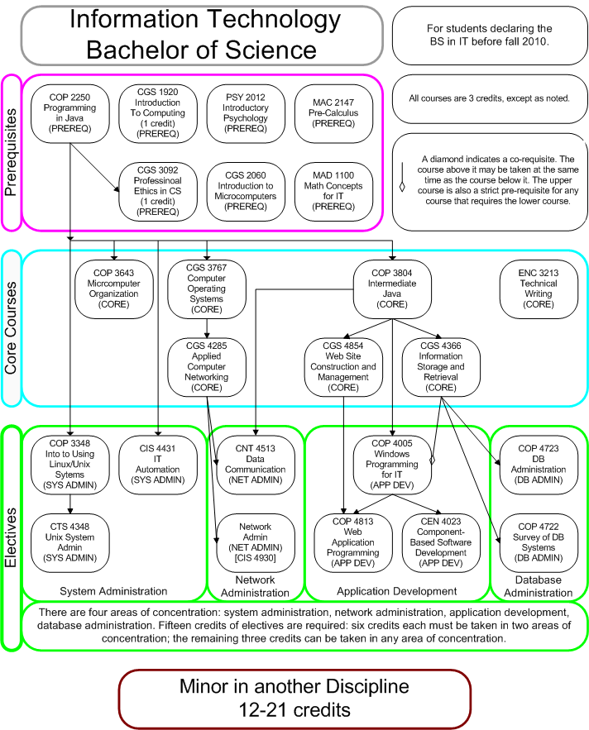
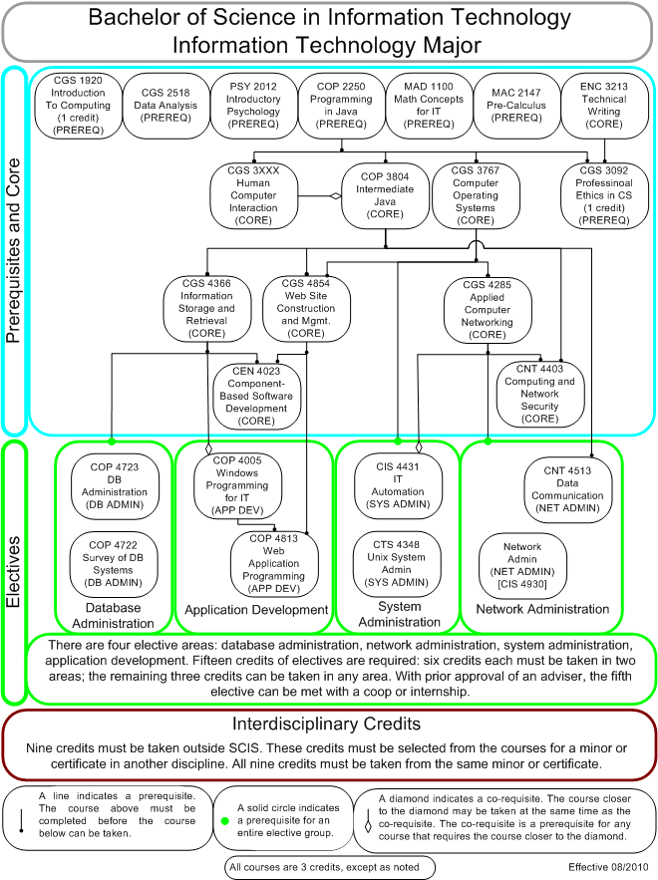

Bachelor of Science in Information Technology

Information Technology Major
Plan of Study

As of the fall 2010 semester, the requirements for the degree have changed. Courses that are marked with * are for students who declared the major before fall 2010. Courses marked with + are for students who declare the major after the summer 2010 semester.

Courses marked with a * will only be offered as long as there are enough students to fill the classes. If you want to take these classes, take them as soon as possible.

Freshman Year - 30 Credits
CGS 1920 - Introduction to Computing (1 credit)
MAC 2147 - Pre-calculus (4 credits)
CGS 2060 - Introduction to Computers (3 credits)
PSY 2012 - Introductory Psychology (3 credits)
UCC courses (12 credits)
General Electives (7 credits)

Sophomore Year - 30 credits
MAD 1100 - Math Concepts for IT (3 credits)
COP 2250 - Programming in Java (3 credits)
UCC courses (16 credits)
General Electives (8 credits)

Junior Year - 30 credits
COP3804 - Intermediate Java (3 credits)
CGS 3XXX+ - Human Computer Interaction + (3 credits)
COP 3643* - Microcomputer Organization * (3 credits)
CGS3767 - Computer Operating Systems (3 credits)
ENC3213 - Professional and Technical Writing (3 credits)
CGS4285 - Applied Computer Networking (3 credits)
CGS4366 - Information Storage and Retrieval (3 credits)
CGS4854 - Website Construction and Management (3 credits)
CGS 3092 - Professional Ethics and Social Issues in Computer Science (1 credit)
IT Electives (6 credits)
General Electives (2 credits)

Senior Year - 30 credits
CEN4023+ - Component-Based Software Development + (3 credits)
CNT4403+ - Computing and Network Security + (3 credits)
IT Electives (9 credits)
Interdisciplinary Courses + (9 credits)
Minor Courses * (15 credits)
General Electives (6 credits)

For students who are deficient in a foreign language, the general electives should include a two-semester sequence in one foreign language.

Students are required to earn at least nine credit hours prior to graduation by attending one or more summer semesters at FIU or any other University in the Florida State system.

Bachelor of Science in Information Technology

Software Major

The School of Computer Science offers a Bachelor of Science degree in Information Technology as a single major with a strong foundation in the theory of Computer Science.

Prerequisites
All students must have completed the following courses (or equivalent) prior to starting the BS in Information Technology program.

CGS 2518 | Computer Data Analysis | CGS 3092 | Prof. Ethics and Social Issues
-or-  CGS 2060 | Intro to Microcomputers | MAC 2147 | Pre-calculus Mathematics
-or-  CGS 2100 | Intro to Micro for Business | MAC 1105 | Algebra and MAC 1114 Trig
COP 2210 | Programming I | MAD 2104 | Discrete Math

Interdisciplinary Credits
Nine credits must be taken outside SCIS. These credits must be selected from the courses for a minor or certificate in another discipline. All nine credits must be taken from the same minor or certificate.

Core Courses
All students must complete all of the following courses:

CEN 4023 | Component-Based Software Dev. | CNT 4403 | Computing and Network Security
CGS 1920 | Introduction to Computing | COP 3337 | Programming II
CGS 3XXX | Human Computer Interaction | COP 3402 | Fundamentals of Computer Sys.
CGS 3767 | Computer Operating Systems | COP 3530 | Data Structures
CGS 4285 | Applied Computer Networking | COP 4338 | Programming III
CGS 4854 | Web Site Construction and Mgmt. | ENC 3213 | Professional & Technical Writing
CGS 4366 | Info Storage and Retrieval

Elective Courses
All students must take two elective courses. Students must select one area of concentration and take two courses in that area.

System Administration Area

CTS 4348 | Unix Admin | CIS 4431 | IT Automation

Network Administration Area

CIS 4930 | Network Administration | CNT 4513 | Data Communications

Application Development Area

COP 4005 | Windows Programming for IT | COP 4813 | Web Application Programming

Database Administration Area

COP 4722 | DB Survey | COP 4723 | DB Admin

Free Electives
All students must complete three additional general elective courses. Prerequisites can count as general electives.

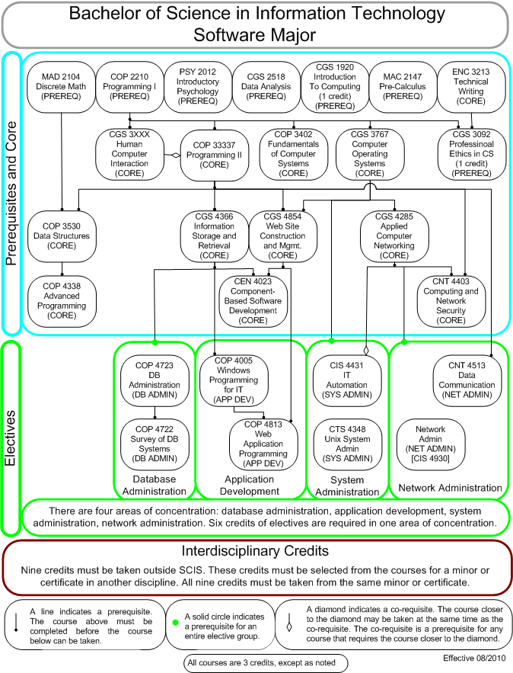

Bachelor of Science in Information Technology

Software Major
Plan of Study

Freshman Year - 30 Credits
CGS 1920 - Introduction to Computing (1 credit)
MAC 2147 - Pre-calculus (4 credits)
CGS 2518 - Data Analysis (3 credits)
PSY 2012 - Introductory Psychology (3 credits)
UCC courses (12 credits)
General Electives (7 credits)

Sophomore Year - 30 credits
MAD 2104 - Discrete Math (3 credits)
COP 2210 - Programming I (4 credits)
UCC courses (16 credits)
General Electives (7 credits)

Junior Year - 30 credits
COP 3337 - Programming II (3 credits)
CGS 3XXX - Human Computer Interaction (3 credits)
CGS 3767 - Computer Operating Systems (3 credits)
ENC 3213 - Professional and Technical Writing (3 credits)
CGS 4285 - Applied Computer Networking (3 credits)
CGS 4366 - Information Storage and Retrieval (3 credits)
CGS 4854 - Website Construction and Management (3 credits)
COP 3402 - Fundamentals of Computer Systems (3 credits)
IT Electives (3 credits)
Interdisciplinary Courses (3 credits)

Senior Year - 30 credits
CGS 3092 - Professional Ethics and Social Issues in Computer Science (1 credit)
CEN 4023 - Component-Based Software Development (3 credits)
CNT 4403 - Computing and Network Security (3 credits)
COP 3520 - Data Structures (3 credits)
COP 4338 - Programming III (3 credits)
IT Electives (3 credits)
Interdisciplinary Courses (6 credits)
General Electives (8 credits)

For students who are deficient in a foreign language, the general electives should include a two-semester sequence in one foreign language.

Students are required to earn at least nine credit hours prior to graduation by attending one or more summer semesters at FIU or any other University in the Florida State system.

Undergraduate Course Offerings

Definition of Prefixes CAP-Computer Applications; CDA-Computer Design/Architecture;CEN-Computer Software Engineering; CGS-Computer General Studies; CIS-Computer Information Systems; CNT-Computer Networks; COP-Computer Programming; COT-Computing Theory; CTS-Computer Technology and Skills

CAP 4710 Principles of Computer Graphics (3). A first course in algorithms/techniques for image generation devices, geometric transformations/matrics, algorithms for hidden surfaces, ray tracing, advanced rendering. Programming with standard graphics interface. Prerequisites: COP 3337 and MAC 2312. This course will have additional fees.

CAP 4770 Introduction to Data Mining (3). Data mining applications, data preparation, data reduction and various data mining techniques such as association, clustering, classification, anomaly detection. Prerequisite: COP 3530. Corequisite: COP 4540.

CDA 4101 Structured Computer Organization (3). Covers the levels of organization in a computer: Design of memory, buses, ALU, CPU; design of microprogram. Covers virtual memory, I/O, multiple processes, CISC, RISC and parallel architectures. Prerequisites: MAD 2104, COP 3402 and COP 3337. This course will have additional fees.

CDA 4400 Computer Hardware Analysis (3). The study of storagehardware functions of a basic computer. Topics include logic elements, arithmetic logic units, control units, memory devices, organization and I/O devices. Prerequisite: CDA 4101.

CEN 4010 Software Engineering I (3). Software Process Model, software analysis and specification, software design, testing. Prerequisite: COP 3530. This course will have additional fees.

CEN 4012 Software Design and Development Project (3). Students design, implement, document, and test software systems working in faculty supervised project teams and utilizing knowledge obtained in previous courses. Required for Software Design and Development track. Prerequisite: CEN 4010. This course will have additional fees.

CEN 4021 Software Engineering II (3). Issues underlying the successful development of large scale software projects: Software Architectures; Software Planning and Management; Team Structures; Cost Estimation. Prerequisite: CEN 4010. This course will have additional fees.

CEN 4023 Component-Based Software Development (3). Concept of software components, component models and web services such as WSDL and SOAP. Prerequisites: COP 4338 or COP 4005 or permission of the instructor.

CEN 4072 Fundamentals of Software Testing (3). Fundamentals of software testing. Topics include: test plan creation, test case generation, program inspections, specification-based and implementation-based testing, GUI testing, and testing tools. Prerequisite: COP 3530.

CGS 1920 Introduction to Computing (1). Overview of the computing field to students, research programs and career options.

CGS 2060 Introduction to Microcomputers (3). A hands-on study of microcomputer software packages for applications such as operating system, word processing, spreadsheets, and database management. For students without a technical background. Not acceptable for credit for Computer Science majors.

CGS 2100 Intro to Microcomputer Applications for Business (3). A hands-on study of spreadsheet and database management packages for business students without a technical background. Not acceptable for credit for Computer Science majors.

CGS 2423 C for Engineers (3). A first course in programming geared for engineering and natural science students that describes the syntax and semantics of ANSI C programming language. Includes developing algorithms and writing for problems in engineering and science.

CGS 2518 Computer Data Analysis (3). A hands-on study of how to use a modern spreadsheet program to analyze data, including how to perform queries, summarize data, and solve equations. For non-technical students. Not acceptable for CS students.

CGS 3092 Professional Ethics and Social Issues in Computer Science (1). Ethical, legal, social issues and the responsibility of computer professionals. Codes of conduct, risks and reliability, responsibility, liability, privacy, security, free speech issues. Prerequisite: COP 2210 or COP 2250.

CGS 3416 Web-based Programming (3). A programming course in Java with emphasis on web-based applications: Applets; Components; Servlets; Java Beans. Not acceptable for credit for Computer Science majors. Prerequisites: COP 2250 and MAD 1100. This course will have additional fees.

CGS 3559 Using the Internet (1). Internet history and importance. What is available on the Net. Tools such as email, listserves, telnet, ftp, Archie, Veronica, Gopher, netfind, the World Wide Web, Wais, and Mosaic. Nontechnical. Prerequisite: CGS 2060 or equivalent.

CGS 3767 Computer Operating Systems (3). Introduction to fundamental concepts of operating systems and their implementation in UNIX, Windows NT and Windows 95/98. Not acceptable for credit for Computer Science majors. Prerequisite: COP 2250. This course will have additional fees.

CGS 4285 Applied Computer Network (3). Principles of computer network design, operation and management. Network protocols. Network configuration. Network security. Not acceptable for credit for Computer Science majors. Prerequisite: CGS 3767. This course will have additional fees.

CGS 4365 Knowledge-Based Management Systems (3). Introduction to knowledge-based and expert systems. Knowledge acquisition, knowledge representation, and creation of expert system. Not acceptable for credit for Computer Science majors. Prerequisite: CGS 4366. This course will have additional fees.

CGS 4366 Information Storage and Retrieval Concepts (3). Introduction to information management and retrieval concepts. The design and implementation of a relational database using a commercial DBMS. Online information retrieval and manipulation. Not acceptable for credit for Computer Science majors. Prerequisite: COP 3804. This course will have additional fees.

CGS 4854 Website Construction and Management (3). The fundamentals of creating and maintaining a website. Installation and maintenance of a web-server. Techniques for building multimedia interactive web-pages. Not acceptable for credit for Computer Science majors. Prerequisites: COP 3804 or COP 3337. This course will have additional fees.

CIS 3900 Independent Study (1-5). Individual conferences, assigned readings, and reports on independent investigations.

CIS 3930 Special Topics (1-5). A course designed to give groups of students an opportunity to pursue special studies not otherwise offered.

CIS 4905 Independent Study (1-20). Individual conferences, assigned readings, and reports on independent investigations.

CIS 4911 Senior Project (3). Students work on faculty supervised projects in teams of up to 5 members to design and implement solutions to problems utilizing knowledge obtained across the spectrum of Computer Science courses. Prerequisite: Permission of the instructor.

CIS 4930 Special Topics (1-3). A course designed to give groups of students an opportunity to pursue special studies not otherwise offered.

CNT 4403 Computing and Network Security (3). Technical study of issues and solutions for computer and network security and privacy. The security problem, encryption and decryption, public key encryption, authentication, operating system security, program security. Prerequisites: CDA 4101 and COP 3337.

CNT 4513 Data Communications (3). Study Computer network models and protocol layers. Topics include: error handling, frames, broadcast networks, channel allocation; network routing algorithms, internetworking, TCP/IP, ATM protocols. Prerequisites: CDA 4101 or (COP 3804 and CGS 4285).

COP 2210 Computer Programming I (4). A first course in computer science that uses a structured programming language to study programming and problem solving on the computer. Includes the design, construction and analysis of programs. Student participation in a closed instructional lab is required. This course will have additional fees.

COP 2250 Programming in Java (3). A first course in programming for IT majors. Syntax and semantics of Java. Classes and Objects. Object oriented program development. Not acceptable for credit for Computer Science majors. This course will have additional fees.

COP 3175 Programming in Visual Basic (3). An introduction to Visual Basic programming with emphasis on Business Applications. Not acceptable for credit for Computer Science majors. Prerequisites: CGS 2100 or CGS 2060. This course will have additional fees.

COP 3337 Computer Programming II (3). An intermediate level course in Object Oriented programming. Topics include primitive types, control structures, strings arrays, objects and classes, data abstraction inheritance polymorphism and an introduction to data structures. Prerequisite: COP 2210. Corequisite: MAD 2104. This course will have additional fees.

COP 3348 Introduction to Using Unix/Linux Systems (3). Techniques of Unix/Linux systems. Basic use, file system structure, process system structure, unix tools (regular expressions, grep, find), simple and complex shell scripts, Xwindows. Not acceptable for credit for Computer Science majors. Prerequisites: COP 2210 or COP 2250 or equivalent. This course will have additional fees.

COP 3402 Fundamentals of Computer Systems (3). Overview of computer systems organization. Data representation. Machine and assembly language programming. Prerequisites: COP 2210 or equivalent. This course will have additional fees.

COP 3465 Data Structures for IT (3). Basic concepts of running time of a program, data structures including lists, stacks, queues, binary search trees, and hash tables, and internal sorting. Not acceptable for credit for CS majors. Prerequisite: Programming II (IT). This course will have additional fees.

COP 3530 Data Structures (3). Basic concepts of data organization, running time of a program, abstract types, data structures including linked lists, nary trees, sets and graphs, internal sorting. Prerequisites: MAD 2104 and COP 3337. This course will have additional fees.

COP 3643 Microcomputer Organization (3). A study of the hardware components of modern microcomputers and their organization. Evaluation and comparison of the various microcomputer systems. Not acceptable for credit for Computer Science Majors. Prerequisite: COP 2250. This course will have additional fees.

COP 3804 Intermediate Java Programming (3). A second course in Java programming. Continues Programming in Java by discussing object-oriented programming in a more detail, with larger programming projects and emphasis on inheritance. Not acceptable for credit for CS majors. Prerequisite: COP 2250. This course will have additional fees.

COP 3832 Advanced Web Server Communication (3). Maintain a web server on the Internet. Learn HTML, PERL, Javascript. Configure the Apache web server. Write interactive server scripts. Discuss Web security & ASP. Use Java applets and ActiveX controls. Prerequisites: CGS 3559, COP 2210 or equivalents. This course will have additional fees.

COP 3835 Designing Web Pages (3). Designing basic pages for display on the World Wide Web. Fundamental design elements and contemporary design tools are discussed. Prerequisites: CGS 2060 or equivalent.

COP 3949 Cooperative Education in Computer Science (1-3). One semester of full-time work, or equivalent, in an outside organization, limited to students admitted to the CO-OP program. A written report and supervisor evaluation is required of each student. Prerequisites: MAC 2312 and COP 3337.

COP 4005 Windows Programming for IT Majors (3). Application development techniques in Windows: Visual Basic Classes, Objects, Controls, Forms and Dialogs, Database, Active X and Internet Programming and Enterprise Application Architecture. Not acceptable for credit for CS Majors. Prerequisite: COP 3804 or COP 3337. Corequisite: CGS 4366. This course will have additional fees.

COP 4009 Windows Components Technology (3). Component-Based and Distributed Programming Techniques: C#, Common Type System, Windows and Web Forms, Multithreading, Distributed Objects. Prerequisites: COP 4226 or COP 4005. This course will have additional fees.

COP 4225 Advanced Unix Programming (3). Unix overview: files and directories, shell programming. Unix tools: sed, grep, and others. Unix internals: file systems, process structure. Using the system call interface. Interprocess communication. Prerequisite: COP 4338. Corequisite: COP 4610. This course will have additional fees.

COP 4226 Advanced Windows Programming (3). Advanced Windows Programming topics including Object Linking and Embedding (OLE), Open Database Connectivity (ODBC), Memory Management Techniques, Dynamic Link Libraries, Multithreaded Programming and Client/Server Applications. Prerequisite: COP 3337. This course will have additional fees.

COP 4338 Computer Programming III (3). Topics include Object-Oriented programming Concepts and Modern Programming Techniques. Prerequisite: COP 3530. This course will have additional fees.

COP 4520 Introduction to Parallel Computing (3). This course introduces the field of parallel computing. The students will be taught how to design efficient parallel programs and how to use parallel computing techniques to solve scientific problems. Prerequisites: COP 4338 and CDA 4101.

COP 4540 Database Management (3). Logical aspects of databases including Relational, Entity-Relationship, and Object-Oriented data models, database design, SQL, relational algebra, tuple calculus, domain calculus, and physical database organization. Prerequisite: COP 3530. This course will have additional fees.

COP 4555 Principles of Programming Languages (3). A comparative study of several programming languages and paradigms. Emphasis is given to design, evaluation and implementation. Programs are written in a few of the languages. Prerequisite: COP 3530. This course will have additional fees.

COP 4610 Operating Systems Principles (3). Operating systems design principles and implementation techniques. Address spaces, system call interface, process/threads, interprocess communication, deadlock, scheduling, memory, virtual memory, I/O, file systems. Prerequisites: CDA 4101 and COP 4338. This course will have additional fees.

COP 4722 Survey of Database Systems (3). Design and management of enterprise systems; concurrency techniques; distributed, object-oriented, spatial, and multimedia databases; databases integration; datawarehousing and datamining; OLAP; XML interchange. Prerequisites: CGS 4366 or COP 4540.

COP 4723 Database Administration (3). Client-server architecture; planning, installation, server configuration; user management; performance optimization; backup, restoration; security configuration; replication management; administrative tasks. Prerequisites: CGS 4366 or COP 4540.

COP 4813 Web Application Programming (3). Creating Web applications with user interfaces, databases, state management, user authentication, error handling, and web services. Prerequisites: CGS 4854 and COP 4005.

COP 4906 Research Experiences in Computer Science (1-3). Participation in ongoing research in the research centers of the school. Prerequisite: Permission of the instructor.

COP 4949 Cooperative Education in Computer Science (1-3). One semester of full-time work, or equivalent, in an outside organization, limited to students admitted to the CO-OP program. A written report and supervisor evaluation is required of each student. Prerequisites: MAC 2312, STA 3033 and COP 3337.

COT 3420 Logic for Computer Science (3). An introduction to the logical concepts and computational aspects of propositional and predicate logic, as well as to concepts and techniques underlying logic programming, in particular, the computer language Prolog. Prerequisites: COP 3337 and MAD 2104. This course will have additional fees.

CTS 2327 Microsoft Windows NT Administration (3). A two-part course covering introduction to Networking and the Windows NT Operating System. This course will cover material that is covered on the Microsoft Certified systems Engineer (MCSE) exam. Prerequisites: CGS 2060, or CGS 2100, or equivalent. This course will have additional fees.

CTS 4348 Unix System Administration (3). Techniques of Unix system administration: system configuration and management; user setup, management and accounting; software installation and configuration; network setup, configuration and management. Prerequisite: COP 3348.

Faculty and Research Interests

JAINENDRA NAVLAKHA | Director; Professor,Ph.D., Case Western Reserve 1977. Analysis of algorithms program verification software metrics.
MARK WEISS | Associate Director; Professor,Ph.D., Princeton, 1987. Data Structures and Algorithm Analysis.
WALID AKACHE | Instructor,M.S. Miami 1984. Computer Science.
DAVID BARTON | Professor,Ph.D., Cambridge 1966. Distributed systems and data communications.
TOBY BERK | Professor Emeritus,Ph.D., Purdue, 1972. Computer graphics and operating systems.
SHU-CHING CHEN | Associate Professor,Ph.D., Purdue University, West Lafayette, Indiana 1998. Electrical and Computer Engineering.
PETER CLARKE | Assistant Professor,Ph.D., Clemson University 2003. Software Engineering, Software Testing, Software Maintenance, and Programming Languages.
TIM DOWNEY | Instructor,M.S., SUNY Albany 1986. Computer Science.
XUDONG HE | Professor,Ph.D., Virginia Polytechnic Institute & State University, 1989. Computer Science.
VAGELIS HRISTIDIS | Assistant Professor,Ph.D., University of California 2004. Computer Science.
KIP IRVINE | Instructor,M.S., University of Miami, 1995. Computer Science.
BILL KRAYNEK | Associate Professor,Ph.D., Carnegie Mellon., 1968. Programming languages and Computer Science Education.
TAO LI | Assistant Professor,Ph.D., University of Rochester, 2004. Computer Science.
CHRISTINE LISETTI | Associate Professor,Ph.D., Florida International University, 1995. Affective Computing, Human-Computer Interaction, Human-Robot Interaction.
XIAOWEN LIU | Assistant Professor,Ph.D., Dartmouth College, 2003. Modeling and Simulation, Parallel Computing.
PATRICIA MCDERMOTT-WELLES | Visiting Instructor,MS, Management Science/Operations Research, University of Miami, 1979.
MASOUD MILANI | Associate Professor,Ph.D., Central Florida 1986. Programming language environments.
GIRI NARASIMHAN | Professor,Ph. D., University of Wisconsin, 1989. Design and Analysis of Algorithms, Experimental Algorithms, Computational Statistics, Neural Networks and Genetic Algorithms, Graph Theory and Combinatorics.
DENG PAN | Assistant Professor,Ph.D., University of New York at Stony Brook, 2007. High Speed Networking, Network Security.
ANA PASZTOR | Professor,DRN, Damstadt, 1979. Cognitive sciences program verification.
ALEXANDER PELIN | Associate Professor,Ph.D., Pennsylvania 1977. Automated reasoning.
NORMAN PESTAINA | Instructor,M.S., Penn State 1979. Computer Science.
NIKI PISSINOU | Professor,Ph.D., University of Southern California, 1991.
NAGARAJAN PRABAKAR | Associate Professor,Ph.D., Queensland 1985. Database systems, graphics.
RAJU RANGASWAMI | Assistant Professor,Ph.D. University of California Santa Barbara 2004. Computer Science.
NAPHTALI RISHE | Professor,Ph.D., Tel-Aviv 1984. Database Management and Systems.
MASOUD SADJADI | Assistant Professor,Ph.D., Michigan State University 2004.Computer Science.
GREGORY SHAW | Instructor,M.S., Barry University 1992.
GOEFFREY SMITH | Associate Professor,Ph.D., Cornel University, 1991.Programming languages and semantics: type systems, computer security.
JOSLYN SMITH | Instructor,M.S., Canada. 1994.
JINPENG WEI | Assistant Professor,Ph.D., Georgia Tech, 2009. System Software Security, Applications of System Virtualization.
JILL WEISS | Instructor,M.S. Barry University 1992.
ZHENYU YANG | Assistant Professor,Ph.D., University of Illinois at Urbana- Champaign, 2007. 3D Tele-immersive Environments.
MING ZHAO | Assistant Professor,Ph.D., University of Florida, 2008. Distributed/Grid Computing, Virtualization, High-performance Systems, Autonomic Computing.
HAO ZHU | Assistant Professor,Ph.D., Penn State University, 2004. Wireless Networks and Mobile Computing.

