Henry Books Database Tables

Publisher (Primary key: PublisherCode)


Branch (Primary key: BranchNum)
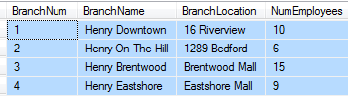

Book (Primary key: BookCode)


Author (Primary key: AuthorNum) Wrote (Primary key: BookCode, AuthorNum)



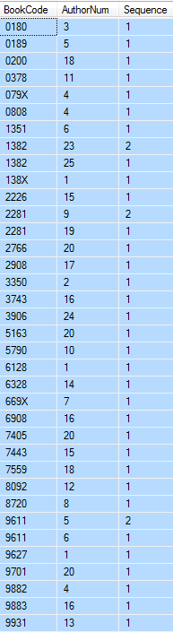

Inventory (Primary key: BookCode, BranchNum)

