Premiere Products Database Tables

Rep (Primary key: RepNum)
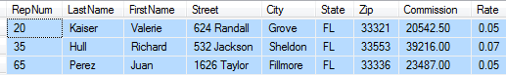

Customer (Primary key: CustomerNum)
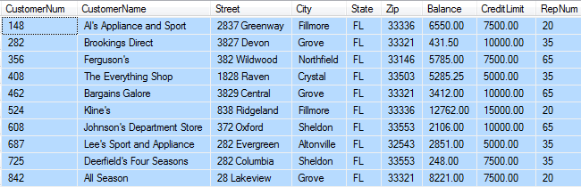

Orders (Primary key: OrderNum) OrderLine (Primary key: OrderNum, PartNum)

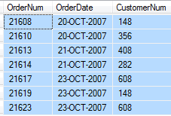

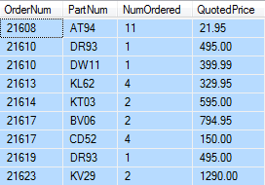

Part (Primary key: PartNum)
