Requirement Analysis Document for IT
Management & Automation of Ruben Dario
Middle School

Group # 4

Rafael Diaz

Eric Enriquez

Suylleng Padilla

Sandor Rodriguez

Advisor: Masoud Sadjadi

March 03, 2009

Introduction:
The School Principal is requesting assistance from IT Managers to implement an automated system to correct the current lack of organization among the computer labs. As the client stated, they suffered problems such as vulnerability of their systems against intruders and lack of backups from their servers, among others. In the past months, the school has experienced delays in backups due to an absence of monitoring services in servers which are down. The efficiency of computers has also been an issue for the school. Since the computers were installed, none of them have received current updates, therefore causing teachers to experience delays during their class.

Purpose of the system
The purpose of this system is to automate Ruben Dario Middle School’s computer system, making it a more secure, more reliable, and a well-organized automated system providing remote control, desk help, audit & asset management, patch management, backups, and monitoring for the middle school.

Scope of the system
The scope of the system will include the following: providing the school with an automated backup system; automate the process of installing current updates and patches; and provide remote control and desk help, to avoid delays. The system should also make available information regarding software and hardware’s inventories. Automated monitoring of the servers and workstations will also be implemented, so the PC’s performance could be analyzed, thus preventing servers from crashing, workstations malfunctioning, etc.

Objectives and success criteria of the project
The goal is to help organize and automate the system to meet the client’s needs for the continuity of their business. Programming automated backups for servers and workstations, providing a more robust security system for student’s workstations to prevent them from accessing material not related to their class scope, automating patch, auditing & asset management, so their computers are up to date and having a better control of computer software and hardware inventories are critical.

Definitions, acronyms, and abbreviations
GUI – Graphical User Interface
RAD – Requirements Analysis Document

Current System
As of now, the current system does not provide sufficient tools to control different technology areas. The current system depends on users to administrate the auditing process. Every time the system goes down, or when they have any issue with the computer labs, the Middle School has to call third party companies and sometimes even help desks. Security has always been a problem in the Middle School.

The Middle School is having the following issues:
- Need for restricting Web Browsing due to students entering into WebPages that are not related with school activities and chatting online with other people using MSN Messenger, Yahoo, or other types of chat clients instead of putting that attention into school related activities.

- Backups of classroom computers, which has been done once a month, is causing a great loss of information through computer crashes and other issues like power outages. Professors are losing students records for attendance, grades, exam templates and lectures.

- The level of security of the computers is not as high as the school would like it to be because students are easily accessing all the computers without any type of user id or password and changing important settings, and adding or removing software. The school has experienced problems with students uninstalling the typing program used by the school (Mavis Beacon), and then those computers had to wait for somebody to re-install the program. Programs like MSN and Yahoo Messenger are being installed without permission.

- A great number of computers are out-of-date in respects to current updates, because currently the school doesn’t have any type of automated system which could do this task. In the workstation machines, Norton Antivirus’ virus signatures are out of date; these machines have never performed a full hard disk scan.

- The current system doesn’t have accurate information about the current software and hardware inventories of the workstations machines. The school experienced a problem with Microsoft office 2003 licenses that were used in many computers without permission and were not getting updates. The company that supplied the license called them to let them know if they wanted to fix the problems by getting new licenses, and to maybe upgrade the software. The school should have been informed ahead of time before the company called.

- Help desk has always been an issue for the school. One of the more common situations is professors have to change their password once every 2 months, because of the systems design; some professors forget their passwords and the computers would get locked, and they had to call third party companies or wait until somebody come an fix the problems.

- The school security is being affected by intruders, viruses & spyware. The current antivirus definitions have never been updated. The current antivirus (Norton Antivirus) was installed, but has never been maintained.

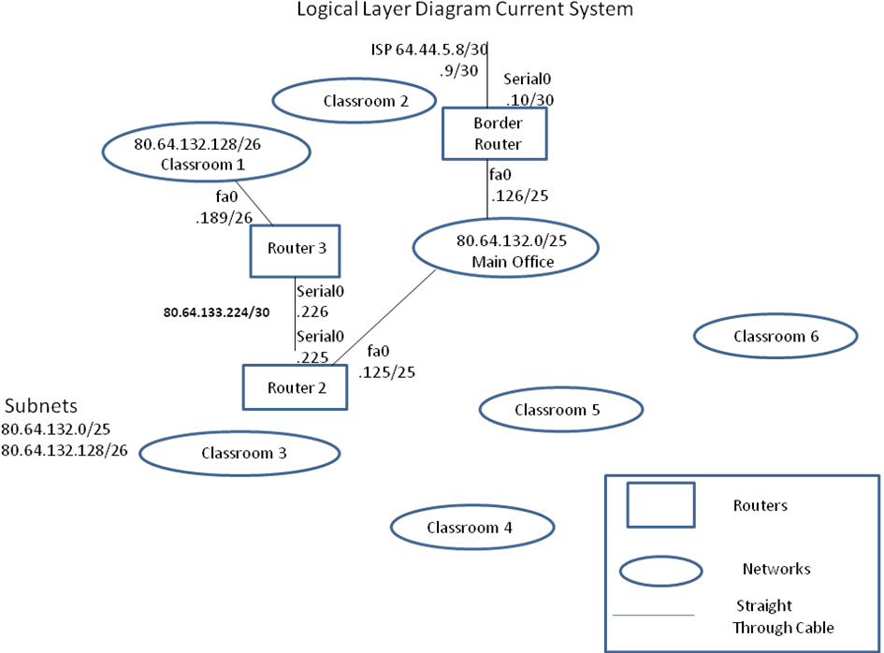

- Functional Requirements & Proposed System
  - Remote Control
In reference to issue 7, the proposed system must provide a way so that the users can interact with the support staff in case any problem arises, without having to wait for technicians to physically come and fix the problem, also causing waste of valuable time for students and teachers. The system must be accessible from anywhere and provide email alerts.
Remote Control is an important feature that must be provided by the system. Administrator should have complete control over all machines connected in the network. This will reduce if not eliminate delays in classrooms because of down systems.

  - Auditing & Asset Management
In reference to issue 5, the proposed system will provide information regarding the computer’s hardware and software inventories. This system should be automated so that there is no need of waiting or depending on users to do it. The system must also provide information regarding licenses, warranties, etc.
Auditing & Asset Management would facilitate the work of technicians by providing them with a complete inventory of the software and hardware installed in each computer. The auditing would also maintain the school’s administrators updated about licenses, and when a renewal is needed. As Mentioned above, the school has had problems with licenses before.

1.3 Monitoring
Monitoring the school’s computer would allow system administrator to draw better conclusions on what are the problems that are causing hung computers, networks problems, or anything that may be affecting the system performance. The school has had problems where programs (Microsoft Word, Power Point) crashed on the student’s machines, and since the school is not monitoring the computers, the machines were running really slow, and consuming unnecessary memory.

1.4 Patch Management
In reference to issue 4, the system should provide patches for all the computers on campus. The system must be able to schedule scans for updates and patches. The proposed solution must provide a history of successfully installed patches and also pending ones. It should also automate the deployment of missing patches using scheduled sessions for installations.
Each lab will have a consistently configured environment that is secure against known and unknown vulnerabilities in operating system and application software. The school needs a team that is responsible for keeping up to date on newly released patches and security issues that affect the systems and applications deployed in its environment. The system would alert administrators and users of security issues or updates to the applications and systems they support and use.

  - Backup & Disaster Recovery
In reference to issue 2, the backups should be performed for the teacher’s and administrator’s computers, since the data saved by the students is not essential to the system. The backups would be done once a week, during the weekends. The backups should be performed once a week because the information (Student’s attendance, etc) is not that crucial to be backed up daily, so scheduling the backups during the weekends would not slow down the performance. The system should provide web-based mode of application, minimizing visits on campus.
In reference to issue 2, the system would have different servers, which would take care of the computer’s operations, security, and also provide backups that would automatically update the daily information from one other server and would come online if other server goes down without interrupting the lab operation. The security of the servers would have an encryption which would make the lab computers virtually impenetrable by any hackers or unregister users.
Since the computers at this middle school will be mostly used by students for class purposes, we can pursue Fast and Easy Recovery, giving the ability to recover more quickly from a major event resulting in data loss. The solution enables point-in-time recoveries to the last backup, making sure systems are up to date with the latest settings, completely and immediately restoring a system from ground through an intuitive bare metal restore process. For more granular recoveries, simply drag and drop selected files and folders or remotely mount drive volumes.

1.6 Help Desk & Ticketing
Since most of the users at the school do not have much knowledge about computers and how they operate, help desk would facilitate the users and the support staff to interact in real time without having to be physically present to fix a problem. Students in the past have caused password changing related problems; many times these computers were down until somebody would come and fix them, delaying classes and schedules. The help desk must provide e-mail alerts and also keep history of troubles and their solutions from the past. In addition the system must also provide chatting features that allow users to interact with the staff.

1.7 End Point Security
In reference to issue 8, the system must provide a way to automatically remove detected threats. Maintain the system automatically updated in regards of virus definitions and software as well. The system must provide an easy to follow interface. It must offer email scanning and provide complete and comprehensive reports.
In reference to issue 3, the computer lab would have a security system that would allow access only to the users approved by the system administrators which in this case would be the teachers. The students would be users, requiring a teacher’s permission to access the technology mentioned.
In reference to issues 1 and 3, the system would restrict WebPages access by allowing them access only to WebPages relevant to their current grade level and their age rating.
The security is also a relevant factor in the current system. As of now there is not a proficient way to protect the computers in the facility. Some of the computers have antivirus (Norton) that are not up-to-date and are exposed to hackers, viruses, spyware etc. The system must provide an automated approach for the security that would keep the software update it. Scanning must be flexible, because during the day teachers and staff are using the computers. Also, the system must provide logs of activities in case on any problem; email scanning is also an important factor of the end point security that must be implemented by the system.

- Agent Roles
2.1 Role 1→ Students (130 Machines)
The student’s computers would be composed of different software, such as Microsoft Office, Mavis Beacon Teaches Typing, that would be necessary for the completion of school assignments. The computers wouldn’t offer the students system administrator access because it wouldn’t allow them to change any pre-installed settings, install any unauthorized software, or access different sections of the computer which could allow the user to inflict certain damage to the computers. The computers would filter out WebPages that the students don’t have access to.

2.1.a Backup: The students don’t require any type of backup because they don’t have any really important information to save and if they do, most of them carry a flash drive so they could store their own information.

2.1.b Patch Management: The updates’ schedule and scans for new software would be done in a weekly basis to maintain all the software updated, so that the students could have current information and all the updates are approved by the administrators.

2.1.c Auditing: Auditing would give current information of all hardware, Licenses, and warranties to the IT administrators which would make their jobs easier by making any troubleshooting or repair time shorter by proving fast information like warranties and licenses duration and current hardware specifications.

2.1.d Web Site Restrict Access: The student would have limited access to unverified web pages to prevent them from going to web pages that they shouldn’t go, and prevent them from seeing any uncensored material.

2.1.e Chat Clients: Students don’t have access to install or use any type of chat client because this could interfere with the learning path by giving them access to talk to their friends during class time.

2.1.f Remote Control: Students will not be authorized to remotely connect to any system.

2.1.g Monitoring: For the students’ machines the monitoring would be primarily focused on: Hard Drive, RAM, Patch, and Hardware Changes. These settings are applied to the students’ role because we need to know if they are running out of space, RAM to see if the software that they are using are consuming more memory than they need to; Patches to be alert if the approved patches have been installed correctly or not, Hardware changes to verify if any changes have been made to the hardware.

2.1.h System Security: The Automatic Updates would be setup to make sure that the virus definitions are up-to-date, Enabled Protection to make sure that the system is protected at all times, and Schedule Scans would be used to check if any intruder or malicious software is installed. Since these are students’ computers, students are always installing programs, playing around with programs or executing programs that might be infected; these computers must have worms, Trojans and spyware protections also available.
2.1.i Help Desk: The help desk features that would be implemented here would be hardware and software inventory, in case the students try to take anything out or replacing any hardware, or also they can try to uninstall a software, and the email alerts for administrators in case of any change or problem in the students’ machines.
2.2 Role 2→ Teachers (5 Machines)
These machines won’t have as much filters and restrictions as the student computer have, because teachers would need to have some leverage of going to web pages that would help them in planning their teaching sessions. Also the computers would have a higher security level to protect all the important information about the student grades, class assignments, and student’s attendance etc.

2.2.a Backup: They would require a weekly full backup to maintain a complete up-to-date backup of all the student’s records, grades, and current information related to the class lessons.

2.2.b Patch Management: The Schedule updates and scans for new software would be done in a weekly basis to maintain all the software updated, so that the users could have current information and all the schedule updates and scans would be pending approval by administrators.

2.2.c Auditing: Auditing would give current information of all the hardware, Licenses, and warranties to the IT administrators which would make their jobs easier by making any troubleshooting or repair time shorter by proving fast information like warranties and licenses duration and current hardware specifications.

2.2.d Web Site Restrict Access: The users would have unlimited access to all the web pages so it wouldn’t impede with the progress of their work and the access to various sources of information.

2.2.e Chat Clients: Teachers don’t have any restrictions in Chat clients because they use them to help them get in contact with other teachers from around the world to discuss ideas and teaching tactics.

2.2.f Remote Control: The teachers will have access to connect remotely only to students’ machines.

2.2.g Monitoring: For the teachers’ machines the monitoring would be focused on: Hard Drive, Page File, and Backup. These settings are applied to the teachers’ role because system’s administrators need to know if they are running out of space, Page File would be important to detect if the system needs improvement in RAM, and Backup to see if the students’ grades and attendances are being kept.

2.2.h System Security: The Automatic Updates would be setup to make sure that the virus definitions are up-to-date, Enabled Protection to make sure that the system is protected at all times, and Schedule Scans would be used to check if any intruder or malicious software is installed. Since teachers are always checking emails, Email Protection must also be available for the teachers’ machines.

2.2.i Help Desk: The help desk features that would be implemented are Online Chat in and Email Alerts. Teachers can have the online chat feature available since anything could come up during regular class time and they need to be available to fix it right away, and the email alerts for teachers in case of any change or problem in the students’ machines or in their own.
2.3 Role 3→ System Administrators (5 Machines)
The Computers would be the ones in full control of the other computers without any type of filters or limitations. It would allow IT Administrator to change passwords and add new users to the network system, to access information and logs need it to troubleshoot problems.

2.3.a Backup: A weekly full backup would be required to maintain all the information of logs and events that happen every week to the school system, which could help in troubleshooting for future use.

2.3.b Patch Management: The Schedule updates and scans for new software would be done in a weekly basis to maintain all the software updated, so that the users could have current information and all the schedule updates are approved by administrators.

2.3.c Auditing: Auditing would give current information of all the hardware, Licenses, and warranties to the IT administrators which would make their jobs easier by making any troubleshooting or repair time shorter by proving fast information like warranties and licenses duration and current hardware specifications.

2.3.d Web Site Restrict Access: The users would have unlimited access to all the web pages so it wouldn’t impede with the progress of their work and the access to various sources of information.

2.3.e Remote Control: The Administrators will have full access to remotely connect to all available machines and servers.

2.3.f Monitoring: For the system administrators’ machines the monitoring would be primarily focused on: Hard Drive, Page File, Backup, RAM, and CPU usage. These settings are applied to the administrators role in case they are running out of space, Page File would be important to detect if the system needs improvement in memory, and Backup to see if the students, teachers and schools files are being backed up correctly or not.

2.3.g System Security: The Automatic Updates would be setup to make sure that the virus definitions are up-to-date, Enabled Protection to make sure that the system is protected at all times, and Schedule Scans would be used to check if any intruder or malicious software is installed. They would be notified with logs whenever any threats are detected. Since administrators also check emails, Email Protection must also be available for the administrators’ machines.
2.3.h Help Desk: The help desk features that would be implemented are Online Chat in and Email Alerts. Administrators can have the online chat feature available because something might come up and they might need to have the chat support available to fix it right away in case the administrators cannot, and the email alerts for them in case of any change or problem in the students’, teachers’ or even their own machines.
2.4 Role 4→ Web & Mail Severs: (1 Machine)
Web Servers: Would be the main source of storage and backup of all the computer systems in the school. These computers would provide internet access to the other computers and are also the first and the strongest line of defense against intruders. These machines would not have anything in common with the other roles, because they would not be use to accomplish any type of school assignment or work and only the ones most qualified and with the most knowledge in the operation of these servers, would be the ones with access to operate and work with them.
Mail Server: This would be the primary source for emails. The computers should be equipped Microsoft Exchange Server 2007. This software besides delivering and organizing in a more efficient ways user’s e-mails accounts, it also provides security against span and viruses.

2.4.a Backup: The servers would require a daily full backup to make sure all the data processed and information received at end of each day would be available for future use and observation.

2.4.b Patch Management: The Schedule updates and scans for new software would be done in a weekly basis to maintain all the software updated, so that the users could have current information and all the schedule updates and scans are approval by administrators.

2.4.c Auditing: Auditing would give current information of all the hardware, Licenses, and warranties to the IT administrators which would make their jobs easier by making any troubleshooting or repair time shorter by proving fast information like warranties and licenses duration and current hardware specifications.

2.4.d Web Site Restrict Access: The users would have unlimited access to all the web pages so it wouldn’t impede with the progress of their work and the access to various sources of information.

2.4.e Remote Control: The Servers will not have remote control because servers are used to keep data only.

2.4.f Monitoring: For the Servers machines the monitoring would be primarily focused on: Hard Drive, Page File, Backup, RAM, and CPU usage. These settings are applied to the Servers’ role in case administrators need to know if they are running out of space, Page File would be important to detect if the system needs improvement, and Backup to see if the students, teachers and schools files are being backed up correctly or not.

2.4.g System Security: The Automatic Updates would be setup to make sure that the virus definitions are up-to-date, Enabled Protection to make sure that the system is protected at all times, and Schedule Scans would be used to check if any intruder or malicious software is installed.

2.4.h Help Desk: The help desk features that would be implemented here would be Hardware and Software Inventory, Email Alerts, and Comprehensive Reports. Hardware and software in case anything goes wrong or hardware fails the servers are very important and need to have the inventory feature available. Emails alerts to the administrators in case anything in the servers work incorrectly or a problem that needs to be fixed right away. Since these are one of the most important roles in the school they need to have comprehensive reports to keep administrator update it about problems, solutions from the past, and make user defined reports to help better maintain the servers.
Table of Roles for the System:
Roles | Backup | Patch Management | Auditing | Remote Control | Monitoring
Students | No | Schedule Updates & Scans  Weekly basis  All approved | Hardware  Licenses  Warranties | No | Hard Drive  RAM  Patch  Hardware Changes
Teachers | Weekly full backup | Schedule Updates & Scans  Weekly basis  All Pending | Hardware  Licenses  Warranties | Limited to Student Machines | Hard Drive  Page File  Backup
Web & Mail Server | Daily full backup | Schedule Updates & Scans  Weekly basis  All Pending | Hardware  Licenses  Warranties | No | Hard Drive  Page File  Backup  RAM  CPU Usage
System Administrators | Weekly full backup | Schedule Updates & Scans  Weekly basis.  All Pending | Hardware  Licenses  Warranties | Full Remote Access | Hard Drive  Page File  RAM  Backup  CPU Usage

Table for Help Desk & Ticketing and End Point Security:

Roles | Help Desk & Ticketing | End Point Security
Students | Email Alerts  Hardware Software Inventory | Spyware  Antivirus, Worms, Trojans, etc.
Teachers | Online Chat  Email Alerts | Spyware  Antivirus, Worms, Trojans, etc. E-mail Protection
Web & Mail Server | Comprehensive Reports  Hardware Software Inventory  Email Alerts | Spyware  Antivirus, Worms, Trojans, etc.
System Administrators | Online Chat  Email Alerts | Spyware  Antivirus, Worms, Trojans, etc. E-mail Protection

Table of Security Roles:
Roles | Web Site Restrict Access | Chat Clients | System Security
Students | Limited access to unverified Web Pages | Deny Access | Automatic Updates  Protection Enable  Schedule Scans
Teachers | Unlimited | No | Automatic Updates  Protection Enable  Schedule Scans
Web & Mail Server | Unlimited | No | Automatic Updates  Protection Enable  Schedule Scans
System Administrators | Unlimited | No | Automatic Updates  Protection Enable  Schedule Scans  View Threats  View Logs

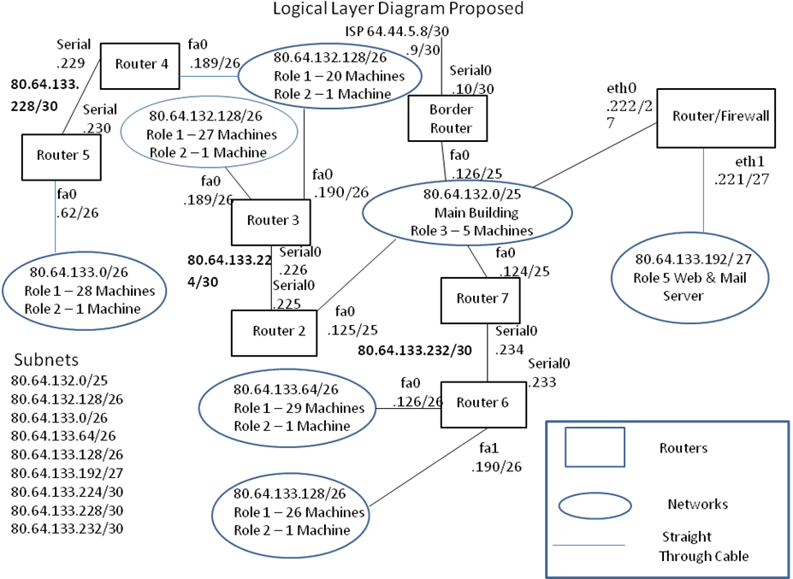

Nonfunctional Requirements
This section will describe nonfunctional characteristics that must be met by the system.
Usability
The software provided should be easy to learn and get acquainted with. It will have a user friendly interface, providing easy-to-follow wizards, menus, clear wording, etc. No matter what feature the school might be trying to implement (backups, security, auditing, patches, remote desktop, etc), the software should provide an easy to follow instructions & GUI. Since most of the users in the school are not computer-oriented, they need an easy to follow system. In case teachers encounter any problem or difficulty, they must be available to see the problem through, and not making a small problem into a big issue.

Reliability
The provided software should maintain school’s administrators informed on how the system is running. Agents would be running on the computers, so they are always monitoring how the system is behaving. The system must be available all day, so it can create better patterns of work for the machines, hence providing a more reliable system because it will keep administrators informed about the performance of the computers, and if there are problems what can be done to address that problem. Reliability is very important for this school because would make sure all the teachers’ work is up-to-date and accomplished on schedule. The system would be composed of different safeguards to minimized errors and downtime. The teachers rely on the system to keep all the information that is being passed to them like (grades, attendance sheets, etc) safe. The system must be available all the time, secure all the time, and preventing any type of information from being lost.

Performance
The system would be maintained through agents who will automatically maintain all operations related to security, auditing, technical support, updates, and backups. The system must be capable of give administrators’ current system analysis with a matter of clicks. The performance is a very important factor for the school, because many classrooms have at least 20 to 30 machines, and they are on all the time. The system must always be available and not slow down their performance. The scans must be either scheduled to run at night or scheduled to run on weekends so students and teachers will not be affected by these. Servers always on and are very important for the school, hence their performance cannot be affected by any limitation or a problem that might cause the server to be down.

Acknowledgments:
Staff
Craig, Elsie

Instructional Staff:
Broas, Eileen L……….. Science Department
Duarte, Maribel……….. Math Department

Glossary
GUI A Graphical User Interface allows interaction with a computer to make the program easier to use.
RAD Requirements Analysis Document, document describing the system in terms of functional and non functional requirements.

