A Feature-Based Analysis & Comparison of IT Automation Tools:

Comparing Kaseya to Log Me In

Developed by:
Christine Marie Rodriguez
Richard Calvo

Advisor:
Dr. S. Masoud Sadjadi
School of Computing and Information Sciences
Florida International University

Contact Information:
sadjadi@cs.fiu.edu,
http://www.cs.fiu.edu/~sadjadi
305 – 348 – 1835

Spring 2010
1. Introduction

Overview:
LogMeIn brings consumers, mobile workers, businesses, and IT service providers with different solutions that offer remote access over the Internet based on their specific needs. LogMeIn offers customers several components that can be integrated to provide different solutions:

- LogMeIn Rescue – This is a web-based remote support without pre-installed software that provides 24/7 support from anywhere, in which your support team can easily and rapidly access and fix remote devices.
- LogMeIn Central – This is a web-based management console that allows you to manage LogMeIn’s remote access, computer management, and VPN connectivity services. LogMeIn Central can be used with LogMeIn Pro, LogMeIn Free, and LogMeIn Hamachi.
- LogMeIn Free – This solution provides you with free remote access to all of your computers (PC or Mac) over an Internet connection.
- LogMeIn Pro – This solution is an extension to LogMeIn Free. Not only does it provide you with remote access to all of your computers, LogMeIn Pro allows you to transfer files from your local computer to your remote computer and vice versa, allows you to print from your remote computer to your local printer, and allows you to share your desktop with anyone worldwide.
- LogMeIn Backup – This solution allows you to securely protect information using remote backup that you control. It also provides disaster recovery.

Background:
The technology used to create LogMeIn was developed by 3am Labs in Budapest, Hungary in 2003. Sometime later, an office in Woburn, Massachusetts was also opened. In 2006, 3am Labs changed its name to LogMeIn, Inc., as it is known today. Currently, LogMeIn’s world headquarters is located in Boston, Massachusetts, as well as European headquarters in Amsterdam, the Netherlands, and Asia Pacific headquarters in Sydney, Australia. In addition to LogMeIn’s headquarters, its development centers are located in Budapest and Szeged, Hungary.

LogMeIn has many different types of customers, which include: large corporations, small to medium sized businesses, internal and outsourced IT service providers, mobile professionals, and individual PC users and technicians. Some known corporations that use LogMeIn are: Best Buy, DHL, IBM, 3M, FujiFilm, etc. LogMeIn serves customers inside and outside of the United States. LogMeIn partnered with Intel in 2008. “Intel and LogMeIn launched the Intel Remote PC Assist Technology (RPAT) service, creating the foundation for Independent Software Vendors (ISVs) to enable their remote management and support solutions for below the O/S access from outside of a LAN environment. Through the creation of this service, Intel RPAT extends the features of Intel’s vPro and AMT technologies to IT professionals who are remote from the computers they are trying to support.” [1]

LogMeIn provides the public with many events and online workshops. The LogMeIn website (www.logmein.com) provides information to all of their events and workshops; some of which are free of charge.

LogMeIn Contact Information in North America:
Woburn
500 Unicorn Park Drive
Woburn, MA 01801
Toll Free: 1.800.993.1790

For contact information outside of the United States, please visit www.logmein.com

Company Highlights:
- 2010 - LogMeIn and UMID Bring Remote Access to Ultra Mobile Computers
- 2010 – LogMeIn Frees the Mac
- 2009 – LogMeIn received the SMB Excellence Award
- 2009 – The Boston Globe Names LogMeIn to Globe 100’s Top Places to Work
- 2008 – Wins Network Products Reader Trust Award for Best in Remote Host Control

OS Coverage:
The operating systems that are supported for LogMeIn Free and Pro2:
- Windows 7 (32-bit or 64-bit)
- Server 2008 (32-bit or 64-bit)
- Vista (32-bit or 64-bit)
- XP (32-bit or 64-bit)
- Server 2003 (32-bit or 64-bit)
- Windows 2000 or Server 2000 (32-bit)
- Mac OS X 10.4.6 or later
The operating systems that are supported for LogMeIn Backup:
- Windows 2000/Server 2000 (VSS not supported)
- XP 32 and 64 bit
- Server 2003 32 and 64 bit
- Vista 32 and 64 bit
- Please Note: On Windows 2000/Server 2000, Backup can’t backup open files because of limitations of the operating systems
LogMeIn Central does not require any operating systems; however, these are its supported browsers:
- Internet Explorer 7 or above
- Firefox 3.0 or above
- Chrome 2.0 or above
- Safari 4.0 or above
- Please Note: Java must be enabled for LogMeIn Central to run
The system requirements that are needed in order for LogMeIn Rescue to run:
- Windows 7, Vista, XP, Server 2003, Server 2008 (all including 64-bit); Windows 2000/Server 2000
- Compatible browser:
  - Internet Explorer 5.5 or later, with support for 128-bit or 256-bit encryption
  - Mozilla-based browsers that are compatible include Firefox 1.5 or later, and Mozilla 1.7 or later
- Broadband connectivity to the Internet
- Up to 20MB of memory + 20MB per RC session
- Up to 30MB of storage space + 20MB for all virtualization and mobile skins

Grouping Managed Devices:
LogMeIn Central allows an administrator to manage all of the computers under an account by allowing central management of all added computers. Using LogMeIn Central the administrator can create alert packages, reports, and groups. After creating a group (original group is automatically name “default group”) the administrator can either manually move already added computers into the new groups or create “deployment links”, which specify what group the new computer will be added to, as well as, what alerts and reporting package they will incorporate. These “deployment links” are sent via email or chat to a user and once the link is clicked, the agent will automatically install on their computer. LogMeIn Central also allows for creating a “Host Preference” package which set the settings for the agents that will be deployed. These “Host Preference” packages can also be assigned to existing agents. LogMeIn Central provides simplicity in creating groups, as well as packages, and assigning each one to a computer. The grouping tab does not include a “filter” view function like in Kaseya, however, it does have a handy search box which searches in real time (as letters are typed) for computers added to any groups.

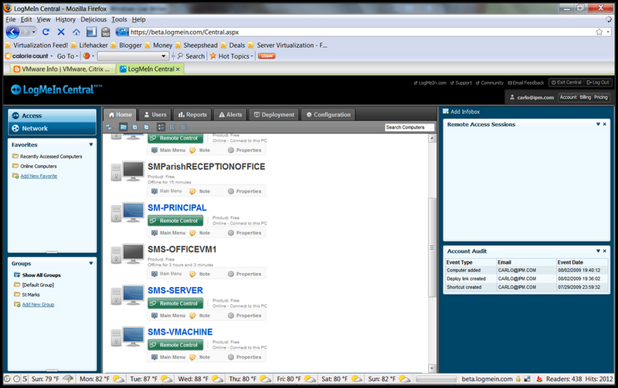
Figure 1 - LogMeIn Central homepage.

Functional Coverage:
LogMeIn covers the following functionalities:
(1) Agent and agent-less architecture (2) Auditing and Asset Management (3) Remote Control (4) Monitoring (5) Backup and Disaster Recovery (6) User State Management (7) Help Desk (8) Reporting (9) System
However, unlike Kaseya, it does not have built-in patch management or endpoint security.

1.1 Architecture
LogMeIn does not integrate its different modules together as well as Kaseya does. The different LogMeIn modules must be purchased separately but may then be integrated whereas Kaseya’s modules are purchased as one solution. Some modules deploy an agent while other modules are agent-less; LogMeIn Central and LogMeIn Rescue is agent-less while LogMeIn Pro, LogMeIn Backup, and LogMeIn Free deploy its own agent. This may result in one computer having more than one LogMeIn agent installed whereas Kaseya would only have one. LogMeIn solutions can be deployed by installing the agent provided on LogMeIn.com once you create an account. LogMeIn Central has a link based, assisted install, called Deploy Link Generator. This feature gives the account administrator the ability to create a link in which the LogMeIn agent can be installed from. This link can is distributed via email or instant message.

Component | Agent Based Architecture | Agent-Less Architecture
LogMeIn Central |  | 
LogMeIn Pro
LogMeIn Free
LogMeIn Rescue
LogMeIn Backup

1.2 Auditing & Asset management
LogMeIn Central and LogMeIn Pro provides auditing and asset management. With LogMeIn Pro, auditing can be accomplished through the dashboard by clicking the “Performance Info” tab. The auditing options available include: (1) CPU Load, (2) Memory Load, (3) Disk Space, (4) Drive and Partition Info, (5) Open TCP/IP Ports, (6) Network Load, (7) Open Files, (8) Registry Keys in Use, (9) DLLs in Use, (10) LMI Connections, (11) Installed Applications, and (12) Loaded Device Drivers. These auditing options are available for a computer as soon as it is clicked, which means that a report does not have to be built. LogMeIn Central provides a more advanced level of auditing. Here, auditing is accomplished under the “Reports > Report Viewer” tab, in which a user can select from a pre-determined set of categories which also contain subcategories. The categories that can be audited include:
(1) Hardware Inventory
Subcategories: CPU, Hardware History, Installed Memory, Motherboard, Network Interfaces, Service Tag,
Storage Hardware, and Top Disk Usage.
(2) LogMeIn Host Software Details
Subcategories: Deploy Links, Host Software Installs, Journal Entries, and Last Boot Date.
(3) Software Inventory
Subcategories: Installed Applications, Installed Operating System Snapshot, Software History, and System
History.
Once a category and subcategory are chosen, the audit is viewed by clicking on “View Report”. Once the report is displayed, a “Chart” option is given, which allows you to view the data in a graphical representation. The report may also be filtered, saved, or added as a favorite. Future audits may not be scheduled whereas Kaseya gives you the option to do so.

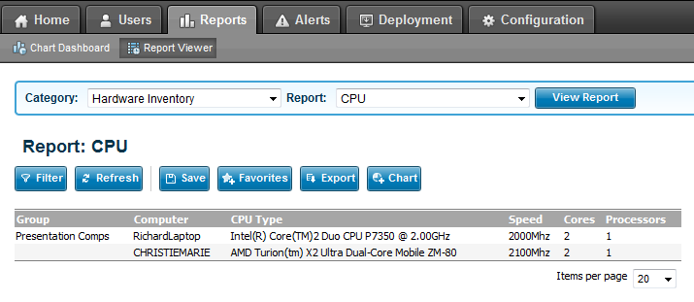
Figure 2 – LogMeIn Central Auditing

1.3 Remote Control
LogMeIn provides reliable remote control access anywhere over the web. LogMeIn Pro/Central provides the ability for a user to add an endless count of computers to their account. Once a computer has been added, clicking its computer name will open up a dashboard that controls many features, such as remote control. When the remote control option is chosen from the dashboard, it signs into the remote computer and starts a session. The session is run in a window that can be adjusted to full screen. In a remote control session, a user has the option to control the remote computers: (1) Volume, (2) Screen Settings, (3) Connection Settings, and (4) Printer Settings. Several tools are available to use as well: (1) Laser Pointer, (2) Chat, and (3) Pen tool. Desktop Sharing, which allows friends and family to temporarily access your PC’s desktop, can also be performed through the dashboard. The dashboard also allows the transferring of folders and files through the “file management” option in. When “file management” is clicked, all folders/files on the local computer are shown on the left hand side of the window and all the folders/files on the remote computer are shown on the right hand side of the window. This allows for easy file transferring from local to remote computers and vice versa. Sharing of Files can also be sent to family/friends by creating a “link” and sending it via email. Once the email is received with the link, the files/folders can be downloaded for use. Printing from a remote computer to a local printer using remote control is possible. Remote Control sessions can be recorded to be played back at a later time.

Similar to Kaseya, LogMeIn gives the ability to assign user permissions for a remote control session. This can be accomplished through LogMeIn Central by clicking “Configuration > Manage Host Preference”. The same rules can be applied here as in Kaseya. For example, messages can be sent to a user before an administrator logs into their computer remotely along with other options. These preferences can be assigned to a group or an individual computer.

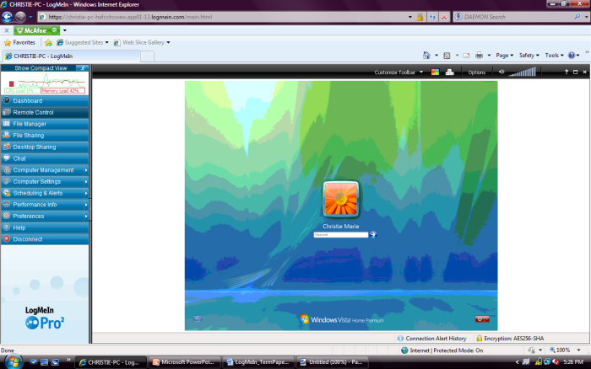
Figure 3 – Dashboard with Active Remote Control Session

1.4 Automation
LogMeIn Pro supports some level of automation under the “Scheduling & Alerts > Task Scheduler” tab in the dashboard. New scripts can be created by clicking on “Create New Task”, in which a script can be scheduled to run by entering common script parameters into a form. These parameters are composed as follows: (1) Name, (2) Run (the command executable), (3) Parameters (any switches), (4) Start in (drive), (5) Comments, (6) Max allowed run time in minutes, (7) Run as (domain\user), and (8) Password. Once a new task has been applied, it can be scheduled to run on a reoccurring basis or just one time. Tasks (scripts) can be modified or deleted whenever necessary. However, unlike Kaseya, it does not have built-in agent procedures. In Kaseya, scripts can have several steps as well as IF-ELSE-THEN statements but this is not possible in LogMeIn. LogMeIn just has very basic scripting. very sophisticated menu and it does not have an option to include IF-ELSE-THEN statements. LogMeIn Pro also has the ability to automate thread priority handling by automatically (based on administrator settings) moving CPU intensive or other lengthy process to a lower priority. This way they are handled in the background to avoid halting other programs and crashing the computer.

1.5 Monitoring
Monitoring can be accomplished through LogMeIn Central. Automated alerts can be created by administrators that notify them when changes/updates occur via email. These alerts can be created by clicking on the “Alerts > Manage Alert Packages” tab within LogMeIn Central. Alert Packages can be created or edited to include wanted alerts such as: (1) CPU Utilization, (2) Used Memory, (3) Free Disk Space, (4) Folder Size, (5) File Size, (6) Computer Offline/Online, (7) Service, (8) Event, (9) Advanced Event, (10) Hardware Inventory, (11) Software Inventory, and (12) System Inventory. Each alert has parameters that control its level and specifics. Alert packages and individual alerts inside alert packages can be deleted as well. Computers or group of computers may be assigned to an alert package. Alert notifications can be viewed by clicking “Alerts > Alert Viewer” as well as through the email sent to the administrator.

Unlike LogMeIn, Kaseya provides a higher level of monitoring. Not only does it provide the monitoring mentioned above, it provides SNMP and Log monitoring. LogMeIn does not have this ability. LogMeIn does provide event logs through LogMeIn Pro under the “Preferences > Advanced Settings” tab.

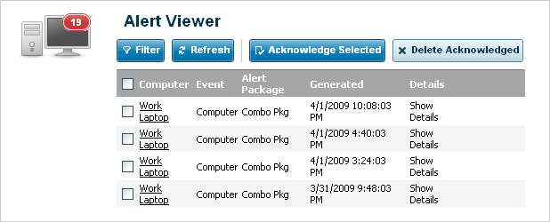
Figure 4 – Alert Viewer in LogMeIn Central

1.6 Patch Management
LogMeIn does not offer a built in patch management solution, however, there are many tools available on the Web to run patch management on managed computers. The easiest solution would be to setup windows to automatically handle patch management. The automatic updates component of windows has been around for 10 years and works very well. However, patch management would have to be configured on each computer manually. Patch management can also be implemented on LogMeIn with the use of scripts. Using the task scheduler option of LogMeIn Pro, an administrator can setup a task to run a script forcing a patch management program to be run which will look for missing updates and download them. One such program that runs patch management is called WUInstall, which is free and can safely be downloaded from the Web. This program can be set to run at logout, login, or on a schedule by the use of the Task Scheduler. This way, the administrator can ensure that missing patches are applied whenever needed. WUInstall also provides support for regular expressions, which allows the administrator to look for specific patches based on category, name, or hot fix IDs.

1.7 Backup & Disaster Recovery
LogMeIn Backup provides a centralized management of backup sets. When LogMeIn Backup is installed for an account, all computers on the account are automatically available in the LogMeIn Backup screen. In order to create a new backup set, a computer must be highlighted. LogMeIn Backup has the ability to create new backup sets (by selecting which folders and files to backup), set a schedule for when and how many times to run the sets, integrity checker to verify that the files are not corrupted, built in encryption, compression support, a remote storage medium, and if the backup set should run automatically by specifying criteria or if it should be run manually. This solution also provides a backup history which shows the previously run sets on any of the joined computers. The data set or subsets of the original set across the LogMeIn network can be restored straight into all computers or into the specific computers chosen. This allows for remote disaster recovery. LogMeIn Backup can also be installed in remote computers. This can be accomplished by creating a “Backup Link”. The backup link is created under “My Computers > Backup> Deploy Links” in the LogMeIn homepage. The backup link can be set to specify the name of the backup group (a group name that an administrator creates), as well as the maximum number of installations of the package. The link created can be manually distributed by email or instant message, or can be automatically generated by LogMeIn and sent out to clients. Once LogMeIn Backup is installed on the remote computer, users or administrators have the ability to remotely login and configure settings.

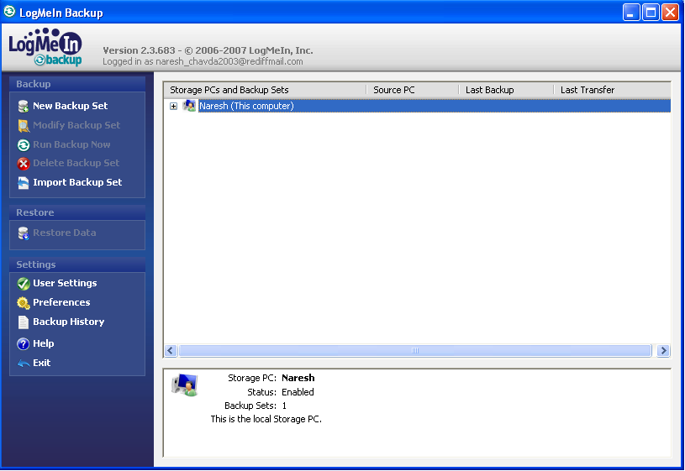
Figure 5 – LogMeIn Backup homepage.

1.8 Endpoint Security
LogMeIn does not provide a built in endpoint security package, however, there are many free publicly available packages on the web. Microsoft offers a free endpoint security package to protect against spyware, viruses, and Trojans called Microsoft Security Essentials. This software runs in the background, which does not interrupt a user. Microsoft Security Essentials may be combined with Windows Defender, a built-in security package all Window operating systems contain. This allows for a more profound level of security. Microsoft Security Essentials can be manually installed on each managed computer; however, there is another option. Microsoft’s security can be run on a script through LogMeIn. This is possible through LogMeIn Pro via its Task Scheduler, in which an administrator can setup automatic definition updates to the security program as well as automatic scans and fixes of any potential threats on the system.

1.10 Help Desk
LogMeIn Rescue provides instantaneous helpdesk support. The administrator first creates a support session which generates a virtual room and a link to the session. The session can be given a pin code, in which the client in need of support enters and joins the session. A link can also be created and sent via SMS, IM, or EMAIL to the client. The client then runs a Rescue applet in order to join the session. Once the client has connected, the technician is able to perform many tasks such as: (1) remote control, (2) file management, (3) view system info, (4) reboot the remote computer, and (5) Manage scripts. A built-in chat function allows the technician and client to communicate throughout the session. Each session is assigned a session ID, can be recorded, and the technician can input notes under “History and Notes” for later reference. The technician can also have the remote computer reboot and reconnect on startup. If the current technician needs help, an invite to another technician can be sent to join the support session. When inviting another technician, permissions can be set to grant or limit certain access to them. This might be necessary if the client does not want another technician to have certain access. The initial technician can specify until when a session can be accessed. This can be modified under “Unattended Access”. Clients may also request support using the “Calling Card” option provided by LogMeIn Rescue. This allows them to request support and connect to a session without having to download the Rescue applet at the start of a session.

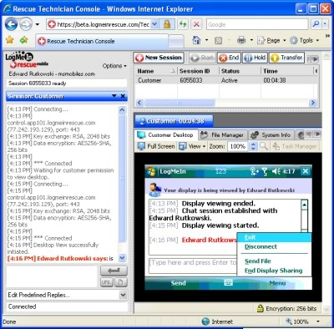
Figure 6 – LogMeIn Rescue

1.11 Reporting
LogMeIn Central provides high level and low level custom reports. The “Report Viewer” allows an administrator to analyze, filter, and explore LogMeIn Access, Alerting, and Inventory data. All data is shown as text, however, there is an option to represent the data in a graphical chart. These charts are viewable under the “Reports > Chart Dashboard” tab. Reports can be exported to XLS (excel) or TSV (tabbed delimited) files. LogMeIn Central has a default reports view when you first click on the “Reports” tab. This includes common reports features, such as: (1) % free of disk space on all installed computers (lists all drives as well), (2) the top 10 installed applications across all computers, (3) alerts in the past week, and (4) installed operating systems on the computers. The “Report Viewer” allows you to filter report display by (1) groups, (2) computers, (3) discovered time, (4) category, (5) property, (6) specific value, or (7) old value. These reports may then be exported or placed in a chart. Each report or chart can be pinned to the sidebar for quick view and comparison.

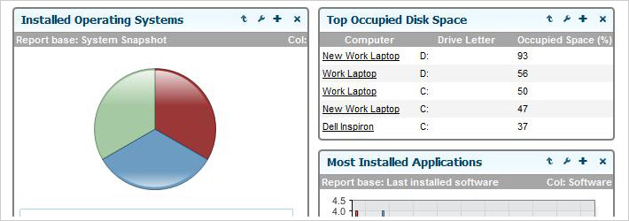
Figure 7 – Advanced Reporting and Analysis

1.12 System/User/Admin Management
LogMeIn Central provides system options whereas Kaseya uses the System module. User settings are available under the “Users” tab. Users can be created and given or denied access to selected computers. User preferences and password change can be accomplished under “Users > My Account”. User Info, such as, (1) Total User Activity, (2) Most Active Users, (3) User Summary, and (4) Account Audit (to view logon information) can be viewed under the “Reports > User Info” tab. More user information can be viewed under the “Reports > Report Viewer” tab. This includes: (1) Account Activity and Usage (remote access sessions and user account access), and (2) User and Computer Access Rights (computer access permissions, local users, user permissions, and user profiles). LogMeIn licenses can be viewed under “Reports > Report Viewer” and then choosing the “LogMeIn Licenses” category. This is similar to the License Manager in the Kaseya System module. In LogMeIn, organizations/clients are named in groups whereas in Kaseya, organizations/clients are given a name and more than one group can be assigned to each organization/client. Kaseya also lets you assign a “type” to each organization/client whereas LogMeIn does not. In LogMeIn, groups can be created, edited, or deleted under the “Configuration > Groups” tab. Once you have created a group, you can manage a group’s preferences under the “Configuration > Manage Host preferences” tab. This is accomplished by first creating a “Host Preference Package” and then assigning it to a group. Changing the system color scheme is not available like in Kaseya.

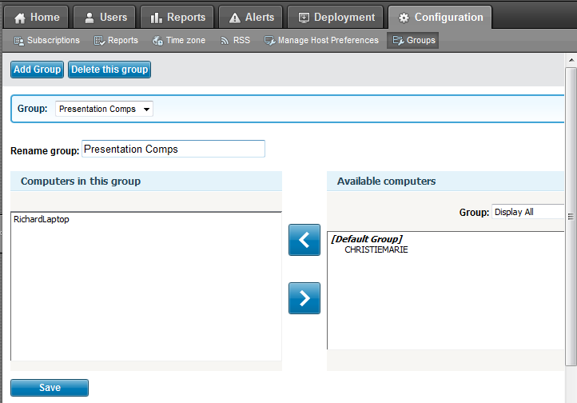
Figure 8 – LogMeIn Central Group Creation

1.13 Usability
LogMeIn provides a very sleek user interface with a bug free (as far as we can tell) environment, complemented by a very easy to navigate menu system. All LogMeIn components are web-based, which provides users with easy access at any time. LogMeIn offers the option of installing a plug-in to easily run everything from the browser. It integrates a snippet at the top left of the web browser window with easy access to control buttons. The add-ons do not have to be installed as the controls on the page itself provide the same functionality. The colors offer great usability and accent the correct features when needed. Overall, it has been proven to be a very quick and easy-to-use interface.

1.14 Reliability
LogMeIn is very stable and is always available to its customers. Customers have given LogMeIn very good reviews, such as: “LogMeIn is a solid software program that’s user-friendly and secure. One of my favorite free programs I recommend to everyone I know” [2]. LogMeIn’s functions are easy to use and understand. LogMeIn provides detailed and straight forward instructions and wording on to how to navigate and use each component, unlike Kaseya, that uses words that are sometimes too technical to understand what a function means.

1.15 Performance
The LogMeIn agents do not slow down the host system in any way. Running three LogMeIn agents at a time shows no decrease in performance or increase in CPU/memory usage. It is very optimized and streamlined. The software is compatible with almost all versions of windows, including Windows 7 x64 bits and the Macintosh operating systems.

1.16 Supportability
As mentioned in this paper, LogMeIn has many operating systems it supports, which makes its supportability trait strong. LogMeIn provides support to each of its products by including a knowledge base system (which allows you to search for answers to a question by providing useful articles), downloads to help with installation, documents such as white papers and user guides, and technical support to answer questions not found on the LogMeIn website. Receiving technical support can be accomplished in two ways: (1) By filling out the easy online support form , which creates a ticket or (2) by calling the technical support number provided on the website. They require a 24 hour turnaround time.
2. Comparison and Discussion
2.1 Evaluating and Discussing: LogMeIn
LogMeIn strengths: (1) solid remote control sessions (2) provides a concrete monitoring solution allowing users to arrange many alerts (3) help desk support is strong by allowing many technicians to take part of a session (4) support of many operating systems and browsers (5) has an integrated and easy to use backup and disaster recovery solution
LogMeIn weaknesses: (1) future audits may not be scheduled (2) does not have patch management (4) does not have endpoint security (5) does not focus on automation (6) several components must be purchased separately in order to integrate LogMeIn

1 | Architecture  Rating: 3 | LogMeIn modules should be available as one download like Kaseya. Instead, modules must be separately purchased an integrated. However, agents are deployed on a machine as easily as Kaseya. Ports do not need to be opened, which reduces the risk of being hacked.
2 | Audit & Asset Mgt  Rating: 4 | Auditing is simple and intuitive. Auditing is straightforward and very easy to generate. It also gives detailed information. However, it does not give you the option to block certain files, folders, or applications like in Kaseya. It also does not let you schedule future audits.
3 | Remote Control  Rating: 5 | The remote control interface is very simple to use. Once agent is installed, your computer is listed on a dashboard on your account’s main page. You can simply click on your computer and it will open up a menu, in which it gives you an option to remote control.
4 | Automation  Rating: 1 | LogMeIn does not focus on automation like Kaseya does. It does not provide any scheduling, which plays a large role in automation.
5 | Monitoring  Rating: 5 | LogMeIn Central provides an easy monitoring solution. Alerts can be set up by categories that contain subcategories. The phrasing of each alert is less technical than Kaseya, which makes it much easier to understand and set up.
6 | Patch Mgt  Rating: 1 | LogMeIn does not provide automatic patch management. A user may setup scripts or run the patch manually by using remote desktop login.
7 | Backup & Disaster Recovery  Rating: 5 | LogMeIn Backup provides a straightforward tool, which lets you perform incremental or full set backups locally or remotely. You can also restore the backup data remotely instead of having to physically be onsite.
8 | Endpoint Security  Rating: 1 | LogMeIn does not provide endpoint security. You must install your own antivirus solution.
9 | User State Mgt  Rating: 4 | LogMeIn provides access to a specified machine, registry, drivers, remote printers, and command prompt.
10 | Help Desk  Rating: 5 | LogMeIn Rescue provides a simple help desk solution. Sessions can be shared between technicians to provide maximum support and tickets may be escalated to a higher tier support. Ongoing communication with the client is possible through the integrated chat function. Sessions may also be recorded for later reference.
11 | Reporting  Rating: 5 | LogMeIn Central provides collective and individual reporting on selected machines. It provides templates that you can use or modify which output graphical charts and/or raw data.
12 | System  Rating: 4 | User settings and information on users can easily be configured with LogMeIn Central. Organizations/clients are created into a group, in which computers can easily be assigned to.
13 | Usability  Rating: 5 | LogMeIn is extremely user friendly. It provides easy to navigate menus and submenus. Each LogMeIn component provides a user guide that explains each feature thoroughly.
14 | Reliability  Rating: 5 | Every component has functioned as expected. There have been no browser crashes while using LogMeIn and connection to the host server has always been successful.
15 | Performance  Rating: 5 | LogMeIn’s agent does not slow your computers performance even when multiple agents are running.
16 | Supportability  Rating: 5 | LogMeIn provides its customers with strong support via telephone, email, support ticketing, and a knowledge base.

2.2 Rating Results Explanation/Discussion:
Individual Solution Comparison Rating System Table

 |  | Kaseya | LogMeIn
1 | Architecture | 5 | 3
2 | Audit & Asset Mgt | 5 | 4
3 | Remote Control | 5 | 5
4 | Automation | 5 | 1
5 | Monitoring | 4 | 5
6 | Patch Mgt | 5 | 1
7 | Backup & Disaster Recovery | 4 | 5
8 | Endpoint Security | 5 | 1
9 | User State Mgt | 5 | 4
10 | Help Desk | 5 | 5
11 | Reporting | 5 | 5
12 | System | 5 | 4
13 | Usability | 5 | 4
14 | Reliability | 5 | 5
15 | Performance | 5 | 5
16 | Supportability | 5 | 5
 | Total | 83 | 62

As the above rating system table illustrates, Kaseya has been rated higher than LogMeIn. This does not mean that LogMeIn is not a good IT automation software; Kaseya just proves to be better. Richard and I were able to come up with this rating by using both Kaseya and LogMeIn to each of its fullest potential and then comparing both. Kaseya has a developed a better way to integrate all of its components together whereas LogMeIn is on the right track but not quite there yet. This is because LogMeIn customers must purchase the different components separately in order to use all of LogMeIn’s features. Unlike Kaseya, LogMeIn does not have built-in patch management or end point security. Kaseya also has a strong module that implements agent procedures, whereas LogMeIn only provides a simple use of scripts. Although Kaseya has proven to be a stronger solution, LogMeIn provides its customers with a great service as well.

3. References
[1] "The LogMeIn and Intel® Partnership". LogMeIn. April 5, 2010
<https://secure.logmein.com/US/about/intel_partnership.aspx>

[2] Tab_Tab, "LogMeIn Reviews". CNet. April 5, 2010 <http://reviews.cnet.com/e-mail/logmein/4852-
3536_7-31394067.html?tag=mncolBtm;rnav>

Acknowledgements:

1. www.logmein.com (which includes the use of all its components)
2. www.kaseya.com (which includes the use of all its modules)

