A Feature-Based Analysis & Comparison of IT Automation Tools:

Comparing Kaseya to [ManageEngine]

Developed by:
[Christopher Fine]
[Charles Martinez]

Advisor:
Dr. S. Masoud Sadjadi
School of Computing and Information Sciences
Florida International University

Contact Information:
sadjadi@cs.fiu.edu,
http://www.cs.fiu.edu/~sadjadi
(305)348-1835

Spring 2010
1. Introduction
Overview:
In terms of automation needs MSP Center Plus contains features such as device monitoring, remote control, patch management, service level management, desktop management, asset management, helpdesk, service automation, technician scheduling, and invoice creation. This product will be our focus in this report as it is the most comparable to Kaseya. The complete versions of this and ManageEngines many other products are not free. If a trial version (usually limited to 60 days) is desired then it may be downloaded for free.

Background:
ManageEngine is a producer of IT management tools; they are the IT management software division of ZOHO Corp. The company came about in 1996, and is headquartered in Pleasanton, CA with offices throughout North America, Europe, and Asia. They support over 40,000 clients worldwide including several fortune 500 companies. ZOHO Corp. began by creating SNMP API’s and network management platforms for network and element management systems for the Telecom domain in 1996. In early 2000s ZOHO Corp. branched out into IT management. Thus, ManageEngine came about with focus on enterprise IT management. Currently ManageEngine provides over 20 products that manage many crucial areas for competent IT management. Training is available for many of ManageEngines products. If one were to choose to take advantage of this they would receive “a walk-through of the application” and “a copy of the course material”. Live Demos can be scheduled as well.

OS Coverage:
There are two types of servers used by this product, which are central server and probe server. MSP Center Plus’s central server version supports computers running Windows Server 2008, Windows Server 2003 Standard Edition, and Windows Server 2003 Enterprise Edition. MSP Center Plus’s probe server version supports computers running Windows Server 2008, Windows Server 2003 Standard Edition, Windows XP Professional, and Windows Vista. This product does not cover Linux and Mac operating systems.

Grouping Managed Devices:
Upon discovery of a network machine Msp Center Plus automatically groups the machines into network devices (servers, printers, switches, routers, and firewalls). If you are not satisfied with the default categories you are able to create your own. To do this first navigate to “network monitoring” followed by “admin” then to “device types”. Here you will click “new device type”. Once the add device type window has opened you are able to input the type of device and a device identifier. After you have done that you must a category and vendor name. To add a new vendor simply click “add vendor” input the name of the vendor and then click the “+” button. The next step is to pick a monitoring level if you are not satisfied with the default or proceed to select a monitoring template. If you are not satisfied with any default monitoring templates you may make your own. Finally click the “add” button to add the newly created device type.

Functional Coverage:
Functions present in both Msp Center Plus and Kaseya include agent based architecture, auditing, asset management, monitoring, patch management, remote control, help desk, and reporting. Msp Center plus does not however have a backup function. Unlike Kaseya Msp Center Plus additionally has probe based architecture. In both products (Kaseya and Msp Center Plus) an admin is able to disable certain things such as an application (which we have done in a Kaseya lab).
Msp Center Plus can be integrated with another ManageEngine product called NetFlow Analyzer. This integration lends to our covered product the ability to monitor bandwidth. With this combination you are able to view traffic patterns within your network(s).

1.1 Architecture
Two architectures are used in Msp Center Plus, which are agent and probe models. In a probe model software is installed in one device (in each location) to allow it to discover and monitor many devices. In an agent model, software is installed on all end systems. For an illustration see the below Figure 1.
Probe models make use of three threads. The first thread checks to see if a task has been assigned. This happens once and is performed after 5 seconds. The second thread will send information concerning events. This happens once after 30 seconds. The third thread will send polled information. Unlike the previous two threads this thread will send the information right away (after the polled information is collected of course). It is additionally noted that a probe should be restarted if the central server’s time zone is changed. The purpose of this is to avoid problems such as data loss.
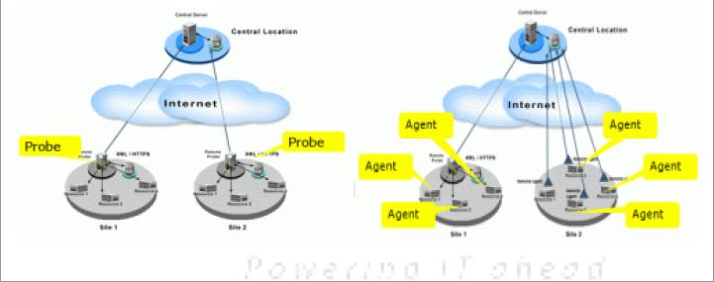
Figure 1: Agent and probe comparison. (MSP user guide pdf)

1.2 Auditing & Asset management
Msp Center Plus allows for auditing and asset management. This feature displays a table which lists information by customer. Next to the customers name you will find different categories such as system count, hardware, total software, prohibited software, expired software, and licensed software. Under each of these categories you will find a number indicating the amount of each that are associated with this customer. If you desire to see a more complete listing for the customer simply click on the customers name. The systems count category can be accessed by click the number under the title (“systems count”). While viewing information within this category you will be able to view a list of the computers in this customers network along with their operating system, service pack, version, domain, virtual memory, free virtual memory, visible memory, and free visible memory details (this can also be viewed as a graph). If you would like to view hardware simply click on the number below the title “hardware”. After doing this you will be able to see all hardware used in the systems of this customer including their type, manufacturer name, and quantity. Software is another option, by clicking on the number under the category “total software” you will be able to view all software including their versions, types, and categories. Furthermore each software is categorized into software type, access type, and license compliance.
Finally to change the time of the next scan navigate to “scheduled scan summary table” (to get to this table) look next to the area labeled “next scan scheduled at” and click the “change” link. You may then set a time and day to conduct the next scan.

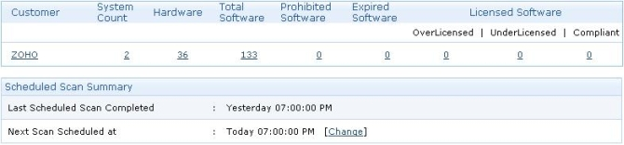
Figure 2: Inventory Summary.

1.3 Remote Control
MSP center plus provides a web based remote control access to a users’ windows machine. This allows you to send “CTRL+ALT+DEL” & “ALT+Tab” commands, blackout the users’ screen, and enable a pop up window asking the user to allow/deny remote access to ensure their privacy is retained. The currently supported operating systems are Windows 2000, Windows XP, Windows 2003 server, Windows Vista, and Windows 2008 server. In addition, whenever a remote connection is established MSP center plus maintains a record of who, and the time span of the session. To start a connection navigate to “desktop management” followed by “remote control” and then click on “connect”. Once connected you can verify that a connection has been made by looking at the area you just clicked which previously said “connect” which will now say “disconnect”. Now that you have done this you can click on the link “view desktop” which will allow you to as the name implies view a users desktop. For this process the computer containing the agent will make use of ports 443 and 8443. It is important that the firewall on this computer is configured to allow traffic to leave through port 8443.
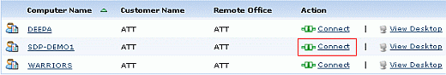
Figure 3: Connecting for remote.
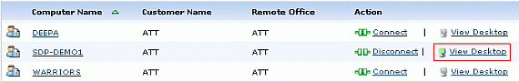Figure 4: Viewing desktop.

1.4 Automation
Msp Center Plus also has the ability to make use of scripting. If one should choose to silently remove agents they may do so through scripting. Any scripts made in Visual Basic, Jscript, Perl, or Python can be executed during certain events. Events where scripts can be executed are during log on, log off, start up, and shutdown. To execute a CLI command, run a cscript, or run a wscript navigate to “desktop management” followed by “configurations” then to “ computer configurations” and finally “execute command”. Here you will enter the name/description you see fit. After doing so you will enter the command or commands you want to execute. You will then “define a target” which is where you pick the desktop in which you wish to perform this action on. To finalize and deploy click “deploy”.
For a short list of commonly used commands provided by ManageEngine use this link http://help.mspcenterplus.com/Execute-Command.html.

1.5 Monitoring
MSP center plus comes equipped with monitoring features. To enable monitoring you must first make sure both a device template and a monitoring template are affiliated with a machine. For a complete step by step walk through on how to do this see the section “Grouping Managed Devices” toward the beginning of this report. Once both of these templates are set up Msp Center Plus will automatically monitor the machine(s) at the intervals specified in the templates. This feature makes use of SNMP, WMI, and CLI protocols. A unique poll I.D. is assigned to each polling performed by the monitor function. Just like Kaseya Msp Center Plus allows you to automatically generate alarms if a managed device goes down, set threshold alarms, set SNMP traps, and use Windows event log alarms. Five icons are used to indicate the level of the problem. A single “!” indicates that attention is needed, a double (“!!”) indicates trouble, an “x” indicates critical, a down arrow indicates the device has gone down and a check mark indicates the machine is clear.

1.6 Patch Management
Msp Center Plus includes a patch management function. This product gives you the choice of manually installing each patch or automating this process. To determine which patches are missing a machine is scanned and compared with a patch database. All patches of course originally come from Microsoft which makes Msp Center Plus the same as Kaseya in terms of patch capability.
First you must update your “vulnerability” database, which means to update your personal database with the main database. To do this you must go to “Desktop Management” followed by “Patch”. Here you can check when the previous “vulnerability” update was performed. Should you decide it is time to update your database you may do so by clicking “change” in the “ vulnerability DB update details” section.
To schedule a Patch Scan for a machine start at “Desktop Management” and navigate to “Patches”. Additionally you may deploy Patches by clicking “Configure Now” where you may choose what way the patches will deployed. You must now click “Configure Scheduler Settings” where you will decide when the patches will be deployed. To finalize the deployment click “Save Changes”.

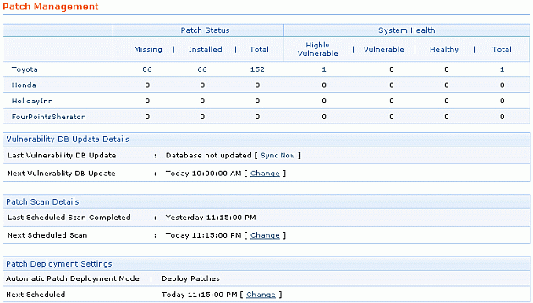
Figure 5: Patch interface.

1.7 Backup & Disaster Recovery
Msp Center Plus does not currently have a back up and disaster recovery function for end users. This product however does have a function which allows you to back up Msp Center Plus itself. To do this you would need to download the file BackupDB.bat and then save it under central/bin/backup. While doing this you might be prompted to either override the existing file or cancel. The correct course of action would be to override. The final step is to create a schedule for this function. To do so navigate to your computers desktop (this step is not done in Msp Center Plus) then to control panel, followed by scheduled tasks.

1.8 Endpoint Security
Msp Center Plus has various security features. Firewall settings can be modified (for Windows xp only) to block or permit access to a computer for certain TCP or UDP ports. When configuring firewall settings you may select either “on”, “off”, or “don’t modify”. Through security policies you are able to enable or disable access to a machine. To do configure a security policy click either “enable” or “disable”.

1.9 System/User/Admin Management

To help assist the administrator they have settings such as Global, patch, inventory, repository, and tools to organize and manage tasks.
Global settings are shared by all customers. Global settings consist of
- Agent- Number of computers that have agents installed, yet to install, failed instillation, uninstalled, or failed uninstallation.
- Custom Groups- Group certain machines of a certain customer to apply a template or configuration.
- User Administration- Specifies usernames and their roles.
- Mail Server Settings- Configure the mail settings for email notification
- Log Settings- Change the log settings either NORMAL or DEBUG.
Patch Settings configure the proxy and scan settings to keep the vulnerability database up to date.
- Proxy Settings- Change settings to allow internet access for maintaining the vulnerability database current.
- Schedule Vulnerability Update- Schedule how often the database should be revised from AdventNet.
- Schedule Scan Settings- How often the systems should be scanned and what action to take after a successful scan.
- Patch Scan Systems- Scan your client systems for any vulnerabilities.
- Latest Patches- List of latest patches by Microsoft.
- Download Patch- List of patches you’d like to download.
- Install Patch- Choose which patches to install on the machines and set deployment settings.
- Supported patches- The patches supported by MSP Center Plus from this section you can download or install the patches.
- Downloaded patches- All patches that have been downloaded into the Central Server.
Inventory Settings change or configure inventory scans, updates, and alerts.
- Schedule Inventory Scan- Helps schedule the inventory scan
- Manage Software Licenses- Add or change the licenses of the software to generate license compliant reports. You can specify filters depending on their compliant status.
- Manage Software Categories- Create and assign software to categories.
- Configure Prohibited Software- Set software that’s available for use and restrict use of certain software for customers.
- Configure Email Alerts- Set email alerts to notify when any new hardware, software or prohibited software is detected on the network.
- Inventory Scan Systems – Scan clients machines for hardware or software to add to an inventory.
- Alerts- View all the alerts on hardware/software inventory.
- Group Software- Group commercial software according to their versions.
Repository- Add or modify a software package or a script. Also
- Software Repository- You can store applications used often that can be installed onto the clients machines. They are kept under Software Packages Repository. Inside the package repository you can see their type, version, manufacturer etc.
- Script Repository- Store scripts that are used routinely. The scripts that are in the repository will be displayed with a description of each.
Tools
- Action Log Viewer – All the actions taken by remote management are displayed here with time, module, and remarks.
- Edit Action Log Settings- Number of days history that you’d like to store.
Users settings can be configured by
- Roles- Configure permissions to the support re/contacts to access the Requests, Solutions and Accounts.
- Contact Additional Fields- Create your own organization fields that should appear in the new contact besides the default fields.
- Support Rep Additional Fields-Create your own organization fields that should appear in the new support rep form besides the default fields.
- Support Reps- Add new reps, assign roles, and enable login.
- Account Additional Field- Create your own organization fields in the new account besides the default fields.

1.11 Reporting
A report can be made into a PDF, XLS, or CSV format and can of course been printed out. Various predefined report categories exist within this product. Predefined report categories include account reports, reports by all request, reports by completed requests, reports by overdue requests, reports by pending requests, summary reports, survey reports, and time spent reports. Should you choose the following actions can be taken on the generated report page: refine a search for a report (click “refine search”), edit a report (click “edit”), or delete a report (click “delete”). Query reports are also possible through this tool. By using this function you will be able to collect data from the database.
Performing the following steps will create a custom report. First navigate to “helpdesk and service automation” followed by “reports”. Now you will have to enter the report title. You must then choose between a tabular or matrix report. Next you will have to select a module and click “proceed to report wizard”. Now this process might go one of two ways (based on what Msp Center Plus shows you next). If the next step is to select a display column then you must select columns from the “available columns” box and move them over to the “display columns box”. If the next step is to select grouping then you must first choose between a simple matrix report (by selecting “simple”) or an advanced matrix report (by selecting “advanced”). Regardless of which of the two steps you have just taken you will need to click “next” to move on to the next step (which is the same next step for both of the possible previous steps). Now you will set the filter options. To do this first select columns and criteria which appeal to you. Next click “choose” and add values. After this click “add to filter” which will add the rule you have just made. Now you are able to can choose between “match all of the following (and) to filter if all the rules are satisfied” or “match any of the following (or) to filter if any of the rules are satisfied”. After clicking next you will select the column to group and click next again. You must now select a summary type and click next once more. Finally you must select a chart type (also selecting fields) and click “run report”.
As in Kaseya Msp Center Plus allows you to schedule a report. To accomplish this you will have to click “new scheduled report”. Carry on the process by choosing to either generate once (generate once), generate daily (daily report), generate weekly (weekly report), or generate based on a custom schedule (generate report). Do this within the report box. Now you must input an email ID in the “to” area. After you will input th subject and message that will appear in the email. Finally click save.
Additionally note that information from reports can be made into graphs like in Kaseya.

1.13 Usability
Within ManageEngine there are multiple products. In this regard depending on your company’s needs it may be necessary to use more than one ManageEngine product causing you to multiple interfaces. However most ManageEngine products have a built in ability to be integrated with other ManageEngine products thus increasing the scope of functions that can be taken advantage of by the user. Msp Center Plus of course is one of these products, which is able to integrate with some of the other ManageEngine products. This automation solution is web-based. After installing the server you must open the “web client” to operate Msp Center Plus. After installation a guide is displayed to inform you of the steps necessary to get this product working. Most steps (not all) have a link in which you can click to bring you straight to the area you need to perform the said step at. In this regard the product is user friendly.

1.14 Reliability
During our evaluation we did not experience any problems with the system going offline. While researching the reliability of the product through Msp Center Plus’s forum we found no indication that this was a common problem.
1.15 Supportability
Support for this product was provided to us through email and a live demo (live via internet/telephone). The support team at ManageEngine is very efficient normally answering your questions within 24 hours.
2. Comparison and Discussion
Overall Kaseya is a more powerful and comprehensive tool. Kaseya is more of an all in one tool where as ManageEngine has many products/tools. Msp Center Plus comes close to being an all in one tool but it lacks certain features that Kaseya has. In our experience it was easier to deploy agents on Kaseya on multiple machines. In Msp Center Plus it is necessary to perform multiple steps. We have chosen to give Msp Center Plus a rating of 3 out of 5.

  - Evaluating and Discussing [ManageEngine’s Msp Center Plus]

1 | Architecture  Rating: 3 | Msp Center Plus uses probes and agents while Kaseya uses only agents. Kaseya as a result is simpler.
2 | Audit & Asset Mgt  Rating: 4 | Both products are close in capability. Kaseya is slightly more powerful in this area.
3 | Remote Control  Rating: 3 | Kaseya is more powerful in this area because of it’s many features and has less restrictions .
4 | Automation  Rating: 5 | Both products allow scripting and are equally powerful.
5 | Monitoring  Rating: 5 | Both are products are even. Both give you the ability to set thresholds, set alarms, etc.
6 | Patch Mgt  Rating: 5 | Msp Center Plus is more user friendly.
7 | Backup & Disaster Recovery  Rating: 1 | Kaseya is better because it’s function backs up machines while Msp Center Plus backs itself (Msp Center Plus configuration).
8 | Endpoint Security  Rating: 3 | Kaseya is more powerful because it includes AVG to scan for viruses.
9 | Reporting  Rating: 5 | Msp Center Plus has one additional feature which is query reporting.
10 | System/User/Admin Management  Rating: 4 | Both products are even.
11 | Usability/Performance  Rating: 3 | ManageEngine is comprised of many products. No one products contains all the functions of Kaseya. Both products perform efficiently.
12 | Reliability  Rating: 4 | Both products are reliable.
13 | Supportability  Rating: 5 | Msp Center Plus offers forums, live demos, responds quickly. Is overall excellent in this regard.

2.2 Rating Results Explanation/Discussion:
Individual Solution Comparison Rating System Table

 |  | Kaseya | Msp Center Plus
1 | Architecture | 5 | 3
2 | Audit & Asset Mgt | 5 | 4
3 | Remote Control | 4 | 3
4 | Automation | 5 | 5
5 | Monitoring | 5 | 5
6 | Patch Mgt | 4 | 5
7 | Backup & Disaster Recovery | 5 | 1
8 | Endpoint Security | 4 | 3
9 | Reporting | 3 | 5
10 | System/Users/Admin Mgmnt | 4 | 4
11 | Usability/Performance | 5 | 3
12 | Reliability | 4 | 4
13 | Supportability | 5 | 5
 | Total | 58 | 50

3. Glossary

Managed Service Provider (MSP) - Allows remote managing of computers.

Simple Management Protocol (SNMP) – “A UDP-based network protocol” (Wikipedia). Is used most commonly for network management systems for the purpose of monitoring devices connected to a network for situations in which an administrator attention might be required.

Application Protocol Interface (API) – Enables interaction to take place with a different software.

Command Line Interface (CLI) - Allows you to enter commands through a command prompt to use the computer.

Unreliable Datagram Protocol (UDP) – Transfer protocol which allows packets to be dropped.

Transmission Control Protocol (TCP) – Transfer protocol which determines which packets have been dropped and makes sure they are retransmitted. Tcp is a reliable transfer protocol.
4. Acknowledgements
We would like to thank Zoho Corp. for providing free use of their product to us.

We would also like to thank the following people for assisting us with our report:

Rob Marshall : Zoho Corp, (925) – 965 – 6921

ManageEngine support team, support@mspcenterplus.com

Masoud Sadjadi: Florida International University, 305-348-1835

5. References

"Simple Network Management Protocol." Web. <http://en.wikipedia.org/wiki/Simple_Network_Management_Protocol>.

"MSP Center Plus - Help Document." 2010. Web. <http://help.mspcenterplus.com/>.

"Command-line interface." 2010. Web. <http://en.wikipedia.org/wiki/Command-line_interface>.

Mitchell, Bradley. "UDP." About.com, 2010. Web. <http://compnetworking.about.com/od/networkprotocolsip/g/udp-user-datagram-protocol.htm>.

“TCP Protocol Overview” 2010. Web. <http://www.lincoln.edu/math/rmyrick/ComputerNetworks/InetReference/83.htm>.

