System Design Document for

IT Management and Automation of

Automated Solutions, Inc.

Developed by:
Tito Esteves (Project Manager)
Leonard Simon
Yunier Rodriguez
Peter Greko

Advisor:
Dr. S. Masoud Sadjadi
School of Computing and Information Sciences
Florida International University

Contact Information: sadjadi@cs.fiu.edu,
More information: http://www.cs.fiu.edu/~sadjadi

April 16th, 2009

1. Introduction
Over the past few years Automated Solutions has been plagued with numerous IT problems. Their issues range from systems crashing to unexpected data loss. This past November an unwanted event occurred in which several of Automated Solutions hosting customers lost their data. The system administrators at Automated Solutions failed to fully restore customers’ data using the available backups. In this case, the problem was that the system administrators never had time to verify the backups. In addition, their backup plan at the time consisted of a full backup for the first of the month and a differential backup for the 7th, 14th, and 21st of each month. When it came time to restore the systems, some of the backups were corrupted. In consequence of their inefficient backup schema and system implementation, restores took a really long time. Because of the failure to restore customers’ data from backup, Automated Solutions lost hundreds of customers. This is one of many problems that have taken place throughout the past years. Due to the current economic conditions, Automated Solutions simply cannot afford to lose any more customers. At Automated Solutions it has been common practice to deal with problems in a sort of break and fix manner. The system administrators at Automated Solutions react to problems that occur instead of taking measures to prevent problems from occurring. Just to be clear, it is not that the system administrators do not care but rather the system administrators simply do not have enough time given the current system implementation.

1.1 Purpose of the system
The purpose of the proposed system is to cut the operating and salary costs for Automated Solutions while increasing the efficiency and quality of the IT management services. In order to achieve this, we will be implementing a complete IT Automation system for the administrators to use throughout the company.
1.2 Audience of this document

The audience of this System Design Document will be system administrators, project managers, CIO, and system designers of Automated Solutions.

1.3 Design goals

The design goals are as follows:

- The IT automation solution picked is web-based and easily accessible by administrators.
- Is reliable so that administrators can depend on the IT automation solution whenever and wherever they are.
- The IT automation solution is always available and manageable 24/7.
- The IT automation solution is at least compatible with Windows-based machines

2. State-Of-The-Art IT Management and Automation Solutions
In sections 2 and 3 below there are two separate rating systems. Within each tool described in section 2, each area of IT in section 2 (Remote Control, Patch Management, etc) is rated on its functionality from 1 being poor and 5 being the best. Within each tool described in section 3 each area of IT in section 3 (Remote Control, Patch Management, etc) is rated based on how well it matches the requirements of the requirements analysis document. At the end of both sections there is a Comparison and Discussion section where the rating totals will be added up and discussed.
  - N-able
Overview: N-able Technologies has 5 major products:
N-central – web-based platform for IT Services Automation & Service Automation
Remote Support Manager – real-time remote PC and server management capabilities (which is included with N-central)
Remote Environment Manager – desktop management tool
N-central OnDemand – hosted, subscription based solution
N-compass – an MSP Performance Reporting solution that enables MSP’s to analyze the performance of their customers’ IT infrastructure from a business perspective. [1]
Background:
N-able Technologies started in 2000 in Ontario, Canada. Now, they have expanded to two additional locations, one in the Untied Kingdom and the other in Sydney, Australia. Currently, N-able technologies is the preferred global supplier of remote monitoring and management technology as well as business support services for managed service providers (MSP’s). [2]
Company Highlights:
- Award-winning provider and market leader of managed services technology
- More then 1,300 global technology partners servicing 36,000 customers who combined generate over $360 million in managed services revenue.
- VARBusiness Partner Program Winner 2008
- VARBusiness Tech Innovator Winner 2007
- Microsoft Gold Certified Partner
- Profit 100 – Canada’s Fastest Growing Companies 2007
- Deloitte – Technology Fast 50 2007 [1]

Functional Coverage:
Supported Operating Systems:
All windows based
Mac OS X
Red Hat 3, 4 and 5 families
SUSE
There are two data collectors that are installed at the client’s site to help collect data. These pieces of software are called agents and probes. Agents are installed on individual devices and they monitor that particular device. Probes are installed on devices on the network and monitor the devices on that network. Probes monitor printers, routers, firewalls, as well as servers.
Grouping Managed Devices: N-central allows administrators to easily group any or all the devices on the network that has been imported into N-central. Administrators can use the default device group names or create their own based on the operating system, department or location.

2.1.1 Remote Control (Rating: 5)
N-central has a proprietary component called Remote Support Manager which allows you connect and manage a remote computer. Other remote control technologies that can be used are VNC, Terminal Services, SSH, RAdmin, and Telnet. Using the Remote Support Manager allows you to log into a remote machine without having to interrupt the user at the other end. Once logged into the remote support manager, there is a column with a list of different management choices on the left with some of the following options:
- File Transfer – able to transfer files from the local machine to remote machine via the File Transfer Protocol (FTP).
- Help Desk Chat – able to chat with the user if they are logged into the machine
- Computer Management – registry modifications, drivers, reboot
- Computer Settings – virtual memory, time, automatic login
- Server Functions – FTP configuration, status, stats, port forwarding, active directory.
- Scheduling & Alerts – system monitoring, email alerts, task scheduler, scripting
- Performance Monitoring – CPU and memory load, disk space, installed applications.
- Security – access control, IP address lockout and filtering.
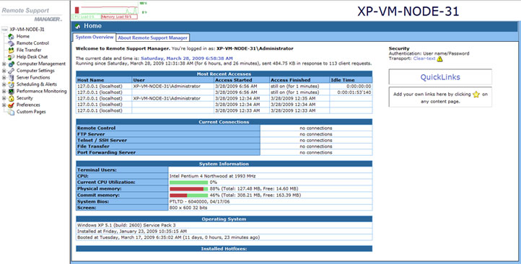
Figure 2.1.1a – Screenshot of the homepage for Remote Support Manager.

2.1.2 Auditing & Asset management (Rating: 3)
When you add a new device within N-central you can use what is called a discovery job to locate any devices on a network. You can also split up or combine the discovery jobs across multiple networks. This is especially helpful if the network has a large number of devices on the network. By initiating a discovery job all of the detected devices are then queued waiting for the administrator to import them into the N-central system and then agents will automatically be distributed to Windows devices. Administrators also have the option to deploy agent manually or via group policy.
Keeping track of all the machines and devices on the network is very simple with the “Windows Explorer” navigation feel on the left hand side of N-central. Below is an image of what the default break down of the different devices would look like:

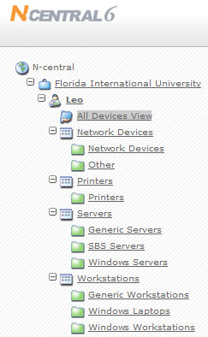
Figure 2.1.2a – Snap shot of the left navigation of N-central and how it demonstrates a “Windows Explorer” feel.
If administrators need to look up certain specs on given devices without having to remote desktop or use the remote support manager which would give them certain specs like CPU speed, CPU type, hard drive capacity, operating system, they could simply use the menu above and click through to the machine that they are interested in and click on the Details tab to see this information. Here is snapshot of a machine running VMware:

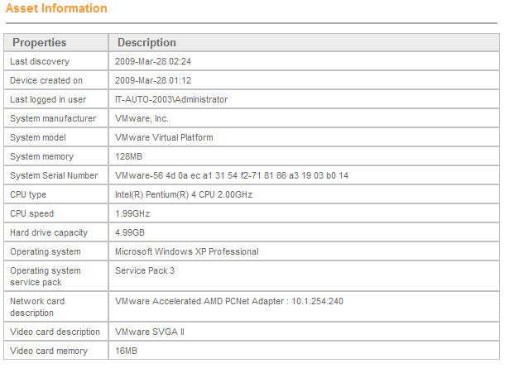
Figure 2.1.2b – Snapshot of some detail information about a machine on the network.
For asset management involving power options and similar features, N-able Technologies has a product called Remote Environment Manager which allows administrators to control some of the power features/settings of the remote machines. For example, the ability to shut down machine after they are idle for a certain amount of time.
There are 3 main asset management features within N-central, Application Compliance, License Compliance, and System Changes. The first feature, Application Compliance, allows administrators to create “black” and “white” lists of applications to track application compliance and protect customers from unauthorized software usage. Here is a snap shot of Application Compliance:

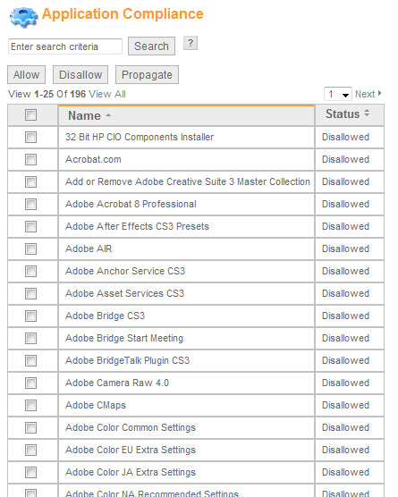
Figure 2.1.2c – Snapshot of some of the applications that can be allowed or denied under the Application Compliance section.
The next major asset management feature is License Compliance. This allows the administrators to monitor the number of licenses of purchased software being used to ensure compliance and plan future purchases.
The last major asset management feature of N-central is System Changes. This feature enables the administrators to monitor the hardware components of an individual device to record and report on hardware changes. Here is a snap shot of this feature and notice how it has section for “Baseline” and then “Current”. Baseline is what the specs was when the machine was first imported into N-central and current would be the real-time state of that particular component.
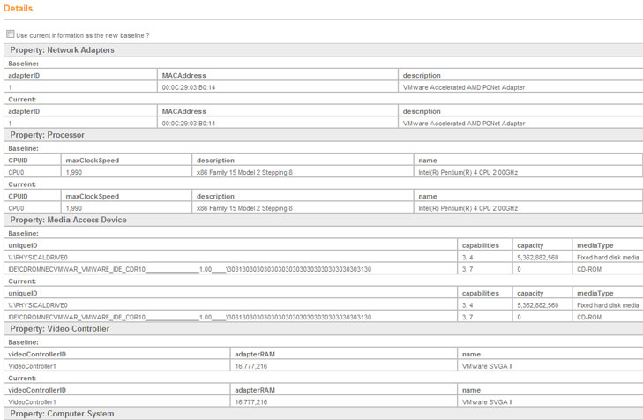
Figure 2.1.2d – Snapshot the System Changes section in N-central.

2.1.3 Monitoring (Rating: 5)
Monitoring has to be one of N-central’s strongest features. As an administrator, when you first login you can setup your N-central profile to show the “NOC View” page which is the page that shows the administrator all of the issues on the network. Some issues could be a Windows XP laptop running out of disk space or a router on the edge of the network having connectivity issues. When looking at the NOC View, there are simple yet effective indicator that explain what each status means. Here is a snapshot of the NOC View:
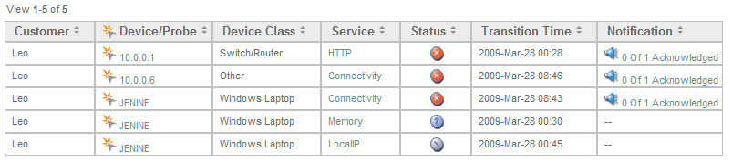
Figure 2.1.3a – Snapshot of NOC View
Here is a legend of the different status icons that could come up to show you what the issue is about:

Figure 2.1.3b – NOC View Legend of icon status icons.
Once you see an issue that can be fixed or if you would like to know more specific information about the issue, the administrator can simply click on the device name and it will provide information about the current status.
N-central also allows the administrators to see a matrix breakdown of a particular computer group or all of the devices on the network to see if there are any issues. For example, from Figure 2.2.1.2a let’s say you would like to see the status of all the Windows Workstations. All you would have to do is click on the “Windows Workstations” link and here is the matrix you will see:

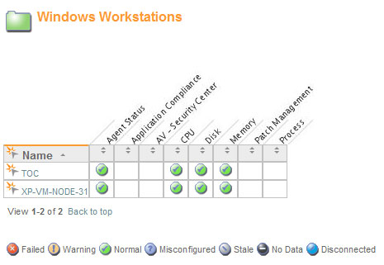
Figure 2.1.3c - Matrix of the Windows Workstations
As you can see of the two Windows workstations on the network they are all running “normal”. N-central allows you to monitor different features like Agent Status, Application Compliance, Anti-Virus, CPU, Disk, Memory, Patch Management, and Processes.
Administrators can be notified through SMS, email and a pager of any issues on the network. Automatic escalation, repeats, delays and acknowledgements ensure that notifications are not missed.
As mentioned in section 2.2.1, N-central uses data collectors called agents and probes. These collectors use Simple Network Management Protocol (SNMP) and Windows Management Instrumentation (WMI) to collect the data on the network devices.
N-central can monitor the following devices & services:
Monitoring of a wide range of devices  - Desktops  - Laptops  - Servers and Web servers  - Printers and copiers  - Routers  - Exchange servers  - Firewalls  - …and virtually every other IP-enabled device | Monitoring support for industry-standard protocols  - SNMP  - Log file analysis  - TCP/IP  - WMI  - Syslog/SNMP Traps  - ODBC  - EDF
IP Network Monitoring  - Ethernet Errors  - Traffic  - Bandwidth  - Frame Relay  - TCP  - SNMP | Windows Network Monitoring  - Application compliance  - Connectivity  - CPU  - Disk  - Disk Queue Length  - Event Log  - File Size  - Local IP  - License compliance  - Memory  - Patch Level  - Process
OS Monitoring  - Windows 2000/2003/2008/XP/Vista, 2008 Small Business Server  - Novell 6.5 SP 1a / SP 2 / SP 3 / SP 4  - Red Hat Linux AS/ WS/ ES 3.0, 4.0, 5.0  - Mac OSX 10.4, 10.5 | Email Monitoring  - Exchange Server  - IMAP  - POP  - SMTP  - SMTP Queues
Printer Monitoring  - Printer Page Count  - Printer Toner Level | Additional Monitoring  - Backup  - Citrix  - Firewall  - RAID controllers  - Local services  - Custom services defined by administrator

2.1.4 Patch Management (Rating: 3)
N-central interoperates with Microsoft Windows Software Update Services (WSUS) to provide cost-effective, efficient patch management. N-central provides simple WSUS configuration and monitoring and reporting of patch levels across WSUS-enabled devices.
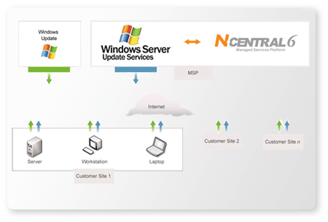
Figure 2.1.4a – How N-central works with WSUS.

N-central connections to the WSUS server and will automatically create a WSUS computer group. This greatly reduces the amount of time it takes to set up and configure WSUS. You can them monitor and report patch levels for those devices, and set up alerts for machines that are falling behind.
2.1.5 Backup & Disaster Recovery (Rating: 3)
Like most IT automation solutions, N-able does not currently have a backup or disaster recovery component installed but N-central can be setup to work directly with Backup Exec. Backup Exec is from the Symantec family and is the Gold Standard in Windows protection and system recovery. Backup Exec can be installed separately from N-central but N-central can monitor Backup-Exec main services to make sure that backup services are running and to ensure backups are initiated.
Administrators can install any backup solution on the network but N-central can only currently monitor Backup Exec services.
2.1.6 Endpoint Security (Rating: 3)
N-central has several security features that will help keep you network safe and secure. Here are several features:
- Proactively monitor and manage multiple security appliances and applications to minimize your customers' IT infrastructure downtime.
- Managed Security Dashboard lets you manage all your security services from one convenient location.
- Proactively monitor ant-spam, spy ware and virus services to ensure your customers' IT infrastructure is always protected.
- Ensure application compliance by remotely detecting non-approved applications.
- Monitor and manage customer firewalls and intrusion detection systems and receive proactive alerts upon their attack.
- Track and manage your customers' security devices to ensure adherence to software licensing and IT governance.
- Warranty, lease and support expiry services allow you to track expiry and replacement dates for security software and hardware.
- Track security performance over time to provide valuable reporting and insight for growth planning and budgeting.
- IT governance compliance is facilitated through 24×7 monitoring and reporting of security issues as defined by industry-specific legislation.
N-central allows the administrator to setup different dashboards for different needs. For example, if all the windows workstations have McAfee Anti-virus installed the administrators can setup a dashboard to monitor the different McAfee services like virus definitions and updates as well as the overall activity. If any issues come up, the administrators can be notified via email, SMS or pager and a status icon will appear in the NOC View indicating an issue.
2.1.7 Reporting (Rating: Not included in rating system)
Performance and Tactical reporting has to be another one of N-able’s strengths. Administrators would use the N-compass product which is built into N-central to generate detail reports. N-compass ships with more then 20 pre-built reports that administrators can use as is or create unique custom reports. You can use N-compass to report on key service performance metrics such as uptime, capacity, and security. Below is a list of some of the types of high-level reporting available within N-compass:

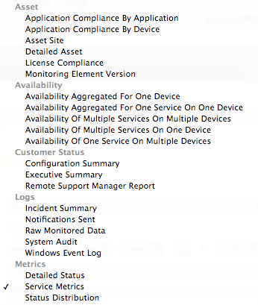
Figure 2.2.1.7a – List of optional reporting tasks within N-compass
Below is a list of some of the detailed low-level reports available:
Application Availability Report | Hardware Inventory Report
Availability Comparison Report | Hardware Upgrade Planning Report
Availability Comparison Report | Managed Devices SLA Report
CCM Call Activity Report | Network Health Overview Report
CCM Server Performance Report | Notification Summary Report
Cisco Call Manager Summary Report | Patch Level Summary Report
Data Availability Report | Remote Control Usage Report
Downtime Cost Report | Software Inventory Report
Event Log Reports | Technical Summary Report
Executive Summary Report | Traffic Usage Report
Firewall Incident Trend Report | Utilization Comparison Report

One of the reporting tools in N-compass allows administrators to see the percentage of time a machine was available in a certain period of time. Below is an example report:

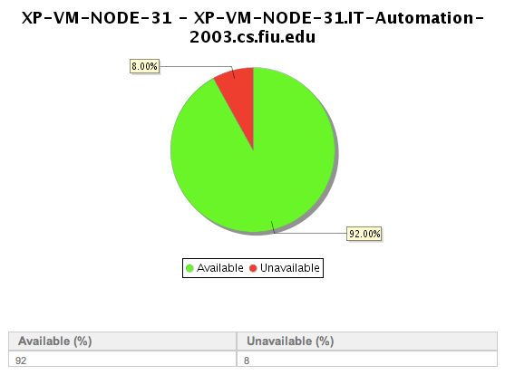
Figure 2.2.1.7b – Availability report for a particular machine in a 24-hour period.
2.1.8 Help Desk (Rating: 4)
N-central does not have a built in ticketing system currently but does integrate with other helpdesk/ticketing systems. Some of those ticketing systems are Tigerpaw, ConnectWise and Autotask. For example, N-central works very well with ConnectWise. When email alerts are generated in N-central they are converted into service tickets using an add-on called Email Connector.
2.1.8 Usability (Rating: 4)
N-central has to be one of the easiest IT automation products out there today. With N-central’s simple “Windows Explorer” navigation administrators have a clear break down of devices/machines. Administrators can also access the N-central anywhere in the world via the web-based interface. Administrators can manage machines easily through the custom dashboard that can be setup.
N-central is also fully brand able by administrators so incase the company has administrators working in different departments or tiers of the company the look and feel of N-central can be changed.
2.1.9 Reliability (Rating: 3)
N-central can be easily configured to work with Microsoft SQL Server’s for backup or data corruption issues. The brain of N-central is located on a central server and this server is in charge of all the key functions of N-central. Functions like the web-user interface, data manipulation, data processing, notifications, and reporting. There is no need for additional servers to worry about or rely on since all of the N-centrals actions are being performed from this central server.
2.1.10 Performance (Rating: 4)
The web-based interface of N-central is quick, sleek and easy on the eyes. Since there are very little images loading on each page the load time in minimal.
With the help of the agents and probes mentioned earlier it makes the data collecting aspect of the system run quickly and efficiently.
2.1.11 Supportability (Rating: 4)
Not only does N-able have a nice range of operating systems it supports but N-able has fantastic technical support and will work closely with administrators incase of an N-able software issue.
2.2 Altiris
Overview: Altiris has 5 major products:
Asset Management Solution – Software which tracks and manages the physical, contractual and financial data associated with the IT assets in your environment throughout their lifecycle—from receiving through disposal. Actively manage software assets to ensure license compliance, reduce leasing costs, and avoid penalties. [1]
Client Management Suite - Suite enables administrators to deploy, manage, and troubleshoot systems from virtually anywhere. Some key features: [2]
• Central Web-based management console
• Role-and-scope-based security
• Zero-touch OS deployment and migration
• Integrated hardware and software inventory with Web-based reporting
• Policy-based software management
• Automated patch management
• Software license compliance and harvesting
• Centralized management of mixed hardware and OS environments
Inventory Solution - track comprehensive hardware information, installed software packages, and operating system settings for all IT assets throughout their lifecycle. Tools for aggregating data allow you to generate audit reports, assess security vulnerabilities and determine hardware needs and availability. Web reports allow you to identify hardware that requires upgrading or replacement. [3]
Helpdesk Solution - incident management tool that allows you to ensure availability and raise service levels while reducing costs. Built-in workflow automatically assigns and escalates tickets to the proper Helpdesk technicians. Helpdesk solution integrates easily with other data sources, including Microsoft Active Directory and Systems Management Server. [4]
Altiris bundles most of these product offerings into a solution called Altiris Total Management Suite.
Total Management Suite - suite of IT lifecycle automation solutions designed to help IT organizations manage, secure and support all IT assets, promoting effective service delivery. [5]
Some key features:
• Integrated IT lifecycle management solution
• Common, Web-based console
• Single, extensible repository and configuration management database
• Zero-touch OS deployment and migration
• Integrated hardware and software inventory
• Policy-based software management
• Automated patch management
• Automated application self-healing and configuration settings management

Background:
Altiris, Incorporated. is a leading provider of service-oriented management software that enables IT organizations to easily manage, secure and service heterogeneous IT assets. [18]They also provide software for web services, security, and systems management products. Altiris was established in 1998 when Jan Newman and Kevin Turpin spun off the software division of KeyLabs. [6] KeyLabs was and still remains a third party testing facility. On April 6th, 2007, Altiris was acquired by Symantec Corporation. Since Altiris was acquired by Symantec, Altiris has been integrating its IT solutions with Symantec products. [7] It is also important to note that “Altiris acquired Computing Edge in September 2000. Computing Edge's founder, Dwain Kinghorn, had come from Microsoft and helped to develop Microsoft's original Systems Management Server product (SMS).” [18]
Company Highlights:
- Have over 20,000 customers managing more than 3 million servers and 60 million desktops and laptops
- Have strategic alliances with key partners such as Oracle, Microsoft, Hewlett-Packard, Dell, Fujitsu, IBM, Cisco and VMware. An example of a benefit of its alliance is Altiris’s collaboration with Intel to use vPro Processor Technology in Altiris products
- Microsoft Gold Certified Partner

Functional Coverage: [8]
Server Minimum Requirements
- Processor—Pentium lll 800 MHz or faster
- Memory—1 GB RAM
- Hard drive—20 GB
- Operating system—Windows Server 2003 or Windows 2000 Server
- Database—Microsoft SQL Server 2000 SP3
- Browser—Microsoft Internet Explorer 6 or later

Altiris Agent Minimum Requirements
- Operating system—Windows 95 or later
- Available disk space—5 MB disk space for Altiris Agent, plus space to install required software
- Memory—64 MB RAM
- Browser—Microsoft Internet Explorer 4 or later

Supported UNIX/Linux Platforms
- Note: Not all Total Management Suite features are supported on all platforms.
- AIX
- HP-UX
- Red Hat Enterprise Linux
- Solaris
- SUSE Linux Enterprise Server
In order to communicate with Altiris servers, software agents are installed on client machines on the network.
Grouping Managed Devices: Altiris allows administrators to easily group any or all the devices on the network that have been imported into Altiris. Administrators can use the default device group names or create their own based on the operating system, department or location.

2.2.1 Remote Control (Rating: 5)
Altiris offers remote control capabilities as part of their Client Management Suite. Altiris calls their remote control tool Flexible Remote Assistance. With Flexible Remote Assistance, administrators can troubleshoot and fix client computers remotely. This reduces disruption to the end user and makes the administrators much more efficient in their day to day functions. [9] To facilitate remote control capabilities, Altiris uses Symantec pcAnywhere technology on the back end. Symantec pcAnywhere is a reliable, secure and proven remote control solution used throughout many organizations. Symantec pcAnywhere has support for the following features: [9]
  - Smart card authentication – ensures connections are extremely secure via strong authentication. In addition, pcAnywhere has support for Microsoft Active Directory authentication
  - File transfer – able to transfer files from the local machine to remote machine
  - Support for multiple platforms - Users can connect to and manage computers running Microsoft® Windows®, Linux®, Mac OS® X Universal, or Microsoft Pocket PC operating systems
Below is a screenshot of pcAnywhere user interface.
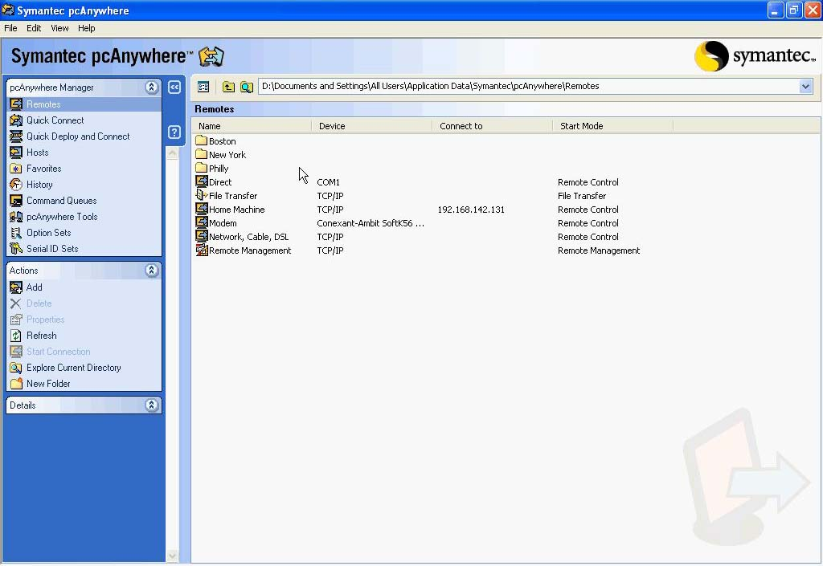

2.2.2 Auditing & Asset management (Rating: 2)
Presently, Altiris has the ability to attain auditing and asset information but in a limited form. Through Altiris’s Asset Management Suite, administrators are able to actively manage the entire asset lifecycle. [10]In addition, the suite helps organizations eliminate unnecessary software and hardware costs. As far as auditing is concerned, Altiris does not currently offer an auditing solution. Below is a screenshot of Altiris asset management console.
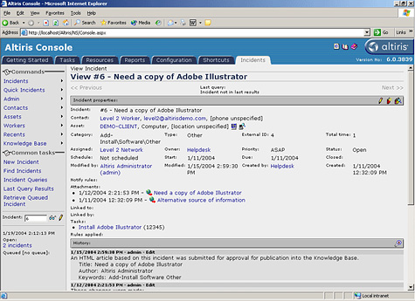
2.2.3 Monitoring ( Rating: 3)
As part of Altiris Total Management Suite, Altiris has a tool to address monitoring of systems. This suite ensures server and client machines are kept up and running by proactively monitoring the health of these machines. [11]Additionally, administrators can configure Total Management Suite to send alerts given defined events. Below is a screenshot of Altiris performance monitor and alerting console.
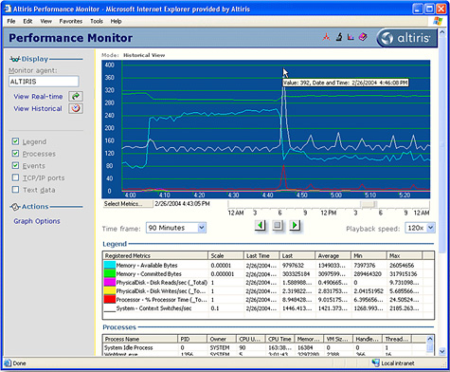
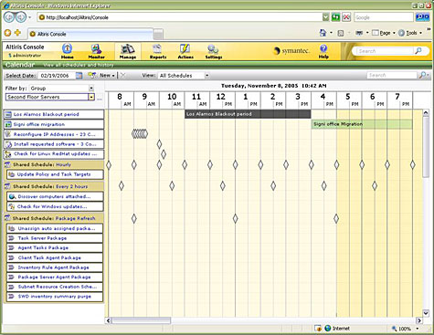

2.2.4 Patch Management (Rating: 4)
With Client Management Suite, you can deploy and update software to any computer in the organization through targeted policy based deployments. This helps ensure clients have the latest software and operating system updates. Patch management can be controlled by the administrators or updates can be requested by end users via a self service portal. [12]Updates can be assigned to groups, locations, or departments. Below are screenshots showing the concepts of deploying updates with Client Management Suite and requesting software via the end user portal.
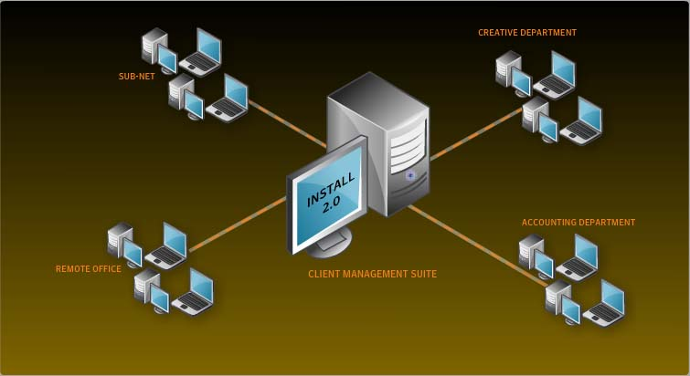
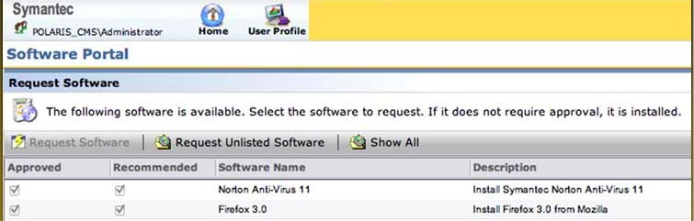
2.2.5 Backup & Disaster Recovery (Rating: 4)
Because Altiris is a subsidiary of Symantec, Altiris offers an add-on to its Total Management Suite for the purpose of backup and disaster recovery. This add-on uses and integrates Symantec Backup Exec System (BES) into Altiris Total Management Suite. Symantec Backup Exec System is considered by many in the IT industry as the standard in backup and disaster recovery. BES allows administrators to restore complete Windows desktop/laptops in minutes, even to dissimilar hardware or virtual environments. [13]Furthermore, BES has new functionality to automate physical to virtual conversions for immediate system recovery. With BES administrators can create real-time, while-you-work recovery points of the entire system and save to any disk-storage device. [13]Moreover, Client Management Suite can also incorporate Symantec Ghost Solution Suite technology. So imaging and deployment of operating systems can also be implemented. Below is a screenshot of BES scheduling that shows the status of the backups.
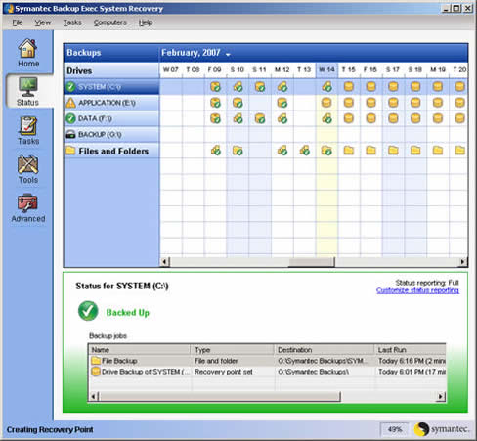

2.2.6 Endpoint Security (Rating: 3)
Altiris offers an add-on to its Total Management Suite for the purpose of endpoint security. This add-on uses and integrates Symantec Endpoint Protection (SEP) into Altiris Total Management Suite. Symantec Endpoint Protection has several security features that will help keep you network safe and secure. Here are several features: [14]
  - Seamlessly integrates essential technologies such as antivirus, antispyware, firewall, intrusion prevention, and device and application control.
  - Requires only a single agent that is managed by a single management console.
  - Provides unmatched endpoint protection from the market leader in endpoint security.
  - Enables instant NAC upgrade without additional software deployment for each endpoint.
SEP stops malware such as viruses, worms, Trojans, spyware, adware, bots, zero-day threats and root kits. [14]Below is a screenshot of network settings in SEP.
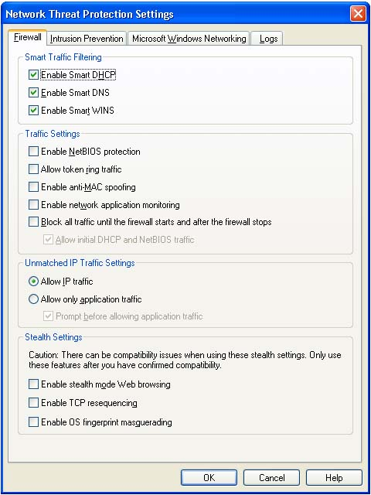

2.2.7 HelpDesk (Rating: 3)
Altiris Helpdesk Solution is a powerful incident management tool that allows you to ensure availability and raise service levels while reducing costs. Some key benefits are as follows: [15]
- Complete incident management and resolution capabilities right out of the box
- Web reports ensure quality of service and efficient IT operations
- Easy to install, implement and maintain
- Conforms to common IT standards for security, manageability, scalability and usability
- Built-in workflow to automatically assign and escalate tickets to the proper Helpdesk technicians
- Reports provide dashboard of information, including incidents assigned to or owned by you.
- Integrated server and site monitoring
- Integrates easily with other data sources, including Microsoft Active Directory and Systems Management Server
Below is a screenshot showing a service request.
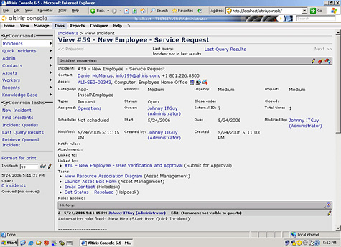

2.2.8 Usability (Rating: 3)
Administrators familiar with Symantec products should find the learning curve for Altiris Total Management Suite to be very minimal. Symantec has been improving cohesiveness between Symantec and Altiris solutions. However on the flip side, administrators unfamiliar with using Symantec products may require some time learning and configuring Altiris. The look and feel of the user interface is very inviting and friendly with its use of pictures and wizards. Nevertheless, the interface cannot be altered in any way and at times some settings can be hidden under many sub menus.

2.2.9 Reliability (Rating: 4)
Dependability of Altiris is quite high since they are owned by Symantec which means Altiris products will have great support for the foreseeable future. Altiris’s web based interface is efficient, stable, and highly available. Total Management Suite integration with heavily utilized IT products such as Symantec Endpoint Protection and Symantec Backup Exec System make it a vastly reliable IT automation solution.
2.2.10 Performance (Rating: 3)
Performance is on par with other IT automation solutions.
2.2.11 Supportability (Rating: 5)
Altiris solutions have support for practically every operating system. Altiris supports Windows 95 or later and many Unix/Linux platforms such as AIX, HP-UX, Red Hat Enterprise Linux, and SUSE Linux Enterprise Server. [8] Symantec offers two packages in terms of support. The first package is basic support. Basic support consists of full support but only Monday through Friday during normal business hours. The second package is essential support. Essential support defers from basic support in that Symantec provides full support twenty four hours a day / seven days a week. Symantec charges $210 per node for basic support and $220 per node for essential support.

Altiris Acknowledgements: The Altiris screenshots shown in section two were taken from Symantec’s website and the exact links can be found in the references section of this document. I would like to thank Derek Allred. Derek is a Symantec sales representative who covers our region. Derek provided me with some valuable input towards my research and directed me to trial versions of Altiris software.
2.3 LANDesk

Overview: LANDesk has 13 major products that can be used together and added to other solutions.
“LANDesk Management Suite — proactively sees, manage, update and protect IT systems.” [1]
“LANDesk Security Suite — performs active endpoint security management.” [1]
“LANDesk Process Manager — automates processes and reduces human error and the costs associated with manual process management.” [1]
“LANDesk Service Desk — delivers outstanding support services to employees and customers.” [1]
“LANDesk Antivirus — quickly assesses and diffuses the risk of viruses and performs Rootkit detection.” [1]
“LANDesk Host Intrusion Prevention System — reinforces existing security efforts against targeted attacks and zero-day threats right at the host level.” [1]
“LANDesk Patch Manager — automates vulnerability assessment and patch management across mixed IT environments.” [1]
“LANDesk Application Virtualization — creates virtual applications using true isolation capabilities.” [1]
“LANDesk Asset Lifecycle Manager — extends LANDesk Management Suite to see and track computer and non-computer resources.” [1]
“LANDesk Inventory Manager — lets enterprises see, monitor and maintain assets in all hardware and software inventories.” [1]
“LANDesk Handheld and Embedded Device Manager — let enterprises proactively see, manage, update and protect handheld and wireless devices.” [1]
“LANDesk Server Manager — instantly assesses server health and keeps servers available and running.” [1]
“LANDesk System Manager — extends LANDesk Management Suite to keep systems performing at their best.” [1]
Background:
“LANDesk was originally founded in 1985 as LAN Systems; LANDesk was acquired by Intel Corporation in 1991. In 2002, LANDesk was established as a standalone company. Then, in 2006, LANDesk was acquired by Avocent. And with over two decades of continuous innovation, award-winning products, and consistent industry leadership, LANDesk is positioned for continued exceptional growth in a rapidly expanding market.” [1]
Company Highlights:
- “LANDesk cofounded the Desktop Management Task Force (DMTF) and spearheaded the Web-based Enterprise Management (WbEM) initiative”. [1]
- “LANDesk Targeted Multicast technology that reduces network traffic by using a temporary subnet representative to simultaneously distribute large OS or application packages to multiple systems”. [1]
- “LANDesk Peer Download technology to speed configuration policy management by using packages from previous recipients on the same subnet, reducing the number of packages sent over the WAN”. [1]
- “Complete, integrated management support for Apple Macintosh computers, including inventory assessment, software distribution and remote control”. [1]
- “LANDesk Trusted Access technology to help enterprises identify and quarantine infected managed and unmanaged computers and access compatibility with Cisco and DHCP network access control capabilities”. [1]
- “LANDesk Management Gateway with patented technology that enables enterprises to manage previously unreachable users across the Internet without a dedicated leased line or VPN”. [1]
- “LANDesk management solutions are translated into multiple languages. LANDesk maintains offices in Brazil, China, France, Germany, Ireland, Italy, Japan, Mexico and the U.K., while delivering IT management solutions through more than 290 leading resellers and VARs worldwide”. [2]
- “LANDesk Management Suite wins Systems Management Award in Network World's Best of the Tests 2009”. [3]
- “LANDesk Security Suite wins Datamation's 2009 Enterprise Security Product of the Year”. [3]

FunctionalCoverage: Supported Client Operating Systems [4]:
Windows:
- Windows Vista Business/Ultimate/Enterprise (32-bit)
- Windows Vista (64-bit)
- Windows XP Professional
- Windows XP Professional, x64 Edition
- Windows 2000 Professional SP4
- Windows NT 4.0 Workstation SP6a
- Windows 98 SE
- Windows 95 B with Winsock 2
- Windows XP Embedded
Apple:
- Mac OS 10.5.x, 10.4.11, 10.3.9, 10.2.8, 9.2.2
Novell:
- NetWare 6.0, 6.5
UNIX and Linux:
- Red Hat Linux Enterprise 3, 4, 5 WS
- Red Hat Linux 7.3, 8.0, 9.0
- SUSE Linux Professional 9.1, 10
- Ubuntu
- Mandriva Linux 10.1
Handheld:
- Windows Mobile 6 Standard and Professional
- Windows Mobile 5 Pocket PC and Smartphone
- Pocket PC 2003 SE and Phone Edition
- Blackberry OS version 4.1, 4.2, 4.3
- Palm OS 4.2 or newer on Treo 650
- Teklogix 753x
- Wyse (XP embedded)
- Neoware CA10 (Windows CE & XP Embedded)
- HP T5520 (Windows CE)
- HP T5700 (XP Embedded)
Server Client Operating Systems:
- Windows Server 2003 (SP1 or greater) Standard Edition
- Windows Server 2003 R2, Standard Edition
- Windows Server 2003 (SP1 or greater) Enterprise Edition
- Windows Server 2003 R2, Enterprise Edition
- Windows 2000 Server SP4
- Windows 2000 Advanced Server SP4
- HP-UX 11.1
- IBM AIX 5.1, 5.2, 5.3
- Red Hat Linux Enterprise 3, 4, 5 ES and AS (with or without EM64T)
- SLES 9 SP2, 10 (with or without EM64T)
- *Solaris 8 (Intel Architecture)
- *Solaris 8, 9 (Sun Sparc)
* Solaris clients must be installed from LANDesk Management Suite, and consume a Management Suite license. Once installed, Solaris clients can be managed using either Management Suite or Server Manager. LANDesk uses agents to gather and monitor devices.
Grouping Managed Devices:
LANDesk let’s administrators group devices together by type, status, location, or any combination of these. Administrators can customize how devices are grouped and when new devices are added it can go automatically to a certain group depending on the set up and the device first audit.

2.3.1 Remote Control (Rating: 4)
LANDesk Remote Control solution is part of the LANDesk Management Suite. LANDesk Management Suite is the main suite and all other suites get added to the management suite. Here is a screenshot of the main LANDesk Management Suite console.

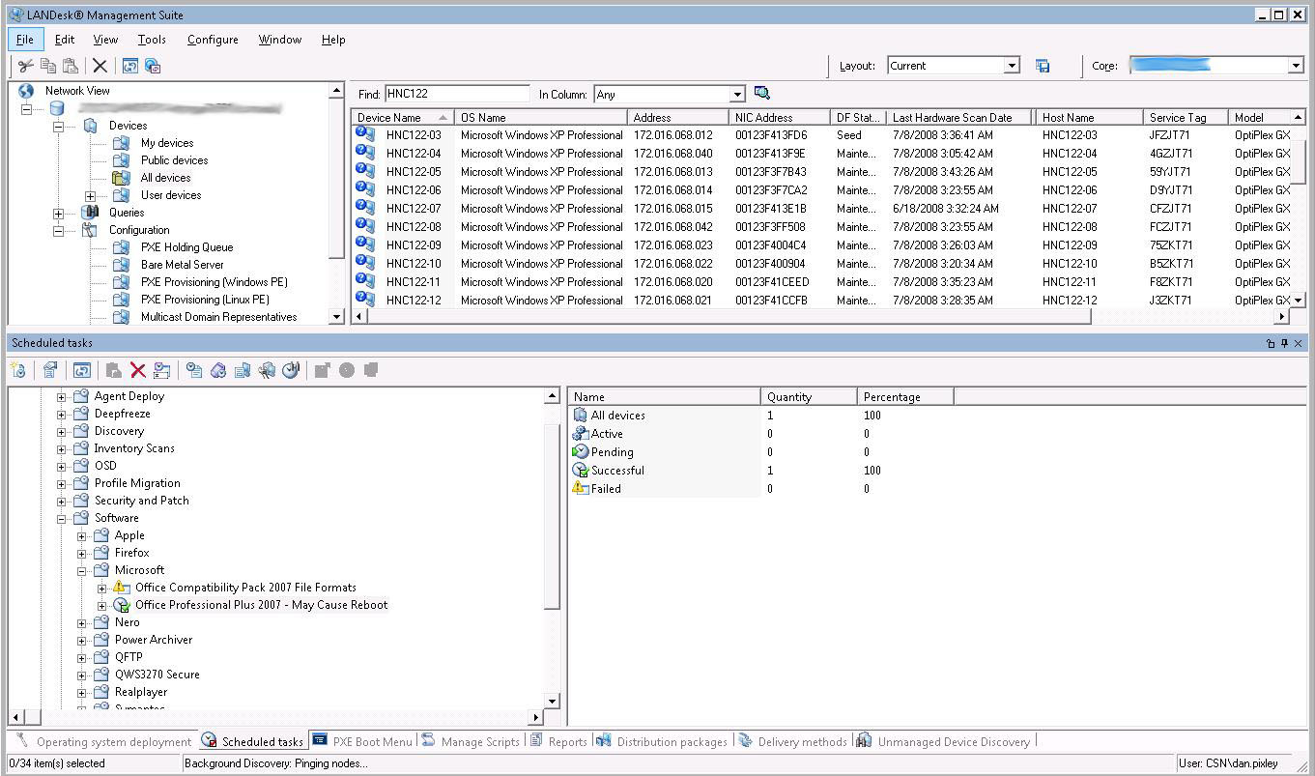
Figure 2.3.1a – Screenshot of the main LANDesk Management Suite console.

The LANDesk remote control tool is very appealing and looks very good. Using patented technology, LANDesk PC remote control software uses the existing Internet connection, as well as certificate-based authentication and SSL encryption, for bidirectional management traffic, letting you perform on-demand remote computer access securely over the Internet. [6] In terms of functionality, “a nice log view at the bottom of the screen documents everything. You can perform any of the actions you would expect from an enterprise remote control utility: chat, file transfer, reboot, and remote execution; which are provided as a very handy toolbar drop-down option that remembers previous commands you have executed. There is another drop-down list that allows you to switch between other active remote control sessions. Rather than filling your screen, the remote client desktop is presented in a resizable window which limits your current view based on the window size”. [5]

“Performance settings allow you to suppress the client desktop wallpaper and color depth may be reduced using a slide control, which allows you to adjust the color resolution in order to affect the speed of your remote control session”. [5] “LANDesk remote control software hides its remote control agent when not in use, so you maintain the highest levels of security with the least amount of impact”. [6] Remote Control Viewer is now available as a Mac application, so you can remote control from your choice of platform.

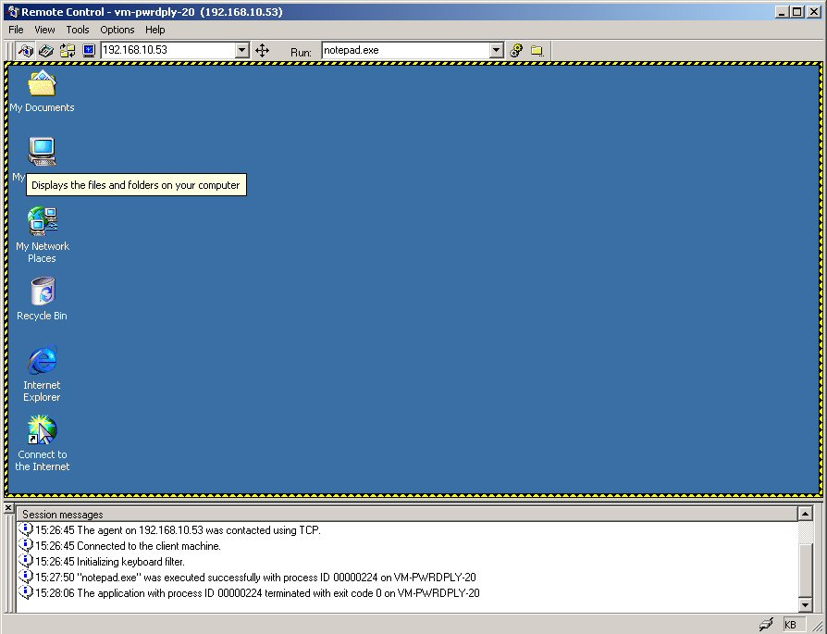
Figure 2.3.1b – Screenshot of a LANDesk remote control session

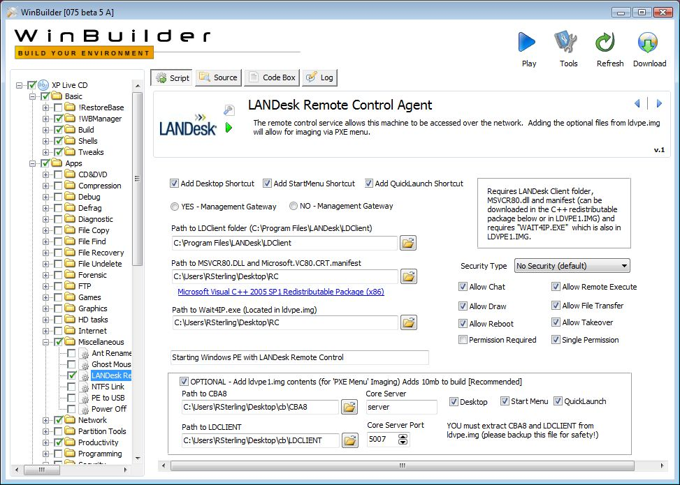Figure 2.3.1c – Screenshot of the initial setup of the Remote Control Agents.

2.3.2 Auditing & Asset management (Rating: 5)
LANDesk auditing and asset management features comes in the add-on packages called LANDesk Asset Lifecycle Manager for asset management and LANDesk Inventory Manager for the auditing part.

LANDesk Asset Lifecycle Manager:

LANDesk Asset Lifecycle Manager goes beyond simple tracking to provide a structured asset repository that extends the management of your organization’s hardware and software assets by starting before the asset exists and going beyond when the asset is retired. This extra connection throughout an asset’s lifecycle helps to reveal the true value of IT systems to allow better planning decisions, informed business analysis and improved business capacity. [7]

Some of the key features are [7]:

- The asset and any of its components can be tracked according to status, version, manufacturer, etc.
- Attaching supporting resources to an asset, and managing these throughout the lifecycle as well.
- The asset and all of its components are available to IT for purposes of troubleshooting, remote control, patching, upgrading, software delivery, and data access.

Refer to Figure 2.3.2a for an overview of the lifecycle of an asset.
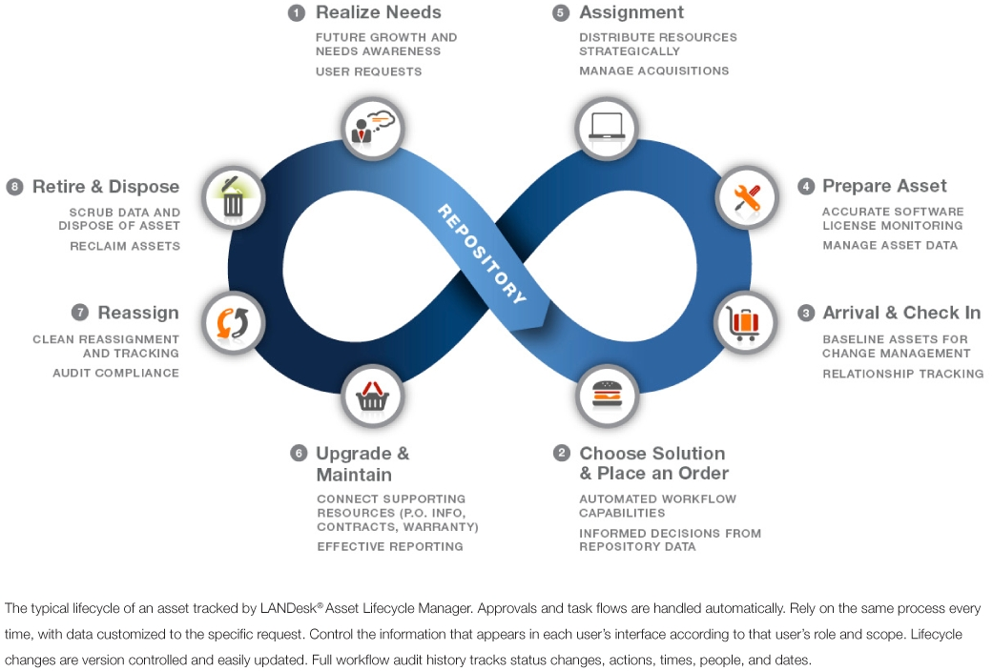
Figure 2.3.2a – Overview of the lifecycle of an asset.

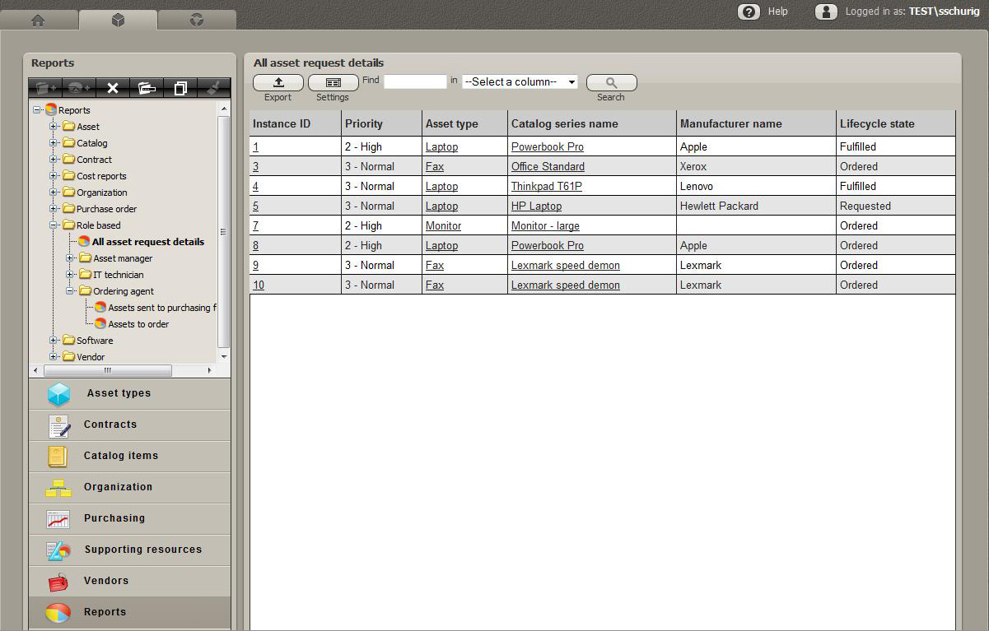
Figure 2.3.2b – Screenshot of asset details screen

LANDesk Inventory Manager:

The inventory comes with a large database of files it can identify. Other files can be added later to the database. But the built in database will get you started by including information on many common commercial applications. [5]

Some of the key LANDesk Inventory Manager’s tasks are:

- Inventory scanning
- Software license monitoring
- Reporting

“LANDesk Inventory Manager uses LANDesk unmanaged device discovery (UDD) to show you what you have, where it is and how it’s being used. Scan the network and identify any IP-enabled device to get an accurate picture of your IT assets. Even find misplaced or forgotten computers, printers and routers. Gather basic inventory data or detailed hardware, software and OS configuration data. Easy-to-use query tools help you analyze inventory data and group assets according to attributes. And automated inventory scans helps you quickly and accurately understand what you have, without manually gathering data”. [8]

Software License Monitoring
LANDesk Inventory Manager’s advanced software license monitoring capabilities help you understand software that is actually in use, not just what’s installed. That helps to recover unused licenses and reduce unnecessary software purchases. [8]

Reporting
“LANDesk Inventory Manager’s extensive reporting tools help you demonstrate license compliance to both internal and external audits. And quickly examine OS and application data to plan upgrades, identify security issues and determine purchase needs”. [8]

2.3.3 Monitoring (Rating: 4)
LANDesk monitoring solution comes in the LANDesk System Manager

LANDesk System Manager gathers health and status information directly from the computer’s hardware, software and OS in real-time. LANDesk System Manager uses industry-standard data sources, including CIM, WBEM, WfM, WMI and SMBIOS for a complete view of component-level system health regardless of configuration. [10]

“It monitors both application availability and hardware components such as processor temperature, fan speed, bus voltage and more”. [10] It also tracks fixed assets such as hard drives or RAM, as well as peripheral devices attached to the USB bus such as printers, removable drives or handhelds. [10] Automatic ASIC detection and monitoring enables IT to monitor hardware from most system vendors. A resident agent gathers information from hardware and software components to give IT staff a complete picture of system health, in real time. Configurable alerts make sure IT knows immediately when problems occur.

Alert management system sends alerts by email, fax, pager, and console popup; generates log file entries and triggers automatic events such as running an application or launching a batch file for instant response. Configurable alert thresholds define informational, caution and warning thresholds and integrate with AMS. [10]

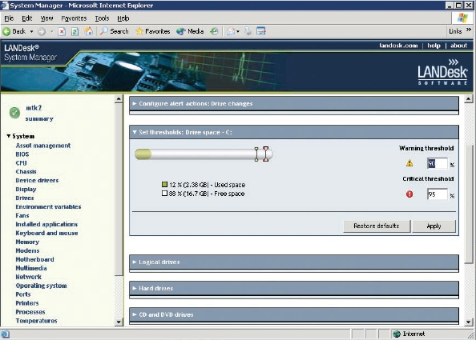
Figure 2.3.3a – Screen capture of disk space monitoring and alerting on LANDesk System Manager

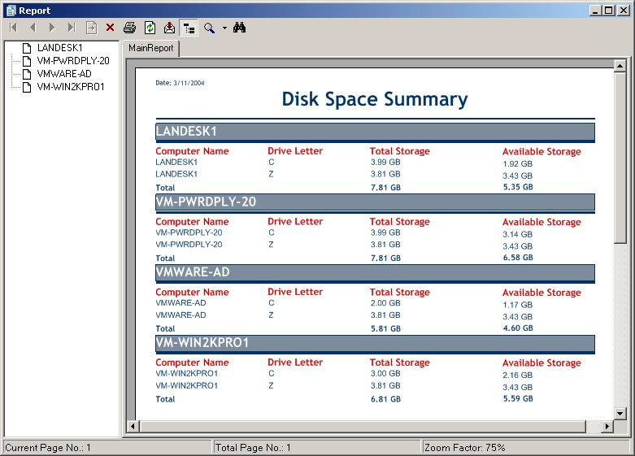
Figure 2.3.3b – Screen capture of a report generated after monitoring disk space on different computers in the network.

2.3.4 Patch Management (Rating: 5)
LANDesk software's Patch Manager is offered on its own and as a component of LANDesk's Security Suite or Management Suite. LANDesk Patch Manager uses proprietary agents installed on target devices and provides thorough vulnerability discovery and remediation, as well as a robust array of tools to customize those tasks. LANDesk permits management of end devices via existing directory structures, like Active Directory, or through groups created in the application. [11]
“Patch Manager's repository of patches can be customized, and the system supports a number of operating systems, including Mac OS X, Red Hat and SUSE Linux, Solaris, and Windows, as well as most common applications, from Apple's iTunes to Sun's JRE, plus popular antivirus systems, including those from McAfee, Sophos, and Symantec. LANDesk also supports a policy-based implementation, where you can define the types of patches you want to install and when”. [11] The patch repository is updated daily by LANDesk, and the frequency with which the management station checks for updates is configurable by IT from hours to months and anywhere in between.
Here it is the key features in detail [12]:
- Set behaviors at agent deployment that determine when the vulnerability scanner runs, how required reboots are handled and whether autofix is enabled.
- Prioritized patch severity gives you added control on which patches are critical.
- Multiple data sources for vulnerability information and also auditing of the devices before applying patches ensure you have accurate patches for your systems.
- Assessment and distribution scheduling let you choose when patches are applied.
- Alerting lets you choose to be notified by e-mail or pager when vulnerability is detected and/or a new definition is downloaded.
- Patch dependency shows you which patches depend on other patches, so you know what new vulnerabilities a patch might introduce.
- Patch history displays all patches installed on a client whether installed by LANDesk or another product.
- Patch uninstalls enables easy rollback for any patch available from the LANDesk patch management database, whether distributed using LANDesk Patch Manager or another tool.
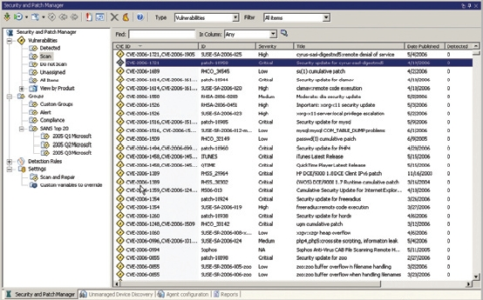
Figure 2.3.4a – Screen capture of the main screen of Security and Patch Manager.

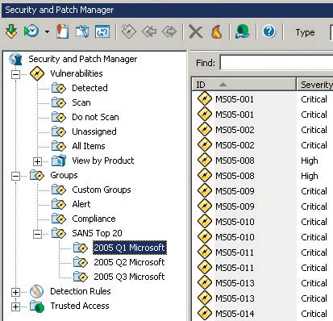
Figure 2.3.4b – Close up screen capture of the Security and Patch Manger

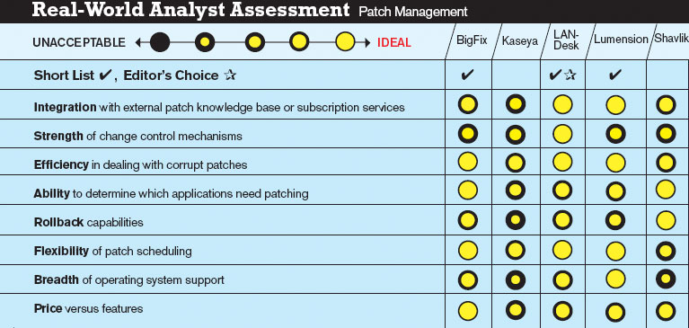
Figure 2.3.4c – Picture table of 3rd party assessment of Patch Management solutions from different providers showing LANDesk patch management strong performance.

2.3.5 Backup & Disaster Recovery (Rating: 0)
LANDesk does not offer any proprietary Backup & Disaster Recovery solution.
2.3.6 Endpoint Security (Rating: 3)
LANDesk solution for Endpoint Security comes in the add-on package called LANDesk Security Suite.
With LANDesk Security Suite you can [13]:
- Minimize network downtime, reduce help desk costs and protect critical data and user productivity by proactively protecting against malicious attacks at the endpoint.
- Reinforce your efforts to comply with security policies by proactively identifying and automatically remediating potential configuration threats.
- Save time and reduce resource needs by automating remediation with security rules, policies and frequent compliance scanning.
- Protect systems and critical data with active control over communication and data port access and the ability to quarantine devices.
- Easily align IT operations with corporate security policies by setting a security policy once that ensures desktops across the network are protected and compliant.
Here are the key features in detail [14]:
- Data Leakage Protection
- New Wireless Access Point Discovery allows you to secure the network by discovering unapproved wireless access points (WAPs)
- USB Encryption and Read/Write Control of USB/CD/DVD protects corporate data from changing hands advertently or inadvertently
- Firewall Management
- Manage the security configuration of the Windows (including Vista) firewall from one console
- Improved XP firewall management
- Network Access Control
- New 802.1x remediation protects the organization from virus outbreaks and unauthorized access
- Require policy compliance such as up-to-date virus pattern files and patches before a device connects
- Application Blacklisting
- New application blocker configurations control applications used by different individuals or groups to improve productivity and security
2.3.7 HelpDesk (Rating: 4)
LANDesk solution for Help Desk is LANDesk Service Desk.

- “LANDesk® Service Desk has a powerful graphical user interface that makes managing and placing service desk requests easier and more efficient for your entire enterprise. Service providers stay connected and productive by being able to access LANDesk Service Desk with a mobile device. And a Web browser-based interface lets service providers and end users or customers easily log incidents, communicate and track service status and requests”. [15]

- “LANDesk Service Desk includes the basics of incident and call logging, assignment, service levels, escalation, form design and user structures to give you access to everything you expect in a world-class service desk solution”. [15]

- “LANDesk Service Desk integrates with leading desktop management tools and toolsets, including LANDesk management solutions as well as Microsoft Active Directory, Novell eDirectory and Touchpaper ActiveAssistance to let you effectively use your existing tools to provide faster, better support with less effort, fewer consoles and less training”. [15]

- “Users can dynamically search for solutions and advice as incident, call, and problem and change information is populated. You control and configure how results are displayed. And knowledge is automatically captured to ensure that the latest, most pertinent information is accessible with the least impact on resources. And reporting capabilities let you record and prove the value of articles with both business usage and feedback”. [15]

- “The always-available Web-based service portal lets users proactively report a problem, find information and initiate a solution to facilitate faster resolution”. [15]

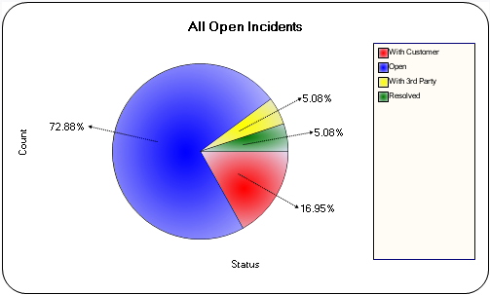
Figure 2.3.1.7a – Chart of Help Desk incident status by percentage.

2.3.8 Usability (Rating: 3)
LANDesk administrators will be very familiar with the interface because it resembles most popular software in that it has tree-view sections, explorer like folders and menus, and wizards for many of the features. LANDesk main console view has many features together into one window with many tabs so at first it can be difficult to know where features are and navigating through them, but once the administrators get used to it, it is very easy to work with.
2.3.9 Reliability (Rating: 4)
LANDesk has a very strong foundation and is very reliable. Both it is console and web based views are very responsive to the user and requires minimal effort to use. Other LANDesk add-on packages can be integrated into the main LANDesk console and even when adding other packages the reliability stays very stable.
2.3.10 Performance (Rating: 4)
LANDesk’s performance start in it is server, where all the packages and add-ons are integrated together to work as one unit. When adding many other packages the performance stays very stable even when more power and resources are being used. The performance for the web based console is strong too and allows for many administrators to be using it at the same time without any lag from the server.
2.3.11 Supportability (Rating: 4)
LANDesk support for different operating systems and devices is one of the strongest points it has. LANDesk offers technical and training for all the operating systems it covers and for all the devices it supports, even handhelds.

22.4 Zenith InfoTech
Zenith InfoTech offers a full IT Automation solution for the Small to Medium sized business.
About the Company
Zenith InfoTech Limited is an India-based company with offices in Pittsburgh Pennsylvania, California, and India. Zenith InfoTech provides managed service infrastructure and business continuity solution to information technology service firms worldwide. The Company has a Network Operations Center and fully managed disaster recovery solution supplies partners the essentials to deliver scalable managed service and Disaster Recovery offerings providing servers for customers and offering local network server solutions for clients that want local backups. The Company offers a range of managed services, such as Desktop Solutions, Server Solutions, Network Devices, Vulnerability Assessment Scans and Demonstrations. It also provides Backup and Disaster Recovery Solutions. Zenith InfoTech Services Sdn.Bhd (Malaysia) AND Zenith InfoTech (Singapore) Ltd are its wholly owned subsidiaries. The Company has a distribution network of over 1,500 resellers/channel partners to distribute and sell its services.
*Excerpt from Google Finance see references for listing
Zenith provides three separate and distinct services:
Managed Service Infrastructure
Zenith InfoTech offers a service and software solution that both give you the power to manage your IT infrastructure yourself or obtain the help you needs from Zenith InfoTech themselves. This gives the customer the flexibility to choose where manpower and Zenith InfoTech systems can help out in keeping the business aspect of the company running and reducing the overhead IT costs.
The main driving force of the Zenith InfoTech Managed Service Infrastructure is the SAAZ platform. This platform provides a comprehensive hosted environment with several tools that do the following:
- Desktop Management
- Server and Network Monitoring
- Advanced Scripting Engine
- Reporting Engine
- Ticketing System
The Managed Service Infrastructure also provides its own data center located in Fremont California, rated to be one of the top-ten collocation facilities. With this environment there is no need to add additional servers, they can host them at their facilities or bundle them with other Zenith InfoTech servers.
With the ability to provide management for customer networks from their 600 man Network Operations Center in Mumbai India, the Managed Service Infrastructure can provide 24/7 monitoring. The Network Operations Center has over 3 years of support experience and 15,000+ sites under their management.

Virtual Help Desk
Zenith InfoTech Systems provides a live help desk service from its Service Desk in Pittsburgh, Pennsylvania. The Service Desk is staffed with experienced Level 1 and Level 2 technicians who have 2+ years of work experiencing supporting end-users on server, desktop and network level issues. This service is delivered using a combination of phone and remote control tools that are a part of the SAAZ software. A flat fee per desktop per month is charged for this Service Desk service.
Business Continuity Solution
This solution focuses on a comprehensive backup and disaster recovery solution specifically designed for the small to medium sized business market. This package is often referred to as Backup and Data Recovery (BDR) by Zenith InfoTech Systems. This solution not only provides a software client application but it also provides a standby server merging both a software and hardware solution combined in one. The solution is also capable of near real-time backups pushing as much as every 15 minutes, capturing data as it changes. What sets this solution apart is that it includes a standby server which allows you to recover from server crashes or data loss in minutes, not hours or days. Full block level backups are done in minutes. Granular file, file folder, email, or email attachments can be restored in minutes as well. Zenith’s BDR models are Network Attached Storage (NAS) device installed with Business Continuity Software (BCS) that run on the Windows Storage Server 2003 platform.
One important feature that Zenith InfoTech Systems offers as part of their Business Continuity Software solution is the ability to virtually create a standby server with the backup image, backups are still maintained on the virtual server. The virtual server is run on the NAS device. This is a great feature that greatly limits costly downtime due to server hardware failures. This makes most server functions transparent to the clients that use them.

Technology Partners
To compliment the SAAZ Software & NOC Services Zenith partners with leading Information Technology Partners to offer you further options. You can choose to use the software and services from Zenith’s Technology Partners or deploy your own preferred alternatives for your end clients. Currently Zenith partners to provide: Antispyware Software, and Remote Control software.
The Antivirus offering has recently changed. Antivirus software is no longer offered directly as part of the SAAZ Platform or within Zenith’s Service Levels. You can select your own Antivirus solution or you can choose an Antivirus Vendor that has partnered with Zenith.
In addition Zenith also has setup with ConnectWise where you can view Asset and Inventory data collected by the SAAZ Software in ConnectWise. Also, if you use ConnectWise you can setup Ticketing synchronization between Zenith and ConnectWise to manage your ticketing in the ConnectWise system.
Antivirus Technology Partners
  AVG |   BitDefender |   VIPRE
Remote Connection Technology Partners

LogMeIn

Spyware Technology Partners    Spybot | Asset Management Partners    ConnectWise
2.4.1 Functional Coverage
The SAAZ infrastructure focuses primarily on Microsoft product line due to its abundance in the small to medium size businesses. Most of these companies operate on Microsoft products due to ease of use and prevalence of products.
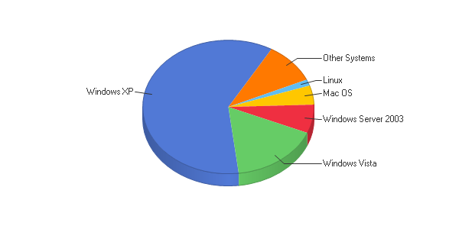
*from the website http://cru.cahe.wsu.edu/WebLog/cru/index.htm
Managed Service Infrastructure SAAZ client software supported Operating Systems
- Windows 2000
- Windows XP
- Windows Vista

Managed Service Infrastructure SAAZ server software supported Operating Systems
- Windows NT Server
- Windows 2000 Server
- Windows 2003 Server
- Windows 2008 Server
- POSIX compliant Hardware monitoring only

What can be Monitored and Managed by the SAAZ Client software for Workstations

- Antivirus definition checks for monitored vendors every 4 hours
- Temporary file and internet debris removal
- Microsoft Patch Assessment
- Disk Based Backup
- Logical Disk space checked for 200 MB free space
- Spyware quick scan during business week full scan weekend
- Microsoft Patch deployment of all or white listed security patches
- S.M.A.R.T. monitoring checking

What can be monitored and managed by the SAAZ client software for Servers

- Stuff about what can be monitored

SAAZ client software for Workstations

The SAAZ client software needs 35mb for the install. It syncs with a SAAZ server either provided by Zenith InfoTech’s datacenter or the customers own server. There is a process that the SAAZ client sets up when installed, this process is defined below. After the installation, the scheduled maintenance that is assigned runs on a schedule for optimum resources for the user, scheduled maintenance can also be run on-demand by the SAAZ server itself. Agents report on any errors to the SAAZ server. Anti-Virus definitions and software can also be deployed to the client using the SAAZ agent and the server. Advanced scripting can also be deployed by the SAAZ client on the workstation.

SAAZ client software for Servers

The SAAZ client software needs only 30mb of space instead of the 35mb for the workstation client. This also communicates to the SAAZ server and reports several things to the monitoring agent. The client software follows several steps when it is first installed. The first step it does is, apply the policy templates that have been assigned to the server. Device monitoring is also setup at this time. Once the agent is started and configured, the SAAZ client sends error codes and unavailability to the SAAZ server. The agent is also capable of mail transaction monitoring also.

2.4.1.1 Remote Control (Rating: 5)
SAAZ architecture uses a technology partner currently provided by LogMeIn. This shows a very flexible way of remote controlling and finding workstations and servers that is used through a web browser for maximum compatibility with administrators preferred workstations.
Brief overview of LogMeIn
LogMeIn is a leading provider of on-demand, remote-connectivity and support solutions to small businesses, IT service providers and consumers. Businesses and IT service providers use LogMeIn's solutions to deliver remote end-user support and to access and manage computers and other Internet-enabled devices more effectively and efficiently.
Advantages of LogMeIn
- Remote Sound Hear email notifications, check web based voice mail or listen to music and podcasts from your host computer
- Drag & Drop Seamlessly transfer files and folders between connected PCs
- Share files or photos instantly with others, even those too large for email
- Remote Printing Automatically print files from your remote PC to your local printer
- Direct Connect Save time and clicks by going directly from the My Computer's page into a remote control or file transfer session
- Mini Meeting Invite a colleague or friend to your PC for an online meeting; view only or full control
- File Transfer Move files quickly between PCs
- File Sync Synchronize files and folders on both PCs in seconds
- Drive Mapping Link your local drives to your target PC
- Quick Clips Short format how to video clips on LogMeIn features and functions

Typical Screenshot of LogMeIn software
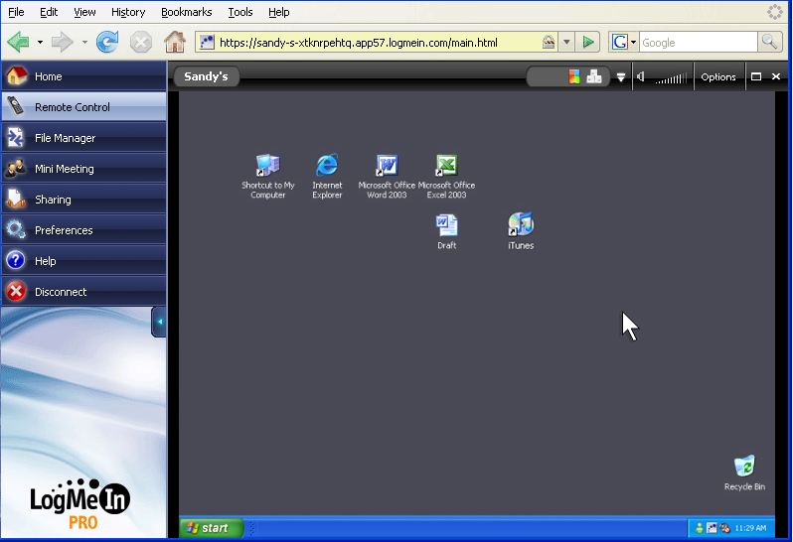
Figure 2.4.1.1a – Screenshot of the LogMeIn software.

Notice that it uses a web browser as its choice of communication and control.
2.4.1.2 Auditing & Asset management (Rating: 4)
With the SAAZ Agent installed system information is captured weekly or on-demand. This information is used for system monitoring but is also reported back to the asset database so you can review system information or run prefabricated asset reports or create your own custom asset report.
Features of the SAAZ Asset Management
- Prefabricated report templates
- Dynamic column and report sorting
- Multi-Site reporting
- Customized asset reporting
- Executive Summary Reports
- Export to Excel
- ConnectWise Asset Synchronization
- End users can review reports in the End Client Portal
- Patching, Spyware, Antivirus Reporting
- Asset Change Reporting
Individual Server Asset management is done through the main SAAZ Server portal as demonstrated below.
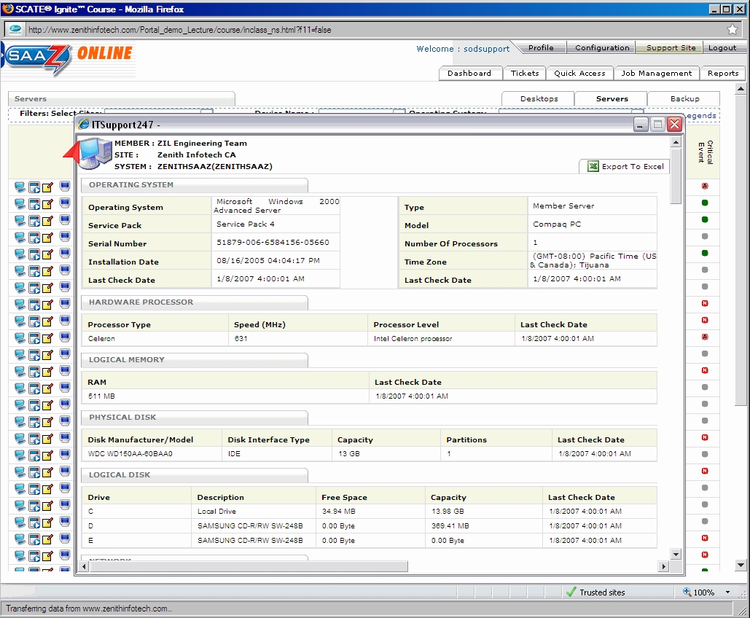
Figure 2.4.1.2a – Screenshot of the helpdesk SAAZ console.
We can see that all the physical assets are viewable below with more asset information that can easily be added. This can also be exported to Excel for further analysis.
2.4.1.3 Monitoring (Rating: 4)
There are 3 distinct management portals used by the SAAZ software solution. There are 2 primary management portals: ITS Portal and Partner Support Portal. The remaining Management Portal is intended for End Client usage. Below is an explanation for each one.
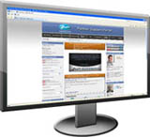  Support Site  - Training Documentation  - Product Videos  - Weekly Live Training  - Business Development Resources  - Marketing Campaign Resources  - MSPtv by Zenith Studios | 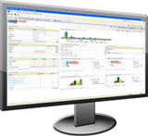  ITS Portal  - Centralized Management  - Portal Overview Dashboard  - Ticketing System  - Alert Overview Dashboard  - Simple Script Deployment Engine  - Patch Deployment Engine  - Prefabricated Reports  - Asset Report Builder
The final one is the one that gives the important monitoring information.
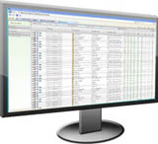

End Client Portal
- Desktop Reporting
- Server Reporting
- Desktop Remote Connections
- Server Remote Connections
- Veritas Reporting
- Business Continuity Reporting
We will be focusing on the End Client Portal which is the SAAZ Server. The interface uses a convenient web interface for true compatibility with most systems that administrators would use for monitoring.

This first window shows the main screen from the SAAZ Server site.

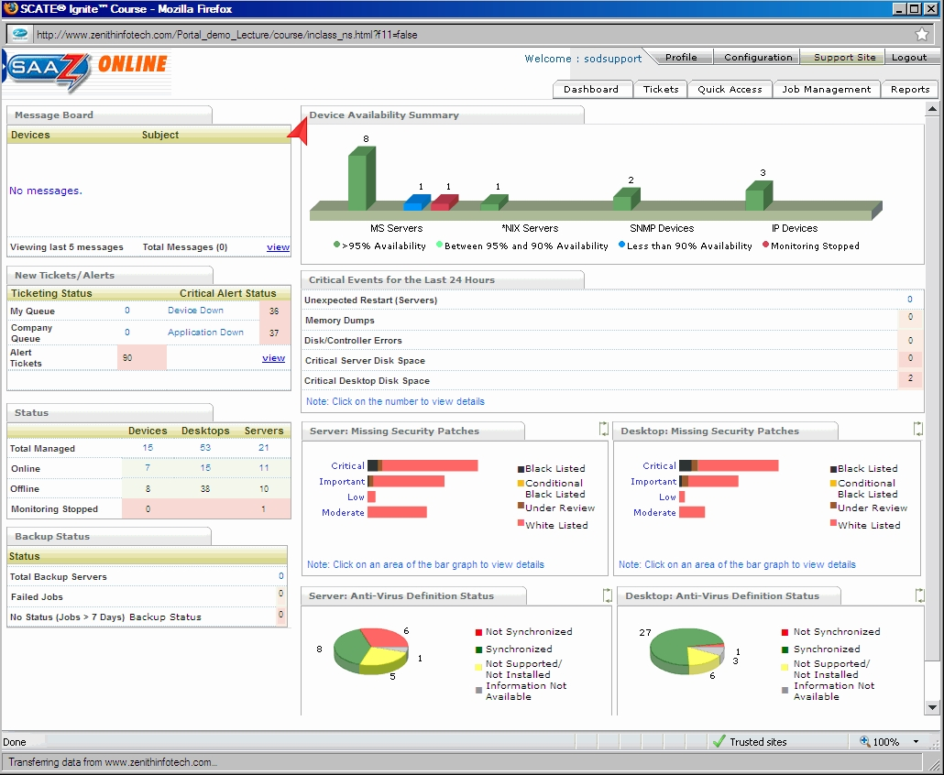
Figure 2.4.1.3a – Screenshot of the main SAAZ Dashboard console.

This is the summary page called the Dashboard and it gives the administrators a top down look at the network starting with the Device Availability Summary. We can see that you can also look at the Ticketing System, Quick Access, Job Management, and Reports. Monitoring is accomplished with the individual SAAZ agents installed on the devices both servers and workstations, these send agent alerts to the SAAZ server which in return displays these results above.

Individual monitoring of alerts can be seen with this example below.

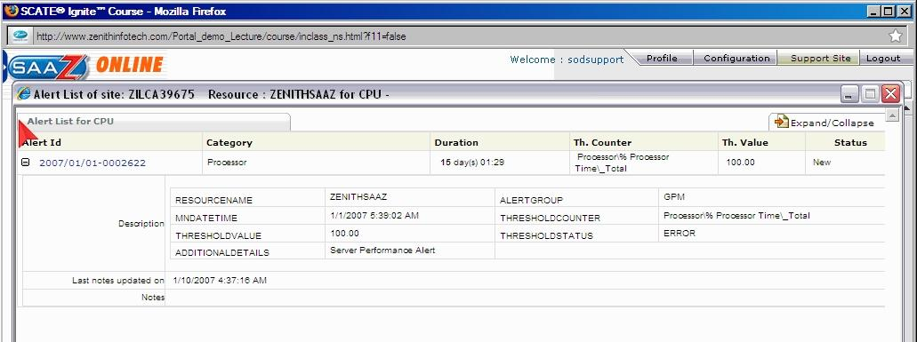
Figure 2.4.1.3b – Screenshot of the individual resource screen SAAZ console.

Of course an overall of all systems on the network can be seen using the Dashboard function as discussed earlier. This window is demonstrated in the next example.

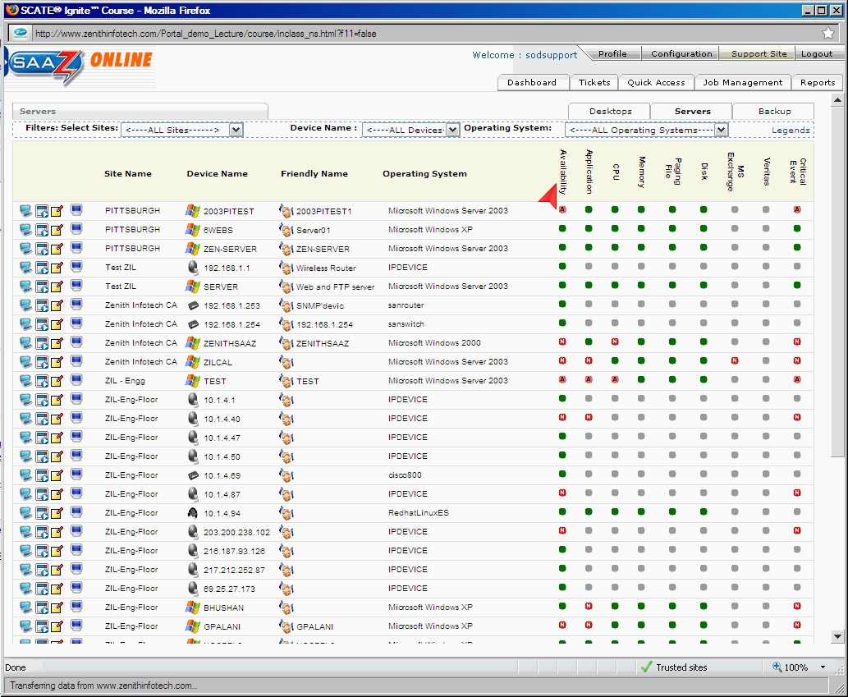
Figure 2.4.1.3c – Screenshot of the computer list SAAZ console.

2.4.1.4 Patch Management (Rating: 4)
Patch management is actually handled by the SAAZ Gateway Component, this component is usually installed locally to either a workstation or server (running windows 2000 or higher) on the local network and is used to download and distribute patches based on what the SAAZ server needs. This functions as a patch caching server so that bandwidth is conserved and new patches are downloaded to just this system from the internet. This component needs an embedded web server to be installed IIS 5.0 or above in order to function properly. Any SAAZ desktop agents installed on the workstations or servers will communicate to this device using standard HTTP and will receive the needed updates.
2.4.1.5 Backup & Disaster Recovery (Rating: 4)
Zenith InfoTech offers a Backup and Disaster Recovery solution that they call their Business Continuity Solution as we discussed earlier. They offer several solutions that include using their Servers to customers having their own server’s located onsite. This is both a hardware and software solution that also provides virtualization which can recreate a virtual server from the backup that it contains if the server were to go down, keeping mission critical servers up the whole time and leaving little downtime to the customers IT infrastructure. The main device is a Network Attached Storage with Zenith InfoTech’s own Business Continuity Software that runs on a Windows 2003 Storage Server platform. This can provide an almost real-time backup with intervals as small as 15 minutes. Backups can be both incremental and full providing flexibility to mission critical needs.

The first backup is called the Base Image and iti is an exact and complete copy of the currently used space on the server. This is a volume copy of each partition, after this all backups are incremental. Once this base image is created it must be shipped to the Zenith InfoTech’s co-location facility where the base image is copied to a server for usage in the Virtual Server backup option. This drive once the base image is copied is then returned to the customer. This creates and incremental forever methodology which they are basing their backup technology on. The customer chooses the backup frequency from the SAAZ server client portal. The incremental backups are stored locally on the customers installation of the NAS but then one incremental is stored offsite at Zenith InfoTech’s data center.

To keep the amount of stored incremental to a manageable size, the backup solution creates something they call Synthetic Incremental backups. This is done by making a larger incremental file from several smaller ones; the different types are listed below.

- Intra-day incremental collapse to a synthetic daily incremental
- Synthetic daily incremental backups collapse to a synthetic weekly
- Synthetic weekly incremental backups collapse to a synthetic monthly
- The synthetic Monthly incremental is currently the highest level back to the base image

Recovery Options

Recovering the files and folders needed is a very simple process where the entire partition is attached on the NAS device. The data can easily be copied to the destination location. The software can even restore SQL tables from a database, a really nice feature.

Instant Visualization Standby Server

The NAS device has the ability to create a virtual standby server using the image that was originally captured and updated through the incremental images. This unique ability is part of the larger Business Continuity Solution. The virtual server retains the same IP address so there is no loss of client productivity. Backups are still performed on the virtual server until the original “downed” server is corrected.

2.4.1.6 Endpoint Security (Rating: 3)
Password Vault feature
The SAAZ server interface has password auditing; this provides security through strong password selection. This password auditing feature uses Zenith InfoTech’s unique Password Vault Technology and provides a controlled process for accessing passwords.

Malware/Spyware Protection and Removal
The SAAZ package provides protection of Malware/Spyware by the usage of its technology partners and has features such as running in the background so that it is transparent to the users.

Anti Virus
The SAAZ server along with the client can track and verify integrity of well known anti-virus programs and combine it in the general alerting agent that the SAAZ server uses. Another Technology partner AVG works closely with Zenith Infotech to provide an Anti-Virus solution but not without its drawbacks as presented with a review below.

  - Review from Customer.

by David Schrag, 5/5/08
I sent the following note to my Zenith InfoTech account managers in February 2008, and I encourage(d) other ZI partners to do the same if they share similar concerns:
As an MSP who relies on Zenith InfoTech’s services for management of my clients’ antivirus software, I am writing to express my displeasure with several aspects of the current implementation of the AVG product line. These problems are listed in order of importance.
1) Having the NOC monitor whether or not AVG is installed and whether the definitions are current is inadequate. A centrally managed antivirus solution must include monitoring and remediation of infections as well. Both the NOC and the MSP should be able to view and report activity on both a client-by-client basis and across the MSP’s client base.
2) I frequently find myself being informed by end-users that their licenses have expired. This is embarrassing to me, not to mention time-consuming. Zenith InfoTech must find a way to ensure that licenses are kept current without intervention from me or my clients.
3) The default settings on AVG often lead to performance problems. For example, standalone machines are configured by default to do a complete scan every day at 8:00 am. If that scan is missed, it kicks off at the next user login. This leads to complaints from users that their computers run extremely slow in the morning. The installation needs to be scripted for so that full system scans are run during off hours, even if no user is logged on at the time of the scan.
4) The rollout of AVG is rather cumbersome, particularly for mobile computers that do not have a constant connection to an AVG ADMIN console. There needs to be a solution that takes less human intervention.
I understand that AVG is currently being offered at an extremely attractive price when bundled with the Zenith InfoTech product. However, saving a few dollars is not worth the risk of having infected machines go undetected and unrepaired or having to manually administer licenses and settings. If AVG is not technically able to provide a complete managed solution, I would prefer to see Zenith InfoTech switch to a different anti-virus vendor.
2.4.1.7 User State Management (Rating: 2)
From discussions with a representative of Zenith InfoTech, user state management is handled by Microsoft’s Active Directory services. There is no need for any additional software for this due to the small size that most of the small to medium size businesses provide. Due to this a rating of 2 is given because the other solutions demonstrate better options.
2.4.1.8 Help Desk (Rating: 5)
Trouble Ticketing System

By using another technology partner Connectwise, a comprehensive ticketing system is provided and integrated in the SAAZ architecture. This provides both trouble ticketing system and alert tracking.
Zenith InfoTech Systems provides a live help desk service from its Service Desk in Pittsburgh, Pennsylvania. The Service Desk is staffed with experienced Level 1 and Level 2 technicians who have 2+ years of work experiencing supporting end-users on server, desktop and network level issues. This service is delivered using a combination of phone and remote control tools that are a part of the SAAZ software. A flat fee per desktop per month is charged for this Service Desk service. The call center is available from 8:00AM till 10:00PM Monday through Friday. There is also premium afterhours support too. By using this you can now use their provided call center and save the massive cost of building a helpdesk infrastructure.
Virtual Help Desk supported operating systems and applications
- Windows 2000
- Windows XP
- Windows Vista
- Microsoft Office 2000/XP/2003/2007
- Microsoft Outlook 2000/XP/2003/2007
- Microsoft Outlook Express
- Lotus Notes 5 and above
- Internet Explorer 5 and above
- Mozilla Firefox
- Adobe Acrobat and Reader 6 and up
- Microsoft Visio 2000/XP/2003/2007

2.4.1.8 Usability (Rating: 5)
The SAAZ webpage interface is incredibly easy to navigate with many ways to get at key systems, cleanly linking everything together. The possibility to look up a system, see all the tickets assigned to it, along with the current status is really incredible. This system is mostly targeted for the small to medium sized business market so the dashboard has been geared toward that. With its top down focus on the network as a whole, it makes monitoring really easy.
2.4.1.8 Reliability (Rating: 4)
The most important fact about Reliability is the fact that Zenith InfoTech actually manages your monitoring servers in its own datacenter which is located in Freemont California, one of the top 10 datacenters out there. This means that extra overhead of managing a local server to act as the SAAZ server is not needed. The interface to the SAAZ server is through a web browser leaving little needed as far as installed software. The only biggest bottleneck is the internet connection itself, if this goes down, all other monitoring is stopped.
2.4.1.8 Performance (Rating: ?)
Due to the unavailability of the software and the server size nature of the product, I was not able to do a performance review.
2.4.1.8 Supportability (Rating: 5)
The massive helpdesk, online tutorials, and service both with hosting and client/server software available really put supportability to the fore front. The ability for the company to completely run your IT Automation software is also a great feature too if your IT department is limited in size.

2.5 Kaseya

Overview: Kaseya Professional Edition covers all major areas of IT such as:
Asset Management – With Kaseya, a simple automated scan of the network will identify any IP-enabled device to obtain an accurate picture of your IT assets. [3]
- Find misplaced or forgotten computers, printers and routers
- Gather basic inventory data or detailed hardware, software and OS configuration data
- Easy-to-use query tools help you analyze inventory data and group assets according to attributes
- Automated inventory scans help you understand what you have, without manually gathering data
Software and License Audit – Discover and inventory all software applications, license keys and duplicate licenses. [4]
- Prevent users from launching unauthorized software whether it is installed or not, even when not connected to the network
- Maintain a comprehensive view of software license use and easily respond to audits with extensive application usage, license compliance reporting, and license reporting features
- Powerful query and reporting capabilities let you quickly view, analyze and understand your IT environment
Performance Monitoring – with Kaseya, IT administrators can proactively monitor system and network devices to ensure maximum uptime and availability. With Kaseya performance monitoring, administrators can do the following: [5]
- Proactively monitor systems and devices to efficiently detect potential problems and automatically respond to defined conditions
- Implement best practices to identify and resolve network infrastructure and system problems
- Optimize the efficiency of the IT department
Help Desk – Kaseya provides an integrated help desk and trouble ticketing system that helps IT professionals easily manage users by providing IT support personnel with the tools they need to resolve issues quickly. Users and support personnel can interact in real time to report, diagnose and resolve issues without ever having to physically visit the desktop. [6]
- Deploy Service Desk / Help Desk capabilities in minutes
- Easy to use with no long training cycles or requirement for consultants
- Accessible from anywhere with no special servers or reconfiguration of your existing computing infrastructure
- Keep track of issues, resolve them quickly and increase customer satisfaction
Remote Control – Kaseya’s remote control capabilities provide easy, fast and secure remote desktop management of your entire computing infrastructure from anywhere. Using Kaseya, you’ll no longer have to struggle to find that laptop in the field or change your firewall settings in order to gain access to computers behind a NAT or gateway. [7]
Patch Management - From simple fully automated patch deployment to script based automation for a customized deployment, Kaseya delivers a secure and comprehensive enterprise class automated patch management solution to help keep security holes closed with a mouse click. [8] Kaseya Patch Management provides IT Administrators and service providers with the tools they need to be successful and keep the organization running.
Endpoint Security - The Kaseya Endpoint Security (KES) solution provides world class, enterprise level anti-virus, anti-spyware, and root kit protection for servers, workstations and mobile computers.
Backup and Disaster Recovery – administrators have the ability to deploy, configure, manage, monitor, secure, backup and restore distributed systems from a single management console. Kaseya backup and disaster recovery offers fast and easy recovery in a fully automated functionality.
Background: Kaseya Corporation is a privately held software company located in San Francisco, San Juan Capistrano (Orange County), Milpitas, CA, Bothell, WA, Miami, Washington, DC, London, Amsterdam, and Singapore. Kaseya was started in January 2000 to build a new type of IT services delivery solution. Kaseya’s product line is quickly becoming a standard in the IT services field. Kaseya’s IT Automation Framework allows IT professionals to proactively monitor, manage and maintain distributed IT infrastructure remotely, easily and efficiently with one integrated Web based platform. [9]
Company Highlights:
- Kaseya markets their products worldwide
- Annual revenue of $2.3 Million
- A global provider of IT automation software for IT Solution Providers and Public and Private Sector IT organizations
- Kaseya's technology is licensed on over three million machines worldwide
- Technology alliance partnerships with other IT solutions such as Autodesk, Catbird, ConnectWise, Tigerpaw, and Untangle

Functional Coverage:
Supported Operating Systems:
Microsoft Windows 98, Me, NT 4.0, 2000, XP, Vista, Server 2003
Macintosh OSX v10.3.9 and above, Intel and PowerPC editions
Linux support is coming soon.
In order to manage computers on the network, administrators install a software agent which communicates with the Kaseya server. The Kaseya agent supports both PC and Mac, and provides a non intrusive, non evasive and seamless OS service addition. This light-weight agent initiates all communications back to the server. Since the agent will not accept any inbound connections, it is impossible for a third-party application to attack the agent from the network. [9]
Grouping Managed Devices: Kaseya allows administrators to easily group any or all the devices on the network that has been imported into Kaseya. Administrators can use the default device group names or create their own based on the operating system, department or location.

2.5.1 Remote Control
Kaseya's remote control software provides the tools needed for secure remote access to all of your managed computers. Administrators have complete control over the remote control functions, including passwords, notification method, screen mode, and control level. In addition the remote control software allows administrators to grant end user access their machines remotely. Each end user also has the capability of optionally blocking remote control software access to their computer systems. Some key features in terms of remote control are as follows: [6]
- Firewall and NAT Friendly
- Access from Anywhere
- Configurable Client
- Secure FTP
- Secure Online Chat
- Video Streaming for Remote Training and Support
- Available to Administrators and End Users
- Maximum Security using 256 bit RC4 Encryption
Unlike other IT solutions, Kaseya has support for multiple remote control clients. These range from RAdmin to VNC. Below is a screenshot showing some other remote control clients such as PcAnywhere, K-VNC, and terminal server.
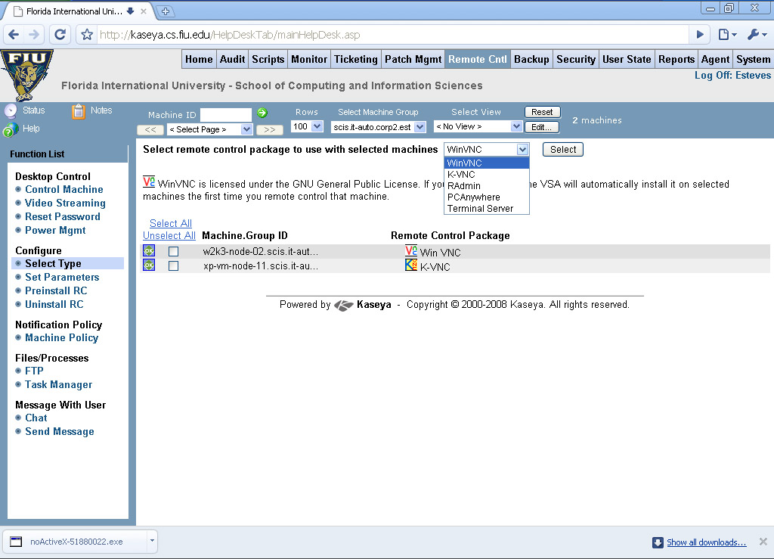
2.5.2 Auditing & Asset management (Rating: 4)
The Auditing and Asset Management features built into Kaseya are very easy to use and spaced out nicely. Once machines on the network have been discovered and they have agents installed those machine will show up in the machine group that is selected. There will be a list of machines to choose from on the left side. Here is a snap shot of what one machine looks like:
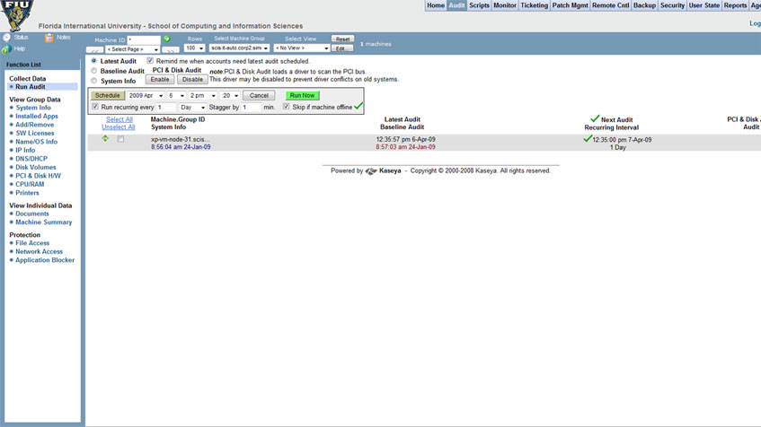
Figure 2.5.2a – Snapshot of Kaseya Audit Dashboard.
As you can see of the left side of this page there are a number of different data groups that are separated for administrators to choose from. Let’s say that an administrator would like to know what applications are installed on this machine. Instead of having to go to the machine or remotely login administrators can simply do to this section and click on the “Installed Apps” link, below is what they would see:
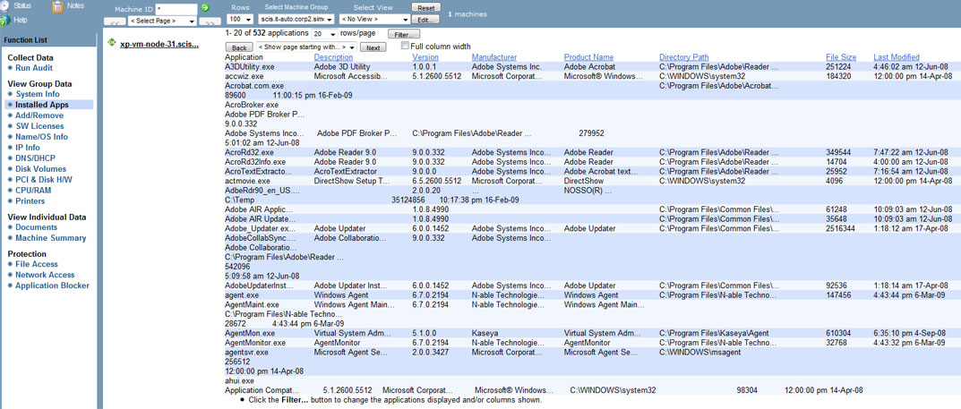
Figure 2.5.2b – Snapshot of Kaseya “Installed Apps” page in the audit section.
Administrators would see a list of the applications installed, version number, path it is installed in as well as the size and when it was last modified.
The Audit section also allows administrators to view entire machines system information in detail it needed. Below is another snapshot of the system information view of this particular machine:
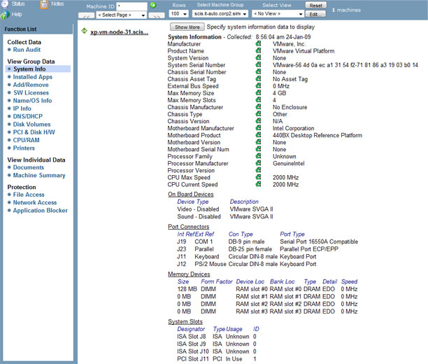
Figure 2.5.2c – Snapshot of Kaseya “System Info” section
In this system information view administrators can see specific information as far as how many memory slots are being used and are remaining to what types of ports are on the back of the machine.
2.5.3 Monitoring (Rating: 5)
Kaseya has a fantastic built-in monitoring system. This feature uses the agents installed on the machines to monitor different services and/or processes on individual machines. For devices that agents cannot be installed on administrators have the option to monitor these devices via SNMP. Devices such as printers for example would not be able to have agents installed but with the use of SNMP administrators can monitor page count and other printer spool services. Kaseya allows administrators to setup and configure monitor sets to easily organize different types of monitoring. For example, the printer spool monitor set allows administrators to monitor the printer queue to see if there are any job errors, or is the printer is out of paper. Below is a snapshot of the printer spool monitor set:
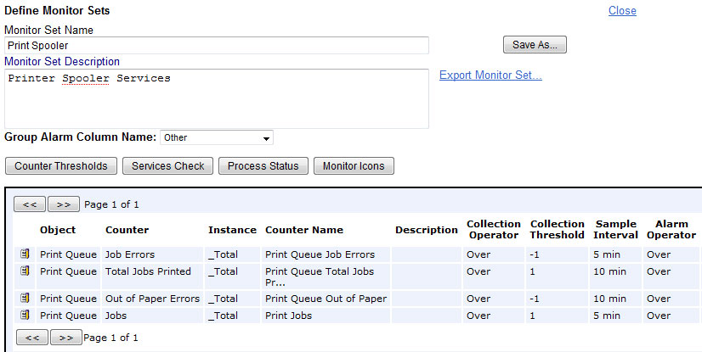
Figure 2.5.3a – Snapshot of Kaseya Printer Spool Monitor Set section
As you can see if there is a error during the print job whether is a out of paper error or any other related error administrators can be notified. Administrators also have the ability to set different thresholds. This can be useful if administrators know when there might be a spike in the printing jobs.
Administrators even have the ability to monitor the actual agents installed on the machines. If there is an issue with the agent itself administrators can be notified by email. Other useful alerts are also available to administrators. Alerts like low disk space, hardware changes, script file alerts, and many others.
2.5.4 Patch Management (Rating: 5)
One of Kaseya’s strengths has to be patch management. There is no need for an additional WSUS server in order to deploy patches. With Kaesya, administrators can see a list of all the machines on the network and simply select the machines they would like to scan for patches. Kaseya then shows administrators very clearly how many patches are installed, missing or denied. Below is a snapshot of what the Patch status page looks like for an individual machine:
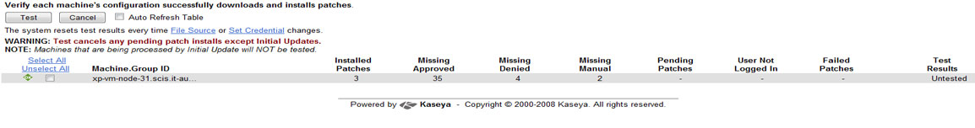
Figure 2.5.4a – Snapshot of Kaseya patch management status
In this view, after the patch scan has completed, administrators can easily see which patches have successfully installed, which patches are missing and approved and which ones have been denied. Kaseya allows administrators to manage which patches are approved or denied by their critical, recommended or optional status. Managing patches with Kaseya can cut administrators time with these built-in features. Below is a snapshot of Kaseya’s “Approval by Policy” page which allows administrators to select which patches should be approved or denied by default:
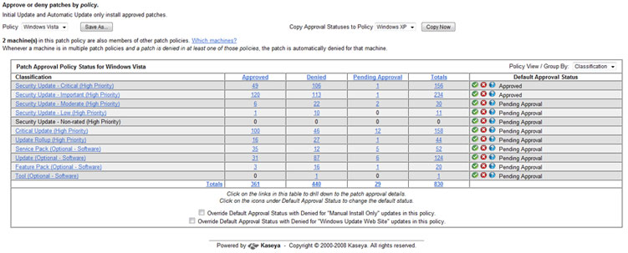
Administrators also have the ability to set a reboot action upon a successful patch or update. This can save the administrator’s time after the patches have been installed. Some patches do require a reboot and this section of Kaseya’s patch management section will allow administrators to configure this type of policy specifically.
2.5.5 Backup & Disaster Recovery
Kaseya’s backup & disaster recover solution is very powerful and the way it displays the status of the backups and the schedules is very user friendly and intuitive. It shows the administrators the status of each backup in progress, the status of backup sets like volumes backups or folders backups.

Through the interface the administrators can get a complete overview of all the backups, it shows them the number and percentage of cancelled backups, skipped backups, failed backups, unscheduled backups, in progress backups, and succeeded backups. It also separates the backups that are local and the ones that are offsite, that way administrators know that all their backup procedures are in place.

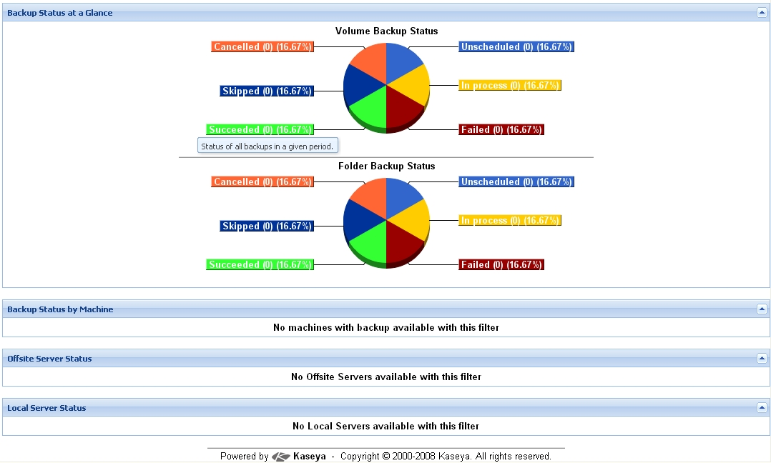
Figure 2.5.5a – Snapshot of Kaseya’s backup status at a glance

The backups itself are very well done, Kaseya offers all the typical types of backups like full backup, incremental backups, and differential backups. The recovery part is straight forward, the administrator select the image or folder to recover from either a local server or an offsite server and starts the recovery, or schedule it. Kaseya also offers backup alerts so that administrators don’t forget to do the backups or schedule them.

2.5.6 Endpoint Security
“Kaseya Endpoint Security (KES) provides security protection for managed machines, using fully integrated anti-malware technology from AVG Technologies. The term malware encompasses viruses, spyware, adware and other types of unwanted programs”. [1] Kaseya continuously monitors all the machines and servers where the endpoint security software is installed. Kaseya cleans and removes all infected files found and alarms can be set to alert administrators of security threats via email notifications, running scripts, and creating job tickets.

The interface status page gives administrators the current security status of all the machines. “This indicators include resident shield protection, mail protection, the number of unresolved threats detected, the number of threats in the virus vault and the version of security protection installed on each machine ID”. [2]

Administrators can also schedule scans for the best time possible and select a staggering time between scans so that scans on more than a set number of machines doesn’t happen at the same time. That way the load on the network can be distributed. Another great feature is setting up profiles for different machines, for example administrators can set up one profile for servers and another one for workstations and then assign different schedules and scans to those profiles.

2.5.7 HelpDesk
Kaseya’s helpdesk and ticketing solution provides a good way for end users to get help from administrators or other technical help people. Just by opening a ticket administrators can attend to a problem completely and keep in touch with the users if they need for information.

Once tickets are opened they are displayed in Kaseya’s interface for easy viewing and keeping track of the status. Tickets with notes entered in the last day will appear highlighted in red while tickets with notes entered in the last 7 days will be highlighted in yellow. Tickets can be search for by name or date or other keywords, as well as it can be filtered and sorted.

Administrators also have the ability of creating notification policies to be alerted when new tickets are created or when tickets change status. These notifications are usually sent out by email. There are many notification types including ticket creation, ticket modified, due date change, and others. Another great feature is the ability to archive old tickets and their solution for future reference. Common problems will happen in the future and having the answer to those problems right there it is a great advantage for administrators.

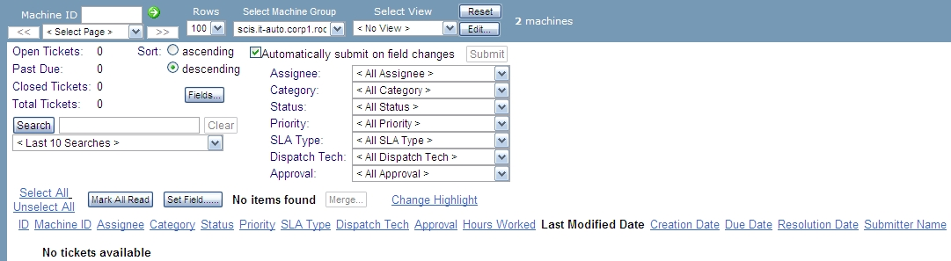
Figure 2.5.7a – Snapshot of Kaseya’s help desk status page

2.5.8 Usability

2.5.9 Reliability
2.5.10 Performance
2.5.11 Supportability (Rating: 5)
Kaseya has several avenues of support, from video how-to guides, phone support, and knowledge base systems.

Kaseya Knowledge Base
The knowledge base starts out with a simple page with several topics. These topics are listed below.
- Backup / Disaster Recovery (BU/DR)
- Core components
- Kaseya Endpoint Security (KES)
- Patch Management
- Server / Agent

Along with this there is a dynamic listing of both Hot Topics and Latest Articles.

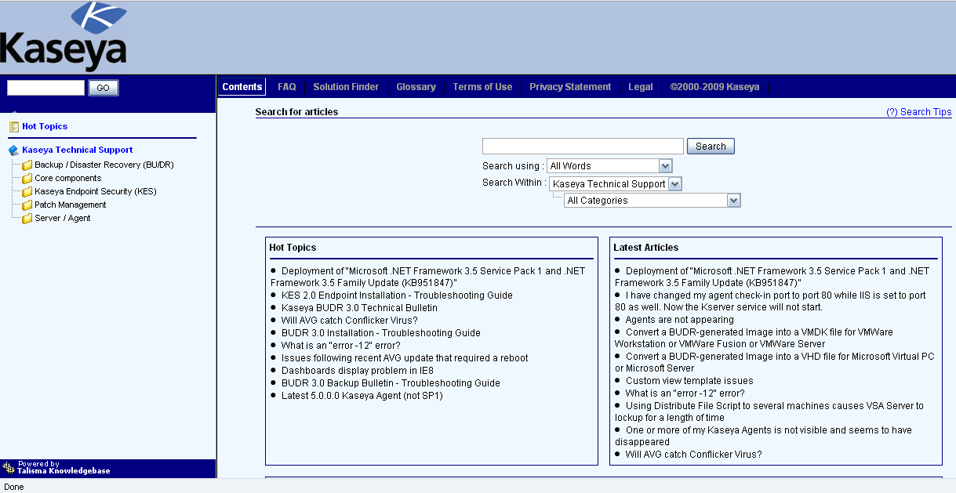
Figure 2.5.11a – Listing from the Kaseya site for the knowledgebase.

Kaseya Forum
There is a form for submitting Problems to Kaseya with the support forum along with a user community to help with issues and share ideas.

Kaseya Call Center
Kaseya has a call center that is available from 8:30AM to 7:00PM Eastern Standard Time from Monday through Friday. This is available for Kaseya customers to call for access to experts.

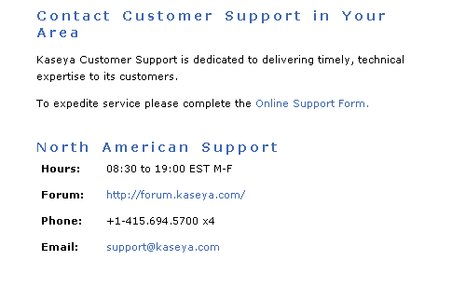
Figure 2.5.11b – Listing from the Kaseya site for support options.

2.6.1 Evaluating and Discussing N-able
The strongest areas of IT automation for the suite of N-able products would have to be Remote Control and Monitoring. The weakest would have to be PM as far as an integration aspect. Yes, N-central has patch management monitoring capabilities but it requires administrators to have to build, purchase licensing, and manage a separate WSUS server. Some IT solutions like Kaseya don’t require a WSUS server for patch management. Below is a detailed table that provides an explanation of the results for each area of IT for N-able:
Remote Control  Rating: 5 | Remote control was rated a 5 because of the many features available to the administrators to manage the customer’s servers as well as the employee servers. The Remote Support Manager feature built into N-central makes the administrators jobs much easier by being able to restart services on the servers remotely with using VNC or another related remote monitoring system. For example, if the SQL service is down on a SQL server the administrators would be able to stop/start/restart the service from anywhere in the world by just having an internet connection and a web browser.
Audit & Asset Mgt  Rating: 3 | Audit & Asset Management was rated a 3 because of its easy “discovery job” feature as well as its machine asset information feature built into N-central. With the discovery job feature administrators can simply add a new machine to the network and N-central will automatically discover this device and notify the administrator and ask to import the machine. Also, once this machine is added to the network a baseline asset information scan is performed. This scan records information like CPU type, operating system type, hard drive make and model and other specifications of the machine. This scan is very useful incase an employee adds a certain piece of hardware like more memory for their machine when they aren’t supposed too. A notification will then be sent to the administrator.
Monitoring  Rating: 5 | Monitoring was rated a 5 due to its amazing GUI and very specific monitoring and notification capabilities. The N-central interface is so easy on the eyes and it is very easy to tell if a server/machine is having issues. From the color-labeled messages to the escalation processes to keep administrators aware of issues that haven’t been resolved so none of them fall through the cracks is simply fantastic.
Patch Mgt  Rating: 3 | Patch Management was rated a 3 simply because of the lack of proprietary patch management capabilities within N-central. The only way to integrate patch management with N-central is by purchasing, configuring and managing a separate WSUS server. Other IT automation solutions have a built in patch management system.
Backup & Disaster Recovery  Rating: 3 | Backup & Disaster Recovery was rated a 3 because of the extra effort having to install, configure and manage a separate backup solution. Administrators can install the backup solution like Backup Exec which works very well with N-central right on the Central N-central server but there is a little bit of a learning curve involved. Also, you cannot manage backups within N-central, it would have to be done via Backup Exec. N-central does monitor the Backup Exec critical server though.
Endpoint Security  Rating: 3 | Endpoint Security was giving a 3 because of the lack of management capabilities with anti-virus and spyware applications. Administrators might have a difficult time keep track of all of those updates and anti-virus application across so many of the servers they house at their location.
User State Mgt  Rating: 4 | User State Management was rated a 4 due to the Remote Environment Manager feature. This is a useful feature to manage employee and server machines power options to extend the life of the hardware.
HelpDesk  Rating: 4 | HelpDesk was rated a 4 because of how administrators would have to manage the tickets. Administrators would have to install, configure and manage 3rd party ticketing systems like Tigerpaw, ConnectWise and Autotask so it could integrate with N-central. This would be a huge help to the administrators since once tickets are made they are converted automatically into emails. Administrators could just answer/resolve the tickets within their email applications.
Usability  Rating: 4 | Usability was rated a 4 because of the simple, fast, efficient web-based interface available to administrators. Administrators would be able to log into from home or anywhere just as long as they have an internet connection. Administrators can also setup different dashboards for the several different hosting plans available to the customers. It would make organizing the data center and servers much easier and effective.
Reliability  Rating: 3 | Reliability was rated a 4 because of the ability to monitor servers and the overall network would be more reliable which would directly increase customer satisfaction.
Performance  Rating: 4 | Performance was rated a 3 due to N-centrals capabilities to monitor network devices. Network uptime is critical as well as a way to be proactive when it comes to stopping network latency and other related issues before they happen.
Supportability  Rating: 4 | Since all of the machines in the server farm and the office are Windows—based, N-able’s product suite would be compatible.

2.6.2 Evaluating and Discussing Altiris
The strongest areas of IT automation for the suite of Altiris products would have to be Remote Control and Supportability. The weakest would have to be Auditing and Asset management because of the lack auditing built in. Yes, Altiris has auditing capabilities but it requires administrators to have to purchase a separate add on connector from another product in order to have auditing functionality. Some IT solutions like Kaseya do not require a separate add on connector in order to do auditing. Below is a detailed table that provides an explanation of the results for each area of IT for Altiris:
Remote Control  Rating: 5 | Remote control is one of Altiris very strong area in IT automation. Altiris remote control has very strong authentication and encryption measures built in. Remote control in Altiris also supports many different operating systems such as Windows, Linux, and Mac OS X. Due to its support for multiple operating systems and strong support for authentication and encryption, Altiris remote control receives a rating of 5.
Audit & Asset Mgt  Rating: 2 | Altiris offers asset management capabilities but Altiris does not currently have built in support for auditing. Altiris offers an add on connector module for auditing. But that auditing connector is not integrated into the user interface. Due to its lack of auditing functionality; Altiris auditing and asset management receives a rating of 2.
Monitoring  Rating: 3 | Altiris is capable of monitoring systems as part of its Server Management Suite. Some of the key highlights of Altiris monitoring capabilities are proactive health monitoring and remediation features. In regards to other IT monitoring solutions such as Kaseya, Altiris is inferior in terms of the level of information attained. Due to these reasons, Altiris monitoring receives a rating of 3.
Patch Mgt  Rating: 3 | Patch management is an area of IT automation in which Altiris does very well. Altiris has support to deploy updates to operating systems other than Windows. This is a feature few other solutions offer. Due to these reasons, Altiris patch management receives a rating of 3.
Backup & Disaster Recovery  Rating: 4 | Altiris uses and integrates Symantec Backup Exec System (BES) into its Total Management Suite. Symantec Backup Exec System is considered by many in the IT industry as the standard in backup and disaster recovery. BES allows administrators to restore complete Windows desktop/laptops in minutes, even to dissimilar hardware or virtual environments. Altiris also incorporate Symantec Ghost Solution Suite technology. So imaging and deployment of operating systems can also be implemented. Due to its tight integration with Symantec Ghost and Symantec BES, Altiris backup and disaster recovery receives a rating of 4.
Endpoint Security  Rating: 3 | Altiris uses and integrates Symantec Endpoint Protection (SEP) into its Total Management Suite. Symantec Endpoint Protection has several security features that will help keep you network safe and secure. However, Total Management Suite only supports SEP for endpoint security. Other IT automation solutions such as N-Able offer endpoint security with other endpoint security products. Due to its limit in choice of security, Altiris endpoint security receives a rating of 3.
User State Mgt  Rating: 3 | User state management is handled via Altiris Client Management Suite. Client Management Suite is capable of deploying the most up-to-date software, and defining power scheme policies to reduce power. In addition, because of Client Management Suite (CMS) integration with Symantec Ghost Solution, CMS can deploy Windows, Mac, and Linux operating systems. CMS is not as robust as other IT solutions in what can be defined in its end user policy settings. Due to these reasons, Altiris user state management receives a rating of 3.
HelpDesk  Rating: 3 | Altiris Helpdesk Solution is a useful monitoring tool. Altiris helpdesk solution integrates easily with other data sources, including Microsoft Active Directory and Systems Management Server. Presently, users can not dynamically search for solutions and advice as incident, call, problem and change information is populated. Due to this reason, Altiris helpdesk solution receives a rating of 3.

2.6.3 Evaluating and Discussing LANDesk
The strongest areas of IT automation for the suite of LANDesk products would have to be Patch Management and Audit & Asset Management. The weakest would have to be Backup and Disaster Recovery because it is not offered at all as a LANDesk product. Other automation solutions offer Backup and Disaster Recovery within their capability which is a real plus for Automated Solutions Inc. since backup is one of their most delicate tasks to accomplish. Below is a detailed table that provides an explanation of the results for each area of IT for LANDesk:
Remote Control  Rating: 4 | LANDesk remote control is very user friendly and intuitive. It uses certificate based authentication as well as SSL encryption. On top of that, it has other features like chat, file transfer, reboot, and remote execution which are sometimes not offered in other remote control automation solutions. On the performance side, it lets you customize the connection speed and suppress the client’s wallpaper and change color depth for increase performance and speed. Because of all of these features, LANDesk remote control receives a rating of 4.
Audit & Asset Mgt  Rating: 5 | Audit & Asset Management is one of LANDesk’s strong areas of IT automation. Audit is in the Inventory Manager package which uses LANDesk unmanaged device discovery (UDD) to show what you have, where it is and how it’s being used. On top of that, just a simple scan of the network will identify IP enabled devices and it will get accurate assets of the systems, even printers and routers.  The Asset Management side is in the LANDesk Lifecycle Manager package which will keep systems’ information updated and provide the administrators the overall status of things like software and hardware status, version, and manufacturer.  LANDesk Inventory Manager will help to keep track of new machines that are added to the network as soon as they are online. Once they have an IP address within the network they can be audited and provide administrators all the necessary information needed. For all these reasons, LANDesk Audit & Asset Management receives a strong rating of 5.
Monitoring  Rating: 4 | Monitoring in LANDesk is accomplished within their LANDesk System Manager package. The monitoring feature gathers health and status information directly from the computer’s hardware, software and OS in real-time. LANDesk System Manager uses industry-standard data sources, including CIM, WBEM, WfM, WMI and SMBIOS for a complete view of component-level system health regardless of configuration.  It monitors both application availability and hardware components such as processor temperature, fan speed, bus voltage as well as fixed assets such as hard drives or RAM. The alert management system sends alerts by email, fax, pager, and console popup. With all these features, LANDesk monitoring is clearly a top performer with a rating of 4.
Patch Mgt  Rating: 5 | Patch Management is clearly the top area for LANDesk. The wide array of features that it has, the customization that administrators can do, and the supportability of different Operating Systems makes it an excellent choice when patch management is important. Supports Mac, Linux, Solaris and Windows. It works with Active Directory, and supports policy-based implementation where the administrator chooses which patches to install and when. All this top of the line features give LANDesk Patch Management automation a strong rating of 5.
Backup & Disaster Recovery  Rating: 0 | LANDesk doesn’t offer any Backup & Disaster Recovery, due to this; the rating has to be 0.
Endpoint Security  Rating: 3 | LANDesk is focused on offering overall security from firewall, to data leakage protection, and everything in between. Other solutions offer just some form of security but not a wide array of them. LANDesk endpoint security has features to discover unapproved wireless access points and block them to keep the network secure. It also offers USB and CD/DVD encryption, Firewall management, application blacklisting, and much more. The only problem is integrating all those features and the configuring them. For this reason LANDesk endpoint security only gets a rating of 3.
User State Mgt  Rating: 2 | LANDesk user state management is integrated in the LANDesk main package and is configurable in easy steps, but don’t offer many features like power saving modes. It is not a strong area for LANDesk and it is why it only receives a rating of 2.
Help Desk  Rating: 4 | LANDesk solution for Help Desk is LANDesk Service Desk, which is in it is own package for all the features that it provides. It includes all the basics of many help desk software like incident and call logging, assignment, service levels, and also more advance features like escalation, form design, and user structure. It also integrates nicely with leading desktop management tools like Microsoft Active Directory, Novell eDirectory and Touchpaper ActiveAssistance. All those reason gave LANDesk Help Desk automation solution a rating of 4.

2.6.4 Evaluating and Discussing Zenith

The Zenith Infotech systems is a perfect fit for small to medium sized businesses that are looking for a quick and easy managed solution to their IT automation needs, without the overhead of hiring and maintaining an IT department. They offer several levels of control and services that can fit most needs. As far as large scalability when looking at an enterprise system, the SAAZ solution doesn’t allow a large company to have the control that it really wants and needs.

Remote Control  Rating: 5 | Using the LogMeIn software in combination with the SAAZ monitoring system, this provides an excellent way of remote control.
Audit & Asset Mgt  Rating: 4 | With the SAAZ interface as the front end and the ConnectWise Technology partner, there is a strong Asset management package.
Monitoring  Rating: 4 | The SAAZ front end Dashboard gives an excellent top down view of the whole network with individual monitoring per computer. As stated in other reviews, a baseline system to measure from would have been nice.
Patch Mgt  Rating: 4 | Using a local machine on the network patch management is distributed nicely with the usage of the SAAZ monitoring server and the SAAZ client software.
Backup & Disaster Recovery  Rating: 4 | This is probably is the most comprehensive feature that they offer, the ease of use and the intelligence with the Virtual server engine if the server ever goes down is incredible. For medium to small businesses this could mean everything. The only drawback being that there is no solution provided for large enterprises, but in their defense, they serve small to medium size businesses.
Endpoint Security  Rating: 3 | SAAZ provides anti-spyware/malware protection along with working with technical partners with AVG virus scan. It is possible to work with other Anti-virus vendors but for most people AVG is the choice, the drawbacks being demonstrated in the customer review.
User State Mgt  Rating: 2 | There is little user state management outside of Microsoft Active Directory system.
HelpDesk  Rating: 5 | With the capability of trouble tickets and the option to provide a level one help desk, Zenith Infotech’s solution is probably the best option a small to medium size business would need. Their support desk covers most software that small to medium sized businesses would use.
Usability  Rating: 5 | The SAAZ interface is extremely ergonomic with quick links to the items and data that is needed.
Reliability  Rating: 4 | The only issue here is the fact that an internet connection is needed to access the SAAZ interface due to the SAAZ hosting site located in California. Self sufficiency is not much of an option for this solution.
Performance  Rating: 0 | Not enough research was done to accurately fill out this part.
Supportability  Rating: 5 | Any level of support is available with extremely flexible solutions. This total solution options combined with their pay-as-you-go and grow is outstanding for small to medium sized businesses.
2.6.5 Evaluating and Discussing Kaseya
Strengths and weaknesses.

Remote Control  Rating: 5 | Kaseya was given a rating of 5 because it has support for multiple remote control clients. Some of these clients are RAdmin, VNC, PcAnywhere, K-VNC, and terminal server.
Audit & Asset Mgt  Rating: 4 | This feature was rated a 4 due to the huge amount of different areas an administrator can audit per machine as well as keep track of the different components and applications installed.
Monitoring  Rating: 5 | Within Kaseya’s monitoring area administrators would be able to monitor not only machines on the network but other IP-enabled devices. Administrators also have an option to set thresholds and set alarms when those thresholds are met.
Patch Mgt  Rating: 5 | This feature really stands out of all of the other features of Kaseya. With patch management built into Kaseya administrators don’t have to setup and configure another separate WSUS server. Kaseya makes it easy for administrators to manage all patches and updates within the Kaseya environment.
Backup & Disaster Recovery  Rating: 4 | Kaseya’s Backup & Disaster Recovery solution is very advanced. It has the most common types of backup like full, incremental, and differential backups. It also has supportability for both local and offsite backups, and backups of just folders to full image backups. Due to all those features, it receives a rating of 4.
Endpoint Security  Rating: 4 | This feature is really well done in Kaseya…everything is automatic and customizable. Antiviruses are installed, and virus definitions updates are download it and apply automatically. Scans can be scheduled, and if threats found, it deals and removes them automatically. This gives Endpoint Security a rating of 4.
User State Mgt  Rating: 4 | User State Management is a great solution, it not only automates many power functions, but by doing that it saves money by saving energy. It can manage when the workstation’s monitors turn off, when to turn off the hard drives, or when to put the machines in stand-by or hibernate. It also provides logs and reports so that administrators can keep track on the amount of times and when these options are being done. User State Management gets a rating of 4.
HelpDesk  Rating: 3 | Help Desk in Kaseya is done by a main window where administrators can see the status of all the tickets open. They are distinguished by different colors depending on when they were open or updated. Tickets can be search, filtered, and sort in various ways. Alarms can also be configured to alert administrators when new tickets are opened or when are due. For these reasons, HelpDesk gets a rating of 3.
Usability  Rating: 5 | The web based admin panel makes navigating Kaseya extremely easy. This is why I give it a rating of 5.
Reliability  Rating: 5 | Stringent hardware requirements and balanced handling of tasks makes Kaseya extremely reliable. The separation of several functions and the ability to handle large loads, proves that this gets a rating of 5.
Performance  Rating: 5 | With a web interface for maximum compatability and the databasing of all the managed clients, Kaseya supplies the performance monitoring that is needed, this is why it gets a 5.
Supportability  Rating: 5 | The massive online tutorials for training, knowledge base, user supported forums, and helpdesk gives all the functions of supporting what is needed. For the users in the network, the advanced helpdesk functions combined with inventory greatly help with problem solving.
Rating Results Explanation/Discussion:
Individual Solution Comparison Rating System Table
 | N-able | Altiris | LANDesk | Zenith | Kaseya
Remote Control | 5 | 5 | 4 | 5 | 5
Audit & Asset Management | 3 | 2 | 5 | 4 | 4
Monitoring | 5 | 3 | 4 | 4 | 5
Patch Management | 3 | 4 | 5 | 4 | 5
Backup & Disaster Recovery | 3 | 4 | 0 | 4 | 4
Endpoint Security | 3 | 3 | 3 | 3 | 4
User State Management | 4 | 3 | 2 | 2 | 4
HelpDesk | 4 | 3 | 4 | 5 | 3
Usability | 3 | 4 | 3 | 5 | 5
Reliability | 4 | 4 | 4 | 4 | 5
Performance | 4 | 3 | 4 | ? | 5
Supportability | 4 | 5 | 4 | 5 | 5
Availability | 4 | 3 | 4 | 5 | 5
Price | 3 | 3 | 3 | 4 | 5
Total | 52 | 49 | 49 | 54 | 64

3. Selecting a Solution
The IT infrastructure currently in place consists of 255 Windows Server 2003 machines. Since Automated Solutions will be expanding their current system to 515 Windows Server 2008 machines, Automated Solutions will need to have an IT automation solution in place to deal with both current and future IT problems. Besides the several web hosting clients, Automated Solutions also needs to support their own workers in various departments.

At present, there are quite a few problems that system administrators are unable to care for given their current system. Some of these problems are as follows: Automated Solutions is currently not in compliance with licensing. If Automated Solutions were audited by government or software companies, they could face very sever fines. Another issue is that conventional KVM switches are used to log into servers. Many trips to the server racks are made throughout the workday to make changes. This can be tedious due to onsite security measures. The last example of problem presently taking place at Automated Solutions is that, the current backup solution only supports restores for one week or one month. In the beginning, there were mostly static pages with little change in content. Now with WEB 2.0 applications, dynamic content is used often and changes are made daily. When a disaster (e.g. HDD crashes) happens, a month worth of information may be lost and this has in return lost loyal customers.
3.1 Remote Control
Currently, administrators at Automated Solutions are walking from server to server to install software, manage/monitor services and processes, and to simply see what the CPU load is at. Administrators are being pulled from handling help desk tickets because the servers need to be managed one by one. This is causing help desk tickets to get backed up so the help desk ticket turn around time is increasing.
Administrators also get calls from office employees needing help with their own machines. They administrators have to again stop what they are doing to attend to these computer issues. Not only does the administrator have to physically walk to the employee office machine the employee has to stop working and take a quick break so the administrator can tend to the issue. So both the administrator and office employee have been taken away from their respective duties because of a simple computer issue or one that could have been prevented.
3.1.1 N-able (Rating: 5)
With N-central’s integrated Remote Support Manager the need for administrators to waste time from walking each server would be cut down to almost nothing.
For example, if an administrator is notified that a Microsoft IIS server isn’t responding or pulling up web pages he/she could log into that specific IIS server via Remote Support Manager and view the processes, services, CPU and memory load and much more to troubleshoot the issue.
The Remote Support Manager can also be used for the employees’ machines. So instead of pulling the administrators out of the data center to work escalations they can just login remotely. If it is an issue that the administrator can show the employee how to fix in case it happens again the administrator can log into the employees computer and use the shared desktop feature and the employee can see the exact steps to resolve the issue.
3.1.2 Altiris
Presently, administrators at Automated Solutions are using KVM switches to log into and manage the servers. Since servers are locked in a secure room due to security reasons, administrators have to travel to this secure room every time they would like to make adjustments to the server.
With Altiris remote control functionality, administrators at Automated Solutions would no longer require long trips to the server room each time a change is required. As a result, the remote administrators become more productive and efficient in their day to day functions. For instance, by utilizing Altiris remote control features, administrators will have more time to tend to end user support.
Since Altiris integrates Symantec pcAnywhere, Altiris remote control capabilities are numerous. PcAnywhere would allow administrators to not only control servers remotely, but also end user computers. Let us say that an end user calls help desk and states that they are unable to open word documents. The administrator who receives the call has a feeling the issue may be that the computer in question may have downloaded an error causing Windows update. At present, Automated Solutions has all end user computers set to automatically download and install all updates.
By means of pcAnywhere technology, administrators would be able to log in to the computer in question and begin to troubleshoot and diagnose the matter. On top of that, if the administrator finds that a Windows update is the cause of the problem, he can then remove the update or transfer a fix to the client computer via the file transfer tool in pcAnywhere.
In the matter of the servers, pcAnywhere technology can be utilized to ensure there are strong authentication and encryption connections between the remote client and the server. PcAnywhere also has support for smart card authentication which gives for an extra layer of protection. [16]
3.1.3 LANDesk (Rating: 5)
Resolving current issues with the servers means taking away time from the administrators to come to the servers physically even if it is something easy to fix. Likewise, when employees encounter problems and issues the administrators or a tech support person have to come to the specific department and handle the problem.
LANDesk Remote Control solution will save a lot of time for this process. The administrators could instead of going to the servers physically, could just connect remotely to the specific server and take care of the problem at hand, which most often than not, is it easy to fix. Another advantage of LANDesk Remote Control is that it has the ability of having multiple remote control sessions open at the same time so administrators could be connected remotely to two or more computers or servers at the same time.
Other features that will help especially when dealing with problems that employees from other department are having, is that LANDesk Remote Control has the ability to do file transfer and chat sessions, which is perfect when explaining how to solve a simple issue to employees in case it happens again.
3.1.4 Zenith (Rating: 5)
Using LogMeIn software, this will adequately meet the needs of Automated Solutions.

3.1.5 Kaseya (Rating: 5)
Kaseya’s built-in remote control feature will enable administrators to remotely VNC into machines to manage them.
Comparison and Discussion: All of the solutions above scored high when it comes to remote control. They would all be a good match for the remote control needs for Automated Solutions, Inc’s work environment.

 | N-able | Altiris | LANDesk | Zenith | Kaseya
Remote Control | 5 | 5 | 5 | 5 | 5
Explanation | N-central’s Remote Support Manger would be a huge help to the administrators when dealing with issues when they cannot physically address them. | With Altiris remote control functionality, administrators at Automated Solutions would no longer require long trips to the server room each time a change is required. As a result, the remote administrators become more productive and efficient in their day to day functions. | LANDesk Remote Control solution will enable administrators to troubleshoot problems with customers’ machines remotely and even be able to chat and transfer files. | LogMeIn software will give the remote control and functionality that administrators need at Automated Solutions. | Kaseya has a simple byt effective remote control feature that will enable administrators to take over the desktop of remote machines for management and troubleshooting purposes.

3.2 Auditing & Asset Management
When new servers are added to the data center or when new employees machines are setup in the office it is hard for the administrators to keep track of the new machines on the network. They currently have to keep an excel spreadsheet of all of the machines and when new software is installed or even when an operating system upgraded it is impossible to keep a efficient record of those changes.
3.2.1 N-able (Rating: 4)
As mentioned before in section 2.3.1.2, N-central has a “Windows Explorer” tree menu that administrators can use to setup different groups if they have to. Using this structure would make it much easier for administrators to keep track of and see the different types of machines on the entire network.
Also, when administrators add a new machines to the network they have to keep record of all the computers components and specs. With the use of probes that N-central uses to collect the data all that information is pulled from the machine automatically so there is no need to go through all the different aspects of each machine.
Discovering new machines add adding them to a monitoring policy or application compliance policy within N-central is very easy. Once the machine is physically connected to the network and the network settings are correct N-central will detect the new machine and the administrator will be asked if they would like to import that machine to the network. In Automated Solutions, administrators lose track of some new machines that are added so attention to critical issues are forgotten.
3.2.2 Altiris
As mentioned in the Requirements Analysis Document of Automated Solutions, administrators use an Excel file to keep track of what software and hardware is installed on each machine. This is a very primitive way to deal with asset management. Altiris has a product to deal with this issue in a more resourceful manner. Altiris Service and Asset Management Suite quickly collect asset details such as asset tags, serial numbers, and manufacturers.
As far as auditing is concerned, Altiris does not currently offer any built in auditing solution to accommodate Automated Solutions. Altiris does offer add-ons where it integrates with other auditing solutions. However, when you add an auditing solution to Altiris, Altiris does not incorporate it the auditing functions into its own user interface. Thus, if Automated Solutions were to use Altiris with an add-on auditing solution, their administrators would have to learn the additional auditing product.
3.2.3 LANDesk (Rating: 5)
As stated in the Requirements Analysis Document of Automated Solutions, Inc., the current way of tracking system assets is too time consuming and not accurate enough. Administrators have to continuously keep updating the spreadsheet where the information is kept every time there is a change in hardware or software.
With LANDesk Lifecycle Manager and Inventory Manager all those inconveniences will be solved. LANDesk Lifecycle Manager will keep systems’ information updated and provide the administrators the overall status of things like software and hardware status, version, and manufacturer.
LANDesk Inventory Manager will help to keep track of new machines that are added to the network as soon as they are online. Once they have an IP address within the network they can be audited and provide administrators all the necessary information needed. No more forgetting about unused machines, routers, or printers within the network.
3.2.4 Zenith (Rating: 5)
Using another technology partner, Connect+Wise, which seems to be common across many IT Automation solutions, this meets the needs of Automated Solutions.

3.2.5 Kaseya (Rating: 5)
With Kaseya’s wide range of auditing and asset management features administrators at Automated Solutions, Inc wouldn’t have to spend so much time keeping track of all of the new machines on the network. Kaseya’s LAN Watch feature will be able to detect machines on the network and have agents deployed to them.
Administrators would be able to easily keep track of the different software versions on the servers to make sure they are all up-to-date. Having this type of monitoring system reduces the administrator’s time having to go from each machine in the data center.

Comparison and Discussion: Kaseya’s auditing and asset management features are stronger where as Altiris is the weakest for Automated Solutions, Inc’s needs.

 | N-able | Altiris | LANDesk | Zenith | Kaseya
Audit & Asset Mgt | 4 | 2 | 5 | 5 | 5
Explanation | N-central’s use of agents and probes makes adding machines and keeping track of them on the network very easy. Administrators at Automated Solutions, Inc can simply install 1 probe on the network and it will automatically pick up all IP-enabled devices on the network. | Altiris only offers an add-on where it integrates with other auditing solutions. However, when you add such an auditing solution to Altiris, Altiris does not incorporate it the auditing functions into its own user interface. Thus, if Automated Solutions were to use Altiris with an add on auditing solution, their administrators would have to learn the additional auditing product. | LANDesk has two separate solutions for Audit and Asset Management to provide the best features on both areas. Administrators will be able to add all the servers and department’s machines where they will be audited and the inventory for all the machines will be displayed in a very user friendly interface. | Zenith works with a technology partner Connect+Wise to give an integrated asset management package. | Kaseya’s interface and tools to keep track of machines whether by operating system or location would make the administrators lives much more easier in the data center.

3.3 Monitoring
Currently, administrators have to log into each computer if they are notified or concerned with the performance of a machine. Many times these are memory, hard drive or connectivity issues that the administrators have to be proactive about in order to keep the SLA with the hosting customers valid.
3.3.1 N-able (Rating: 5)
With N-centrals monitoring capabilities administrators would be proactive and smart. N-central has a NOC View which with 1 click shows all of the “issues” on the network. They could be CPU, memory, connectivity, anti-virus, or patch management issues that need to be acknowledged. By simply clicking on the issue gives the administrators a detailed overview of the problem.
N-central has default thresholds also set in place for those different monitoring needs but administrators may also setup their own custom threshold in case they notice a trend in issues.
Switches, routers and other network connectivity devices are used in Automated Solution’s data center and they too get congested and sometimes need monitoring as well. N-central monitors these devices with the use of probes so administrators in the data center can keep an eye on the performance of those devices.
3.3.2 Altiris
At the moment, IT monitoring problems at Automated Solutions are dealt with as they occur, instead of preventing problems from occurring. This break and fix approach has been devastating to Automated Solutions and has even cost them customers.
With Altiris monitoring which is part of the Server Management Suite, administrators at Automated Solutions can help increase server and client availability. It has proactive health monitoring and remediation features which are operated centrally through an event console. [11]The event console tracks key metrics on critical server components. Corrective actions and tasks are configured based on the severity of the problem. A variety of alerting options ensures Automated Solutions administrators are kept up to date in problem status and remediation actions. Below is a screenshot which displays health monitoring and some remediation features. Notice the way issues are grouped from most severe to least.
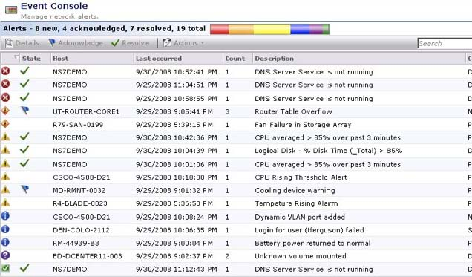

3.3.3 LANDesk (Rating: 4)
Monitoring is one of the areas where Automated Solutions Inc. needs help on. Monitoring is very important to deal with issues and prevent them before they occur and not solve them afterwards. Right now administrators have no way of knowing if a server is low on memory or a machine is reaching the Hard Drive maximum available space.
With LANDesk System Manager’s monitoring feature, Automated Solutions Inc. will be able to keep track and monitor all the software and hardware in real time and set up custom alarms if a specific asset needs to be monitored. It could track hard drive space and RAM available, monitor CPU temperatures, network bandwidth use, and much more. This will help Automated Solutions in many of their current issues by preventing them.
3.3.4 Zenith (Rating: 4)
This is where the SAAZ interface can really shine; there are many companies that use this product for server farm monitoring.

3.3.5 Kaseya (Rating: 5)
Administrators have several hundred machines to keep track of and to make sure all the components are working properly. With Kaseya’s monitoring feature administrators will be able to keep a close eye on certain hardware aspects of each machine. For example, if a hard drive is getting full or a machines memory is getting used too much.
Comparison and Discussion: Kaseya’s monitoring capabilities surpasses the rest where Altiris is the weakest of the other solutions.

 | N-able | Altiris | LANDesk | Zenith | Kaseya
Monitoring | 5 | 3 | 4 | 4 | 5
Explanation | With N-central’s “NOC View” administrators at Automated Solutions, Inc. can easily see what machines are having issues without having to navigate around in the IT automation solution. | With Altiris, administrators at Automated Solutions can help increase server and client availability. It has proactive health monitoring and remediation features which are operated centrally through an event console. | With LANDesk monitoring solution, administrators will be able to monitor the health and status of all the machines and servers in the network. Alarms can be set up to alert administrators before problems arise instead of fixing problems after they occur. | Using the SAAZ interface that is running on a separate managed computer, Monitoring can be done anywhere in the world using a web browser, this opens up many possibilities for the administrators when they need to go remote. | Kaseya enabled administrators in the data center to know when there is a hardware or network issues by setting thresholds and alerts.

3.4 Patch Management
Administrators have an extremely difficult time keeping track of patches and updates from Windows since there is no management solution in place. They tend to forget which machines have been updated as well as which ones need to be updated.
3.4.1 N-able (Rating: 2)
Automated Solutions does not have any plans to add a Windows Server Update Services (WSUS) server anytime soon so this is where using N-central for patch management is an issue. N-central doesn’t have a stand-alone patch management repository service to collect updates from Microsoft and needs to use a WSUS server. Even though N-central interoperates nicely with a WSUS server not having one completely skips over patch management automation with N-central.
So having an IT automation solution that has its own patch management service which keeps a collection of updates would be best for Automated Solutions needs.
3.4.2 Altiris
As mentioned in the Requirements Analysis Document of Automated Solutions, administrators have automatic updates set to automatic. This is due to the lack of a patch management plan. From time to time, this has caused problems at Automated Solutions because several machines run software that conflict with some Windows update.
To resolve this issue, Altiris patch management can be implemented to patch only approved machines in a very granular level. Additionally, Altiris has support to deploy updates to operating systems other than Windows. This is a feature few other solutions offer. Below is a screenshot of Altiris importing updates for Red Hat Linux Enterprise.
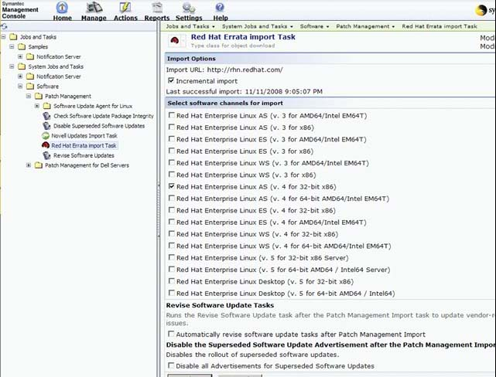

3.4.3 LANDesk (Rating: 5)
Automated Solutions Inc. has been having issues with patching and updating Windows systems because there is no Patch Management solution in place. Often is not known which machines have already been updated and to what level depending on the machines’ current software packages.
LANDesk Patch Management solution is one of LANDesk strongest points. It supports other Operating Systems like Mac and Linux besides the usual Windows which is a huge plus for Automated Solutions Inc. if they expand their systems to offer Linux web hosting. It keeps track of which machines have been updated, with which patches, and before doing applying new patches, it checks the machines’ current software to make sure there is no compatibility issues. It also alerts administrators by email or pager when new updates come out or when problems arise.
3.4.4 Zenith (Rating: 4)
A local server running the SAAZ patch management downloader and then remotely controlled by the SAAZ portal, could potentially make updates that must happen off the internet a problem. Webhosting companies sometimes get hit by exploits that need to be patched outside of the internet connection due to the nature of the situation. This would make it kind of difficult to handle this situation and would probably have to be manually patched.

3.4.5 Kaseya (Rating: 5)
With Kaseya’s patch management capabilities administrators would spend less time dealing with the frustration task of having to keep track of the patches that installed successfully, failed or pending updates. Security is key to these machines in the data center since they host customers data. Having a fast, time saving patch management solution like Kaseya would greatly improve administrator’s efficiency.

Comparison and Discussion: Both Kaseya and LANDesk get the highest rating for patch management since there are patch management tools built into the solutions. N-able on the other hand gets the lowest rating since administrators would have to install/configure a separate machine just for patch management purposes.

 | N-able | Altiris | LANDesk | Zenith | Kaseya
Patch Mgt | 2 | 4 | 5 | 4 | 5
Explanation | Administrators would have to purchase, install, configure and manage a separate WSUS server in order to use the patch management features in N-central. | Altiris patch management can be implemented to patch only approved machines in a very granular level. Additionally, Altiris has support to deploy updates to operating systems other than Windows. This is a feature few other solutions offer. | LANDesk patch management is very automated and can be customized to patch systems with new patches and updates on schedule. Before doing updates, it will check the machine’s inventory to make sure it’s applying the updates to the right system. This will help administrators by saving them time by not having to check each patch for compatibility before being deployed. | On the local side Zenith has a patch management server that just downloads the patches as per directive of the SAAZ administration server that is located in the SAAZ datacenter. This gives administrators control over a number of things, first there are certified downloads that were tested out and there are blacklisted updates that are also listed with an option to install them if you like. | Kaseya has a built-in patch management feature that will enable administrators to manage patches and upgrades without having to install/configure a separate WSUS server on the network.

3.5 Backup and Disaster Recovery
Backups are currently being performed however managing them is a difficult task for the administrators.
Currently, Automated Solutions in performing full and differential backups which is better then nothing but since the differential backups are initiated the 7th, 14th and 21st of the month there is a huge gap when data is not backed up.
3.5.1 N-able (Rating: 4)
N-central doesn’t have a proprietary backup feature but it does work very well with Backup Exec by Symantec. Unfortunately, the administrators of Automated Solutions would have to learn Backup Exec since N-central only monitor’s critical Backup Exec services. This means they would have to manage the backups with the Backup Exec GUI and then can monitor them with N-central.
3.5.2 Altiris
The backup method at Automated Solutions is causing loss of data for both administrators and end users. Also administrators are having a hard time keeping track of all the backups. Clearly, Automated Solutions needs a better approach to backup and disaster recovery.
Altiris has an add-on connector to integrate Symantec Backup Exec System (BES). Symantec Backup Exec System would alleviate Automated Solutions current pains in terms of backup and disaster recovery.
3.5.3 LANDesk (Rating: 0)
Automated Solutions Inc. has a very high need for backup and disaster recovery solutions that will help them to backup the entire web hosting customer data. LANDesk doesn’t offer any backup and disaster recovery solution so Automated Solutions Inc. will have to get a third party solution for backup which is an inconvenience to have to deal with more software.
3.5.4 Zenith
The backup solution that is provided with the Zenith Infotech is probably the best feature that it provides. This gives the capability of virtually bringing up the server that went down. Unfortunately for web hosting applications, this would not work too well due to the performance hit that the Virtual Machine server would present.
3.5.5 Kaseya (Rating: 4)
Kaseya offers a solution for backup within their offerings. It offers all the different types of backups that Automated Solutions Inc needs like full, incremental, and differential backups. Backups can be scheduled within Kaseya to the requirements noted in the Requirements Analysis Document. Another requirement that Automated Solutions has is the support of offsite backup, which Kaseya offers. Administrators will be able to backup different customer folders from the servers, as well as backing up complete images from the other workstations.

Comparison and Discussion: N-able, Altiris and Kaseya all have backup solutions, but Kaseya has better backup management features then the rest. LANDesk doesn’t have any backup solutions integrated in it.

 | N-able | Altiris | LANDesk | Zenith | Kaseya
Backup & Disaster Recovery | 4 | 4 | 0 | 4 | 4
Explanation | N-central has the ability to integrate with Backup Exec so administrators can monitor the backup services, but the administrators would have to manage Backup Exec via Backup Exec’s management console and not N-central’s | Altiris has an add-on connector to integrate Symantec Backup Exec System (BES). Symantec Backup Exec System would alleviate Automated Solutions current pains in terms of backup and disaster recovery. | LANDesk does not offer any solution for Backup and Disaster Recovery as part of their packages. | Using their own hardware product and an offsite Datacenter this will give the correct backup solution that Automated Systems is looking for. | Kaseya’s backup and disaster recovery will give administrators the ability to perform all types of backups like full, incremental, and differential. It also is able to do backups of only folders or entire Hard Drive images on both local and offsite locations.

3.6 End-Point Security
Automated Solutions does install anti-virus software and spyware protection on all machines but they currently have no way of managing those updates or monitoring the services used by those security applications.

3.6.1 N-able (Rating: 3)
N-central allows you to deploy software across the network then monitor critical services used by those different security applications. N-central works well monitoring and deploying Symantec Anti-virus, McAfee Anti-virus, Sophos, and Trend Micro. N-central can also monitor and notify administrators if a virus definition update on one of the machines has failed, succeeded or if there are additional errors.
3.6.2 Altiris
Endpoint Security at Automated Solutions has not been very effective to say the least. End users in the office constantly complain of seeing pop ups on their screens while working. Presently, antivirus is installed on all the computers but is not centrally managed.
Through its integration of Symantec Endpoint Protection, Altiris would be able to centrally manage and ensure all computers in Automated Solutions receive all the latest antivirus updates. Although Altiris only supports Symantec Endpoint Protection for its endpoint security, SEP would be a great improvement upon their present security setup.
3.6.3 LANDesk (Rating: 2)
Security threats at Automated Solutions Inc. is a constant problem because even thought all machines have antivirus software installed is not being managed from a central point. Sometimes definition updates are not done as soon as they are out and other times it has errors and the definitions are not updated.
LANDesk offers endpoint security in many levels including firewall solutions, network breach monitoring, and antivirus integration. It can keep track of which antivirus software is installed in which machines and it can then check, download and install new definitions and keep a log of errors if they occur. This helps administrators to know that all the machines are safe and secure from the most up to date threats.
3.6.4 Zenith (Rating: 3)
There really is not proper way to do penetration testing with the software provided and must be done by the administrators themselves.

3.6.5 Kaseya (Rating: 4)
Automated Solutions Inc. has workstations on all their departments where non-technical users use them. It is critical that these machines are secured and all the antivirus software is up to date with the most recent virus definitions. Kaseya offers endpoint security and installs virus software and definitions automatically, the administrators can also schedule the scans at different times so that not all the scans happen at the same time and it helps to lower the network load.

It also has a very user friendly interface where administrators can see the status of all the machines threats, virus definition’s version installed, and any scans scheduled. Alarms and alerts can also be set up to email administrators of new threats, failed definition updates, or scanning problems.

Comparison and Discussion: Kaseya has better end point security features where LANDesk has less out of all the IT solutions.

 | N-able | Altiris | LANDesk | Zenith | Kaseya
End Point Security | 3 | 3 | 2 | 3 | 4
Explanation | Administrators at Automated Solutions, Inc. can manage various types of anti-virus software. | Through its integration of Symantec Endpoint Protection, Altiris would be able to centrally manage and ensure all computers in Automated Solutions receive all the latest antivirus updates. Altiris only supports Symantec Endpoint Protection. | LANDesk endpoint security manages many types of security, from antivirus to firewall protection. It is able to monitor, scan, and update the antivirus on schedule and clean and delete threats when it finds it. This will be of great help for Automated Solutions’ department workstations. | There are several options to choose from but only 2 main virus scan vendors that are fully supported, they do offer volume discount licenses but are limited to 2 products with little support for others. | Kaseya’s Endpoint Security is able to deploy different types of antivirus software depending on the needs. Once installed it will scan machines and download new virus definitions automatically and keep the systems protected. Automated Solutions Inc. will be helped from this solution, especially on their department systems.

3.7 Users-State Management
Time and time again administrators have had to replace power supplies because they burn out from the machine being on constantly. The company’s electric bill has been getting higher over the years as new machines are added and new employees join the company.

3.7.1 N-able (Rating: 4)
N-central has a product called Remote Environment Manager which allows the administrators to control some of the power features/settings of the machines on the network. This feature could be a huge help especially for the employee machines. Automated Solutions, Inc is a 24/7 operation and each employee has his or her own computer so there are times when employees aren’t on their shift they leave their computer on. This is mostly the case for the employees’ machine in the sales, customer service and technical support department. There is no need for them to keep their machine on when they aren’t at work. By using this feature built into N-central administrators can globally or individually configure the different power options and/or even schedule them. So for instance if an employees machine is inactive for X number of minutes or hours then shutdown the machine safely or turn on the screen saver.
3.7.2 Altiris
User state management is handled via Altiris Client Management Suite. Client Management Suite is capable of deploying the most up-to-date software, and defining power scheme policies to reduce power. In addition, because of Client Management Suite (CMS) integration with Symantec Ghost Solution, CMS can deploy Windows, Mac, and Linux operating systems. CMS is not as robust as other IT solutions in what can be defined in its end user policy settings. Due to these reasons, Altiris user state management receives a rating of 3.

3.7.3 LANDesk (Rating: 3)
User State Management on LANDesk is done within their main management package. It provides solutions by setting up custom policies for all the power options of a system. From turning off monitors when idle or putting the systems in standby mode. Automated Solutions Inc. will benefit greatly from this on their office machines that are usually left on at night by employees. Assigning power policies to these machines will save a lot in electricity and also will help in security by locking systems when not in use.

3.7.4 Zenith
There was no way to truly test this for the solution provided.
3.7.5 Kaseya (Rating: 4)
Kaseya has a feature for User-State management that it will be of great help to Automated Solutions Inc. All the employee’s machines are usually left idle at night and some monitors don’t turn off and it is wasting lots of electricity. With Kaseya’s User-State management, administrators can create policies for different machines and departments so that power policies can monitor these workstations and apply the policies when the machines are idle.

Some of the features that it can monitor and adjust are turning off monitors, turning off hard drives, putting the systems in stand-by mode, and hibernate the machines. All these configurations can be customized to be applied in a certain amount of time after the machines are idle. Kaseya also prepares reports of logs of when and for how long all this configurations were in use.

Comparison and Discussion: N-able and Kaseya have several user state management features but Kaseya’s features are a better fit for Automated Solutions, Inc’s workload.

 | N-able | Altiris | LANDesk | Zenith | Kaseya
User State Mgt | 4 | 3 | 3 | ? | 4
Explanation | Administrators can use N-central’s Remote Environment Manager to manage the power settings and other user state settings. | Client Management Suite is capable of deploying the most up-to-date software, and defining power scheme policies to reduce power. In addition, because of Client Management Suite (CMS) integration with Symantec Ghost Solution, CMS can deploy Windows, Mac, and Linux operating systems. CMS is not as robust as other IT solutions in what can be defined in its end user policy settings. | LANDesk can monitor and assign power policies to machines to turn on off the monitors when idle, put systems in stand-by mode, or even hibernate them. Automated Solutions Inc. will surely get help from a solution like this. | There was no way to accurately identify the functions that are needed for Automated Solutions. | Administrators using Kaseya for User State Management are capable of setting many policies for different machines’ groups to turn off the monitors of idle systems, hard disks when not in use, and other features. This was one of the requirements of Automated Solutions Inc. and Kaseya delivers very strong in this area.

3.8 Help Desk
Administrators at Automated Solution handle the help desk tickets generated by the technical support staff but sometimes those tickets are not handled completely and/or are forgotten.

3.8.1 N-able (Rating: 3)
N-central works very well with several ticketing systems like Tigerpaw, ConnectWise, and Autotask. Again, this would mean if Automated Solutions does use N-able products they would also have to learn one of those ticketing systems as well as the Backup Exec solution.
Email alerts are standard with any of the ticketing systems mentioned above so the administrators are alerted when a new ticket or issues arises.
3.8.2 Altiris
Help desk at Automated Solutions is done in a very old fashioned manner. Automated Solutions does not make use of any modern features to improve its help desk.
Altiris Helpdesk Solution can help Automated Solutions move in the right direction in terms of help desk and reducing costs. Helpdesk solution can automatically assign and escalate tickets to the proper help desk technicians. It also integrates easily with other data sources, including Microsoft Active Directory.
3.8.3 LANDesk (Rating: 3)
Automated Solutions Inc. current help desk functions and features are not up to the level that it should be to be efficient. Help desk tickets are hard to keep track of and update, and there is not feature to add solutions to past problems to a FAQs or solutions center.
LANDesk Service Desk will help tremendously in this by providing more features like a web based portal where tickets can be entered and updated. It can dynamically search for solutions and advice as incident, call, problem and change information is populated. You control and configure how results are displayed. And knowledge is automatically captured to ensure that the latest, most pertinent information is accessible with the least impact on resources. It also integrates with leading desktop management tools and toolsets, including LANDesk management solutions as well as Microsoft Active Directory, Novell eDirectory and Touchpaper ActiveAssistance.
3.8.4 Zenith (Rating: 4)
This has to be the most in depth solution that any of the IT Automation solutions have presented. Not only does Zenith Infotech have training courses and a helpdesk, they also offer level 1 helpdesk services for small to medium sized businesses.

3.8.5 Kaseya (Rating: 3)
Automated Solutions Inc. has many customers with their web hosting business, as well as employees that many times need technical help from the administrators with problems with their workstations. Having a help desk ticketing system will help administrators tremendously by prioritizing requests and dealing with problems in a timely and efficient manner. With Kaseya’s ticketing system, administrators will be able to keep track of all the tickets in a very user friendly interface and see the status or any chances from one main window. Alerts can also be configured to alert administrators when new tickets are opened or when tickets change priority.
Another great feature is the ability to save and archive the solutions to past issues so that when the same problem happens again in the future, the answer will be there already. Or a FAQ or knowledge center can be setup with answers so that users can get help themselves before opening tickets.

Comparison and Discussion: All of the solutions basically scored the same for HelpDesk and they are all similar in many ways.

 | N-able | Altiris | LANDesk | Zenith | Kaseya
HelpDesk | 3 | 3 | 3 | 4 | 3
Explanation | Administrators would have to install and learn a separate ticketing system since N-central doesn’t have it’s own. | Helpdesk solution can automatically assign and escalate tickets to the proper help desk technicians. It also integrates easily with other data sources, including Microsoft Active Directory. | LANDesk ticket system is full of features to find and filter tickets, viewing them in a very user friendly interface either on the main console or in a web interface where tickets can be opened or modified. | This will be adequate for the needs at hand. | Kaseya’s HelpDesk solution is very easy to use. Administrators will be able to filter tickets by status easily, set up alerts when new tickets are opened or modified, and also will be able to search for answers to past tickets and archive them for future references.

3.9 Usability
Administrators at Automated Solutions are in the need of a automation solution that is accessible remotely via a website. This is important incase there is a high priority or critical issues in the data center and the administrator might no be physically at the data center and my need to remotely access the servers.
3.9.1 N-able (Rating: 4)
N-centrals interface is extremely easy to use and has many help section to guide them in the right direction incase they are stuck.
Different dashboards can be setup for each subset of machines in the data center so the administrators can easily tell which servers and how many are connected and online. For example, Automated Solutions has several Exchange servers that need to be monitored and they have hired an administrator to manage them. N-central can be configured in a way that when that Exchange administrator logs into the N-central web-based interface only the exchange server show up. This is a great way to delegate control to certain administrators.
3.9.2 Altiris
The need for a stable and reliable IT automated solution is of the utmost importance to Automated Solutions. Their present network infrastructure has given them too many problems and too much pain.
The look and feel of the user interface is very inviting and friendly with its use of pictures and wizards. Nevertheless, the interface cannot be altered in any way and at times some settings can be hidden under many sub menus.
3.9.3 LANDesk (Rating: 4)
Having a reliable infrastructure and knowing you can depend on it to be stable is a high priority to Automated Solutions Inc.
LANDesk could provide that level of assurance. LANDesk will be very familiar to current users and easy to use because it resembles most popular software in that it has tree-view sections, explorer like folders and menus, and wizards for many of the features.
3.9.4 Zenith (Rating: 4)
The SAAZ administration interface with its Dashboard feature can greatly help administrators with superior network overview monitoring along with functions to zoom in on certain servers, with its alert system and ticketing views, solving these issues is simple.

3.9.5 Kaseya (Rating: 5)
The main administration interface has intuitive tabs and other navigation functions that make it easy to navigate.

Comparison and Discussion: N-able and LANDesk are the strongest in this category but Altiris’s features aren’t as useful to the administrators.

 | N-able | Altiris | LANDesk | Zenith | Kaseya
Usability | 4 | 3 | 4 | 4 | 5
Explanation | Administrators will be able to customize the look & feel of N-central’s interface for other employees at Automated Solutions, Inc. | The look and feel of the user interface is very inviting and friendly with its use of pictures and wizards. Nevertheless, the interface cannot be altered in any way and at times some settings can be hidden under many sub menus. | The user interface of LANDesk main console is very easy to use and learn. It resembles a windows explorer application with tree-view sections, button and drop down boxes so that the users are familiar with doing all the functions. | The user interface is customizable and has a dashboard function that is easy to get to the critical functions that is needed. | With an excellent login the user interface here shows the best that is needed for solving Automated Solutions issues with both the Servers and desktops.

3.10 Reliability
As mentioned previously, the SLA at Automated Solutions is critical making sure customers are satisfied and there is no downtime.

3.10.1 N-able (Rating: 4)
Employee’s machines as well as the customers hosting machines in the data center would run much better using N-central because of the vast number of monitoring features and capabilities

3.10.2 Altiris
Reliability is something that needs to be consistent throughout any organization. In the case of Automated Solutions reliability is extremely crucial. Being a web hosting company, clients expect a high level of availability.
Altiris can be used in order to meet such high standards. Altiris’s web based interface is efficient, stable, and highly available. Total Management Suite integration with heavily utilized IT products such as Symantec Endpoint Protection and Symantec Backup Exec System make it a vastly reliable IT automation solution.
3.10.3 LANDesk (Rating: 3)
Even with so many features, LANDesk is still very reliable. Automated Solutions Inc. servers and network infrastructure will be helped a lot by integrating so many things into one solution; it will lessen the issues of software compatibility.
3.10.4 Zenith
Having a dedicated datacenter that is run by Zenith InfoTech themselves, reliability is a key factor here. This leaves a lot of computing power in a separate location for the monitoring and management of the datacenter. If a catastrophic failure happens at the datacenter, all the information on server configurations and HD space are all stored elsewhere. Rebuilding from a great loss could me massively easier.

3.10.5 Kaseya
Using a web browser for management controls and the client application comes with remote control software, the reliability not only comes in the interface but with the rigid requirements for hardware too. There are several plans put into place for topologies that discuss support for clients that it presents. The reliability that Kaseya presents is worth a full 5.

Comparison and Discussion: N-able and Altiris are the strongest in this category but LANDesk’s features aren’t as reliable to the administrators.

 | N-able | Altiris | LANDesk | Zenith | Kaseya
Reliability | 4 | 4 | 3 | 4 | 5
Explanation | With N-central’s monitoring capabilities administrators would be on top of server and network issues. | Altiris’s web based interface is efficient, stable, and highly available. Total Management Suite integration with heavily utilized IT products such as Symantec Endpoint Protection and Symantec Backup Exec System make it a vastly reliable IT automation solution. | LANDesk integrates many solutions into one package and even with all those features it is very stable and reliable. | The web brower service combined with the many functions and hardware design is great for the job at hand. | Web browser management will work best for the needs at hand.

3.11 Performance
Both the servers and employees office machines need to be up-to-date with anti-virus and spyware to ensure optimal security. Also, network performance in a hosting company is a huge area that needs to be monitored closely.

3.11.1 N-able (Rating: 3)
N-central allows administrators to keep track of the updates as well as monitor the anti-virus processes. N-central also allows administrators to keep track of routers, switches and other network devices for network connectivity issues as well as latency issues.
3.11.2 Altiris
Again being a web hosting company, the performance of Automated Solutions web servers and network in general must be at very high level.
In terms of performance, Altiris can help ensure performance by proactively monitoring systems, updating systems with the latest software and operating system updates, and having a means to provide an adequate backup and disaster recovery plan for Automated Solutions.
3.11.3 LANDesk (Rating: 4)
Having so many servers and so much critical data on them of our customers is very delicate business. Automated Solutions Inc. can’t afford to have performance issues when customers depend on them.
LANDesk performance is up to par to most automated solutions with similar number of features integrated into one console and software. It offers performance in both it is desktop console as well as its web based interface portal. Performance issues will be a rare occurrence with LANDesk set of solutions.
3.11.4 Zenith (Rating: 4)
With webhosting on the mind, Zenith performs great with its off site main server being maintained by Zenith InfoTech. This frees up any local server being heavily bogged down and can give performance reviews to anybody around the world that has access to login to the SAAZ management interface. The client side of things barely takes up any space allowing the software to function well with the OS that it is installed on.

3.11.5 Kaseya (Rating: 5)
Kaseya provides the best functionality that is needed for the task at hand.

Comparison and Discussion: Altiris and LANDesk are the strongest in this category but N-able’s features aren’t as useful to the administrators.

 | N-able | Altiris | LANDesk | Zenith | Kaseya
Performance | 3 | 4 | 4 | 4 | 5
Explanation | Performance of the machines/servers on the network would be better with N-central because of the hardware and network monitoring. | Altiris can help ensure performance by proactively monitoring systems, updating systems with the latest software and operating system updates, and having a means to provide an adequate backup and disaster recovery plan for Automated Solutions. | Performance on Automated Solutions Inc. servers and machines won’t be compromised by using LANDesk automation solutions. LANDesk is design to perform at its best even when working with many machines at a time. | Unfortunately with the offsite nature of the SAAZ server, if the internet connection goes down, it is impossible to successfully manage the servers at hand. | Performance will provide the best solution that is needed.

3.12 Supportability
All of the machines at Automated Solutions, Inc. are Microsoft Windows based. Currently, there are no plans on expanding to other platforms.

3.12.1 N-able (Rating: 3)
N-central works with all of the flavors of Windows as well as other incase future platforms are added to the network.
N-central’s interface is also fully customizable and brandable so when employees log into the N-central interface they will feel safe and secure.
3.12.2 Altiris
Altiris support for multiple operating systems is important for the future growth of Automated Solutions. As stated in the Requirements Analysis Document, Automated Solutions may support Linux hosting in the near future.
The remote control capabilities in Altiris allow administrators to give a high level of support to their end users. Altiris common interface amongst all their products and Symantec products make it extremely useful towards the Altiris implementation in an organization such as Automated Solutions.
3.12.3 LANDesk (Rating: 4)
LANDesk ability to support so many different Operating Systems will be a great advantage for Automated Solutions Inc. in the future when the point comes when they want to expand and offer Linux web hosting. They won’t need to worry about adding any other automation solution since administrators and management will know that LANDesk will be there to offer them support in that area when the need arise.
3.12.4 Zenith (Rating: 4)
Zenith InfoTech has several methods of support ranging from a helpdesk for phone help, to forums and a knowledge base. The forums are community based and monitored by Zenith. Zenith InfoTech is a channel provider and is supporting the reseller not the actual end client.

3.12.5 Kaseya (Rating: 5)
Supportability of Kaseya and its integrated solutions give Automated Solutions the best choice here. Helpdesk functions combine with inventory database offering the support desk a view of both the user rights and the hardware software installed on the system. Remote control functions allow a lot of control combined with its chat interface.

Comparison and Discussion: Altiris and LANDesk are the strongest in this category but N-able’s features aren’t as useful to the administrators.

 | N-able | Altiris | LANDesk | Zenith | Kaseya
Supportability | 3 | 4 | 4 | 5 | 5
Explanation | N-central works well with Windows-based machines throughout the network at Automated Solutions, Inc. | The remote control capabilities in Altiris allow administrators to give a high level of support to their end users. Altiris common interface amongst all their products and Symantec products make it extremely useful towards the Altiris implementation in an organization such as Automated Solutions. | LANDesk has a wide range of system that support. From windows based systems, to Macintosh operating systems, to even Linux and handhelds devices. The support for all these different technologies is strong and LANDesk techs are always there if questions arise. | With the combination services, hardware, and software, Zenith can easily deliver the service level and give the administrators the supportability that they need. With the offsite SAAZ admin panel and the ease of use in installing the client, administrators can focus on other more important issues than worrying about an additional server. | Kaseya seems to really work well with this ISP environment while providing functionality for the office too. The helpdesk and interface for Kaseya can easily handle a top down approach and keep the separation that is needed for the workstations and the servers.

3.13 Summary of the Rating and Selecting a Solution
After rating all of the solutions, Kaseya seems to be the best IT automation solution to fit Automated Solutions, Inc’s work environment. Remote control, patch management and monitoring are very important factors that Kaseya scored highly on.

RAD-Based Comparison Rating System Table

 | N-able | Altiris | LANDesk | Zenith | Kaseya
Remote Control | 5 | 5 | 5 | 5 | 5
Audit & Asset Management | 4 | 2 | 5 | 4 | 5
Monitoring | 5 | 3 | 4 | 4 | 5
Patch Management | 2 | 4 | 5 | 4 | 5
Backup & Disaster Recovery | 4 | 4 | 0 | 4 | 4
Endpoint Security | 3 | 3 | 2 | 3 | 4
User State Management | 4 | 3 | 3 | 2 | 4
Help Desk | 3 | 3 | 3 | 5 | 3
Usability | 4 | 3 | 4 | 5 | 5
Reliability | 4 | 4 | 3 | 4 | 5
Performance | 3 | 4 | 4 | ? | 5
Supportability | 3 | 4 | 4 | 5 | 5
Availability | 3 | 3 | 3 | 5 | 5
Learning Curve | 4 | 4 | 4 | 5 | 4
Price | 3 | 2 | 3 | 4 | 5
Total | 54 | 51 | 52 | 59 | 69

Altiris Acknowledgements: The Altiris screenshots shown throughout section three were taken from Symantec’s website and the exact links can be found in the references section of this document. I would like to thank Derek Allred. Derek is a Symantec sales representative who covers our region. Derek provided me with some valuable input towards my research and directed me to trial versions of Altiris software.
4. Glossary
IT | Information Technology
Administrators | Employees that are in charge of managing and administering the servers.
MSP | Managed Service Provider
SUSE | One of the many Linux operating system distributions
VNC | Virtual Network Computing – allows administrators to remotely connect to machines.
SSH | Secure Shell – another method for the administrators to remotely connect to a machine.
FTP | File Transfer Protocol – method of transferring files from a local to remote machine.
CPU | Central Processing Unit – the brain of a computer
NOC | Network Operations Center – centralized area of a company where administrators monitor the network and operations.
BES | Symantec Backup Exec System
SSL | Secure Socket Layer
SAAZ | The main driving force of the Zenith Infotech Managed Service Infrastructure

5. References
LANDesk
http://www.landesk.com/Corporate/Information/History.aspx [1]
http://www.landesk.com/Corporate/Information/Index.aspx [2]
http://www.landesk.com/AboutLANDesk/Default.aspx?id=236 [3]
http://it.usu.edu/landesk/ [4]
http://www.appdeploy.com/reviews/sw_landesk_8.0_p3.asp [5]
http://www.landesk.com/remote-control-software.aspx [6]
http://www.landesk.com/uploadedFiles/ds_ALM_en-A4.pdf [7]
http://www.ldms.com/Products/LANDesk/landesk_inventory_manager.htm [8]
http://www.landesk.com/SolutionServices/product.aspx?id=1448 [9]
http://www.landesk.com/WorkArea/downloadasset.aspx?id=4473 [10]
http://www.networkcomputing.com/channels/security/showArticle.jhtml?articleID=207603221 [11]
http://www.landesk.com/WorkArea/downloadasset.aspx?id=4467 [12]
http://www.landesk.com/SolutionServices/product.aspx?id=978 [13]
http://www.ldms.com/Products/landesk/landesk_security_suite.htm [14]
http://www.networkd.com/landeskservicedesk_features.html [15]

Zenith Infotech
"532298 - Zenith Infotech Ltd. - Finance." Google. 09 Apr. 2009 <http://www.google.com/finance?q=BOM:532298>.

Zenith Infotech Inc. Leading The Way In Managed Services. Brochure. Author. Zenith Infotech. 9 Apr. 2009 <http://www.zenithinfotech.com/v8msp_Sgls_Low_Res.pdf>.

Zenith Infotech Inc. Backup and Disaster Recovery Solutions. Brochure. Author. Backup and Disaster Recovery Solutions. Zenith Infotech. 9 Apr. 2009 <http://www.zenithinfotech.com/BDR_lo_sgls.pdf>.

Zenith ARCA Overview. Brochure. Zenith ARCA Advanced Recovery Appliance. Zenith Infotech. 9 Apr. 2009 <http://www.zenitharca.com/marketing/Zenith_ARCA_Overview(for_web).pdf>.

"Report for Computer Resources." Computing and Web Resources. 09 Apr. 2009 <http://cru.cahe.wsu.edu/WebLog/cru/index.htm>.

Kaseya
http://help.kaseya.com/WebHelp/en-US/kes/2000000/index.htm?toc.htm?2939.htm (Security Tab) [1]
http://help.kaseya.com/WebHelp/en-US/kes/2000000/index.htm?toc.htm?2939.htm (Security Status) [2]
http://it.kaseya.com/solutions/it_asset_management.aspx [3]
http://it.kaseya.com/solutions/performance_monitoring.aspx. [4]
http://it.kaseya.com/solutions/service_desk_help_desk.aspx. [5]
http://www.kaseya.com/products/pc-remote-control.aspx [6]
http://www.kaseya.com/products/patch-management.aspx. [7]
http://www.indeed.com/cmp/Kaseya. [8]
http://www.kaseya.com/products/cross-platform.aspx [9]

N-able
http://n-able.com/about/corp_background.php/ [1]
http://n-able.com/about/ [2]

Altiris
http://www.symantec.com/business/service-asset-management-suite. [1]
http://www.symantec.com/business/client-management-suite. [2]
http://www.symantec.com/business/inventory-solution. [3]
http://www.symantec.com/business/helpdesk-solution. [4]
http://www.symantec.com/business/total-management-suite. [5]
http://en.wikipedia.org/wiki/Altiris. [6]
http://www2.altiris.com/company/history/index.asp. [7]
http://www.symantec.com/business/products/sysreq.jsp?pcid=pcat_infrastruct_op&pvid=helpdesk_sol_1. [8]
http://www.symantec.com/business/client-management-suite [9]
http://www.symantec.com/business/service-asset-management-suite. [10]
http://www.symantec.com/business/server-management-suite. [11]
http://www.symantec.com/business/client-management-suite. [12]
http://www.symantec.com/business/backup-exec-for-windows-servers. [13]
http://www.symantec.com/business/products/family.jsp?familyid=endpointsecurity [14]
http://www.symantec.com/business/helpdesk-solution. [15]
http://www.symantec.com/norton/symantec-pcanywhere. [16]
http://en.wikipedia.org/wiki/Altiris. [17]

