08
Fall

1. Introduction
Advisor: Dr. S. Masoud Sadjadi - School of Computing and Information Sciences - Florida International University
Contact Information: sadjadi@cs.fiu.edu
More information: http://www.cs.fiu.edu/~sadjadi 04/07/09
cccccfffffffs

Developed by:
Project Manager: Seijiro Ikeda
Johann Padron
Steven King
Krysta Riefkohl
Asher Shlactman
Luis Mendieta
Edward Selgas

System Design Document for IT Management and Automation of North Miami Beach Senior High School

1.1 Purpose of the system
The purpose of this implementation is to mitigate the main issues that reside in our current infrastructure at North Miami Beach high school. Our infrastructure has been affected for a variety of issues such as network outage, inconsistent system performance, data loss, and inappropriate user permission management. Therefore, the following goals have been forecasted to be the main priority of this project in order to address the failures mentioned above.

1. Efficient backup and recovery
2. Centralized user management
3. Monitoring and auditing
4. Reliable endpoint security
5. Software deployments and scripting
6. Help desk and ticketing
7. Patch management

In addition to these goals, which cover most of the functional aspects of our network, we have to ensure that the non-functional factors of our infrastructure are present in order to enjoy of the full advantages of the upgrade, these are included but not limited to: usability, reliability, performance and supportability.
1.2 Audience of this document

The audience of this System Design Document would be the Administrators, which would be the Principal and Assistance Principal and the On-side technicians of North Miami Beach Senior High School. The IT Administrator would be responsible for the implementation of the solution.

1.3 Design goals
Our design goals established on this project have been focused in the implementation of a centralized system which is going to manage all aspects related to management as well as security and back-up. After many software trials and testing, we came to the conclusion that at the time of deployment, it must be ensured that all the environment issues have to be addressed by a total management suite that is going to able to increase productivity as well as reduce cost and network downtime.

2. State-Of-The-Art IT Management and Automation Solutions
  - LANdesk Management Suite & Security Suite Solution w/ Management Gateway
Overview:

LANDesk offers a multi-tier solution for network automation, control, and security. The automation occurs through two products primarily, Management Suite and Security Suite. Management Suite offers the ability for a secure management interface over the Internet, manages software licenses, and improved software package distribution to client machines. Along with that it offers profile migration making it easier to migrate from one OS to another, integrated remote control, inventory asset management, multiple device support for handhelds, desktops, and laptops across multiple platforms, also showing off support for Intel vPro Support. Security Suite offers excellent endpoint protection. Management is also available over the Internet, this suite offers multiple protection levels. It uses Advance Vulnerability Detection, looking for areas of your network that are open for attack. Industry standard Host Intrusion Prevention, it integrates well with the patch management feature offered in management suite to offer excellent enforcement of policies for all machines on your network.

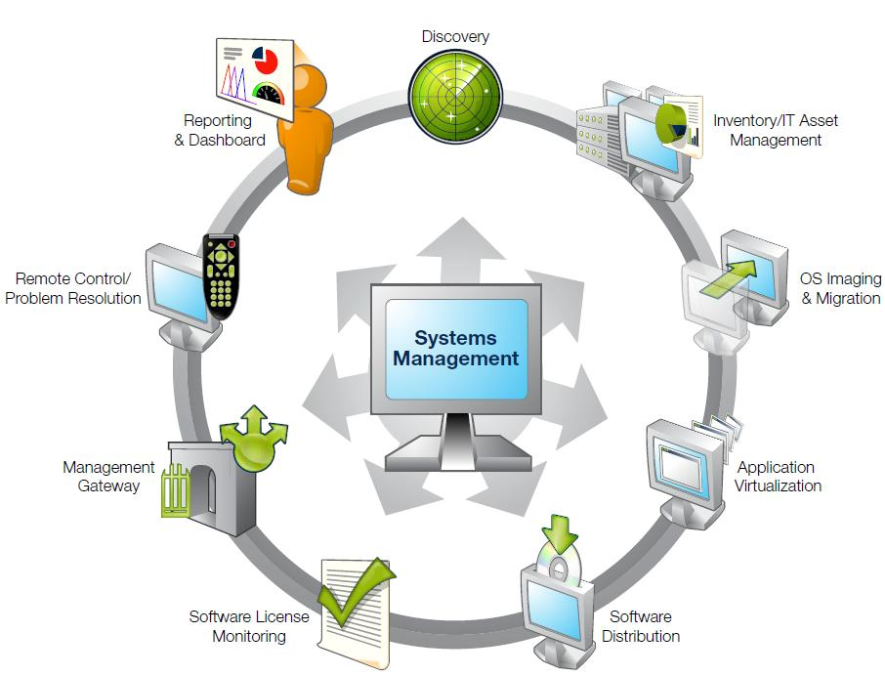

Background:
Originally founded in 1985 as LAN Systems, LANDesk was acquired by Intel Corporation in 1991. In 2002, LANDesk was established as a standalone company. Then, in 2006, LANDesk was acquired by Avocent. The foundation for LANDesk’s leading IT management solutions was laid more than 20 years ago. And LANDesk has been growing and innovating the systems, security, service and process management spaces ever since. Our singular focus and our commitment to understanding customers’ real business needs—and to delivering easy-to-use solutions for those needs—are just a few of the reasons we continue to grow and expand.

LANDesk pioneered the desktop management category back in 1993. That same year, IDC named LANDesk the category leader. And LANDesk has continued to lead the systems configuration space: pioneering virtual IT technology in 1999, revolutionizing large-packet distribution with LANDesk® Targeted Multicast™ technology and LANDesk® Peer Download™ technology in 2001, and delivering secure systems management over the Internet and hardware-independent network access control capabilities with LANDesk® Management Gateway and LANDesk® Trusted Access™ Technology in 2005.

In 2006, LANDesk added process management technologies to its product line and began integrating the systems, security and process management markets. LANDesk also extended into the consolidated service desk market with LANDesk® Service Desk, and was acquired by Avocent to operate as an independent division.
Today, LANDesk continues to lead the convergence of the systems, security, process and service management markets. And our executives, engineers and other professionals work tirelessly to deliver leading solutions to markets around the globe.
(This part was taken directly from LANDesk website)

Functional Coverage:

The LANDesk solution on the systems is managed via an agent client that sits on the client machines. The solution is a cross-platform covering Windows, Mac OS, and Linux based operating systems. The agent client is installed on any computer running one of these operating system, mobile devices however are limited in management and are not agent controlled.

Grouping Managed Devices:

LANDesk can manage typical systems such as laptops and desktops, along with mobile devices. Along with what devices it can cover it can manage systems locally or remotely anywhere where the device has a connection to the internet back to the management server. It also allows for multiple methods for grouping and filtering managed systems. It can manage and group systems based on what subnet they are in or a user defined group, which the administrator(s) would setup and move computers into the group. You can also define group and filtering based on the roles of the machine: server, clients, share drives, special such as software that runs off of them shared over the network.

    - Remote Control

LANDesk Management Suite offers a centralized console based remote control system. Which connection is secure over you network and has the ability to be very robust in low-bandwidth or dial up situations. Because of the simplified and full encompassed audit trail, you know what has been done already and what needs to be done and it can mean quicker resolution times.
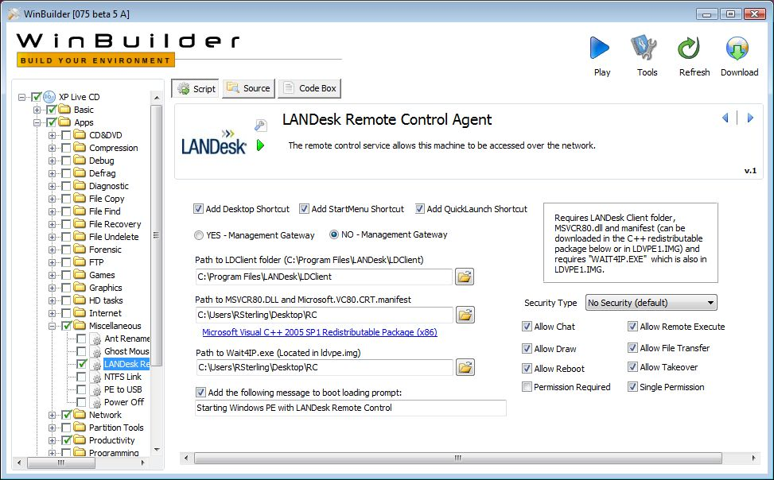

    - Auditing & Asset management

LANDesk Management Suite offers a scalable asset management option with this software package. Reports are offered in multiple formats such as doc, pdf, html, xls, and rtf. It allows for discovery of inventory even if it is unmanaged and offers easy integration into planning upgrades. Multiple features across this suite make auditing and reports easier to poll and to produce and read.
    - Monitoring

Management Suite in coupling with Security Suite offer the best monitoring possible. Management Suite offers Software License Monitoring, through this tool you can prevent users even while offline or if they change the program's name from running or even being installed. You can also manage the licenses to your software, and generate reports to audit your machines. You have the option of also logging though the Internet. This offers a secure connection method through the software to provide you a secure method without having the added cost of dedicated lines and the security loop hole of a VPN opening ports on the firewall. Remote users can be managed through the Internet as well. The Security Suite offers strict monitoring of your network and individual client computers security state.
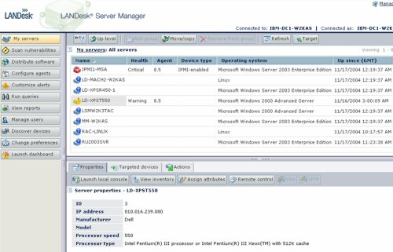

2.1.4 Patch Management

Security Suite offers Patch management as part of a regular security standard. Using policy standards, all client machines are issued policies, which are continuously checked to make sure all clients are in the policy and compliant. If a machine is not compliant, it brings it back into sync. The patch management feature offers details on new patches and what vulnerabilities it might cause and what dependencies it might need including their vulnerabilities. Custom packages may also be built depending on your organization structure and can be protected from unintentional or malicious tampering with MD5 hashing algorithm encryption. Obsolete or older patches still remain available, but are removed from distribution for a faster up-to-date patch process. The patch management feature can handle the OS and additional software.
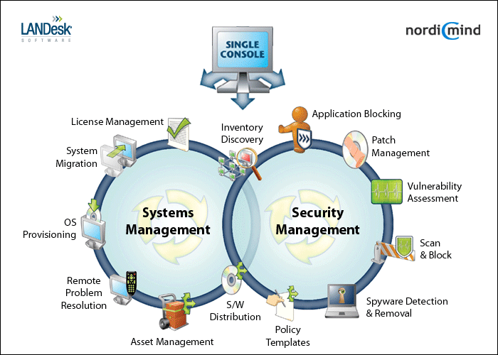

2.1.5 Backup & Disaster Recovery

The LANDesk Management Gateway offers an Enterprise level product that Includes automatic redundant backups to ensure configuration and log information is always available. The hardware uses two redundant disks to ensure the data backup and in case of a disk failure on one of the drives.

2.1.6 Endpoint Security

LANDesk's Endpoint Solution is called LANDesk Security Suite. The product key features offer IT professionals a list of critical tools and abilities in the security of their network. It allows IT Administrators the ability to manage over the Internet, Security Suite has Advanced Vulnerability Detection. This feature identifies possible areas that are compromised including non-compliant machines. When this happens, it brings the client computer back into sync with the security policies. Further to that it offers a zero day protection feature built into the AV client. This feature has the AV look for behavior typical of malicious code and/or software to prevent and limit damage to system(s). It also employs Host Intrusion Prevention, and as stated earlier its security policy abilities focus on Antivirus and Firewall enforcement. The firewall feature also allows freeing resources from a client machine and having one point for a firewall rather than managing multiple machines firewall policies.
2.1.7 User State Management

The Management Suite's Enterprise Scalability features allow administrators the ability to take repetitive tasks such as migrating users, creating new users, and other tasks related to this field and make them automated via scripts and better console management through LANDesk.
2.1.8 Help Desk

The Help Desk aspect is handled by the integration of detailed auditing tools and various other administrators’ tools through LANDesk Management software and Security Suite. Also for all computers that are Intel vPro compatible offer the ability for out-of-band discovery, remote heal ability despite of the OS that is loaded or whatever state the system is currently in.
2.1.9 Usability

LANDesk products Management Suite, Security Suite, and Management Gateway offer very user friendly GUI for configuration and management. Obtaining Audits and Reports from the products were easy to run and to read after they were compiled. Setup was straight forward and the use and configuration was the same. In my opinion an entry level IT Administrator would be able to learn how to use the product to its full potential and makes it easy for end-users productivity.

2.1.10 Reliability

The LANDesk products used proved to be very reliable. The management suite and security suite did not crash and neither did the agent sitting on the managed machines. The policies and processes set up were enforced and carried out over the network without a problem. All machines were always in compliance.

2.1.11 Performance

Management Suite and Security Suite did not impact client or server machines greatly in resources to run and maintain running. Program responded and deployed patches, polices, and software in a quick turnaround time. Compared to features offered products installed performed up to par. All products are fairly easy to use and configure making it an efficient IT automation suite.

2.1.12 Supportability

LANDesk can be deployed to manage mobile devices, desktops, and laptops. The software can go across multiple platforms such as Windows, Linux, and Mac. The use of the security suite and management suite integrate well to manage cross platform networks.

  - Windows 2003 Server

Overview/Background:

Windows 2003 Server is found in most companies and businesses today. Many companies or businesses are reluctant to update to Server 2008 as a result of compatibility. Microsoft released Windows 2003 Server in April 2003. Microsoft itself has been around since the mid 1980’s. Server 2003 currently has four flavors: Standard Edition, Enterprise Edition, Datacenter Edition and Web Edition. What makes these flavors different from one another is the hardware it can support. One might be able to support 64 bit processing vs. 32 bit processing, one might be able to support up to 4GB memory vs. 64GB of memory and different types of processing. Most companies and businesses already have a server 2003 in place but for those who don’t and have a server available can purchase 2003 server from $999 (Standard Edition) to $3,999 (Enterprise Edition). Though it is not web based, it can be remote into from any location via the remote desktop program. The reality is that technicians tend to overlook the power of the operating system and look for third party solutions. These solutions though user friendly are expensive and time consuming. Not everyone is Microsoft certified, but with a little knowledge you can save your company plenty of time and money and take advantage of what the server operating system has to offer. That is why I think this is a very good solution for most.

Functional Coverage:

Server 2003 supports all Microsoft Windows NT (2000/XP) workstations. It mildly supports Apple computers and does not at all support Linux machines. Microsoft Windows NT machines can be completely managed and monitored by Server 2003. Server 2003 does not use an agent or a probe to manage or monitor its workstations. The only underlying technology is that the computers are added to the domain on that server.

Grouping Managed Devices:

The only pre-requisite to manage the desktop computers, laptops, and servers as far as Windows Server 2003 is concerned is that the machines need to be added to the domain. This can be performed remotely via a script to all the machines in the network. Once on the domain, Active Directory can manage these computers and put them in specific containers to facilitate managing.

2.2.1 Remote Control:

Remote Control is not a problem because all NT machines (Windows XP/2000) have remote desktop capabilities. As long as the remote desktop option is checked, you can remote desktop to any machine in your network assuming you are the administrator to your machines. You can perform file transfers via the remote computers RUN command. You can also use MMC (Microsoft Management Console) on your server for instance and add the remote desktops snap in. This will allow you to add all the workstations in your network to the mmc console saving you the hassle of having to remember all the computer names in a very organized fashion.
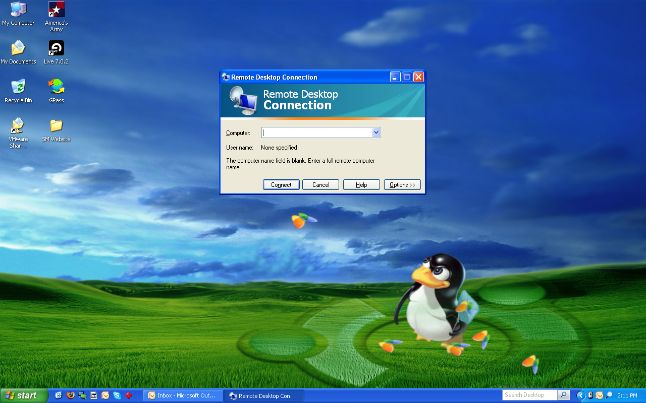
The following picture depicts the Remote Desktop application native to all NT workstations. This application allows the ability to remotely control any computer in your network.

2.2.2 Auditing & Asset Management:

With active directory, you have the ability to manage computers remotely. You can pull generic information such as the remote computers operating system, logs, alerts, devices and services to name a few. You can also perform remote tasks such as disk defragmentation and disk management. These tasks are the same as if you were managing the computer locally but are performed remotely on the server. For advanced auditing you can set up scripts to pull custom information from all the workstations in your network. Though auditing is not one it it’s powerful features, someone with script knowledge could get a decent amount of information about their machines.

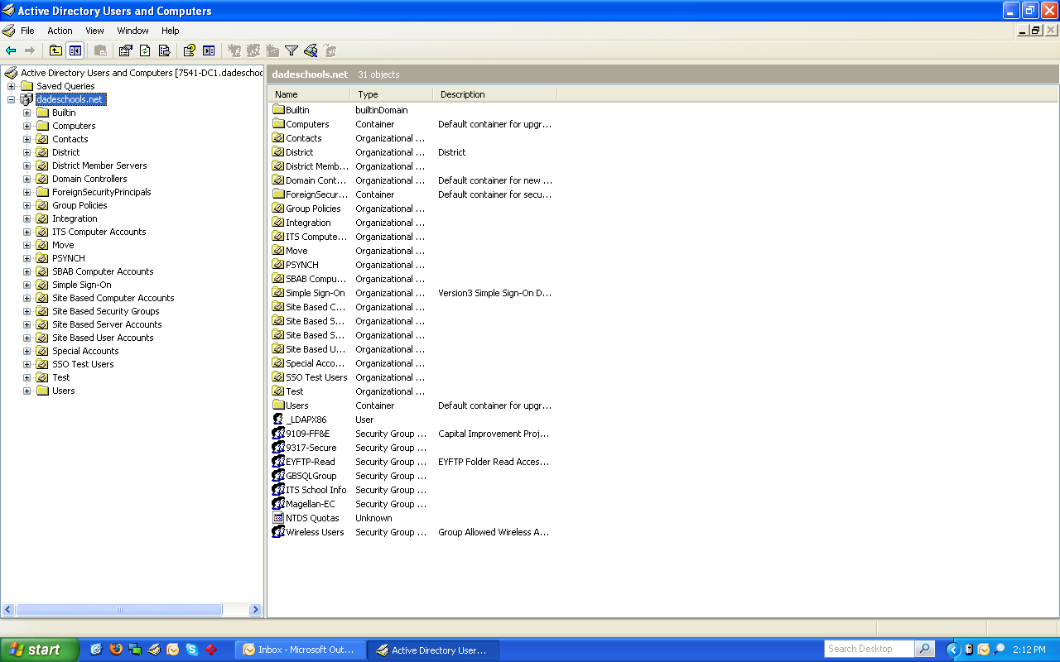
The following picture depicts the Active Directory application native to all servers. This application allows the ability to manage the users and groups in your network.

2.2.3 Monitoring:

Windows has built in logs and alerts located in the computer management section. With active directory you can access these logs and alerts remotely and monitor the machines from the server. In addition you can create specific scripts, deployed from group policies that can monitor these logs and alerts for you and use them to retrieve specific application, internet explorer, security and system information as well as warning and error logs. Though monitoring is not one it it’s powerful features, someone with script knowledge could get a decent amount of monitoring about their machines.

2.2.4 Patch Management:

WSUS (Windows Server Update Services) allows a technician to pull down Microsoft updates from the Microsoft server down to the local server. Once the windows updates are downloaded, they can be pushed to all the computers in the network. Though computers have the ability of performing windows updates automatically, using WSUS can conserve network traffic allowing the internet to be used more efficiently. By eliminating all the machines on the network from pulling updates from Microsoft, you are now dedicating only one machine for the task. Another great reason to use WSUS is that you can delegate which updates to push to your computers. Some updates may not be appropriate or even necessary for your network. MSI (Microsoft Installer) packages can be used to deploy software remotely. You can create MSI packages of any programs or set of programs and have them pushed via group policies to all the computers in your network from the server. Creating MSI packages is really easy and convenient enough to keep all the software in your network up to date. You can push as many software packages as you want to any number of computer in your network.

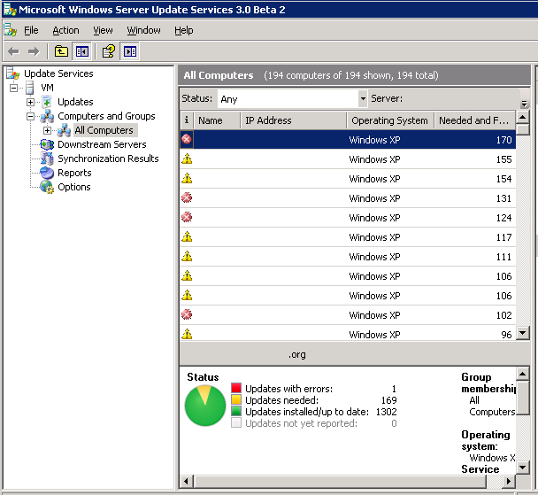
The following picture depicts the WSUS application. This application allows the ability to push patches to all the computers in your network.

2.2.5 Backup & Disaster Recovery:

As far as the hardware of that server is concerned, you can make sure to purchase a server with dual power supplies and a minimum of three hard drives for a RAID 5 configuration for redundancy. As far as the computers on the network, you can have all the profiles in the network roaming and located on the server so that if any of the computers were to fail, the user would not suffer the loss of his or her files. Windows 2003 server has an NT backup application that will back up the server. You can use this application to backup to DVD’s and image based files. With this program you have the ability to backup or restore, choose which files specifically you want backed up, choose the type of media to back up too, choose type of backup example incremental, differential, or daily and schedule your backup. Though this may not cover the computers in the network, at least it will cover the end user’s files.
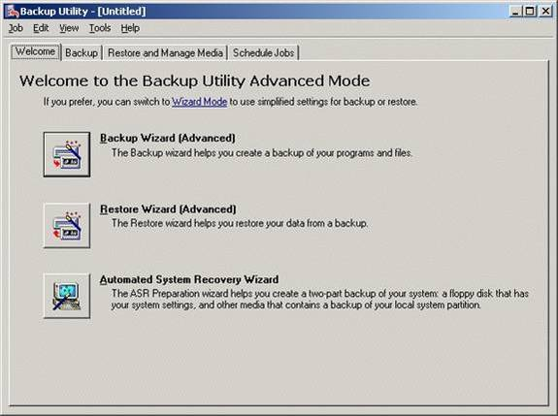
The following picture depicts the NT Backup application native to all servers. This application allows you to backup your server with great ease.

2.2.6 Endpoint Security:

One of the most exiting features of Windows 2003 server in my opinion is group policy in active directory. You can assign group policies to both users and computers in your network. Applying a policy to a computer forces that policy on that computer no matter what user is logged into that computer. Applying a policy to a user forces that policy on a user no matter what computer that user is logged into. With active directory, you can limit both what computer that user can log into, or what time that user can log in. In addition, with group policies, you can apply a policy from as simple as removing the ability to access the C drive, to as intense as locking the machine so tight that it can only be used to access the web and perform standard word processing. As far as antivirus, you will need to rely on a free anti-virus such as AVG. With MSI packaging, you can push this program to all the computers on the network. One thing to keep in mind, if policies are aggressively enforced and a powerful firewall is in place, it will be less likely that you will receive a virus on any of the computers in the network.
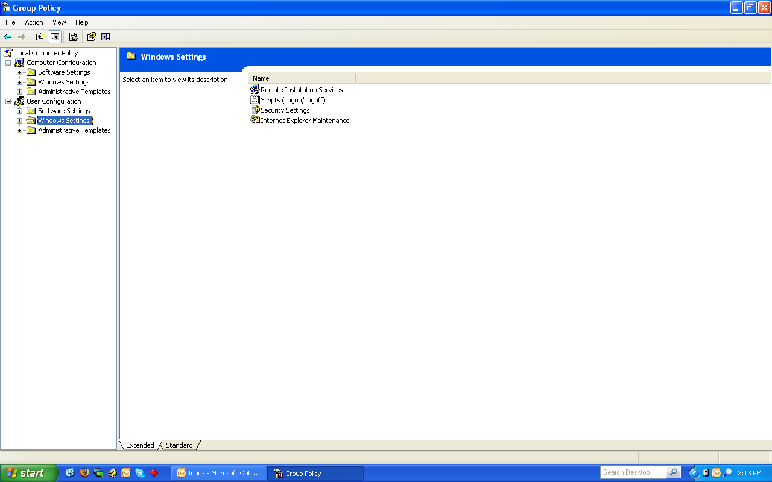
The following picture depicts the Group Policy application native to all servers. This application allows you to apply policies to all the computers in your network.

2.2.7 User State Management:

In addition to being able to apply group policy to users or computers on your network, you can also apply user state profiles. Two examples that can be used are roaming and mandatory profiles. A roaming profile is a profile located not on the local machine, but on the server itself. This profile will be pulled down to the user as he logs into any machine on the network. Thus having his profile and files following him no matter what computer he is logged into. A mandatory profile is also a profile not located on the local machine, but the server itself. This profile will also be pulled down to the user but on the other hand will be fixed and will never change. This profile is created by the technician in the case that the technician would like to keep the user from saving documents onto the computer. When the user logs off, anything saved on that profile will be removed and the next user will receive the same mandatory profile as the previous user. Scripting is a very custom option that you can use in Windows 2003 Server. You can create a specific batch file or visual basic script that can be pushed to one or many computers in your network. You can set it to either affect specific workstations or specific users in your network. Scripting is only limited by the knowledge of the technician implementing it. This could be the most powerful tool of all the tools available that you can use in Windows 2003 Server.

2.2.8 Help Desk:

With the implementation of Microsoft Exchange on your server, this works in conjunction with the users in active directory. You can create mail boxes for all he users in the network. You can also create a separate E-Mail for a specific technology account that can be used to receive work orders from your users. Adding web server services from IIS to your server with front page extensions allow you to create a web page that serves as an electronic work order form that can be used to E-Mail your technological work orders in a form of an E-Mail.

2.2.9 Usability:

If Server 2003 meets the needs of your company or business, usability would definitely be a perk. Most already have server 2003 in their network so no overhead is required. For those who do not have server 2003 implemented, adding computers to the domain can be done very easily through scripts binding the computers to your server. Microsoft has a lot of support on the internet for Server 2003. Like mentioned above, you do not need to be Microsoft certified to handle your way around the server. Google in some cases could answer about 75% of your questions with active directory.

2.2.10 Reliability:

As long as your server 2003 operating system is installed on a server chassis with dual power supplies and a minimum of three hard drives for a RAID 5 configuration for redundancy you should no issues with reliability. Even then you can have a backup domain controller that would serve as a backup to your primary domain controller if that one would fail.

2.2.11 Performance:

With good processors and a good amount of memory, Server 2003 should perform very well. I would recommend if using Standard Edition to have its capacity of 4GB of memory installed for the best performance. I would also recommend performing weekly defragmentation and disk clean ups. I would also make sure to have it up to date to the latest Microsoft patches.

    - Supportability:

Most to all companies and businesses today are mainly using Windows computers. Unfortunately Server 2003 is very limited to supporting Mac and can not at all support Linux. With Server 2003 you do not have monthly fees and it is very inexpensive compared to third party solutions.

2.3 Numara Track It!
Overview:

Numara Software is known primarily for two IT management solutions, Track-It! and Footprints. Track-It! is Numara’s help desk and asset management solution, and Footprints is their service management solution. Track-It! is a GUI based and provides a familiar workspace for IT management professionals. It has many unique features and is most notable for its exceptional help desk solution. Footprints is a web-based service management solution that is highly customizable due to its ability to be integrated with other solutions that are Windows service-based or SQL based. Also of note is Numara’s Patch Manager, which is a Windows patch management solution.

Background:

Numara Software was first founded in 1991(as Blue Ocean Software). They were acquired by Intuit in 2002, but were bought out by TA Associates (an private equity firm) in 2005. According to Numara, the Track-It! software that they have developed has become the most widely used help desk and asset management solution in the world. With 50,000 customers and 200 employees, Numara is not just a trailblazer in IT management, but a market force as well.

Functional Coverage:

Numara Track-It! is Windows based and therefore must be run on a Windows based server or virtual server. Numara can manage and audit Windows based workstations and also has limited support for Mac OS X based systems. Hardware and software monitoring, including software licenses, can be managed by Track-It!, but integrated patch management is unavailable, though a patch management solution with a similar interface is sold by Numara. Additionally, Numara does not provide an integrated back-up solution in Track-It!, nor do they provide a backup solution.

Grouping Managed Devices:

Numara provides customizability of device profiles which allow types and subtypes to be defined for devices, as well as grouping by network. This allows for managing device groups, instead of limiting management to one large group of individual devices, or categories that aren’t customizable. This is a key feature in managing this type of network due to the number of roles and locations there are to deal with in the high school.

2.3.1 Remote Control
The Track-It! Remote system allows fast and easy access to systems available for remote control. The technician merely has to click one button from the appropriate view to take control of the machine.
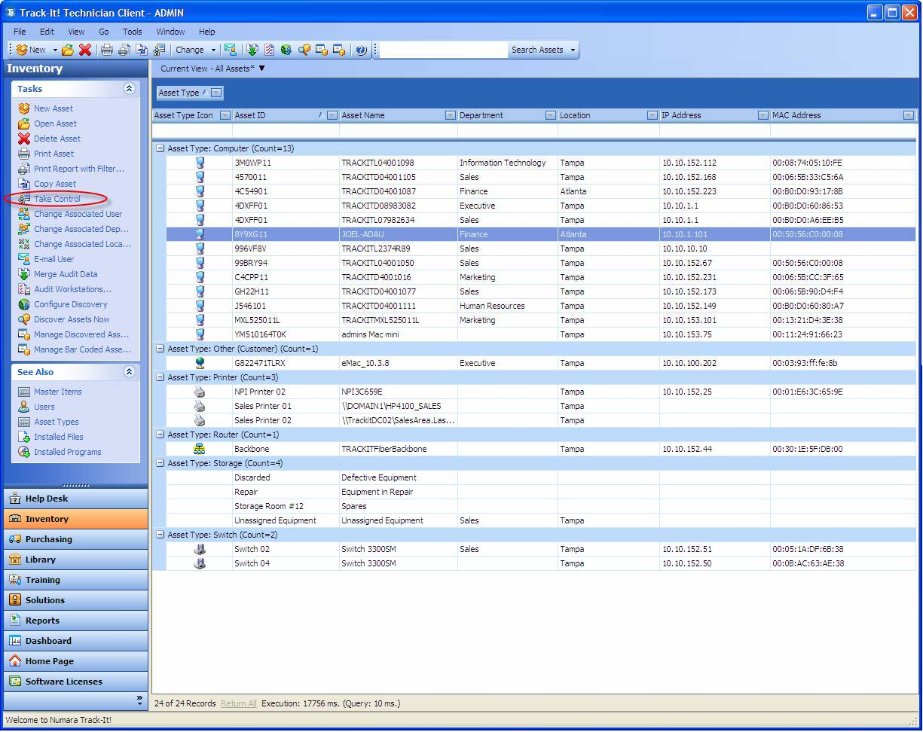

2.3.2 Auditing & Asset management

Track-It! features agent-based auditing which allows for on demand tracking of assets that are registered. In addition, the auto-discover feature allows for assets to be added automatically, without having to manually configure each one, a key to speeding up the set up of larger and more fluid systems.

2.3.3 Monitoring

Network monitoring is an add-on feature available for Track-It!, meaning that it can be part of an integrated solution.

2.3.4 Patch Management

This is an add-on feature to Track-It!, which allows for easy tracking and patching of managed systems.

2.3.5 Backup & Disaster Recovery

Numara Track-It does not feature an integrated backup solution, thus a third party solution such as Paragon would be required.
2.3.6 Endpoint Security

As with backup, a third party solution must be used for anti-virus, anti-malware, anti-spyware, anti-rootkit and firewall management.

2.3.7 User State Management

User state management is not a feature of Track-It!, meaning Active Directory or third party software will have to be used.

2.3.8 Help Desk

The help desk system in Track-It! is quite robust, it can turn e-mails into work orders, features a tiered work order system, built-in knowledge management and automated notifications and elevations

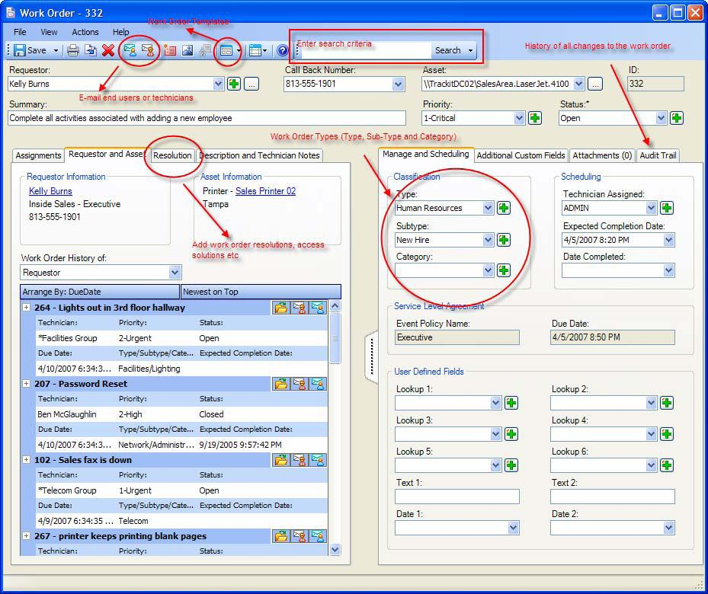

2.3.8 Usability

One of the main draws of Track-It!, it features a GUI modeled after Microsoft Outlook, which leads to easier use and less training time than other systems available.

2.3.9 Reliability

There is no reason to think that through the functional coverage, great reliability cannot be achieved.

2.3.10 Performance

The asset management and monitoring should allow a consistent level of performance to be achieved across the board.

2.3.11 Supportability

The powerful help desk feature of Track-It! should allow for a superb level of support that if implemented properly, could fully rectify, to the degree that is possible, and track all issues with ease.

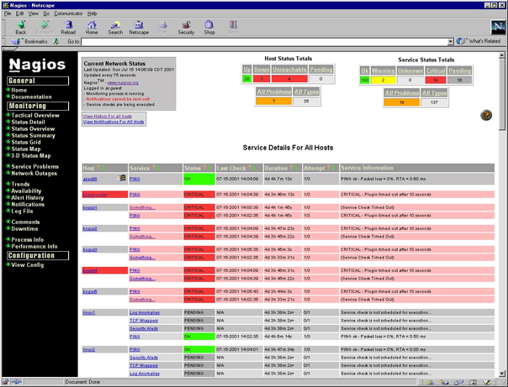
2.4 Nagios
Screenshot of Nagios interface

Overview:

Nagios was written 1999 by Ethan Galstad. It is an open source program and networking monitoring software application. It was originally called NetSaint, but the name had to be changed to Nagios due to legal issues with owners of similar trademark. Nagios stands for “Nagios Aint Gonna Insist On Sainthood”, which is in relation to their original name. Its initial release was on March 14, 1999. Nagios was created to work under Linux and other Unix-like operating systems that have a C compiler and TCP/IP configured. Nagios is licensed under the terms of the GNU General Public License Version 2 under the Free Software Foundation. In 2008, Nagios won the LinuxQuestions.org 2008 “Monitoring Application of the Year” and was honored as being one of Infoworld's “Best of Open Source Software”, also called the BOSSIE Award. Nagios can monitor Windows, Linux/Unix, routers, switches, firewalls, printers, services, and applications.
Functional Coverage:
Only Linux and UNIX-like operating systems support Nagios, but it is able to monitor Windows systems, Linux/Unix systems and Netware Server.
Nagios can monitor network services such as SMTP, POP3, HTTP, NNTP, and Ping among others. All monitoring services can be modified to the user's needs through the availability of plug-ins and add-ons provided by and to Nagios. Due to the array of plug-ins and add-ons available it is difficult to say what cannot be monitored because you can modify the software to monitor what you wish.
The agents used depend on what operating system is being used.

Grouping Managed Devices: Nagios has the capacity of separating devices into separate groups to be monitored. To do so, you just need to configure the main configuration file.

2.4.1 Remote Control
Nagios does not offer any remote control ability; however, if accompanied with Opengear's SDT connector, Nagios is able to remotely access sites [Linux Devices 2008]
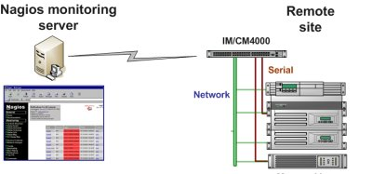
SDT for Nagios in Action

2.4.2 Auditing & Asset management

Nagios does not have any auditing built in. Through a program called Remedy to accompany Nagios, administrators can audit passwords, unauthorized users, system logs, and the patch management among other things.

2.4.3 Monitoring

Remote monitoring is available and supported through SSH or SSH encrypted tunnels. By the software providing us with immediate notification of any problems via cell phone, pager, and email, it allows for technicians to take immediate action to tackle the problem. It also provides comprehensive network monitoring through Windows, Linux/UNIX, routers, switches and firewalls, printers, services and applications. Advertised as allowing you to gain insight into your network and fix problems before your customers even know they exist. Nagios monitors CPU, memory, file system size, processes. If you know how to create scripts, there is basically nothing you cannot monitor.
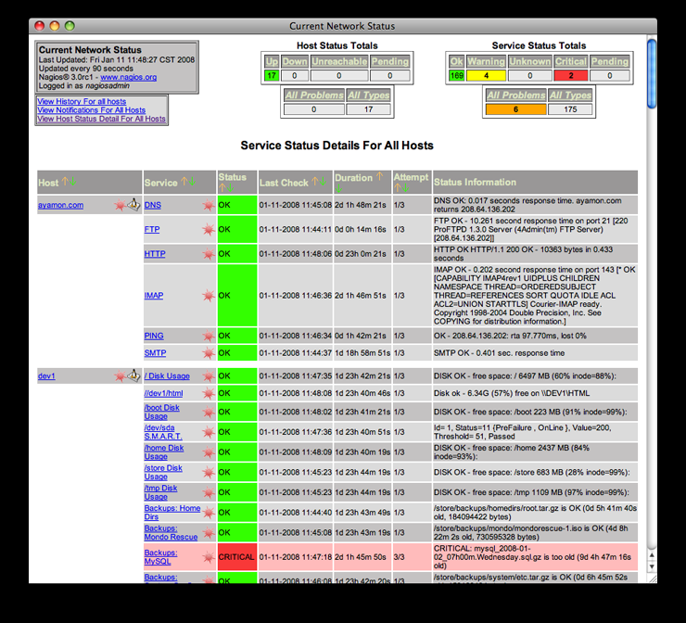

Alert History

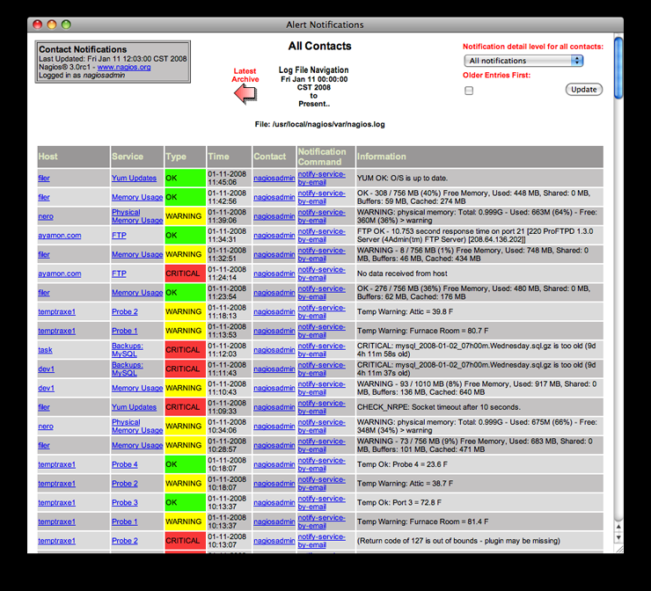
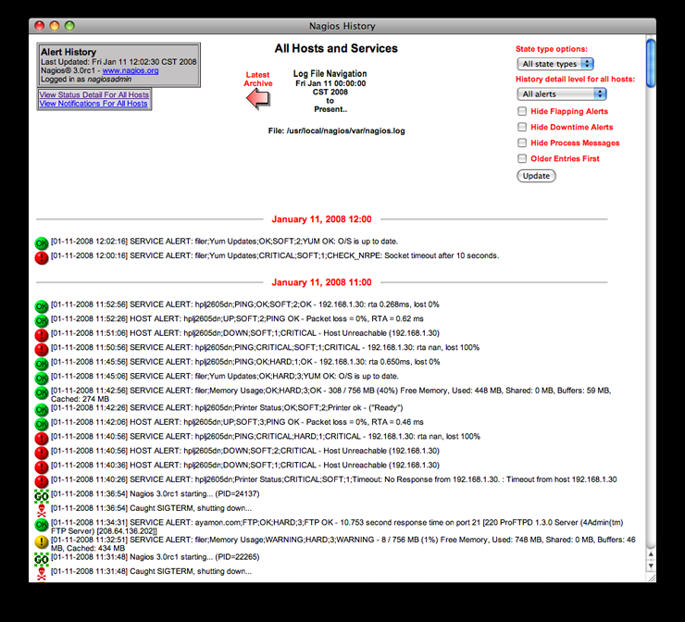
2.4.4 Patch Management

The interface is always checking for issues and attempts to repair them. It does not repair them by itself, but scripts can be created to control certain features and software can be added. The software also provides some literature on what scripts would be useful and some best practices. The scheduled downtime is used for network upgrades and it provides capacity planning capabilities through usage monitoring. What can and cannot be patched is based on what scripting you provide the interface. It can be modified to patch anything your program it to patch. Same goes for what patching information can be attained or not. Nagios offers a lot of flexibility with its plug-in and add-ons, but it may be an inconvenience that this feature is not built in.

2.4.5 Backup & Disaster Recovery

Nagios does not offer any backup or disaster recovery; however, it acknowledges problems through web interface and automatically restarts failed applications, servers and hosts with web handlers so technicians don't have to. The software provides literature on ideas on how to secure the system so as to protect it from the outside. These ideas include some scripts and some common best practices that help when installing the software and using the interface. A program that can be used to offer backup and disaster recovery is Amanda. It allows the administrator to do a single backup server for multiple systems.
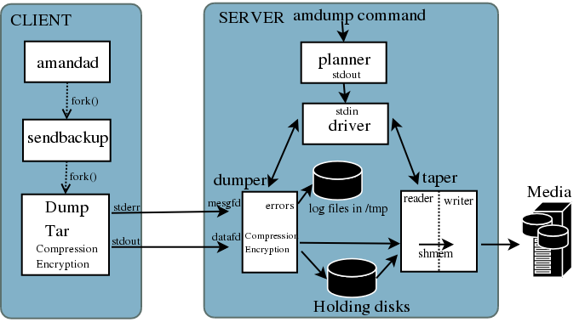
Amanda Software Architecture

2.4.6 Endpoint Security

Nagios does not offer any endpoint security. A program that can be used in collaboration with Nagios to provide endpoint security is Blue Coat. What can be secured by it is web access, blocks malware,...etcs and reports any attempts to access such things.

2.4.7 User State Management

Multiple users can access the interface and each user has their own restricted , unique view. It also has an extensive community website network and over 250,000+ users worldwide and it is completely customizable because users have full access to the open source software's code.

2.4.8 Help Desk

It offers integration with existing applications through trouble ticket systems and wikis. The software also offers basic support services, Nagios Solution Providers, which offer enhanced support, integration, and monitoring services for organizations.
2.4.8 Usability

The interface is very easy to use and every user's interface is customizable allowing the users and administrators easy navigation.

2.4.9 Reliability

The software is labeled as a “stable, reliable and respected platform.” It has been in development for 10 years and still offers room for customization on the code. It has won multiple awards for reliability.

2.4.10 Performance

It is known for stability and claims that users and administrators do not have to worry about any lockups or computer crashing.

2.4.11 Supportability

If any issues were to arise, organizations are offered basic support services, which offer enhanced support and monitoring services.
  - Level Platforms
Overview:

Level Platforms is the leading provider of managed software and has produced the IT automation solution called Managed Workplace. The pricing for the solution goes upwards to “$2,499 upfront with a $60/month/site”[4] payment.

Background:

Forming in 1999, the prestigious company provided IT solutions for SMBs. In May 2004, Level Platforms released Managed Workplace: an IT automation solution that provides remote monitoring and other management software products to ISPs. “Level Platforms won the Microsoft IMPACT award in November 2004 for networking infrastructure Solution of the Year”[2]. Later in March 2007, Level Platforms joined the MSP partners including Microsoft, Intel, and Cisco.

Functional Coverage:

Although it only works with Windows, Managed Workplace can monitor devices with systems like UNIX, Windows, Solaris and Mac. It’s open standard, agentless, and provides secure management practices.

Grouping Managed Devices:

Working with servers, workstations, routers, switches, laptops, and printers, Level Platforms will be able to provide connectivity between them with ease.

2.5.1 Remote Control

Remote Control is offered at fast speeds from any computer via the Internet to the customer’s workstation on site. It does not require additional licensing costs and has support for multiple remote control solutions: Telnet, Putty, VNC, SSH, and RDP. Managed Workplace is also capable of implementing silent or secure sessions to accomplish FTP, SMTP, DNS, and customize TCP ports.

2.5.2 Auditing & Asset management

Unfortunately, Managed Workplace does not provide auditing, but with the 3rd party integration, the auditing is offered through Microsoft and Asigra. However, it does offer a great Asset Management solution. It uses auto-discovery technology to give accurate network data to the end user. This ensures that the clients have up-to-date asset information. Managed Workplace includes full hardware and software discovery out of the box consolidation.
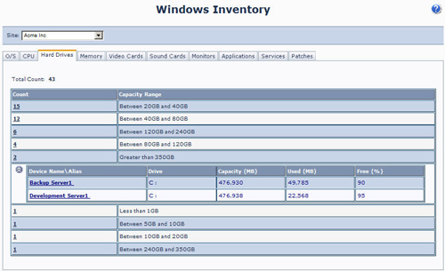

2.5.3 Monitoring

Managed Workplace uses auto-discovery tools to identify all the IP based devices on site. It monitors all network components such as workstations, servers, routers, or switches through protocols like ICMP, Syslog, or NetBios. It can also monitor application usage on the PCs which can be customized to the clients choosing. Integrated monitoring with the alerting feature makes Manage Workplace can give the user an easy to use solution. 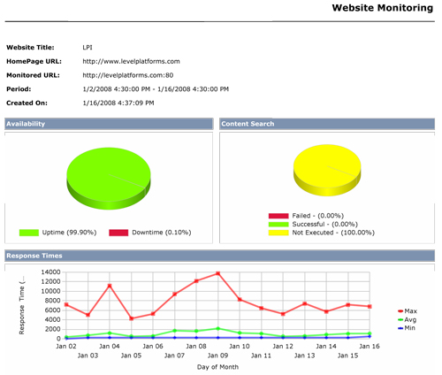
2.5.4 Patch Management

Managed Workplace uses patch management to protect workstations from new threats. It’s adapted to the technology of Microsoft’s Windows Services Update Server (WSUS) and provides patch scanning, identifying, and deployment. Taking bandwidth into consideration, Managed Workplace is designed to “obtain each patch for single download and redistributed internally”[3] . Patches include anything with the Windows Operating System or Microsoft based application.
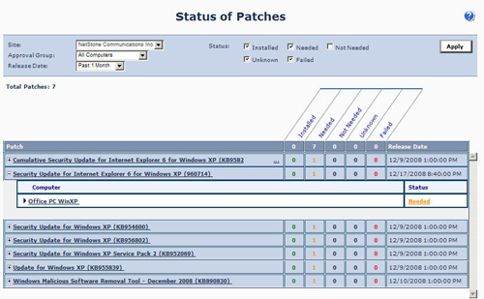

2.5.5 Backup & Disaster Recovery

Level Platforms by itself does not provide all features to its clients including Backup and Disaster Recovery. To remedy this situation, what Level Platforms did was to have 3rd Party Integration including companies like Microsoft, Autotask, ConnectWise, Onforce, and Tigerpaw. Microsoft does provide a backup recovery method in Vista to replicate the OS image on a DVD to offer backup to the clients. There is also file transfer wizards in Windows XP. There is also an article stipulating that Level Platforms and Asigra, the technology specialists in agentless remote backup and recovery are doing a joint program to provide the highest quality in remote backup and remote monitoring. [1]
2.5.6 Endpoint Security

Combined with the integration of 3rd parties like Microsoft or Autotask, Managed workplace has “full SSL support and no inbound communication”[3]. It provides a secure solution for the customer by being ISO-complaint and does not have open port requirements.

2.5.7 User State Management

Using the 3rd party integrated features, Managed Workplace can identify the user’s states throughout the network. It has fully featured User roles and permissions to allow tailored access with the partners of Level Platforms. The policy modules for the out of box solution include HP, Cyberwall, Dell Servers, Juniper, McAfee, and more. [1]
2.5.8 Help Desk

Managed Workplace utilizes VNC to remote into their client’s computers. Help Desk can show the customer what was the problem and how to fix it if it happens in the future. This way, the cost of providing help desk support can be deducted and also customer satisfaction is sustained.

2.5.8 Usability

Managed Workplace uses a GUI so it’s simple for the end user. It has an easy to use, agentless management system. The configuration and maintenance are brought online by the “OnSite Manager instantly and begins managing those devices”[3]. As new versions become available, only a single upgrade is needed to make the update. Although due to all the capabilities Level Platforms has, there is a learning curve, but it’s a small price for all the features it has.

2.5.9 Reliability

Using the 3rd party integrated features, Managed Workplace can be quite reliable. Freedom9 is a 3rd party that brings storage solutions for data backup and recovery system which provides a fast and reliable system. Along with Microsoft and the other MSP partners, Level Platforms is one of the most versatile solutions out there along with many features for the customer.

2.5.10 Performance

Due to all the partners Level Platforms has, Managed Workplace delivers quality performance to the SMB users. The solution is notified by monitoring devices and Managed Workplace is able to remotely connect to them in seconds “to provide patch management and other solutions to ensure high performance”[3]. Also with updates on the versions of Managed Workplace, performance is increased every time.

2.5.11 Supportability

Managed Workplace has the capability of supporting many clients, due to all the partners Level Platforms has. Microsoft is one of the big partners that have major support for its users. In 2008, the technical support team for Level Platforms has “increased by 55% since the previous year”[4].
  - Altiris
Overview:

altiris IT management suite offers a variety of IT automation products starting from small businesses all the way to large enterprises, also among their solutions are: Server management suite, client management suite, endpoint protection suite, helpdesk suite, service and asset management suite, and deployment solution.[1]

Background:
Altiris IT management suite developed by altiris Inc, is a subsidiary of Symantec, altiris specializes in service-oriented management software which allows organizations to manage IT assets. They also provide software for web services, security, and systems management products. Established in 1998, Altiris is headquartered in Lyndon, Utah, United States. Altiris has over 20,000 customers managing more than 3 million servers and 60 million desktops and laptops. Altiris offers an array of it management products such as security, infrastructure operations, information risk and compliance, storage and business continuity.[2]
Functional Coverage:

Altiris management suite is a multiplatform solution, is fully compatible windows based machines, Mac OS, as well as Linux machines; it uses an agent to monitor and manage assets from a centralized location.

Grouping Managed Devices: : altiris management suite offers a handful of facilities that are uses to manage and control IT assets remotely and locally, if offers advanced filtering features that allow IT managers to group managed devices based on roles, operating system, and location

    - Remote Control and Help Desk

Altiris suite has a solution dedicated for remote control and helpdesk and ticketing, is called Altiris helpdesk solution, this solution covers most of the aspects related with ticketing and remote administration, for remote administration, it uses a proprietary solution built in onto the software, file transfer, and well as user status, and connectivity statistics. The helpdesk solution comes with a Built-in workflow to automatically assign and escalate tickets to the proper Helpdesk technicians, also it offers Web reports to ensure quality of service and efficient IT operations. .[3]

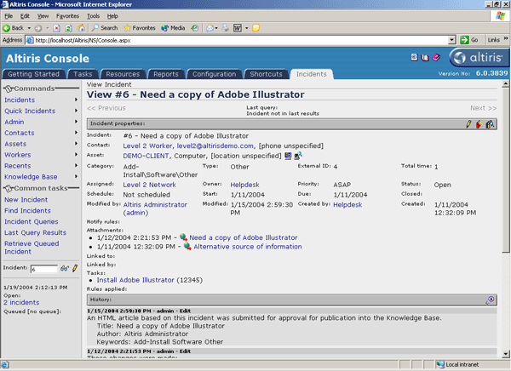

    - Auditing & Asset management

Altiris Management solution Actively track IT asset location, configuration, deployed versions, relationships, and historical information, also, the solution is able to track software and hardware usage for reallocation and contract negotiation, another highlight from this solution is the ability to capture detailed information about desktops, notebooks, and servers and determines how many copies of an application are installed on your users' systems. .[4]

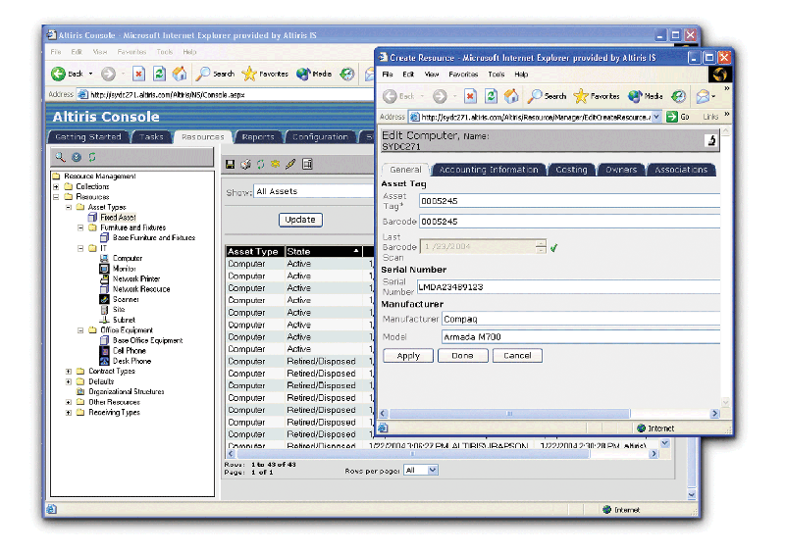

    - Monitoring

The Altiris Server Management Suite offers a dashboard used to organize servers into vital groups to provide a quick status of current health. It includes self-healing remediation tasks already configured, before critical events occur. The solution allows the analysis and resolves challenges faster with the flexible historical performance viewer. [5]

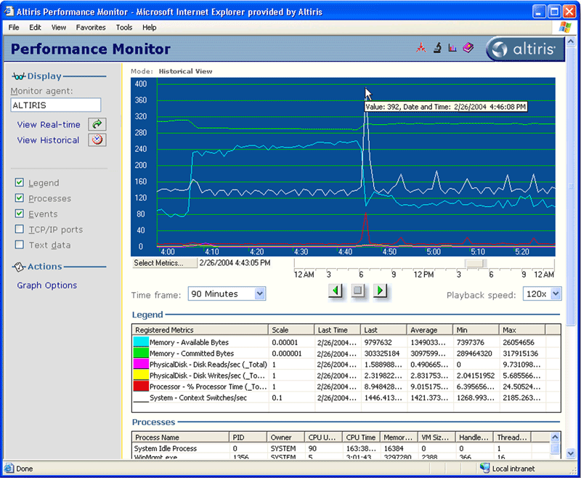

2.6.4 Patch Management

Patch management and deployments are handled to users via agents installed on client machines, also Provides a repository that includes information on each software bulletin, such as technical details, severity ratings, and number of updates, also, Discovers detailed information on the OS and applications, and inventories installed updates, finally it also includes detailed reports and alerts on patch updates and distribution status. [6]

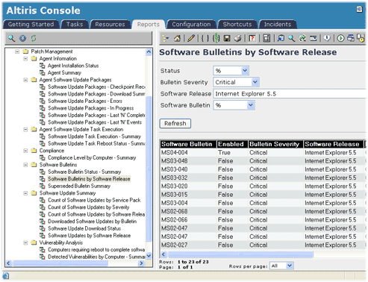

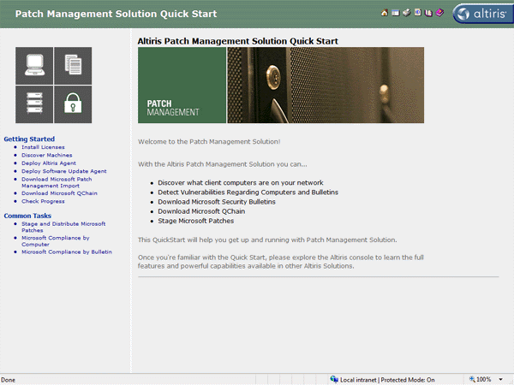

2.6.5 Backup & Disaster Recovery

Altiris management suite offers Recovery to completely dissimilar hardware, including differences in RAID types, disk types, processor types, NIC cards, entirely different system manufacturers; it supports several platforms within the windows server family, such as windows vista, windows 2008 server, 2003 server family and XP family. [7]

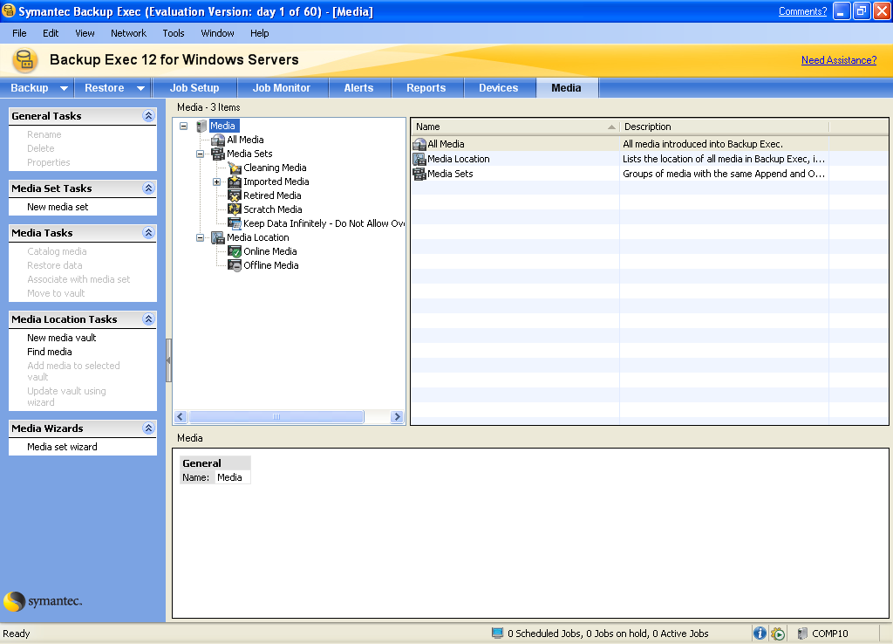

2.6.6 Endpoint Security

Altiris management suite offers an endpoint security solution with features that includes: the Creation variable security policies that automatically change based on user location. Also comes with advanced firewall protection that centralizes firewall settings, enforces trusted communications, and it can't be turned off by the end user. Protecting endpoints from the moment network traffic enters the computer, the driver-level firewall opens communication ports for authorized network traffic only, blocks all unwanted intrusions, and completely hides the endpoint from port scans and other attacks, blocking malicious hackers before they get started, preventing denial of service attacks, port-scans and protocol based attacks, in a way t hat optimizes security compliance and system performance. [8]
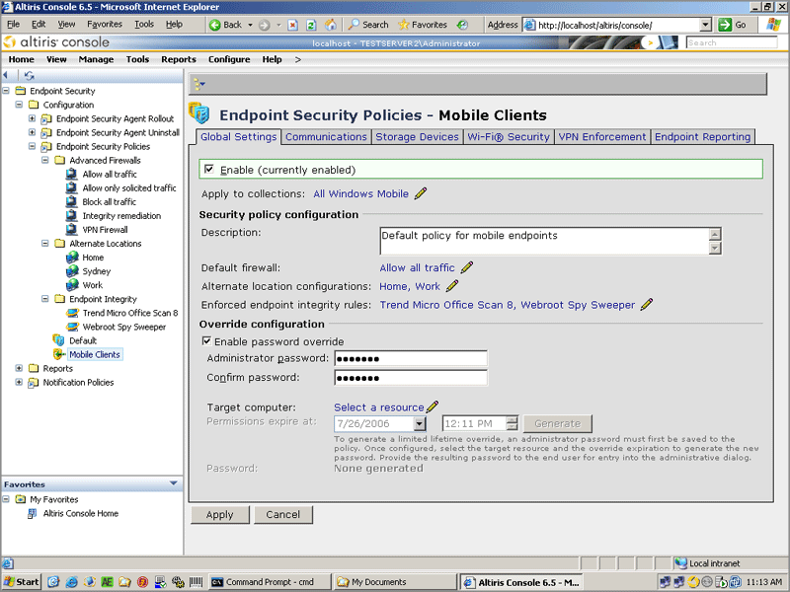

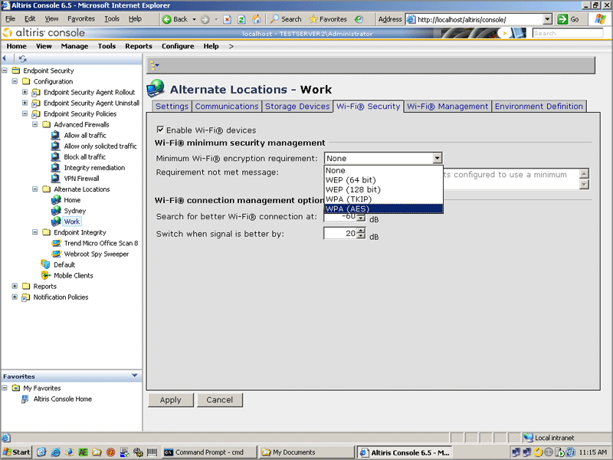

2.6.7 User State Management

Altiris management suite would meet the needs with its user state management. Altiris uses an agent that has the ability to track and monitor user state as well as machine status, the admin could easily setup permissions and policies according with user’s rights via web browser, so it gives the flexibility to manage and monitor the whole environment from virtually anywhere.

2.6.8 Usability

Altiris IT management suite definitely will meet the needs of any company or business, usability and ease to use is really a plus. Most already have server 2003 in their network so no interpretability issues will arise. For those who do not have server 2003 implemented, adding computers to the suite will not be a problem since the agent will take care of it only with a couple of clicks. Symantec has a lot of support on the Internet for its product line. Like mentioned above, you do not need to be a Symantec guru to handle your way around the server.

    - Reliability

Current system is very reliable and stable, system crashes are very rare, and downtime is only caused by outages in the area, reliable error reporting and extensive data replication capabilities make this solution a good reason to have a goodnight sleep.

    - Performance

With good processors and a good amount of memory, Alters solutions should perform very well. I would recommend having around 4 GB of memory installed for the best performance. Since the suite is not resource hungry, the servers won’t get overloaded, so crashes and system interruption won’t be a problem.

    - Supportability

Most to all companies and businesses today are mainly using Windows based equipment. Unfortunately Altiris management suite is only limited to windows server product line and can not at all support neither Linux nor Mac.
  - N-able Technologies.
08
Fall
N-able, is an IT Automation & Managed Services Solution. According to their records and many other sources all over the web, N-able is one of the most popular and well-respected global suppliers for remote monitoring and management, providing state of the art technology for business, support services for managed service providers in all over the world. With their respected awards such as:
N-able is a market leader and award-winning provider of managed services technology and business transformation services, with more than 1,300 global technology partners servicing 36,000 customers who combined generate over $360 million in managed services revenue and significant revenue increases year after year.

N-able Technologies, provides to small and medium-size companies with a great managed service with automation software and business transformation services for resellers, such companies as IT Leaders, Wave Technologies, Precision IT Group, IT Authorities, masterIT, JPMerc & Co., Pardee Network Solutions, Control Circle, CHIPS Computer Services, Solsoft, just to name a few. Their product include various aspect such as Velocity System that comprises remote monitoring and management platform, and performance reporting; and Momentum System, an on-demand Web-based remote monitoring and management service that monitors and manages multiple customer information technology systems with devices at multiple client sites over the Internet with an very reliable and fast pace. “The company delivers technology and training that transforms service organizations into managed service providers by combining products, people, and processes to help service providers develop, sell, and deliver managed services” [11]. N-able Technologies, Inc. was founded in 2000 and its headquarter is located in Ottawa, Canada.

The following data gathered from N-able’s website will provide us with the different products offered by N-able: [1]
- N-central — the leading remote monitoring and management platform deployed globally by MSPs servicing the SMB market.
- Remote Support Manager — an included component that is integrated with N-central to give MSPs real-time remote PC and server management capabilities.
- Remote Environment Manager — a desktop management tool that enables MSPs to create, manage and enforce standardized environments for all PCs at a customer site.
- N-central OnDemand — the leading remote network, desktop and security monitoring and management service designed for MSPs delivering time-based managed services.
- N-compass — an MSP Performance Reporting solution that enables MSPs to demonstrate the performance of their customers' IT infrastructure from a business perspective.
Functional Coverage:

As a wide range of supportability and well-known company, N-able stands up with a variety of operating systems such as Windows 95/2000/XP/Vista, Mac OS X, Novel, SUSE, and Redhat Linux based.
Note: N-able works on Intel based chips only, not on AMDs.
Just like in any other software, some minimum system requirements are needed. According to N-able website, the minimum system requirements are as fallow:

For N-compass,
Hardware [2]:
- Processor: Minimum Pentium 4 (3 GHz) or equivalent.
- Memory: Minimum 1 GB (2+ GB recommended).
- Hard Drive Space: N-compass™ 3.0 requires a minimum of 60 GB for a dedicated data partition. This will allow N-compass to:
    - Import data from an N-central server that monitors up to 5,000 services.
    - Retain data for up to 1.5 years.
Software [2]:
- Operating System (one of the following required).
    - Microsoft Windows Server 2003 Standard Edition with Service Pack 2.
    - Microsoft Windows Server 2003 Enterprise Edition with Service Pack 2.
    - Microsoft Windows Server 2008 Standard Edition.
    - Microsoft Windows Server 2008 Enterprise Edition.
- Database System Supported (one of the following required).
- Microsoft SQL Server 2005 Standard Edition with Service Pack 2.
- Microsoft SQL Server 2005 Enterprise Edition with Service Pack 2.

Note: 32-bit and 64-bit platforms are supported.

Another great and cost effective-handy feature from N-able is that it’s capable of supporting virtual machines environment from VMware. “N-able Technologies has added VMware ESX Server 3.x to its list of N-central Certified Server Hardware” [2]. Not only that, N-able also provide customer support to VMware environments, handling these virtual machine in the same manner as any other physical machine’s customer support with N-central certified hardware.
Because virtual machine restrict us in some ways that differ from actual physical machines such as abstraction layer between the hardware and the operating system, we need to take into consideration two aspects when using this method:
- System Performance:
Because of this nature, N-able is not capable of guaranteeing the performance of the system due to these factors, which are stated in their website: [2]
  - Variability in field environments resulting from VMware server configurations.
  - The number of parallels virtual machines.
  - The performance of the underlying system.

Even though this is a problem cause by the infrastructure of virtual machines, N-able tries its best maintaining guidelines on configuring the VMware instances that N-central should run in. This method is applied in order to maximize the performance of the virtual machine and also its reliability as much as possible.

- Supportability:
Just like I mentioned above, since the nature of how virtual machines works and the abstraction layer between the hardware and operating system, N-able is unable to provide us with customer support such as troubleshooting on VMware systems or any performance issues related to VMware environments factors.

Recommended Configuration for virtual machines, using VMware according to N-able’s data base:
VMware Server [2]

- VMware ESX Server Version 3.5.
- The system must have sufficient RAM and hard drive space to provide permanently allocated resources as outlined below.
- Current N-central recommended hardware configurations specify 1 Quad Core Xeon Processor (51xx or better). We recommend that the VMware server be able to provide this level of processor performance to the N-central Guest Virtual Machine.

N-central Guest Configuration
- Guest Type: Typical.
- Guest Operating System: Linux.
- Version: RedHat Enterprise Linux 5 (32 bit).
- Number of Virtual Processors: 2 minimum.
- Memory: 6,144MB (6 GB) minimum.
- Network: 1 network interface card required.
- Virtual Disk Capacity: 140 GB minimum.

It’s safe to say that even N-able is capable of handling Linux and RedHat Enterprise Linux 5, it was not tested by me since I could not have access to these software, neither the physical capabilities/requirements in my machines in order to accomplish these testing.
The fallowing are the features that N-able has by default; of course 3rd party application are welcome but are not listed here: [3]

- Remote Monitoring.
- IP Network Monitoring.
- Windows Network Monitoring.
- Fast, Easy Deployment.
- Flexible Web-Based Administration.
- Alerting.
- Remote Management.
- Remote Domain Policy Management.
- Remote Desktop and Server Support.
- Managed Device Remote Control.
- Attended Remote Control.
- Patch Management.
- Security.
- Asset and License Management.
- Automatic Script Execution / Scripting.
- Intel vPro -Based PC Management.
- Microsoft System Center Essentials.
- Tactical Operational Reporting.
- Business Performance Reporting.
- Interoperability.

The fallowing are features that N-able does not have by default:

- Back up and Disaster Recovery.
- Desk Help and Ticketing are not built-in as default, but can be implemented as an Add-On to N-central.

Note: Desk Help is provided by N-able as an additional-option feature.

In order to accomplish tasks on some of the features previous mentioned above, N-able uses software agents and probes to gather all critical data and built inventory on devices on customers’ networks.

Agents:

Agent is a piece of software that acts for user or other program in a relationship of agency. Such action implies the authority to decide which action is appropriate. In N-able’s case, agents are not invoked for a task, but they activate themselves. N-able uses agents for different tasks, such as remote connection, deployment of scripts and patch managements to allow connectivity to that specific machine were agent where previously installed on and perform the decided task.

N-central Probe:

N-able uses probe to monitor multiple private networks without compromising their security, including every scheme of IP used. This component stays installed in the customer’s network in order to become monitored. Probe comes in two deployment methods:
- “Windows probe software: Software-based probe that provides WMI and network-based monitoring of up to 25 KNEs” [12].
- “Probe software: Probe software ISO installed on certified probe hardware (network appliance) provides full monitoring functionality” [12].

Grouping Managed Devices:

Definitely N-able provides groping managed devices over the network. As previously mentioned, multiple computers can be monitored and remotely managed at the same time with bare minimum or no lag at all. Devices range from desktops, laptops, windows mobile phones, printers, routers, servers, firewalls and virtually any IP-enabled device connected to the network. With its category selection, we can create a filters, section or subcategory, where then they can assign different functions depending on their needs.

2.7.1 Remote Control

For today’s IT service providers, cutting cost and time is the key to success. Therefore, implementing the right tool at the right time is essential for every occasion. Remote Control is one of those tools. N-able offer us a friendly remote control yet powerful, fast and effective way to accomplish these tasks before small problems become bigger. N-able’s remote control tool will allow us to seamlessly access and take full control of customer devices regardless of their type or location.

This feature will enable us to troubleshoot and fix issues from a single dashboard. This will speed up the process by deserting weather a technician should be or not physically present on that particular machine in order to fix its issues. Also with N-able we are capable of remote control devices that are not under N-central, for example we can gain remote control over any Windows device by just asking the user to connect to a Web page and complete a form. This is very useful tool for new computers that doesn’t have the agent installed yet on their machines or for service providers who deliver help desk outside of a fixed managed service contract.

N-able Technology INC, as a well-respected IT Automation & Managed Services Solution company, in their product N-central they offer us features like: integrated remote control capability, that allows to our technical staff to control any Windows-based device (2000/2003/NT/XP) under management in a secure, flexible and powerful way. Since remote control is integrated in their product as a pre-packaged and seamlessly remote solution, it lowers our cost and time by not having us to rely on third parties applications in order to accomplish our needs in the remote control field. Also N-central’s remote control doesn’t rely on open external ports or VPN’s.

2.7.2 Auditing & Asset management

Auditing & Asset License Management are implemented to manage customer’s networks using critical information such as application compliance, system changes and license compliance.

This method is implemented to keep our customer’s network in a peak performance, in our particular case NMB Senior High. In order to manage effectively our network, proper asset management is a must. According to N-able’s website [4], we can implement Integrated Asset Management; which will allow us to monitor critical device information such as:

- System Changes: This will monitor the hardware components of an individual device to record and report on hardware changes.
- License Compliance: Monitor the number of licenses of purchased software being used to ensure compliance and plan future purchases, keeping everything legit and running smoothly.
- Application Compliance: Basically this will create "black" and "white" lists of applications to track application compliance and protect unauthorized software usage by our customers.

2.7.3 Monitoring

One of the most important tools in IT Automation is monitoring and N-able is well known for this. This is critical to the delivery of effective management services that keep our school’s infrastructure up and running.

As mentioned above, N-able as a respected company for IT automation, have reliable and well-rounded tolls like monitoring. “N-central features a built-in tool to monitor the availability and performance of IP-enabled devices, including desktops, laptops, servers, printers, copiers and routers” [13]. N-central uses software agents and probes to gather all critical data and build an inventory of devices on our network in a very efficient way, which will allow us to detect problems before they lead to costly downtime.

N-central supports monitoring on a wide range of services, virtually any on network device. It comes with a pre-defined setting with over a hundred services. The fallowing are the devices and services that N-central are capable of monitor:

Monitoring of a wide range of devices: [3]

- Desktops
- Laptops
- Servers and Web servers
- Printers and copiers
- Routers
- Exchange servers
- Firewalls
- And virtually every other IP-enabled device

Monitoring support for industry-standard protocols

- SNMP
- Log file analysis
- TCP/IP
- WMI
- Syslog/SNMP Traps
- ODBC
- EDF

IP Network Monitoring

- Ethernet Errors
- Traffic
- Bandwidth
- Frame Relay
- TCP
- SNMP

Windows Network Monitoring

- Application compliance
- Connectivity
- CPU
- Disk
- Disk Queue Length
- Event Log
- File Size
- Local IP
- License compliance
- Memory
- Patch Level
- Process

OS Monitoring

- Windows 95 to Vista
- Mac OS X
- Novell
- SUSE and Redhat Linux

Email Monitoring

- Exchange Server
- IMAP
- POP
- SMTP
- SMTP Queues

Printer Monitoring

- Printer Page Count
- Printer Toner Level

Additional Monitoring

- Backup
- Citrix
- Firewall
- RAID controllers
- Local services
- Custom services defined by you

N-central has the great capability of alerts, which can send alerts to us via either via emails, pager or SMS when warnings or failures occurs on our network, so we can address these issues in a fast en efficient manner before the become more complicated or to a point of losing critical data, which is always a high priority in any company, in our case NMB school.

2.7.4 Patch Management

N-central uses Windows Software Update Services (WSUS) to provide a cost effective and scalable patch management. N-central provides us with an easy WSUS configuration, as well as reporting of patch levels and monitoring across WSUS-enable devices.

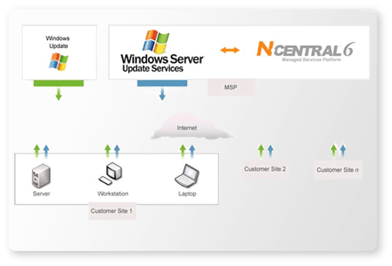
Figure 2.1.1.4a – Patch Management function. [5]

Patch management is the single most effective way to secure our network. This is done by having N-central directly connected to WSUS server, downloading updates and patches automatically, reducing the amount of time that this could take to do them individually on each machine. After updates or patches are obtained, we can monitor and report on patch levels for those devices and even set up alerts to those devices that are falling behind with the updates.

2.7.5 Backup & Disaster Recovery

Unfortunately, Backup and Disaster Recovery is not supported by N-able at this moment. But implementing a third-party application could accommodate this lack of service.

2.7.6 Endpoint Security

Security is always a must, nowadays even more. Having hackers, trojans, fisher, spam, virus, etc, we cannot take the change to overlook at this field, therefore N-central provides us with a reasonably security.

N-central offers monitoring atispam, spyware and virus services that ensure our IT infrastructure is always protected. It proactively monitors and manages multiple security appliances and applications to minimize our IT infrastructure downtime. Also, they ensure application compliances by remotely detecting non-approved applications. Tracking security performance over time to provide valuable reporting is a very nice service that N-central provides with its security service. And track and manage firewalls and intrusion detection system and proactive alerts are just some of the security features that N-central provides us wit.

2.7.7 User State Management

User State Management comes very handy when it comes to policies and inoperative machines, meaning computers that are not being used for x period of time. For example, employees or students usually leave their station after work hours and forget to turn off their computers, leaving them vulnerable for the online predators since the system is up and running and open to the network. Also the consumption of electricity will affect the company with higher and unnecessary electricity bills, just because their forgot to turn off their computers or just trying to be clever by leaving their workstations on and avoid the boot up time saving them time when they come back to work the next day, next shift or next class in case of a student. All these problems can be avoided by controlling the computers power management remotely or by creating policies. Thankfully, N-central provides us with a product called Remote Environment Manager. This product will allow the administrator of the company, in our case NMB Senior High School to control the power management for all the computers located in the network. This great service from N-central is controlled by the administrator, which could have the choice of setting up power-schedules individually or globally to the computers connected to the network. This would be a great compliment for any company since electricity bills will be cut off and also lowering the risk of online malicious treads or predators.

2.7.8 Help Desk

One of the most important features that any IT automation solution offers to speed up the process of troubleshooting is Help Desk. N-able currently doesn’t provide us with this feature as a built-in package with N-central, but it’s offered to us an additional Add-on to our N-central product by paying low monthly fees, or buying it on its own by purchasing a license with N-supportPro. This will allow us to attend our customers with fast, effective help, regardless of the operating system they're using. N-supportPro will allow us to remote support multiple computers our NMB Senior High School with a secure, stable, efficiently and economically way by implementing an small downloadable client in order to start their sessions faster.
Fallowing are some of the benefits that N-supportPro offers, according to N-able’s website [14]:

- Shorten case resolution times and reduce repeat calls for the same issue.
- Reduce costs by increasing service desk productivity.
- Increase the number of incidents resolved on first contact.
- Minimize the need for costly, time-consuming visits to customer sites.
- Improve customer satisfaction by providing fast, non-intrusive and effective technical assistance.

N-supportPro is amazingly well structure to accommodate Help Desk in many different features. Some of these great features that N-supportPro offers are:
- Using the Administrator mode, we can have the ability to reboot and reconnect remote machines without losing the control connection.
- With N-supportPro we can get a complete diagnostics report on the remote machine, with a simple click.
- Thanks to their proxy-friendly and NAT, N-supportPro make it easy to crate a chat conversation, assign a code to that person that needs assistance in their machine and even a voice and video conversation; all this can be done trough the web interface.
- N-able supports “Drag and Drop Two-Way” File Transfer.
- Record and Playback Remote Control Sessions
- With N-supportPro, we can establish Remote Control in Seconds thanks to the lightweight client that can be downloaded truth their web-interface into individual machines or deployed truth the network.
- Files can be sent and received between the technicians and the client.
- Extensive System Snapshot with Remote Diagnostics.
- Print documents remotely on the operator's printer - no file transfer or special configuration is required.
- Show or Hide Applications during Remote Control.
- Brandable Interface will enable us to use our own NMB logo.
- Customize chat windows, e-mails and surveys with the look and feel of your service organization.
- Sound alerts are also available.
- Multi-platform support includes Windows, Linux, Mac and mobile devices
- And last but not least, N-supportPro can support Pocket PC Users.

Note: All these option are sold as an Add-on by paying a low monthly fee or just by purchasing their long-term license on its won, provided by N-supportPro.

2.7.9 Usability

With the easy and friendly GUI, N-able is simple to operate. To accomplish a task we have different approaches that are done by having two columns; one on top we have the (Setup, Reports and Help) tabs; and on the left pane we have the Network Devices, Printers, Servers and Work Stations. Each individual tab has subcategory related to that specific tab. In Figure 2.1.1.8a and Figure 2.1.1.8b we can appreciate more of the interface that N-able works on.

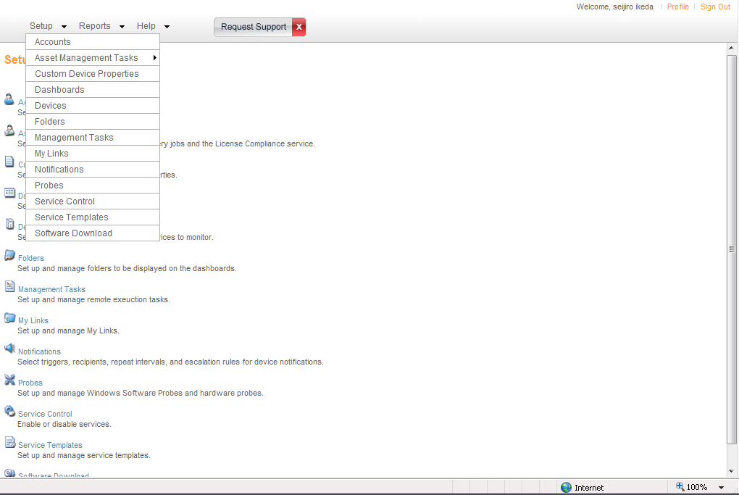
Figure 2.1.1.8a – Three tabs located on top-left (Setup, Report and Help).

Each tab has its own submenus that allow us to reach to the desire task in an organized and easy way. Inside “Setup” tab, we have:

- Accounts.
- Asset Management Task.
- Custom Device Properties.
- Dashboard.
- Devices.
- Folders.
- Managements Tasks.
- My Links.
- Notifications.
- Probes.
- Service control.
- Service Template.
- Software Download

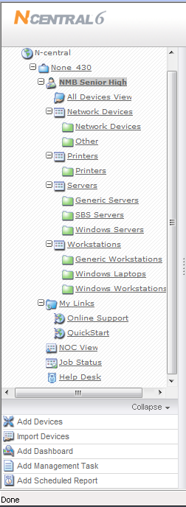
Figure 2.1.1.8b – Left pane, always visible from the main page.

In Figure 2.1.1.8b we find Network Devices, Printers, Servers and Work Station, each with their own respective subcategory. In this pane we can check the current status of the selected device. Different detail subcategories about the selected device are displayed, all nicely done with a clean GUI and friendly colored legend. In Figure 2.1.1.8c, we can see a little example of N-central’s legend and layout of their web interface management system.

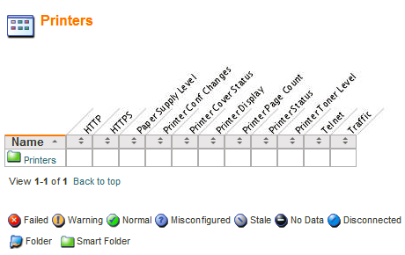
Figure 2.1.1.8c – Example of N-central’s Legend and Layout of the Printers
Section.

Overall N-central offers a very friendly and eye catchy Web Interface, where everything can be understood in an easy manner. But even though N-able offers a friendly interface, I found it tedious when finding a specific task. Everything is subcategorized into different folders and layers, where makes it hard to deal with.

2.7.10 Reliability

N-able is famous for the Monitoring. Their infrastructure is very well stable and reliable. With lightweight client and small footprints to be deployed or individually installed, their remote support is easily managed trough their web interface. And their 24/7 Support is provided with great feedback from previous customer. Regardless all these positive aspects from N-able, I found many incompatibilities installing their Probe and Agent; problems related with .DLL level. Extended personal research, I found many companies that were unsatisfied with their product. For example: David Wertz, president of PC Work Plus, stated: “We couldn’t even get six customers set up on N-able, despite spending hundreds of man-hours and thousands of dollars over a two month period.”[6]

This problem evolve from trying to implement N-able in PC Work Plus company, and he only tried with six of his customer having less than 100 workstations.

At the end of his journey with N-able, Mr. Wertz stated: “ The N-able software looks nice – it has all the bells and whistles – but it is about 25 percent as usable as Kaseya. And ultimately, that’s what really matters.” [6]

2.7.11 Performance

Performance wise, N-able stood up very well. By implementing a lightweight client, remote assistance can be done fast and simple, making any company or in our case NMB Senior High, resolving problems in a fast manner producing a higher productivity overall. Great monitoring system, prevented problem from expanding to a highly cost and timely consume error that could be resolved if proper tool were to have, in this case N-central Monitoring tool.

2.7.12 Supportability

N-able is not only well recognized by their great Monitoring tool, but also for the Support. Their support range from: 24/7 online product and business support, Telephone and Electronically support via phone calls, Self-service Portal, Product Documentation and online training and just few of the supports provided by N-able. It’s safe to say that in order to acquire their best customer support satisfaction, the “Maintenance and Support Program” should be purchased. N-able only provided their best support, which they call “Premium” only if the customer buys their Maintenance and Support Program, versus their “Standard” support, which only includes “24/7 Online and Business Training”.

  - Comparison and Discussion

2.8.1 Evaluating and Discussing LANdesk

Remote Control  Rating: N/A | N/A
Audit & Asset Mgt  Rating: N/A | N/A
Monitoring  Rating: N/A | N/A
Patch Mgt  Rating: N/A | N/A
Backup & Disaster Recovery  Rating: N/A | N/A
Endpoint Security  Rating: N/A | N/A
User State Mgt  Rating: N/A | N/A
Help Desk  Rating: N/A | N/A
Usability  Rating: N/A | N/A
Reliability  Rating: N/A | N/A
Performance  Rating: N/A | N/A
Supportability  Rating: N/A | N/A

2.8.2 Evaluating and Discussing Windows Server 2003:

Server 2003 would be a great solution for North Miami Beach Sr. because its already implemented, it’s already paid for and it is compatible for the machines it has. Even if the school did not have a server and was not implemented, this solution is very inexpensive and implementation would not take long. It does not require a large learning curve and though limited in some areas that third party solution would thrive, it can handle a small network such as a high school compared to a larger company or business. Being that Server 2003 is user friendly, can be reliable, performs very well if the hardware allows and supports the machines currently at the school it is a great overall solution.

Remote Control  Rating: 4 | Remote Desktop works really well and just as good as other remote control solutions. The only advantage VNC has over Remote Desktop is that you do not log off the remote user.
Audit & Asset Mgt  Rating: 2 | It does not really provide the best audit and asset management. With scripting you could only do so much. I would consider another solution for auditing and asset management.
Monitoring  Rating: 2 | It does not really provide the best monitoring. With scripting you could only do so much. I would consider another solution for auditing and asset management.
Patch Mgt  Rating: 4 | WSUS works really well and just as good as other patch management solutions. The GUI is very user friendly and overall easy to use.
Backup & Disaster Recovery  Rating: 2 | It does not really provide the best backup and disaster recovery. I would consider other solutions for backup and disaster recovery.
Endpoint Security  Rating: 5 | Group Policy can provide endpoint security very well and almost flawless. You can limit anything and everything on the users profile.
User State Mgt  Rating: 2 | It does not really provide the best user state management. I would consider other solutions for user state management.
Help Desk  Rating: 3 | Though it is not a true ticketing system, with IIS and Exchange you could get a decent work order system. Thus giving you the ability to facilitate your network.
Usability  Rating: 3 | Windows Server 2003 is very user friendly.
Reliability  Rating: 3 | Windows Server 2003 is very reliable.
Performance  Rating: 3 | Windows Server 2003 performs very well.
Supportability  Rating: 3 | Windows Server 2003 has great support.

2.8.3 Evaluating and Discussing Numara Track It!

Numara Track-It! provides many strong features in its solution, but also has multiple weakness that may disqualify it as a valid solution. While remote control, auditing and asset management, monitoring, help desk and non-functional features are strong, it lacks some of the fundamental features that the system requires, like patch management, endpoint security and user-state management.

Remote Control  Rating: 1 | The fast and efficient system in Track-It! is extremely effective, but is only accessible from the main console.
Audit & Asset Mgt  Rating: 2 | Numara fully provides all the features that are required by the system for auditing and asset management.
Monitoring  Rating: 4 | Numara provides all the features needed, as well as some other features that may prove useful as well, such as automatic network device discover.
Patch Mgt  Rating: 2 | Although integrated support for patch management is not provided, a similar solution with a similar interface is provided, which is better than a solution from another third-party.
Backup & Disaster Recovery  Rating: 1 | There is no integration provided whatsoever for backup tools.
Endpoint Security  Rating: 2 | There is no integrated endpoint security or available addon.
User State Mgt  Rating: 3 | Though some synchronization exists, no effective management solution is provided.
Help Desk  Rating: 3 | Track-It! probably provides a complete and robust help desk solution, including tiered ticketing and a knowledgebase.
Usability  Rating: 3 | Although the GUI of Track-It! is very familiar, it is only accessible where the console is installed. A web based solution would be much more preferable.
Reliability  Rating: 3 | Due to the auditing and monitoring, as well as the history of the software, reliability should be expected from Track-It!
Performance  Rating: 3 | As with reliability, since the software has been available for so long, and the user base is so large, performance should be at an efficient level.
Supportability  Rating: 1 | Documentation, a large user base, and a terrific help desk mean that supportability should be at a high level on both the user and administrator sides.

2.8.4 Evaluating and Discussing Nagios

Nagios’ only real “out of the box” strength is monitoring and user state management. The other functional coverage is pretty much non-existent if another program is not incorporated or if scripts are not written to customize the service to your needs. Also, overall this solution cannot be used at our school because it can only be used on Linux and Unix-like operating systems and North Miami Beach Senior High School only has Windows operating systems running on their computers.

Remote Control  Rating: 1 | Nagios does not provide Remote Control. Outside services or programs must be used to assist.
Audit & Asset Mgt  Rating: 2 | Nagios does not provide an Auditing and Asset Management service, but with scripts and outside programs it can add.
Monitoring  Rating: 4 | Very good monitoring services. It is pretty extensive and monitors a wide array of services. With scripting, it can be even more useful.
Patch Mgt  Rating: 2 | Nagios does not provide Patch Management, but with the use of scripts it can be set up.
Backup & Disaster Recovery  Rating: 1 | Nagios does not provide Backup & Disaster Recovery, but with the help of outside programs to assist it, it can be set up.
Endpoint Security  Rating: 2 | Nagios does not provide Endpoint Security, but like the rest of the functionalities, it can be added.
User State Mgt  Rating: 3 | Allows for user interface customization and modification with scripts.
Help Desk  Rating: 3 | Offers outside help desk services, but nothing within the software.
Usability  Rating: 3 | Easy to use if familiar and comfortable with scripting.
Reliability  Rating: 3 | Very reliable, not much crashing.
Performance  Rating: 3 | Performs well.
Supportability  Rating: 1 | You are charged for supportability.

2.8.5 Evaluating and Discussing Level Platforms

Level Platforms is an excellent solution to implement to any company in need of automation software. Although it does not have the auditing feature, it contains many features in place of it.
Remote Control  Rating: 4 | Fast, connects via the internet, works with VNC, Putty, Telnet, and SSH
Audit & Asset Mgt  Rating: 3 | Doesn’t have auditing, but does have auto-discovery for assets
Monitoring  Rating: 5 | Monitors all IP based devices, reliable, pre-defined templates, extensible alert systems
Patch Mgt  Rating: 4 | Works with WSUS, download once, redistributed internally basis.
Backup & Disaster Recovery  Rating: 3 | Although it doesn’t have a backup recovery system itself, the 3rd party integration covers the backup solutions due to Microsoft
Endpoint Security  Rating: 3 | Has full SSL support and no inbound communication
User State Mgt  Rating: 4 | It has fully featured User roles and permissions to allow tailored access with the partners of Level Platforms
HelpDesk  Rating: 4 | Managed Workplace utilizes VNC to remote into their client’s computers. Help Desk can show the customer what was the problem and how to fix it if it happens in the future
Usability  Rating: 3 | There is a learning curve to utilize the software, given all the features it has
Reliability  Rating: 3 | Freedom9 has its backup and recovery system alongside the program
Performance  Rating: 4 | Given all the 3rd party integrated companies alongside with Level Platforms, the performance of Manage Workplace would be of high quality
Supportability  Rating: 4 | Level Platforms is very manageable and able to support the users it has

2.8.6 Evaluating and Discussing Altiris: Overall Altiris management suite is capable of doing most of the demanding task seen today, a bit of resource hungry and a lack of user state features are a minus, but overall the solutions offers lost of other features that are worth the investment.

Remote Control  Rating: 4 | Reliable and secure for remote connectivity, it support mobile workers as well, it has robust security features such as 128, 192, 256 bit encryption, plus it works in heterogeneous environments
Audit & Asset Mgt  Rating: 4 | Tracks software usage as well as hardware, its also designed to provide self help, with an extensive knowledge base to avoid trivial issues and improve efficiency
Monitoring  Rating: 3 | It offers self-remediation task, and organize servers into vital groups, provides quick monitoring, and status of the equipment’s health. Lack functionalities and flexibility
Patch Mgt  Rating: 4 | Supports heterogeneous environments, provides easy to use migration tools, console is easy to use
Backup & Disaster Recovery  Rating: 4 | Because offers Recovery to completely dissimilar hardware, including differences in RAID types, disk types, processor types, NIC cards, entirely different system manufacturers, which makes more reliable than the competition.
Endpoint Security  Rating: 4 | Detects threats in real time, virus database is updated everyday, also is easy to use and to manage, and it integrates fully with other suites from Altiris.
User State Mgt  Rating: 2 | Lacks features, as well as flexibility, there are better suites that provide a better functionality for a lot less
Helpdesk  Rating: 4 | Roust web-reporting capabilities, easy to install implement and deploy, and offer a complete incident and management resolution processing.
Usability  Rating: 4 | Really easy to use, learning curve really narrow compared with the competition, more cost effective when it comes to training
Reliability  Rating: 5 | System is pretty robust, very few crashes have been reported and the ones reported have been because hardware failure!
Performance  Rating: 3 | Very resource hungry, lots of services running in the background, even for simple configuration, needs a minimum of 1gb and to run a processor of 2 GHz minimum and 10gb of hard-drive storage, so it needs a robust server with lost of memory and processing power.
Supportability  Rating: 3 | Even though it supports Linux Mac, and the 2003 server family, it doesn’t support 2008 server and that’s a big negative since most of the companies are migrating to 2008 server, it would be a waste of capital
2.8.7 Evaluating and Discussing N-able

N-able as one of the leaders in the market for IT Automation and remote managed solution, which offers a wide variety of option, from Remote Control, to Auditing and Asset Management. N-able does it all, well almost all! N-central is a great web based IT Automation tool for most small and medium-size companies since it cover most of the tools necessary for their maintenance. Their strength is Monitoring, since it’s capable of handling multiple devices at the same time in a very effective way; such devices are: Desktops, Laptops, Servers, Printer, Firewall, just to name a few. In the other hand, N-able’s weakness is the lack of Backups and Disaster Recovery, which is essential in any company in order to protect their critical data. Of course, this could be resolve by implementing a third party application, but this will only add another layer of complexity since the technicians will have a new learning curve for this third party application, that will require additional time to accomplish the requirement needs for the company, or in our case NMB Senior High School.

I personally find N-able as a well-rounded tool that covers almost all the tools needed except Backup and Disaster Recovery. That’s why overall I give it 4 out of 5 stars.

Remote Control  Rating: 5 | Lightweight client and stable platform makes it easy to remotely assist any computer with any OS.
Audit & Asset Mgt  Rating: 4 | System Changes, License Compliance and Application Compliance keeping the network in a peak performance.
Monitoring  Rating: 5 | Monitor almost any device, uses most industry-standard protocols, does IP Monitoring, Windows Network Monitoring, Monitors most OS, has variety of notification and printer monitoring.
Patch Mgt  Rating: 3 | Uses WSUS. N-central connects directly to WSUS server, keeping the workstations up to date.
Backup & Disaster Recovery  Rating: 1 | Not supported by N-able.
Endpoint Security  Rating: 3 | N-able has AntiSpam, Spyware and Antivirus, with a reasonable security.
User State Mgt  Rating: 3 | Capable of monitoring power management for computers on the network and configure to their needs.
Help Desk  Rating: 4 | Improve customer satisfaction by providing fast, non-intrusive and effective technical assistance.
Usability  Rating: 4 | Offers a very friendly and eye catchy Web Interface, where everything can be understood in an easy manner.
Reliability  Rating: 3 | Monitoring wise, N-able is great. In other aspect, no so good.
Performance  Rating: 4 | Lightweight client, remote assistance can be done fast and simple, making any company or in our case NMB Senior High, resolving problems in a fast manner producing a higher productivity overall.
Supportability  Rating: 4 | Good technical support, client support and OS support.

Rating Results Explanation/Discussion:
Individual Solution Comparison Rating System Table
 | LANdesk | Windows Server 2003 | Numara Track It! | Nagios | Level Platforms | Altiris | N-able
Remote Control | N/A | 4 | 4 | 1 | 4 | 4 | 5
Audit & Asset Management | N/A | 2 | 5 | 2 | 3 | 4 | 4
Monitoring | N/A | 2 | 5 | 4 | 5 | 4 | 5
Patch Management | N/A | 4 | 2 | 2 | 4 | 4 | 3
Backup & Disaster Recovery | N/A | 2 | 1 | 1 | 3 | 4 | 1
Endpoint Security | N/A | 5 | 1 | 2 | 3 | 4 | 3
User State Management | N/A | 2 | 2 | 3 | 3 | 2 | 3
Help Desk | N/A | 3 | 5 | 3 | 4 | 4 | 4
Usability | N/A | 3 | 3 | 3 | 4 | 4 | 4
Reliability | N/A | 3 | 5 | 3 | 3 | 4 | 3
Performance | N/A | 3 | 5 | 3 | 3 | 3 | 4
Supportability | N/A | 3 | 5 | 1 | 4 | 3 | 4
Availability | N/A | 3 | 5 | 3 | 4 | 3 | 5
Price | N/A | $999 Standard Edition | N/A | FREE | $2499 +  $60/month/site | 210  Per license | $650 monthly per PC
Total | N/A | 39 | 48 | 31 | 47 | 45 | 48

The above rating table shows the results that we felt that best suited each IT Automation Solution. Rates were given according to various aspects, such as: Complexity, usability, Reliability, etc. That would separate one solution from another. At the end, you can see a Total Score. This way we could have a better understanding on where and what specific application suits better in comparison among all these tools.

3. Selecting a Solution
Target Organization’s Problem Overview:

North Miami Beach Senior is a school where technology is utilized almost 24/7. As the IT technicians of the school, it is our duty to make sure that the students, teachers, staff, and administration have the best computing experience. All workstations in the school will be Windows XP and Windows Vista. Some of the problems that NMB has are hard disk failure, server failure, slow troubleshooting, security breaches, and inconsistent system performance. The usability, performance, reliability, and supportability of our solution to these problems must make things easier for everyone. Some functional requirements that are needed to solve these problems are auditing, network monitoring, ticketing and help desk, remote control, patch management, scripting, and user state management.

3.1 Remote Control

As mentioned earlier, a technician spends up to half of his time walking from incident to incident. There is no prioritization, and an emergency may arise where he is needed, but is unavailable while dealing with a trivial issue while he is urgently needed elsewhere.

3.1.1 LANdesk
N/A

3.1.2 Windows 2003 Server:

Server 2003 would meet the needs with its remote control. The technician would need remote control access to all administrative, office, teacher and student workstations. With remote desktop the technician would be able to do so as long as the end user’s machine has an Internet connection. The only disadvantage of remote desktop compared to other remote control solutions is that it logs off the end user. With other remote control solutions such as using VNC, the end user can see what the technician is doing which works great when the technician is educating the end user with a problem or when the technician needs to what the end user is currently viewing. On the other hand that could be considered an advantage as well in the case that the technician does not want the end user to see what he is doing.

3.1.3 Numara Track It!
The requirement set forth initially was for the purpose of servicing systems as quickly as possible. Because of Track-It!'s fast remote control system, it appears to satisfy this requirement, partly. Track-It! is centrally managed, so a computer cannot be controlled remotely from anywhere on the network.

3.1.4 Nagios

Nagios does not offer any Remote Control. Therefore, without bringing in some other program or add on to assist in this functionality, it would not really benefit North Miami Beach Senior High School. Kaseya would benefit the schools. Also, Nagios can’t even be run because our school only has Windows operating systems, not Linux.

3.1.5 Level Platforms
Using Telnet, SSH, or Putty to remote control a single workstation without having the need to physically walk is timesaving. The time spent on walking to the remote station can be better utilized to support other problems in NMB. With the speed offered by Level Platforms, NMB will greatly benefit with Remote Control.

3.1.6 Altiris
Altiris management suite would meet the needs with its remote control. The tech will be able to proactively support and deliver service without complications. The ticket system is easy to use and very robust, the remote feature has access to all the machines in the environment as long as Internet connectivity is present, and it’s deployed in silent mode so the user doesn’t need to now that the machine is being serviced.

3.1.7 N-able
With 500 plus computers at NMB Senior High, physically walk to each computer in order to troubleshoot them is not an easy task, neither a smart way to manage their problems. Thanks to N-able capability of using remote connection, reaching to these computers is a breeze. N-central’s Remote Connection is a very important feature offered by N-able that will benefit the school in a very high efficiency and reliable way, cutting time and increasing productivity, saving time to the IT Department which they can use to target other issues more important.

Comparison and Discussion: Each solution examined provided an integrated solution, with the exception of Nagios. However, only N-able and Kaseya provide solutions that are complete and web-accessible, and would be the best choice for the problem. The web accessibility would allow a technician to provide remote support from anywhere on the network.

 | LANdesk | Server 2003 | Numara Track It! | Nagios | Level Platforms | Altiris | N-able
Remote Control | N/A | 4 | 4 | 1 | 4 | 4 | 5
Explanation | N/A | Remote Desktop works really well and just as good as other remote control solutions. | Fast and easy system only accessible from support console. | Nagios does not provide Remote Control at all. Kaseya does. | Can use ssh, putty, or telnet to remote control computers | N/A | Lightweight clients and probes make it easy and fast to Remote Control computers through  N-central’s web-interface.

3.2 Auditing & Asset Management
Malfunctioning hardware as a result of power failures, overheating, dust accumulation, and insufficient electricity flow to networking devices. This includes workstations, servers, switches, and routers.

3.2.1 LANdesk
N/A

3.2.2 Windows 2003 Server
Server 2003 would not meet the needs with its auditing and asset management. Though you can pull certain information from the server such as the remote computers operating system, logs, alerts, devices and services. It needs to be done per computer unless you are familiar with scripts. Even with scripts it might not output as organized as other auditing solutions. The technician at North Miami Beach Sr. would need to know which computers needs replacement and would find it difficult without being able to run a full network audit report displaying certain filters. In this specific area, a third party solution might meet this requirement better than using Server 2003.

3.2.3 Numara Track It!
Track-It! will allow for effective auditing and reporting as required due to its strong agent-based auditing and customizable reporting systems.

3.2.4 Nagios

Nagios does not offer any Auditing.

3.2.5 Level Platforms

NMB has many devices that need to be documented for inventory. Also this solution can help solve any anomalies from device malfunction and quickly remedy the issue. The auto-discovery feature makes it easy for the NMB technicians to track the different nodes that are on the network.

3.2.6 Altiris
Altiris management suite would meet the needs with its asset management and IT inventory. It proactively checks for asset status as well as hardware status and health, it keeps account of all the assets lifecycle and contains a powerful reporting mechanism to address this capability

3.2.7 N-able
As implemented in every school, documenting devices for our school inventory is not an exception. At NMB Auditing & Asset Management is a must. Even though creating asset management report is not often run, it’s essential for our school. This helps solve anomalies from device malfunction, so proper care will be implemented to remedy this problem. Thanks to N-central we can monitor critical devices information such as: System Changes, License Compliance and Application Compliance, keeping NMB’s network in a peak performance.

Comparison and Discussion: Only Track-It!, Altiris and N-able provided solutions. While Track-It! is arguably the best solution of the ones examined, there are issues to take note of. Management must be performed on the machine that the management console is installed on. Kaseya provides all of the required features, and is web-accessible once again making it optimal for the problems of NMBSH.

 | LANdesk | Server 2003 | Numara Track It! | Nagios | Level Platforms | Altiris | N-able
Auditing & Asset Management | N/A | 2 | 5 | 1 | 2 | 4 | 4
Explanation | N/A | It does not really provide the best audit and asset management. With scripting you could only do so much. | Automated auditing and reporting enhanced by automatic network discovery. | Nagios does not offer any auditing. Kaseya does. | Does not provide auditing. | N/A | N-central provides a well rounded Automated Auditing and Asset Management.

3.3 Monitoring
System failures include overheating of the internal devices. Manufacture defects also causes for system failures on the machines such as bad hard drives or bad memory

3.3.1 LANdesk
N/A

3.3.2 Windows 2003 Server

Server 2003 would not meet the needs with it’s monitoring. Though you can access logs and alerts remotely and monitor the machines from the server. It needs to be done per computer unless you are familiar with scripts. Even with scripts it might not be as powerful as other monitoring solutions. Third party solution let you monitor the machines in real time and alert you via E-Mail, or even text to inform you of any specific situation. In this specific area, a third party solution might meet this requirement better than using Server 2003.

3.3.3 Numara Track It!

The automatic device discovery and available network monitoring subsystem will fulfill the needs of the school's system. The system is simple to use and provides tools that allow for monitoring some of the largest systems.

3.3.4 Nagios

Nagios does offer good monitoring services. With all its checks it will help the school figure out where a problem has occurred and where it has occurred. It will provide immediate notification of the problem and ensure there are no inconsistent system performance, no system failures, no server or disk failures and no outages. This functionality of the system can definitely benefit the high school; however, in the end, it cannot be used because our school only has Windows operating systems.

3.3.5 Level Platforms

Measuring the bandwidth and PC utilization is key to document for our students in NMB. Since the school runs different applications such as Word, Grade book, and other programs, we can ensure than Managed Workplace will monitor the activity with ease. We will also monitor if a device is off or malfunctioning since the monitoring is integrated with the asset management and audits.

3.3.6 Altiris
The Altiris Suite offers a dashboard used to organize servers into vital groups to provide a quick status of current health. It includes self-healing remediation tasks already configured, before critical events occur. The solution allows the analysis and resolves challenges faster with the flexible historical performance viewer.

3.3.7 N-able
The best tool provided by N-able. Due to the complexity, yet friendly user interface, monitoring is a breeze for N-able. Due to the high traffic of Internet source used by the students at NMB, monitoring is a must to keep the bandwidth in a good performance. Students often utilize the computer for unauthorized application that demands a lot of bandwidth, such as: Torrent Clients and Online Games. Using N-able to monitoring and capping these issues is great way to keep the Internet bandwidth in its peek performance. Of course, N-able is much more capable than just capping and monitoring high demand of Internet bandwidth, but this is just one of the main issues coming from students. Another problem that could be resolve by implementing N-able is by monitoring devices that are malfunctioning, such as disk failures, which leads to data loss. Over the past two years, there have been many hard drive failures; this problem could be addressed by implementing a monitoring on the temperature of the disk or server in general, which it can alert the IT technician either via SMS or email, which then leads to a proper action by the technician, whether it could be a kill-signal to the server and shut it down in order to cool it off. This way, NMB will avoid spending more money on purchasing new HD so often, prevent lost data and lowering the chances of misfire by overheating components.

Comparison and Discussion: Track-It! Level Platforms, Altiris and N-able all provide acceptable solutions to this problem. Kaseya, however, provides extensive monitoring features and customizable sets and alerts within its highly integrated system.

 | LANdesk | Server 2003 | Numara Track It! | Nagios | Level Platforms | Altiris | N-able
Monitoring | N/A | 2 | 5 | 1 | 5 | 4 | 5
Explanation | N/A | It does not really provide the best monitoring. With scripting you could only do so much. | Highly scalable and effective monitoring tools. | Compared to Kaseya, Nagios’ monitoring seems more extensive. | Leading company in monitoring and reporting, provides quality service | N/A | The best tool that N-able offers. Capable of monitor any IP-Enabled device at the same time with a great performance.

3.4 Patch Management
Viruses that are not blocked by the current antivirus halt system stability and performance.

3.4.1 LANdesk
N/A

3.4.2 Windows Server 2003

Server 2003 would meet the needs with its patch management. Though it may not be as immediate as other patch management solutions, WSUS handles pushing Microsoft patches to its workstations well. It has a very nice graphical user interface and is really easy to use. Patch management could be scheduled in the late nights so it does not interrupt the staff or teachers while at work. Server 2003 would meet the needs with it’s software deployment and scripting. Teachers always need the latest java, flash, and reader to run specific educational programs such as the Excelsior Grade book. In addition, educational software that comes with textbooks need to be installed on teacher workstations. With MSI packages, the technician could create packages for the latest of software and push them to specific computers or users on the network.

3.4.3 Numara Track-It!
The patch management add-on would seem to serve all of the patch management needs, and in fact, there is also an available deployment solution. However, there is no built in scripting subsystem available, a serious flaw in the system, as it limits system-wide actions.

3.4.4 Nagios

Nagios has no built in patch management, but with all the available plug-ins and scripts that can be written to automate the patch management, it can control certain issues in the school's system.

3.4.5 Level Platforms
NMB runs with most of the workstations having Windows XP. With Managed Workplace, the workstations will be fully updated for their OS and Windows applications. With the help of 3rd party integration, NMB can be assured that Managed Workplace will be a very reliable software solution

3.4.6 Altiris
Altiris management suite is fit and approver for patch management. Its reliable and easy to use interface makes deployment productive and less cost effective; its custom scripting toolbox is compatible with an extensive array of languages, so it gives the admin the flexibility and the ability to run deployments effectively.

3.4.7 N-able
Since must computers at NMB runs on Windows platform, N-able is a great candidate for Patch Management since it uses Windows Software Update Services (WSUS). This method will ensure a secure network by having NMB’s computer up and running with the latest updates. This is done by having N-central directly connected to WSUS server, which then it will download updates and patches automatically and pushing them through the network, reducing a great amount of time that this could take by doing them individually in each machine at NMB Senior High. Also N-central has a very handy tool that will monitor every computer in the network for monitor and report on patch level and even create alerts for those devices that are falling behind with patches and updates, so they can also receive the proper attendance for patch management.

Comparison and Discussion: Windows Server 2003, Nagios, Altiris and N-able provide WSUS based patch management. Kaseya, however, provides a system that allows for easy grouping and approval. This gives again gives Kaseya the nod.

 | LANdesk | Server 2003 | Numara Track It! | Nagios | Level Platforms | Altiris | N-able
Patch Management | N/A | 4 | 2 | 1 | 3 | 4 | 3
Explanation | N/A | WSUS works really well and just as good as other patch management solutions. | Patch management not integrated, scripting not provided. | Nagios has no built in patch management like Kaseya | Has built in patch management software | N/A | Good Patch Management provided by N-central through WSUS.

3.5 Backup and Disaster Recovery
Network failures and hard disk failures can occur and needs to be backed up accordingly.

3.5.1 LANdesk
N/A

3.5.2 Windows Server 2003
Server 2003 would not meet the needs with its backup and disaster recovery. Server 2003 does have a built in program called NT Backup, but this program works great with backing up the server and not necessarily the machines on the network. This might be one of Server 2003’s biggest flaws. You can have the users profiles on the server but though that will protect the users files, which will not help if the end user machine has a hardware failure. Server 2008 has since fixed this issue. In this specific area, a third party solution might meet this requirement better than using Server 2003.

3.5.3 Numara Track-It!
Another flaw in this solution is that it does not feature integrated backup. Although not the most critical of systems to have integrated, it is still a notable flaw, as a separate imaging system would also have to be found.

3.5.4 Nagios

Nagios does not have a built in backup and disaster recovery. With a program called Amanda accompanying Nagios, you can set up a single master backup server to back up multiple hosts over network to tape drives/changers or disks or optical media. Nagios itself will not benefit the school when it comes to backup and disaster recovery.

3.5.5 Level Platforms
In case of data loss, our backup system is great with the help of Asigra, one of the best backup and recovery solutions. Level Platforms has a wide verity of 3rd party integrated software at its use. This is the reason why backing up our data won’t be a difficult task. It is NMB’s top priority to have a secure backup recovery system and with Managed Workplace, it’s possible.

3.5.6 Altiris
Altiris IT management suite would meet t meet the needs with its backup and disaster recovery. It offers reliable data replication, data imaging, even with dissimilar software, and it covers these above as well as the other aspects of the data recovery as well as disaster recovery.

3.5.7 N-able
In case of a disk failure, data loss or any other major disaster, N-able would not meet the needs with Backup and Disaster Recovery. This option is not provided by default and 3rd party application is recommended in order to address this lack of service from N-able.

Comparison and Discussion: Only Altiris provided a truly integrated quality solution. Kaseya can also provide backup and disaster recovery without lacking all of the other required features that Altiris does.

 | LANdesk | Server 2003 | Numara Track It! | Nagios | Level Platforms | Altiris | N-able
Backup and Disaster Recovery | N/A | 2 | 1 | 1 | 3 | 4 | 1
Explanation | N/A | It does not really provide the best backup and disaster recovery. I would consider other solutions. | No solution available outside of third parties. | Nagios has no built in Backup like Kaseya does. | Accompanied with Asigra, it can provide great backup services | N/A | Backup and Disaster Recovery is NOT provided by N-able. Though this could be addressed by using a 3rd party application, it would be nice to have it built-in with N-central.
3.6 End-Point Security
The solution must have a secure method of sending data to workstations. Antivirus software to remedy bugs on the network is vital

3.6.1 LANdesk
N/A

3.6.2 Windows 2003 Server
Server 2003 would meet the needs with its endpoint security. This feature I think it really difficult to beat by third party solutions. Microsoft with active directory on Server 2003 is laid out in a very easy to understand manner. You turn on or off certain policies to specific users or computers on the domain. For instance, administrators do not need policies, but teachers need to be limited to what they can or cannot install. Students need to be very limited and in some cases completely limited to what they can do. By using policies you can specify what exactly you would like to take away from a particular user or computer on the network. In addition you can set specific log in times and log in machines to a specific account to limit when and which computer they can use. Administrators, office staff and teachers can log in at any time, but students can only log in between school hours.

3.6.3 Numara Track It!
Again, Track-It! comes up short in an area that is only a minor problem to not have an integrated solution, most solutions would rely on third party software, but the lack of integration is not preferable or acceptable in comparison to solutions that do provide it.

3.6.4 Nagios

Nagios does not offer any endpoint security. A program that can accompany Nagios for endpoint security is Blue Coat. It will help monitor the student's web access, block malware and make sure to protect the system from viruses. Nagios alone will not benefit the school.

3.6.5 Level Platforms
Security is a crucial aspect in any network, especially in schools. NMB must keep a secure firewall to block any threats, viruses, worms, and any other malicious content that can compromise the experience our students and staff has. Managed Workplace has all the features NMB needs to reduce downtime and improve security and stability

3.6.6 Altiris
Altiris management suite would meet the needs with its endpoint security. The firewall feature that comes with the suite makes the solution very competitive among other third party solutions. One if these features are the Creation variable security policies that automatically change based on user location, also, also comes with advanced firewall protection that centralizes firewall settings, enforces trusted communications, and it can't be turned off by the end user making the environment less prone to outside threads.

3.6.7 N-able
Security is a must at NMB, critical information from students and staff are store in our school, and therefore security is a high priority for us. N-central could definitely meet the needs for it, thanks to monitoring spam, spyware and viruses built in with N-central, ensuring that NMB’s IT infrastructure is always protected. It’s capable of remotely detect non-approved application, which comes very handy for us since students often try unauthorized application at the school. Keeping track of the security performance and creating reports upon this, is a great tool that will definitely benefit NMB. Last but not least, by managing proactive alerts, firewalls, intrusion detection system, will assure that not intruder gets into NMB’s network and access critical data. Although N-able’s security is not its best strength, it will provide a reasonable security at NMB but further security application should also be implemented to reinforce its lack of high-end security power.

Comparison and Discussion: Altiris and N-able provide the endpoint security features required. Once again, though, Kaseya also fully provides this service and all of the other specific features that are called for.

 | LANdesk | Server 2003 | Numara Track It! | Nagios | Level Platforms | Altiris | N-able
Endpoint Security | N/A | 5 | 1 | 1 | 2 | 4 | 3
Explanation | N/A | Group Policy can provide endpoint security very well and almost flawless. | No integrated solution. | Nagios does not have built in endpoint security like Kaseya. | Only the 3rd party integration software can provide security | N/A | Good Endpoint Security. N-central provide us with Antispam, Anti-Spayware and Antivirus.

3.7 Users-State Management
The students do not have policies on their profile, and as a result are able to install inappropriate software that could retrieve passwords such as key loggers.

3.7.1 LANdesk
N/A

3.7.2 Windows 2003 Server
Server 2003 would meet the needs with its user state management. At North Miami Beach Sr., administrators and the technician require the availability of files on their computer regardless of location. With roaming profiles, these individuals will be able to have access to their files on any computer in the network as a result of files being located on the server. Students in the library on the other hand do not need the ability to save to the computers. So in greater detail mandatory roaming profiles could prevent them from using the computers for anything but research. With active directory, the technician could also push scripts to specific users or computers on the network to create specific mapped drives to resources needed by students.

3.7.3 Numara Track It!
Since Windows Server has a built in management system for Active Directory, lacking this system seems to be a minor flaw as well. TrackIt! does allow for synchronizing its own user directory with Active Directory, however, this is not an integrated solution.

3.7.4 Nagios
Nagios does offer users their own individual, customizable views on their accounts.

3.7.5 Level Platforms
Managed Workplace can supply a policy that can be customized to the technician’s needs. NMB has staff, teachers, administration, and students. So using Managed Workplace to create these policies would be beneficial for NMB, since the profiles created for each workgroup will be assigned accordingly. Microsoft also has features along with Managed Workplace that provides a more efficient environment for policies.

3.7.6 Altiris
Altiris management suite would meet the needs with its user state management. Altiris uses an agent that has the ability to track and monitor user state as well as machine status, the admin could easily setup permissions and policies according with user’s rights via web browser, so it gives the flexibility to manage and monitor the whole environment from virtually anywhere.

3.7.7 N-able

With N-central policies can be create to satisfy the need of NMB Senior High School, all done by the school administrator. Policies are used to bring security standards to a higher level and make the administrator’s life easier; these policies can vary from blocking student or staff from accessing unauthorized application or settings, to power management in order to save energy consumption to the school by shutting down computers remotely.

Comparison and Discussion: Level Platforms and N-able provide user state management features, whereas the other solutions basically lack the fundamentals needed. Kaseya is the only solution that provides completely all of the features needed to manage the system at NMBSH.

 | LANdesk | Server 2003 | Numara Track It! | Nagios | Level Platforms | Altiris | N-able
User State Management | N/A | 2 | 1 | 1 | 4 | 2 | 3
Explanation | N/A | It does not really provide the best user state management. I would consider other solutions. | No integrated solution. | Like Kaseya, Nagios offers users customizable views of the interface. | Has customized policy settings to the users needs | N/A | Capable of using policies to different users; also Administrator can create schedules for Power Management and Settings. All this could be accomplish thanks to “Remote Environment Manager” tool.

3.8 Help Desk
There is no prioritization, and an emergency may arise where he is needed, but is unavailable while dealing with a trivial issue while he is urgently needed elsewhere.

3.8.1 LANdesk
N/A

3.8.2 Windows 2003 Server
Server 2003 would meet the needs with its help desk. Though it may not be as fancy as some third party solution would use, using Exchange on the server with a web page work order system that E-Mail’s you the end users concerns works just fine. Some third party solutions could even get you a dialogue chat with the end user as you are fixing their issue. For North Miami Beach Sr., a simple web page work order system would work just fine. It will just serve as a means for staff or teachers to communicate their technological issues to the technician.

3.8.3 Numara Track It!
This is the biggest strong point of TrackIt! and the current system's biggest weakness. The ease of use, tiered ticketing, e-mail integration and built in knowledge base make this a powerful solution. What Track-It! does, it seems to do quite well.

3.8.4 Nagios

The school would be able to have access to the Nagios support services, Nagios Solution Providers for any troubleshooting that may be needed. There is nothing in the program however, that has a built in help desk.

3.8.5 Level Platforms
Any Troubleshooting that may occur throughout the school will be done effectively and efficiently. Managed Workplace utilizes VNC to remote into their client’s computers. So this cuts down on any traveling the technician has to do. Teachers, Staff, students and the administration computers will be monitored. So the technician will know about the problem already when the user calls for the Help Desk.

3.8.6 Altiris

Altiris management suite would meet the needs with its remote control. The tech will be able to proactively support and deliver service without complications. The ticket system is easy to use and very robust, the remote feature has access to all the machines in the environment as long as Internet connectivity is present, and it’s deployed in silent mode so the user doesn’t need to now that the machine is being serviced.

3.8.7 N-able
By having NMB buying the extra license for the N-supportPro, the school can benefit with the premium version for Help Desk, which unfortunately is not part of the default package for N-central. N-supportPro will provide the school with multiple remote attendances with fast, effective help, regardless of what operating system the computer is running on. With its secure, stable, efficiently and economically way to implement clients trough the network, NMB’s computer could be accesses remotely and troubleshooted in a very fast manner.

Also N-able makes it easier for the professor and staff to communicate with the IT department trough the chat interface or if needed, trough the voice and video chat interface, speeding up the process of resolving the issue and saving time, which it could be implemented later on other problems. This method will definitely increase the productivity of every professor and staff at NMB Senior High.

Comparison and Discussion: Track-It!, Altiris and N-able all provide or have available help desk features. Track-It! has the most robust, fast and easy to use help desk of all the systems examined, due to the customizability, tiered ticketing, and e-mail integration. Kaseya does not provide all the features that brought to the table by Track-It!, however it does provide a full solution to the problems of the high school with regards to support.

 | LANdesk | Server 2003 | Numara Track It! | Nagios | Level Platforms | Altiris | N-able
Help Desk | N/A | 3 | 5 | 1 | 4 | 4 | 4
Explanation | N/A | Though it is not a true ticketing system, with IIS and Exchange you could get a decent work order system. | Exceptionally robust feature set and system, including e-mail to ticket conversion. | Nagios does not have built in support, but it does offer outside support services. | Can utilize VNC to get to the source and fix the problem so the user sees how to solve it. | N/A | An extra feature, not included in N-central’s Package, N-supportPro need to be purchased separately. N-supportPro supports any OS and alerts that will facilitate the job of the performance as a whole for NMB Senior High School.

3.9 Usability
The experience should not appear different to the end user as much as possible, the administration, teachers and students should need little to no training to use the system

3.9.1 LANdesk
N/A

3.9.2 Windows 2003 Server
At North Miami Beach Sr. a server is present with Server 2003 already installed. This makes implementation painless. The only aspect required would be making sure the computers are added to the domain, which is not a difficult task. Using scripts makes this task even easier. Managing users and computers on the domain does not require a major learning curve but a lot of useful information can be found at Microsoft's website online.

3.9.3 Numara Track-It!
With a familiar GUI, the learning curve should not be steep for technicians, and the only visible change to the systems from TrackIt! would be the agent running and how services are done, fulfilling the needs of the system and more.

3.9.4 Nagios
Nagios’ interface is very easy to use, but would be even better for a user familiar with scripting so they could make the software even better.

3.9.5 Level Platforms

Using Managed Workplace uses a GUI so it’s simple for the end user. The technicians will be the only people to operate on the automation solution. So the technician must learn all the capabilities of Managed Workplace so that they can provide the administration, students, teachers, and staff the proper computing experience. However, there is a learning curve involved.
3.9.6 Altiris
Usability and ease are two of the main features of this product. Most already have server 2003 in their network so no interpretability issues will arise. For those who do not have server 2003 implemented, adding computers to the suite will not be a problem since the agent will interoperate with various platforms and if detected will take care of it only with a couple of clicks. Symantec has a lot of support on the Internet for its product line. Like mentioned above, you do not need to be a Symantec guru to handle your way around the server.
3.9.7 N-able
Due to the easiness of N-able web interface and friendly GUI, NMB’s technicians won’t have to experience a big learning curve, except of the capability of N-central. Overall the usability of N-able is considered reasonable and not perfect, due to the complex of organization of their tools, which happens to be organized layer after layer. This will be the only downside when it comes to usability for N-able. But after all, it’s something that could be learned in a short period of time, it’s just a matter of getting used to the interface and layout.

Comparison and Discussion: Almost all of the systems examined would provide an acceptable level of usability, the exception being Nagios, and that's to be expected of any integrated solution. Kaseya provides the most integrated solution, however, and that makes it, far and above the rest, the absolute best choice in terms of usability.

 | LANdesk | Server 2003 | Numara Track It! | Nagios | Level Platforms | Altiris | N-able
Usability | N/A | 3 | 3 | 1 | 3 | 4 | 4
Explanation | N/A | Windows Server 2003 is very user friendly. | Though the solution is quite good at what it does, it lacks a web based interface. | Nagios and Kaseya are both easy to use, but Kaseya doesn’t require scripting to provide all services. | Technicians will be able to utilize Managed Workplace, but there is a learning curve | N/A | User-friendly GUI and Web-Interface. Making the learning-curve easy for the new user or Administrator

3.10 Reliability
The new system needs to be reliable; regular crashes, network outages, and catastrophic data loss are never to be expected.

3.10.1 LANdesk
N/A

3.10.2 Windows 2003 Server
At North Miami Beach Sr. the server with the Server 2003 operating system has dual power supplies with three hard drives in a RAID 5 array. In addition there is a backup domain controller in the event that the primary domain controller was to fail. Having this kind of setup makes it very reliable. In the case that one of the hard drives would fail, as a result of the RAID 5 array, no data will be lost and a replacement hard drive can be installed without any effect to the server.

3.10.3 Numara Track-It!

The monitoring features of TrackIt! will allow for consistency that isn't achievable without a management system. The lack of backup, however, means that another solution would have to be used in addition to TrackIt!, meaning most reliability would be determined independently of TrackIt!.

3.10.4 Nagios
It was labeled as a “stable, reliable, and respected platform” [Nagios.org 2008]. However, it only runs on Linux and Unix-like system, so it would not be a reliable program for North Miami Beach Senior’s computers, which run Windows operating systems.

3.10.5 Level Platforms

NMB must have a reliable network. With Managed Workplace, and using the 3rd party integrated features, Managed Workplace can be quite reliable. Having backup solutions and recovery methods for each of the workgroups in NMB is part of the proper solution. Monitoring all devices and tending to them for any malfunctioning occurrences will reduce downtime.

3.10.6 Altiris
Current system is very reliable and stable, system crashes are very rare, and downtime is only caused by outages in the area, reliable error reporting and extensive data replication capabilities make this solution a good reason to have a goodnight sleep, and it would mitigate most of system interruptions experienced in our current environment

3.10.7 N-able
As mentioned before in the RAD, NMB Senior High is a public school with a high rate of students and staff. Therefore, a reliable program is a must for this school. With over 500+ computers, NMB needs a platform stable enough to handle this payload. N-central, well recognized by its monitoring capabilities can handle this type of daily punishment. In the other hand, even though N-able is well recognized by its monitoring, it’s also recognized by its lack in Backup, Disaster Recovery, Patch Management and End Point Security. This makes this program not reliable enough.

Comparison and Discussion: All the systems examine should provide a great deal more reliability than the current system. They are tried and proven, and even though Nagios is linux based, making it seem a difficult solution to implement, it could be run on a virtual server. Kaseya is also a proven system, and its increased integration would probably make it slightly more reliable than the other solutions.

 | LANdesk | Server 2003 | Numara Track It! | Nagios | Level Platforms | Altiris | N-able
Reliability | N/A | 3 | 5 | 1 | 3 | 4 | 3
Explanation | N/A | Windows Server 2003 is very reliable. | Should provide a proven, tested and reliable system | Reliable software, but only runs on Linux and Unix like systems. | Reliable, to keep downtime to a minimum | N/A | Some incompatibly issues and bugs should be addressed. Not 100% reliable.

3.11 Performance
The students at NMB senior high will be able to use the resources of the workstations with sufficient performance without any computer lockups.

3.11.1 LANdesk
N/A

3.11.2 Windows Server 2003
At North Miami Beach Sr, the server with the Server 2003 operating system has twin dual core processors with 4GB of memory making the Server 2003 operating system perform very well. Short of some minor maintenance such as disk defragment and disk cleanup on a weekly basis the server should perform very well. Setting disk quotas on the hard drives would be a good idea to limit the capacity of certain profiles that way keeping the hard drives with adequate space for defragmenting.

3.11.3 Numara Track-It!
The asset management and monitoring features of TrackIt! are robust enough to keep the school's computers running consistently.

3.11.4 Nagios
Nagios is known for its stability and users do not have to worry about lockup or crashing. It is a very consistent performer. It would be a good choice for monitoring in the school if it ran Unix-like operating systems.

3.11.5 Level Platforms
Bandwidth Control is another feature that Manage Workplace utilizes and the technicians will put it to good use at NMB. The students will have the sufficient amount of bandwidth to complete their homework and browse the web. However, the majority of the bandwidth goes to the teachers, administration, and staff since they have the crucial software needed to run NMB. Rest assured that both will have the performance needed to do what is desired.

3.11.6 Altiris
With good processors and a good amount of memory, Altiris solutions should perform very well. I would recommend having around 4 GB of memory installed for the best performance. Since the suite is not resource hungry, the servers won’t get overloaded, so crashes and system interruption won’t be a problem. Some minor hardware upgrades are needed before the implementation.
3.11.7 N-able
Due to the lightweight for N-able’s client and web interface, N-central is a good candidate to operate well at NMB School. By having a fast platform as IT automation tool, NMB bandwidth won’t be consumed as much as other tools, leaving plenty of bandwidth to the students and staff to accomplish their needs or homework in a high performance manner. But also, It’s safe to mention that any high demand on bandwidth by the IT department, will be implemented during non-school ours, which could be anytime after 6:00pm or/and weekends.
Comparison and Discussion: Track-It! is critically acclaimed for its performance, however, most of the solutions would provide an acceptable level of performance, with the lone question being Nagios which would require a virtual server, thus decreasing performance. Kaseya also performs quite well and shouldn't experience any trouble with the amount of hardware it will need to manage. In addition, Kaseya won't be slowed by the requirement of additional third party software to run along side it.

 | LANdesk | Server 2003 | Numara Track It! | Nagios | Level Platforms | Altiris | N-able
Performance | N/A | 3 | 5 | 1 | 4 | 3 | 4
Explanation | N/A | Windows Server 2003 performs very well. | Acclaimed for speed, supports a large system with mySQL or Oracle DBs | Very reliable and stable, but can’t be used in the school.. | Has many features to keep performance at a high. | N/A | Lightweight clients and probes. Overall a well-rounded package with different tools that will keep any system in peak performance.

3.12 Supportability
When problems do arise, such as the troubleshooting experience should be efficient and not time consuming, on the students side or the administrative side.

3.12.1 LANdesk
N/A

3.12.2 Windows Server 2003
North Miami Beach Sr. is composed of windows based machines. Server 2003 can only support windows based machines. For the most part the school would be supported adequately with Server 2003 but in the near future if the school purchases Apple and Linux based machines, than the school would have to look for an alternative solution for those machines.

3.12.3 Numara Track-It!
TrackIt!'s powerful help desk and ticketing will make the system extremely supportable, with speed and ease for the end users from the ticketing system and remote controllability, fulfilling all needs.

3.12.4 Nagios
Since the only operating system used at NMB Senior High is Windows, the supportability of Nagios would not really be useful, but Nagios does provide basic support services.

3.12.5 Level Platforms
Managed Workplace has the capability of supporting many clients, due to all the partners Level Platforms has. If there is a problem, the students, teachers, and administration can count on the technician to provide support for the computer systems. If there is a higher-level problem, LPI can come and provide tech support as well.

3.12.6 Altiris
At north Miami beach high most of our infrastructure is ruled by windows based operating systems, so Altiris wont have any difficulties to be integrated to this new environment, as a matter of fact it would be seamless and easy since the program interface is so intuitive, administrators will get the system up and running in a blink of an eye.

3.12.7 N-able
At NMB Senior High, the only operating system currently used is Windows. This system is supported by N-central. But in case of an extension of operating system such as Mac OS X or Linux based computer, N-central is capable of handling these Operating systems with no problem. N-central provides a variety of clients that will satisfy the needs of any operating system, with a stable and fast manner.

Comparison and Discussion: Track-It! is once again the stand-out among the examined systems, however, the other systems would provide better support than is available now. Kaseya, while perhaps not providing the level of support that Track-It! provides, does provide completely the support needs of the school. In addition, its integration makes it a more complete solution for supportability as all specific needs can be addressed from Kaseya's web-accessible console.

 | LANdesk | Server 2003 | Numara Track It! | Nagios | Level Platforms | Altiris | N-able
Supportability | N/A | 3 | 5 | 1 | 3 | 4 | 4
Explanation | N/A | Windows Server 2003 has great support. | One of the most used systems. As a result of support. | Provides basic support services, but of no use to our school. | Has great services like VNC to help support the user. | N/A | Great Technical Support provided by N-able. From 24/7 Online Teaching, to Phone Support. N-able, also supports most OS such as: Linux, Windows, Mac OS X; and supports most of hardware components nowadays used by small and medium-size companies.

3.13 Summary of the Rating and Selecting a Solution

After analyzing all our solution in order to resolve the pains for out RAD at NMB Senior High School, we decided that the best IT Management and Automation Solution would be Altiris and N-able, due to their wide variety of tools that satisfy the needs of NMB Senior High School. Tools such as: Remote Control, Audit& Asset Management, Path Management, Backup and Disaster Recovery, Endpoint Security, User State Management and Help Desk are vital for our school. Unexpectedly, we weren’t thinking of using all these tools for our school, but after intensely looking into all of them, we realize that all of these tools are extremely essential for NMB. That being said, we compared our studies in each solution and Altiris and N-able came up in the first place in our rating table, due to the well-rounded packages that they offer, and that could be greatly appreciated it if implemented at NMB. Notice that the scores for these two solutions were not 100% scores, since we all agreed that the best full IT Automation package was Kaseya, due the intensive amount of tools and high quality performance offered by tem. Kaseya’s extremely well infrastructure not only has every tool needed by NMB, but it also offers us with high-end platform and technology that function in a reliable way, keeping our system in a peak performance addressing every aspect mentioned before. Therefore, our decision on the best IT Management and Automation Solution for NMB Senior High School would be Kaseya.

RAD-Based Comparison Rating System Table

 | LANdesk | Server 2003 | Numara Track It! | Nagios | Level Platforms | Altiris | N-able
Remote Control | N/A | 4 | 4 | 1 | 4 | 4 | 5
Audit & Asset Management | N/A | 2 | 5 | 1 | 2 | 4 | 4
Monitoring | N/A | 2 | 5 | 1 | 4 | 3 | 5
Patch Management | N/A | 4 | 2 | 1 | 3 | 4 | 3
Backup & Disaster Recovery | N/A | 2 | 1 | 1 | 3 | 4 | 1
Endpoint Security | N/A | 5 | 1 | 1 | 3 | 4 | 3
User State Management | N/A | 2 | 1 | 1 | 4 | 2 | 3
Help Desk | N/A | 3 | 5 | 1 | 4 | 4 | 4
Usability | N/A | 3 | 3 | 1 | 3 | 4 | 4
Reliability | N/A | 3 | 5 | 1 | 3 | 5 | 3
Performance | N/A | 3 | 5 | 1 | 4 | 3 | 4
Supportability | N/A | 3 | 5 | 1 | 3 | 4 | 4
Availability | N/A | 3 | 5 | 5 | 4 | 4 | 5
Learning Curve | N/A | 3 | 5 | 3 | 2 | 4 | 4
Price | N/A | $999  Standard Edition | $5,145 | FREE | $2499 + $60/month/site | $210  Per license | $650 monthly per PC
Total | N/A | 39 | 52 | 20 | 46 | 53 | 52
4. Glossary
N.A.G.I.O.S : Recursive acronym that stands for, “Nagios Ain't Gonna Insist On Sainthood”.
Remedy: created by BMC Software Company in 2004, for auditing and help desk services.
Amanda : stands for Advanced Maryland Automatic Network Disk Archiver. It is a backup system that allows the administrator to set up a single master backup server to back up multiple hosts over network to tape drives/changers or disks or optical media. Amanda uses native dump and/or GNU tar facilities and can back up a large number of workstations running multiple versions of Unix.
Blue Coat: a program that provides secure web communications, optimizes security and accelerates performance for its users.
WSUS - Windows Server Update Services

NT - New Technology

MSI - Microsoft Installations

IIS - Internet Information Services

OU’s - Organizational Units

RDP – Remote Desktop Protocol

DB- Database

MySQL- Database management system
5. References

5.1 LANdesk References:
N/A

5.2 Windows Server 2003 References:

http://www.microsoft.com/windowsserver2003/default.mspx

http://www.microsoft.com/windowsserver2003/howtobuy/licensing/pricing.mspx

5.3 Numara Track-It! References:

http://www.numarasoftware.com/Track-It.asp
http://www.numarasoftware.com/pdf/NTI85_TD_ReviewersGuide.pdf
http://www.numarasoftware.com/helpdesk/resources/Track-It_8.5.2_Administrators_Guide.pdf
http://www.numarasoftware.com/patchmanager.asp

5.4 Nagios References:

http://www.nagios.org/about/
http://en.wikipedia.org/wiki/Nagios
http://nagios.sourceforge.net/docs/nagios-3.pdf
http://www.linuxdevices.com/news/NS4321098567.html

5.5 Level Platforms References:

www.levelplatforms.com [3]
http://www.crn.com/software/191600705 [4]
http://www.levelplatforms.com/Vendors/Managed_Vendors.aspx
http://www.asigra.com/pressroom/print_us_press/level.htm [1]
http://en.wikipedia.org/wiki/Level_Platforms[2]
http://www.terian.com/vendor.asp?vendor=Level+Platforms

5.6 Altiris References:

http://www.symantec.com/business/total-management-suite[1]

http://en.wikipedia.org/wiki/Altiris [2]

http://eval.symantec.com/mktginfo/enterprise/fact_sheets/b-datasheet_helpdesk_sol_91344-01_11 2007_en.us.pdf [3]

http://www.symantec.com/norton/symantec-pcanywhere[3]

http://www.symantec.com/business/asset-management-solution[4]

http://www.symantec.com/business/server-management-suite[5]

http://www.symantec.com/business/deployment-solution [6]

http://eval.symantec.com/mktginfo/enterprise/fact_sheets/b-datasheet_backup_exec_system_recovery_08-2008_12001750-2.en-us.pdf [7]

http://eval.symantec.com/mktginfo/enterprise/fact_sheets/b-datasheet_endpoint_protection_12-2008_12836807-4.en-us.pdf[8]

5.7 N-able References:

Website Source: “N-Able.” Network and Systems Management Software for Professionals. 2008. 7 April 2009. <http://www.N-able.com/about/corp_background.php> [1]

Website Source: “N-Able.” Network and Systems Management Software for Professionals. 2008. 7 April 2009. <http://www.N-able.com/support/hardware/server.php> [2]

Website Source: “N-Able.” Network and Systems Management Software for Professionals. 2008. 7 April 2009. <http://www.N-able.com/software/features/remote-monitoring/devices/> [3]

Website Source: “N-Able.” Network and Systems Management Software for Professionals. 2008. 7 April 2009. <http://www.n-able.com/software/features/asset-management> [4]
Website Source: “N-Able.” Network and Systems Management Software for Professionals. 2008. 7 April 2009. <http://www.N-able.com/software/features/patch-management/> [5]

Website Source: www.kaseya.com/download/en-us/msp_case_studies/pc.%20works.cs.kaseya.pdf [6]

Website Source: “N-Able.” Network and Systems Management Software for Professionals. 2008. 7 April 2009. <http://www.N-ableondemand.com/software/features/vpro/N-able_Intel_vPro.pdf> [7]

Website Source: “N-Able.” Network and Systems Management Software for Professionals. 2008. 7 April 2009. <http://bsminfo.com/index.php?option=com_content&task=view&id=572&Itemid=153> [8]

Website Source: “N-Able.” Network and Systems Management Software for Professionals. 2008. 7 April 2009. <www.N-able.com> [9]

Website Source: http://www.mspmentor.net/company-profiles/N-able/ [10]

Website Source: http://www.linkedin.com/companies/n-able-technologies [11]
Website Source: “N-Able.” Network and Systems Management Software for Professionals. 2008. 7 April 2009. <http://www.n-able.com/support/hardware/probe.php> [12]
Website Source: “N-Able.” Network and Systems Management Software for Professionals. 2008. 7 April 2009. <http://www.n-able.com/products/remote_monitoring.php> [13]
Website Source: “N-Able.” Network and Systems Management Software for Professionals. 2008. 7 April 2009. <http://www.n-able.com/products/nsupportpro.php> [14]

N-Able Acknowledgement:
I would like to thank N-able for providing me with the “Central6” FREE Trial Version for their IT Automation MSP software provided in their website.

N-able Disclaimer:
Some of the information and screenshots gathered in this document comes from different sources, such as N-able, Inc. and “Central6” FREE Trial MSP Software, which was tested by me on Mac OS X, Windows XP and Windows 2003 Server Operating Systems. In the other hand, I did not test some of the information and data mentioned in this document due to limited recourses at my disposal; limited recourses such as Novell, SUSE, RedHat Linux OS, Devices, Hardware Requisites, etc. All screenshots posted in this document were obtained during and after the testing phase of Central6 Software.

