2.3 LANDesk

Overview: LANDesk has 13 major products that can be used together and added to other solutions.
“LANDesk Management Suite — proactively sees, manage, update and protect IT systems.” [1]
“LANDesk Security Suite — performs active endpoint security management.” [1]
“LANDesk Process Manager — automates processes and reduces human error and the costs associated with manual process management.” [1]
“LANDesk Service Desk — delivers outstanding support services to employees and customers.” [1]
“LANDesk Antivirus — quickly assesses and diffuses the risk of viruses and performs Rootkit detection.” [1]
“LANDesk Host Intrusion Prevention System — reinforces existing security efforts against targeted attacks and zero-day threats right at the host level.” [1]
“LANDesk Patch Manager — automates vulnerability assessment and patch management across mixed IT environments.” [1]
“LANDesk Application Virtualization — creates virtual applications using true isolation capabilities.” [1]
“LANDesk Asset Lifecycle Manager — extends LANDesk Management Suite to see and track computer and non-computer resources.” [1]
“LANDesk Inventory Manager — lets enterprises see, monitor and maintain assets in all hardware and software inventories.” [1]
“LANDesk Handheld and Embedded Device Manager — let enterprises proactively see, manage, update and protect handheld and wireless devices.” [1]
“LANDesk Server Manager — instantly assesses server health and keeps servers available and running.” [1]
“LANDesk System Manager — extends LANDesk Management Suite to keep systems performing at their best.” [1]
Background:
“LANDesk was originally founded in 1985 as LAN Systems; LANDesk was acquired by Intel Corporation in 1991. In 2002, LANDesk was established as a standalone company. Then, in 2006, LANDesk was acquired by Avocent. And with over two decades of continuous innovation, award-winning products, and consistent industry leadership, LANDesk is positioned for continued exceptional growth in a rapidly expanding market.” [1]
Company Highlights:
- “LANDesk cofounded the Desktop Management Task Force (DMTF) and spearheaded the Web-based Enterprise Management (WbEM) initiative”. [1]
- “LANDesk Targeted Multicast technology that reduces network traffic by using a temporary subnet representative to simultaneously distribute large OS or application packages to multiple systems”. [1]
- “LANDesk Peer Download technology to speed configuration policy management by using packages from previous recipients on the same subnet, reducing the number of packages sent over the WAN”. [1]
- “Complete, integrated management support for Apple Macintosh computers, including inventory assessment, software distribution and remote control”. [1]
- “LANDesk Trusted Access technology to help enterprises identify and quarantine infected managed and unmanaged computers and access compatibility with Cisco and DHCP network access control capabilities”. [1]
- “LANDesk Management Gateway with patented technology that enables enterprises to manage previously unreachable users across the Internet without a dedicated leased line or VPN”. [1]
- “LANDesk management solutions are translated into multiple languages. LANDesk maintains offices in Brazil, China, France, Germany, Ireland, Italy, Japan, Mexico and the U.K., while delivering IT management solutions through more than 290 leading resellers and VARs worldwide”. [2]
- “LANDesk Management Suite wins Systems Management Award in Network World's Best of the Tests 2009”. [3]
- “LANDesk Security Suite wins Datamation's 2009 Enterprise Security Product of the Year”. [3]

FunctionalCoverage: Supported Client Operating Systems [4]:
Windows:
- Windows Vista Business/Ultimate/Enterprise (32-bit)
- Windows Vista (64-bit)
- Windows XP Professional
- Windows XP Professional, x64 Edition
- Windows 2000 Professional SP4
- Windows NT 4.0 Workstation SP6a
- Windows 98 SE
- Windows 95 B with Winsock 2
- Windows XP Embedded
Apple:
- Mac OS 10.5.x, 10.4.11, 10.3.9, 10.2.8, 9.2.2
Novell:
- NetWare 6.0, 6.5
UNIX and Linux:
- Red Hat Linux Enterprise 3, 4, 5 WS
- Red Hat Linux 7.3, 8.0, 9.0
- SUSE Linux Professional 9.1, 10
- Ubuntu
- Mandriva Linux 10.1
Handheld:
- Windows Mobile 6 Standard and Professional
- Windows Mobile 5 Pocket PC and Smartphone
- Pocket PC 2003 SE and Phone Edition
- Blackberry OS version 4.1, 4.2, 4.3
- Palm OS 4.2 or newer on Treo 650
- Teklogix 753x
- Wyse (XP embedded)
- Neoware CA10 (Windows CE & XP Embedded)
- HP T5520 (Windows CE)
- HP T5700 (XP Embedded)
Server Client Operating Systems:
- Windows Server 2003 (SP1 or greater) Standard Edition
- Windows Server 2003 R2, Standard Edition
- Windows Server 2003 (SP1 or greater) Enterprise Edition
- Windows Server 2003 R2, Enterprise Edition
- Windows 2000 Server SP4
- Windows 2000 Advanced Server SP4
- HP-UX 11.1
- IBM AIX 5.1, 5.2, 5.3
- Red Hat Linux Enterprise 3, 4, 5 ES and AS (with or without EM64T)
- SLES 9 SP2, 10 (with or without EM64T)
- *Solaris 8 (Intel Architecture)
- *Solaris 8, 9 (Sun Sparc)
* Solaris clients must be installed from LANDesk Management Suite, and consume a Management Suite license. Once installed, Solaris clients can be managed using either Management Suite or Server Manager. LANDesk uses agents to gather and monitor devices.
Grouping Managed Devices:
LANDesk let’s administrators group devices together by type, status, location, or any combination of these. Administrators can customize how devices are grouped and when new devices are added it can go automatically to a certain group depending on the set up and the device first audit.

2.3.1 Remote Control (Rating: 4)
LANDesk Remote Control solution is part of the LANDesk Management Suite. LANDesk Management Suite is the main suite and all other suites get added to the management suite. Here is a screenshot of the main LANDesk Management Suite console.

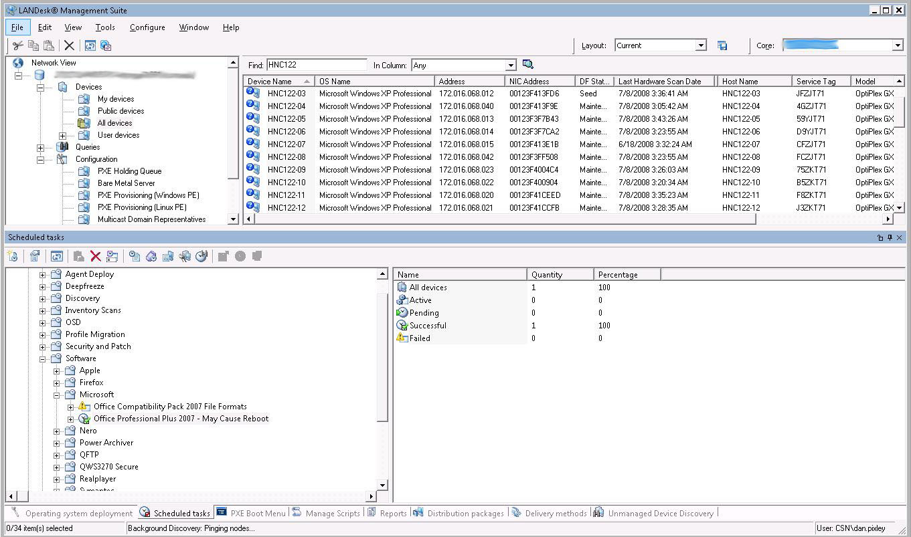
Figure 2.3.1a – Screenshot of the main LANDesk Management Suite console.

The LANDesk remote control tool is very appealing and looks very good. Using patented technology, LANDesk PC remote control software uses the existing Internet connection, as well as certificate-based authentication and SSL encryption, for bidirectional management traffic, letting you perform on-demand remote computer access securely over the Internet. [6] In terms of functionality, “a nice log view at the bottom of the screen documents everything. You can perform any of the actions you would expect from an enterprise remote control utility: chat, file transfer, reboot, and remote execution; which are provided as a very handy toolbar drop-down option that remembers previous commands you have executed. There is another drop-down list that allows you to switch between other active remote control sessions. Rather than filling your screen, the remote client desktop is presented in a resizable window which limits your current view based on the window size”. [5]

“Performance settings allow you to suppress the client desktop wallpaper and color depth may be reduced using a slide control, which allows you to adjust the color resolution in order to affect the speed of your remote control session”. [5] “LANDesk remote control software hides its remote control agent when not in use, so you maintain the highest levels of security with the least amount of impact”. [6] Remote Control Viewer is now available as a Mac application, so you can remote control from your choice of platform.

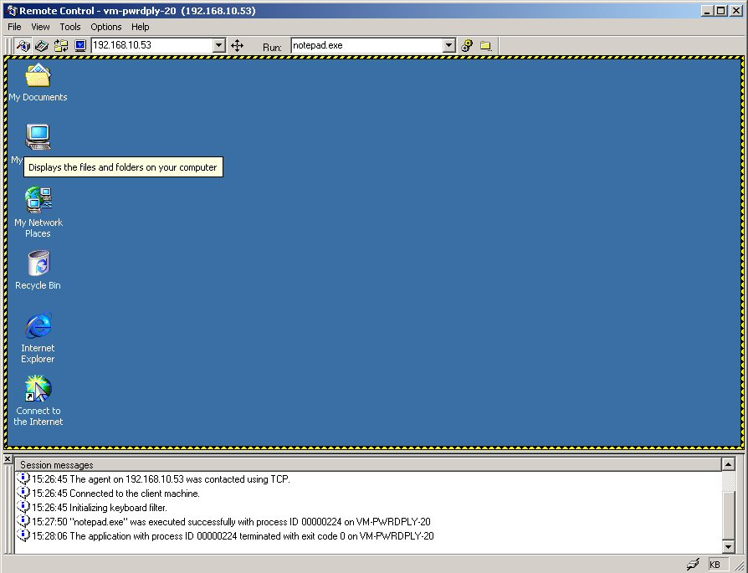
Figure 2.3.1b – Screenshot of a LANDesk remote control session

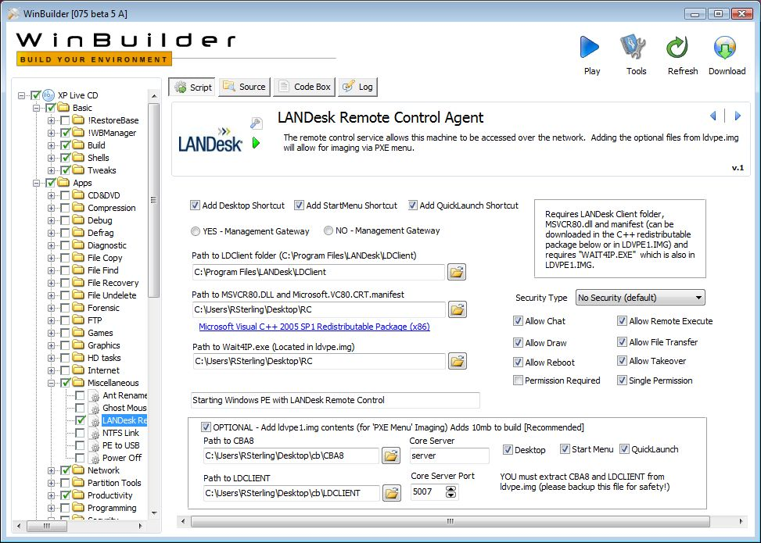Figure 2.3.1c – Screenshot of the initial setup of the Remote Control Agents.

2.3.2 Auditing & Asset management (Rating: 5)
LANDesk auditing and asset management features comes in the add-on packages called LANDesk Asset Lifecycle Manager for asset management and LANDesk Inventory Manager for the auditing part.

LANDesk Asset Lifecycle Manager:

LANDesk Asset Lifecycle Manager goes beyond simple tracking to provide a structured asset repository that extends the management of your organization’s hardware and software assets by starting before the asset exists and going beyond when the asset is retired. This extra connection throughout an asset’s lifecycle helps to reveal the true value of IT systems to allow better planning decisions, informed business analysis and improved business capacity. [7]

Some of the key features are [7]:

- The asset and any of its components can be tracked according to status, version, manufacturer, etc.
- Attaching supporting resources to an asset, and managing these throughout the lifecycle as well.
- The asset and all of its components are available to IT for purposes of troubleshooting, remote control, patching, upgrading, software delivery, and data access.

Refer to Figure 2.3.2a for an overview of the lifecycle of an asset.
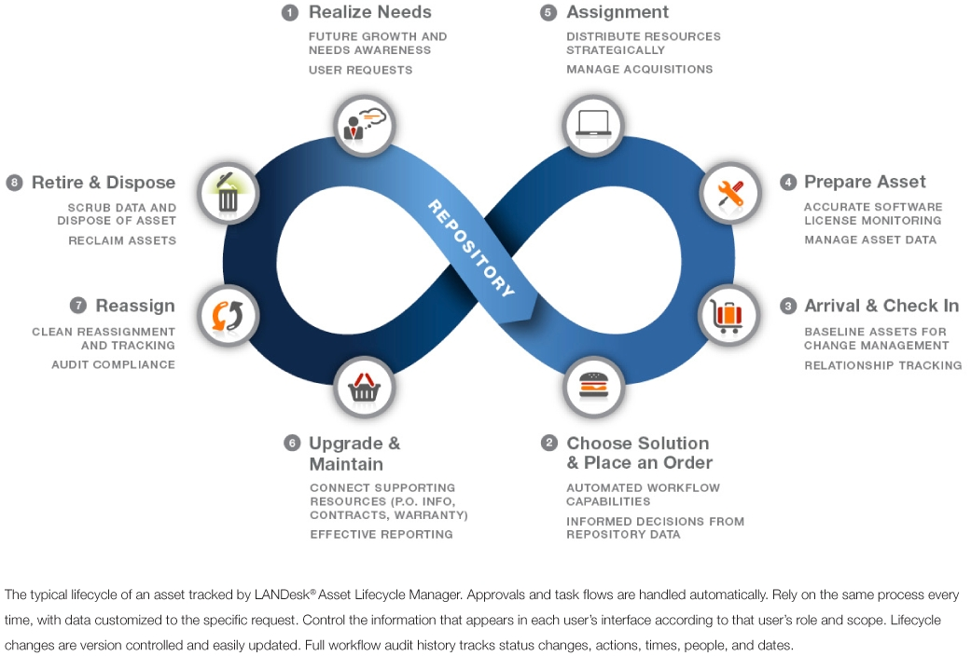
Figure 2.3.2a – Overview of the lifecycle of an asset.

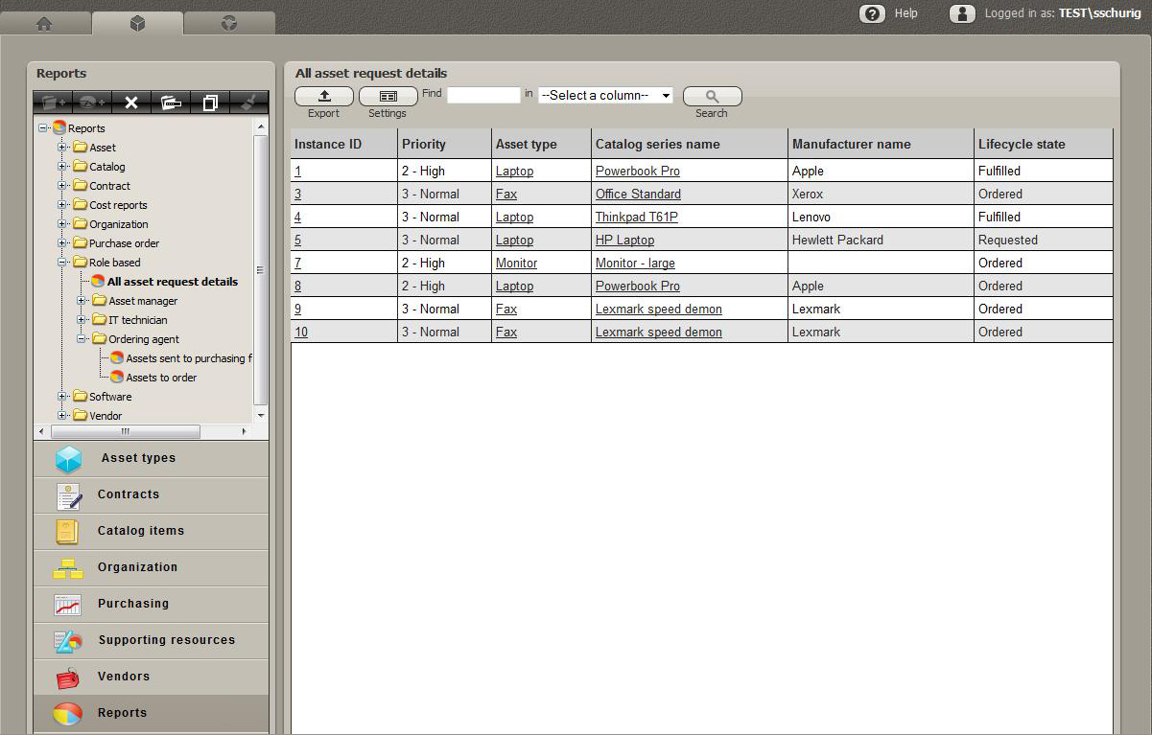
Figure 2.3.2b – Screenshot of asset details screen

LANDesk Inventory Manager:

The inventory comes with a large database of files it can identify. Other files can be added later to the database. But the built in database will get you started by including information on many common commercial applications. [5]

Some of the key LANDesk Inventory Manager’s tasks are:

- Inventory scanning
- Software license monitoring
- Reporting

“LANDesk Inventory Manager uses LANDesk unmanaged device discovery (UDD) to show you what you have, where it is and how it’s being used. Scan the network and identify any IP-enabled device to get an accurate picture of your IT assets. Even find misplaced or forgotten computers, printers and routers. Gather basic inventory data or detailed hardware, software and OS configuration data. Easy-to-use query tools help you analyze inventory data and group assets according to attributes. And automated inventory scans helps you quickly and accurately understand what you have, without manually gathering data”. [8]

Software License Monitoring
LANDesk Inventory Manager’s advanced software license monitoring capabilities help you understand software that is actually in use, not just what’s installed. That helps to recover unused licenses and reduce unnecessary software purchases. [8]

Reporting
“LANDesk Inventory Manager’s extensive reporting tools help you demonstrate license compliance to both internal and external audits. And quickly examine OS and application data to plan upgrades, identify security issues and determine purchase needs”. [8]

2.3.3 Monitoring (Rating: 4)
LANDesk monitoring solution comes in the LANDesk System Manager

LANDesk System Manager gathers health and status information directly from the computer’s hardware, software and OS in real-time. LANDesk System Manager uses industry-standard data sources, including CIM, WBEM, WfM, WMI and SMBIOS for a complete view of component-level system health regardless of configuration. [10]

“It monitors both application availability and hardware components such as processor temperature, fan speed, bus voltage and more”. [10] It also tracks fixed assets such as hard drives or RAM, as well as peripheral devices attached to the USB bus such as printers, removable drives or handhelds. [10] Automatic ASIC detection and monitoring enables IT to monitor hardware from most system vendors. A resident agent gathers information from hardware and software components to give IT staff a complete picture of system health, in real time. Configurable alerts make sure IT knows immediately when problems occur.

Alert management system sends alerts by email, fax, pager, and console popup; generates log file entries and triggers automatic events such as running an application or launching a batch file for instant response. Configurable alert thresholds define informational, caution and warning thresholds and integrate with AMS. [10]

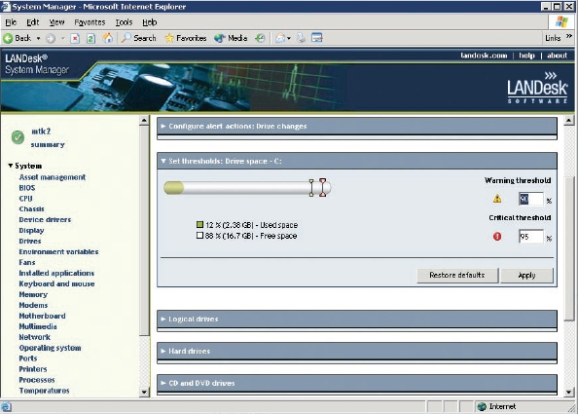
Figure 2.3.3a – Screen capture of disk space monitoring and alerting on LANDesk System Manager

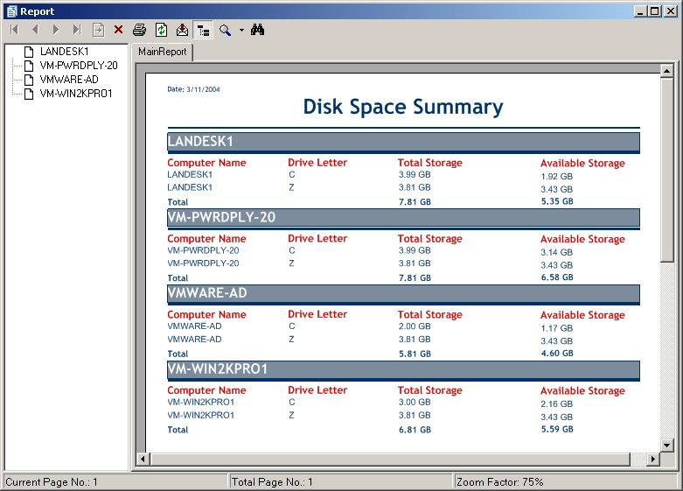
Figure 2.3.3b – Screen capture of a report generated after monitoring disk space on different computers in the network.

2.3.4 Patch Management (Rating: 5)
LANDesk software's Patch Manager is offered on its own and as a component of LANDesk's Security Suite or Management Suite. LANDesk Patch Manager uses proprietary agents installed on target devices and provides thorough vulnerability discovery and remediation, as well as a robust array of tools to customize those tasks. LANDesk permits management of end devices via existing directory structures, like Active Directory, or through groups created in the application. [11]
“Patch Manager's repository of patches can be customized, and the system supports a number of operating systems, including Mac OS X, Red Hat and SUSE Linux, Solaris, and Windows, as well as most common applications, from Apple's iTunes to Sun's JRE, plus popular antivirus systems, including those from McAfee, Sophos, and Symantec. LANDesk also supports a policy-based implementation, where you can define the types of patches you want to install and when”. [11] The patch repository is updated daily by LANDesk, and the frequency with which the management station checks for updates is configurable by IT from hours to months and anywhere in between.
Here it is the key features in detail [12]:
- Set behaviors at agent deployment that determine when the vulnerability scanner runs, how required reboots are handled and whether autofix is enabled.
- Prioritized patch severity gives you added control on which patches are critical.
- Multiple data sources for vulnerability information and also auditing of the devices before applying patches ensure you have accurate patches for your systems.
- Assessment and distribution scheduling let you choose when patches are applied.
- Alerting lets you choose to be notified by e-mail or pager when vulnerability is detected and/or a new definition is downloaded.
- Patch dependency shows you which patches depend on other patches, so you know what new vulnerabilities a patch might introduce.
- Patch history displays all patches installed on a client whether installed by LANDesk or another product.
- Patch uninstalls enables easy rollback for any patch available from the LANDesk patch management database, whether distributed using LANDesk Patch Manager or another tool.
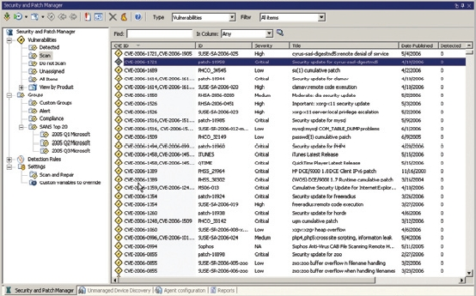
Figure 2.3.4a – Screen capture of the main screen of Security and Patch Manager.

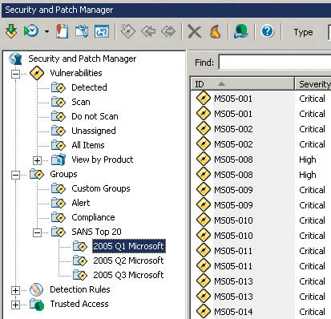
Figure 2.3.4b – Close up screen capture of the Security and Patch Manger

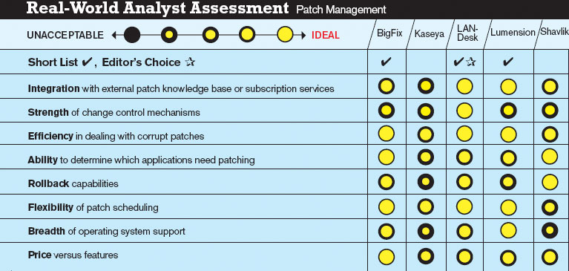
Figure 2.3.4c – Picture table of 3rd party assessment of Patch Management solutions from different providers showing LANDesk patch management strong performance.

2.3.5 Backup & Disaster Recovery (Rating: 0)
LANDesk does not offer any proprietary Backup & Disaster Recovery solution.
2.3.6 Endpoint Security (Rating: 3)
LANDesk solution for Endpoint Security comes in the add-on package called LANDesk Security Suite.
With LANDesk Security Suite you can [13]:
- Minimize network downtime, reduce help desk costs and protect critical data and user productivity by proactively protecting against malicious attacks at the endpoint.
- Reinforce your efforts to comply with security policies by proactively identifying and automatically remediating potential configuration threats.
- Save time and reduce resource needs by automating remediation with security rules, policies and frequent compliance scanning.
- Protect systems and critical data with active control over communication and data port access and the ability to quarantine devices.
- Easily align IT operations with corporate security policies by setting a security policy once that ensures desktops across the network are protected and compliant.
Here are the key features in detail [14]:
- Data Leakage Protection
- New Wireless Access Point Discovery allows you to secure the network by discovering unapproved wireless access points (WAPs)
- USB Encryption and Read/Write Control of USB/CD/DVD protects corporate data from changing hands advertently or inadvertently
- Firewall Management
- Manage the security configuration of the Windows (including Vista) firewall from one console
- Improved XP firewall management
- Network Access Control
- New 802.1x remediation protects the organization from virus outbreaks and unauthorized access
- Require policy compliance such as up-to-date virus pattern files and patches before a device connects
- Application Blacklisting
- New application blocker configurations control applications used by different individuals or groups to improve productivity and security
2.3.7 HelpDesk (Rating: 4)
LANDesk solution for Help Desk is LANDesk Service Desk.

- “LANDesk® Service Desk has a powerful graphical user interface that makes managing and placing service desk requests easier and more efficient for your entire enterprise. Service providers stay connected and productive by being able to access LANDesk Service Desk with a mobile device. And a Web browser-based interface lets service providers and end users or customers easily log incidents, communicate and track service status and requests”. [15]

- “LANDesk Service Desk includes the basics of incident and call logging, assignment, service levels, escalation, form design and user structures to give you access to everything you expect in a world-class service desk solution”. [15]

- “LANDesk Service Desk integrates with leading desktop management tools and toolsets, including LANDesk management solutions as well as Microsoft Active Directory, Novell eDirectory and Touchpaper ActiveAssistance to let you effectively use your existing tools to provide faster, better support with less effort, fewer consoles and less training”. [15]

- “Users can dynamically search for solutions and advice as incident, call, and problem and change information is populated. You control and configure how results are displayed. And knowledge is automatically captured to ensure that the latest, most pertinent information is accessible with the least impact on resources. And reporting capabilities let you record and prove the value of articles with both business usage and feedback”. [15]

- “The always-available Web-based service portal lets users proactively report a problem, find information and initiate a solution to facilitate faster resolution”. [15]

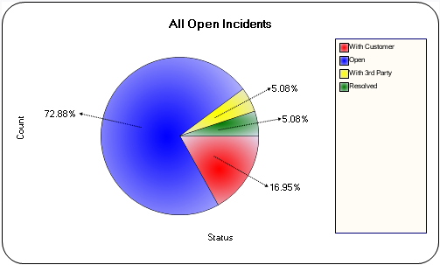
Figure 2.3.1.7a – Chart of Help Desk incident status by percentage.

2.3.8 Usability (Rating: 3)
LANDesk administrators will be very familiar with the interface because it resembles most popular software in that it has tree-view sections, explorer like folders and menus, and wizards for many of the features. LANDesk main console view has many features together into one window with many tabs so at first it can be difficult to know where features are and navigating through them, but once the administrators get used to it, it is very easy to work with.
2.3.9 Reliability (Rating: 4)
LANDesk has a very strong foundation and is very reliable. Both it is console and web based views are very responsive to the user and requires minimal effort to use. Other LANDesk add-on packages can be integrated into the main LANDesk console and even when adding other packages the reliability stays very stable.
2.3.10 Performance (Rating: 4)
LANDesk’s performance start in it is server, where all the packages and add-ons are integrated together to work as one unit. When adding many other packages the performance stays very stable even when more power and resources are being used. The performance for the web based console is strong too and allows for many administrators to be using it at the same time without any lag from the server.
2.3.11 Supportability (Rating: 4)
LANDesk support for different operating systems and devices is one of the strongest points it has. LANDesk offers technical and training for all the operating systems it covers and for all the devices it supports, even handhelds.

