If one fails, all fails
White Paper
Sajjad Zaidi

Abstract
This paper explains in detail the importance of having an automated system, utilizing Kaseya in today’s global virtual IT world. The power of this tool and its capabilities are that it can provide on demand, detailed and hassle free access in order to manage and maintain its IT infrastructure; a crucial aspect to any organization. The tools provided by Kaseya are vital for those in charge of IT to make strategic decisions that are beneficial. This paper discusses what Kaseya does and what these tools are and why they have a competitive edge over other contenders.

Table of content

- Approach to manage IT infrastructure

- Total management solution under one umbrella

- Competitors approach

- Future of Automation

- Conclusion

Approach to manage IT infrastructure

Classic Approach non-Automated systems

In today’s global enterprise model of business, ventures are not confined to a specific area or office. The business model that most enterprises are now beginning to follow is an excellent example of using the world’s best and newest resources available to them. The usual method is having offices scattered over the cities, states, and sometimes, even countries overseas. For example, accounting offices and sales offices are usually in different location, where as production offices are mostly overseas. With computers at every location the management of these remote locations can become a hassle. Either they have contracts with local MSP’s or they find they must deploy their own local IT staff; all ineffective method for handling incidents. Remote management can take away most of the difficulty however there are still some limitations to these tools that are preventing total IT management consolidation. Some of these tools in questions that are commonly used in the industry are pcAnywhere™ and LogMeIn™. There are add-on modules and other similar tools now available in the market, but they are still less than perfect. As companies grows so does the IT departments and it is usually this area that suffers when there are budget constraints. Another issue that can stymie performance is not having enough manpower to address issues in a timely manner. In this type of IT infrastructure a business suffers and scalability always becomes a big issue, keeping it from reaching its full potential.
Many companies have third party contracts to get the job done, but is it cost beneficial?

Modern Approach with Automation

The automated system and tools have been born as a result of these issues faced by IT departments. With the implementation of automation, there is now the capability of making life easier and more productive. Kaseya is the leading IT automation tool now available in the market that can get the job done in both less time and be cost-effective, both benefits that are unparalleled.

Kaseya is equipped with many tolls under one platform that gives complete access to computers connected to a network. Kaseya has many tools at its disposal such as

- Patch management
- Backup and Disaster recovery
- User state management
- Scripting engine to deploy customized scripts, programs and OS
- Monitors sets to manage devices attached to the network
- Endpoint security
- Ticketing
- Remote control
- Customizable Reports
- Ticketing System
- Audit
These available features can make the job of an IT administrator easier and eradicating scalability as a problem. These tools are highly customizable and available on demand.

Total IT management under one Umbrella

Kaseya provides a web UI that is accessible from the Internet that gives total access to devices plugged into a network. Total management under one umbrella is basically a concept that works with an infrastructure that comprises of 10 to a 1000 (not limited to) computers that require effective management.

Minimum Kaseya Server Requirements
• Single processor (1.0 Ghz, 160 Mhz front side bus, 1 MB cache)
• 1 GB RAM
• 40 GB hard drive
• Microsoft Windows Server 2003
• Microsoft Internet Information Server (IIS) version 5 and up
• Microsoft SQL Server 2005 (or 2000) or SQL 2005 Express Edition
(Included in standard download)
• Kasey cannot be installed on a server running Microsoft Exchange
• 100 Mbps Network Interface Card (NIC)
• DSL or Cable modem Internet connection
• TCP/IP open ports: 80 inbound and outbound, 5721 inbound

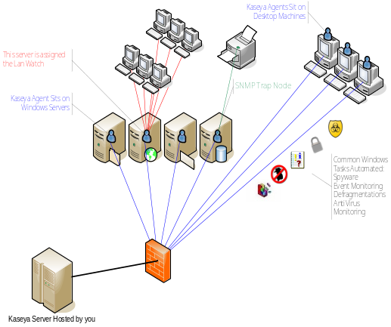

Dashboard
Kaseya dashboard displays the vital information and is customizable. This detailed information usually takes hours to gather if done manually. The home page gives an overview of
- Computers Connected and online
- Patch status of the machines
- Operating system Distribution
- Alarms
- Gateway
- Pending Tasks
- Tickets generated and assigned to techs
- Messages
This information allows for a birds eye view of all the computers. This feature gives the power to any admin and he will be aware of what needs to be done if there are any issues that require immediate resolution.

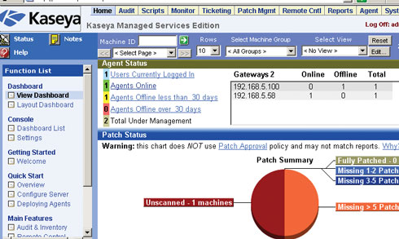

Audit
As soon as the agent goes live on a machine a basic audit is generated. This audit provides:
- System info
- Installed application on each individual server and workstation
- Can also monitor the add/remove programs
- All Software installed and its licenses and verify if they are genuine
- What OS is currently running and what are the computer names and what group they belong to. The machines can be divided into different group for example: Accounting, HR etc. for easier management
- IP info gives the IP address, subnet mask, default gateway, country info and the MAC address.
- Audit also collects DNS/DHCP servers address of WS and Servers and their Primary and Secondary WINS
- Detailed information about disk volumes
- PCI and disk Hardware info
- CPU and RAM
- What printers they have access to
- Documents can be uploaded on each individual machines if required regarding this information
- Administrator can also block files and application access to machines or group if required
This crucial information is available as soon as the agent goes live. Manual Process can take forever. With this information scalability becomes easier and the upgrade process is easier.

Scripting Engine
Effective use of this tool gives control over the machines and takes management to whole another level. This feature provides
- Patch deployment
- Application deployment. With this feature applications or a group of applications can be deployed as a package. The applications can be installed silently without disrupting the users
- Through File transfer machines can retrieve files which can usually takes a lot of time if done manually
- Customized scripts can be created with the scripting engine where scripts can be written on a user-friendly interface that requires basic algorithm to build. With the help of If and else statements these scripts can be build and deployed. The range of these scripts can go from rebooting a machine to checking mailbox storage on Exchange server. This gives an admin the power to control machines that is more effective and efficient. These scripts can be scheduled to run any time depending on system behavior

Monitor
Alarms can be set to monitor, for example: disk space, memory, SNMP sets, etc., and are triggered based on settings and thresholds. Monitor sets are customizable and depend on the administrator and what they want to monitor.

Log parsing is another useful feature that provides universal query access to text-based data such as log files, XML and CVS files, as well as key data resources on a operating system such as event log, registry, and file system. The admins can then monitor what information is required and how it should be processed. Another powerful tool for the system administrator is the ability to dispose, retrieve and use this information.

Ticketing
The ticketing system can generate tickets based on typical problems that occur day to day. Application, Network, and Workstation, etc., are the most common problems that the IT department deals with everyday. These tickets can be assigned to techs based on priority, importance and SLA type.
The notification policy can define the email’s notification policy for each group ID and can send email alerts based on priority, due date and even based on the tech the ticket is assigned to.

Patch Management
Kaseya scans for all missing patches and tells the admin what patches are missing and must be scheduled. Since patches are released frequently and based on importance, it is a must that they be applied.

This feature allows admins to not only scan all machines, but to also scan for the missing patches available for immediate download, therefore allowing for distribution based on policy. If a machine has the automatic update on, this will create conflicts if they are not compatible with the currently installed programs. Kaseya has designed a system that makes sense and the distribution of these patches can be administered by policy. Admins can create a policy based on priority of the patches. A policy can then be defined, and all machines will then accept security and critical updates. Another policy can dictate that if software or service packs should be distributed. A combination can be configured as per requirement and then the machines can be assigned to these policies.

Knowledge based (KB) is a very useful feature that can deny or approve a patch. These KB articles are based on problems that may occur on a system if certain patches or a combination is applied.

Patches can be installed silently without disrupting the users and can be skipped if the machine is offline. Automatic updates can be disabled and the rollback option is also available.

An effective patch management system can prevent many problems that can occur in the future. If machines are not patched in a timely fashion, security holes can become a major problem, especially if mission critical data and applications are running.

Remote Control

This feature is self-explanatory but Kasey has many other features that come with the remote control feature. There are 4 remote control tools that are provided:
- WinVNC
- K-VNC
- RAdmin
- Terminal Server
A Video streaming session can also be instantiated if machines do not have an agent installed. A FTP session can also be initiated and a task manager if a process needs to be killed.

This feature allows a one-on-one connection and can fix issues on an individual end user level and is effective.

Backup

For backup Kaseya provides the Acronis ™ tool. The backup feature page displays the Backup status report of individual machines the status shows:
- Volume Backup Status
- Folder Backup Status
This information is displayed as a pie chart which is easy to read and convenient.

The Full list of backup Features are:
- Status report (Delivered via pie chart format)
- Scheduled Volumes (schedules volume at any time with VSS Support)
- Pre/Post Script (Scripts can be delivered to suspend services)
- Schedule Folders (to Schedule folder backup)
- Backup Sets
- Backup logs
For Recovery Feature Kaseya Provides
- Explore volumes
- Explore Folders
- Verify Images
- Image to VM
- Auto recovery
- CD recovery (ISO can be created)
- Universal Restore (Recovery via recovery boot CD)

Offsite replication is also available where local servers can transfer data to a specified path using TCP/IP on a selected port. Any managed machine can also act as an offsite replication server.

Under the configuration settings, directory location can be specified to store backup images and can be password protected (up to aes 256). Alerts can be generated via Tickets, Alarm and scripts can also be schedules if backup is complete. Compression ratio option can define the compression level and a size of a file can also be configured. Logs are also generated to record the backup activity.

Security

Kaseya provides AGV™ for the Security solution that can also be manually scanned and updated if desired. Scans can be schedules at a desired date and time. Files can be remotely managed if placed under quarantine and logs are generated to check status of individual machines.

A license management features can notify the admins if licenses have reached its age, which is another useful feature. Imagine maintaining this information for 100 computers.

Each machine can be configured to what folders should be scanned and emailing scans can also be enabled.

Alarm sets can be set and applied to machine groups depending on their status. Tickets and scripts can be initiated if alarms are triggered.

Fully automated security patch scan, patch deployment and history information is available with the click of a mouse. Scalable, secure, configurable and
location independent along with encrypted communication using 256-bit RC4 with rolling keys are some of the most important features of Kaseya. No open ports, no plain-text data packets on the network, meaning there is nothing for attackers to exploit.

User State Management

Policies can de defined and assigned to machines based on their roles. KUSM provides:
- Power Management
- Pinter Management
- Mapped Drives
Desktops can be standardized with custom settings and these settings can be deployed on different machines based on their roles.

Reports

The flow of information through reports generated by Kaseya is extremely effective in decision and policy management. Kaseya can generate reports based on each feature and functions are available under its commands. These reports are customizable and can be exported in different formats like HTML, Word and Excel.

Kaseya Executive Summary report as seen below is the most comprehensive report system available. It gives the Admins and IT heads what they need to know about their network on demand within seconds.

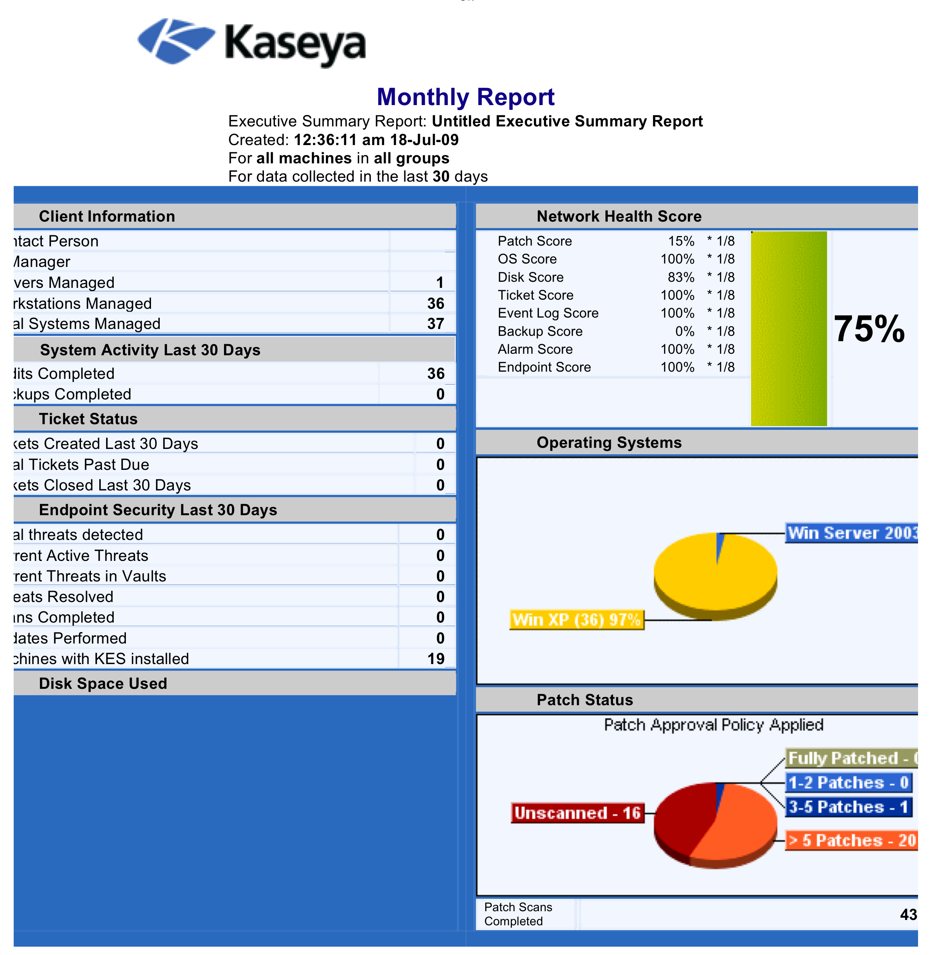
Some other reports generated are:
- Aggregate logo
- Machine Summary
- Patch management
- Inventory
- Software
- Disk Utilization
- Network Statistics
- Uptime History
- Logs
- Ticketing
- Monitor
- Backup
- User State
- Power Savings
These reports give on demand information and are useful for Scalability.

Agent
Kaseya uses agent-based deployment to manage Server and Workstations. The Minimum requirement for an agent to run is as follows:

• 333 MHz Pentium-class CPU or greater
• 128 MB of RAM
• 30 MB of free disk space
• Network Interface Card (NIC) or modem
• Microsoft Windows 98, Me, NT 4.0, 2000, XP, Vista, Server 2003
• Macintosh OSX v10.3.9 and above, Intel and PowerPC editions
• TCP/IP Outbound Port 5721
• No Inbound Ports

Agents can be deployed via email, login scripts, Lan Watch or manually which makes the task easier if machines are either connected to a network or an individual device that may float, like a laptop for example.

Agent settings can be copied and applied to different machine if they have similar roles. Another useful feature of agent log is that is can report on how many times the agent checked in, if there is an error and if the agent is alive. The agent can also be uninstalled and deleted if Management is no longer required.

System

Under this feature Admin roles can be defined and Machines can be assigned into different categories and roles.
Theses roles can me modified to provide different levels of access and can be restricted to function access and log-on hours.

Admin Accounts can be initialized and History can be monitored

Under the Server Management feature, Admins can also contact Kaseya Support directly if a problem cannot be resolved by techs.

Competitors Approach

Many management solutions are available in the market and what they fail to deliver is the complete package. One of the Solutions available in the market is MSP Center plus by ManageEngine™ (ZOHO Corp).

What is missing?

Security

There is no antivirus or spyware integration available with the solution. IT professions have to either conduct this manually or by some other method in order to get the job done.

The drawbacks that come with these issues are many and a domino effect can happen. Some of the issues are:
- Automatic ticket generation in case machines are left un scanned or missed a scan due to a problem
- Keep a manual record of antivirus licenses.
- Have to keep individual record if machines are scanned.
- No remote quarantine management
- No report or logs generated by the system for monitoring
- Alarm sets cannot be defines and techs have to monitor this event manually

Backup

No backup solution is available out of the box. This missing feature alone can cause problems.

Drawbacks:
- Manual Solution or third party contract which is not cost effective
- Automated scheduling of volumes or folder
- Tickets and logs are not generated
- Separate monitoring consumes time and Money
- Reports cannot be generated and this lacks total Automation
- Alerts cannot be generated into tickets and scripts or emails are not generated
- Scheduling of transfer is not integrated

Other Missing features

- No WSUS integration
- Ability to parse custom log files
- No cross platform support for desktop management only supports Windows OS
- Remote chat session between a user and Tech
- Video Streaming
- 64 bit window support

Future of Automation with Kaseya

Kaseya has many new tools that are scheduled to be released. The new features will take the IT to a whole new level of Automation. Some new features that are planned are:

- New Ajax UI
- Linux agent
- Unix, HP/UX, Sun Solaris, AIX
- Mobile Agents: Windows, Apple, Symbian
- Live Connect
Kasey’s Apple ™ Iphone application is also on its way. Which gives the admin to monitor their network on the GO

Conclusion

The modern day IT infrastructure demands a solution that can provide total integration. The concept of automation is to provide a solution that not only saves time but can also reduce cost. Without security and BUDR, major problems can arise in the IT department of any business. IT Automation requires a solution that is comprehensive and works as a team. If one aspect fails, then the entire system fails with respect to automation.

