Created by: Norman Wright

2.5 Zenith Infotech
- The IT automation solution- The IT Automation solution I chose was Zenith.
- Overview: Zenith provides separate solutions for MSPs and Backup and Disaster Recovery. There primary MSP is the SAAZ managed services software, and their primary Backup and Disaster recovery tool is known as BU/DR. Zenith also provides a help desk solution known as Virtual Service Desk. All 3 services are meant for small to medium businesses. Each service is priced separately, and prices are calculated based on the need of the company. There are no enterprise solutions currently available at this time.
Due to the dominance of Microsoft windows in the small/medium business environment, Zenith's products and services are mostly based on Microsoft's line of products. Basic support is offered for other platforms that may be used by users. At this time Zenith is working to find partners that may cover a wider range of updates (some noted patch agent partners were "Shev link” and patch link).
While no sample software was available for download at the time of this write-up, a representative of the company, Clinton Gatewood, assured us that one would be made available for our group to test in the near future. However, Clinton made himself available to answer any questions that we had with regard to their line of products.

A brief background of the company’s history- Zenith Infotech was started by Akash Saraf, Managing Director and CEO, in 1996 and made inroads in the Indian banking and financial industry by developing solutions for total branch automation [1]. In 2000 – 2001, Akash foresaw the need for IT infrastructure management solutions for small and midsize businesses. After capturing significant market share in the Indian corporate segment (in competition with such industry giants as HP, IBM and CA), he approached the managed services industry in the U.S. with Zenith Infotech’s product and services solutions. Akash led the company to a leadership position in the U.S., and in 2005, saw Zenith Infotech post 1,600 percent growth. Recently, in cooperation with Intel, Akash realized a “dream-come-true” by bundling Zenith Infotech’s SAAZ software with every motherboard on vPro technology shipped by Intel [2].

- Company highlights- Zenith Technologies is a company with numerous distinctions such as:
  - Being hailed by software partners and experts alike as being one of the leaders in their industry, along such competitors as Kaseya, N-able, and Level Platforms (LPI) [4][5][6][7]
  - Zenith is also the only managed services infrastructure provider with more than 600 network engineers and senior-level support staff tending to its partners needs [9].
- The main IT automation products/solutions the company offers (along with a summarized description of each individual offering).
Grouping- Some grouping functionality such as user cannot make custom groups at this time is available.

Below is a sample of the SAAZ End Client portal
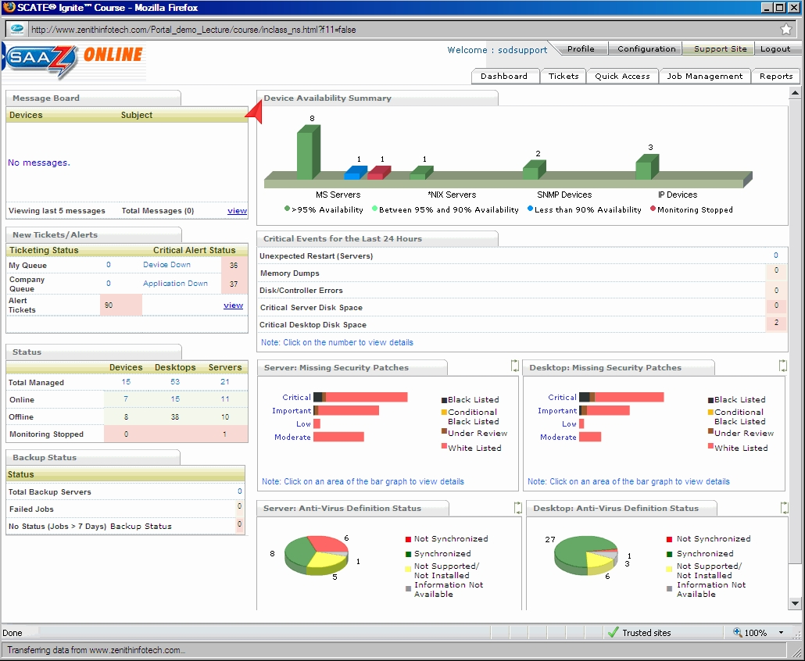

2.5.1 Functional Coverage
- Show which operating systems are supported- Windows 2000, Windows XP, Windows Vista for Desktop systems; Windows NT, Windows 2000, Windows 2003, Windows 2008 for Servers
- Explain what can and cannot be managed and monitored by given solution- The system can provide desktop maintenance, Server monitoring, asset monitoring and management, scripting and patch management.
- Explain what underlying technology (agent, probe, etc.) is used to manage and monitor network with given solution- The Zenith SAAZ agent is used monitor and manage systems that are on used a company’s network.

2.5.1.1 Remote Control
- Discuss if researched solution has built in remote control ability- Is accomplished through LogmeIn. Zenith is currently working on password vault to allow for easier remote connection.
- Diagram showing interface for Logmein 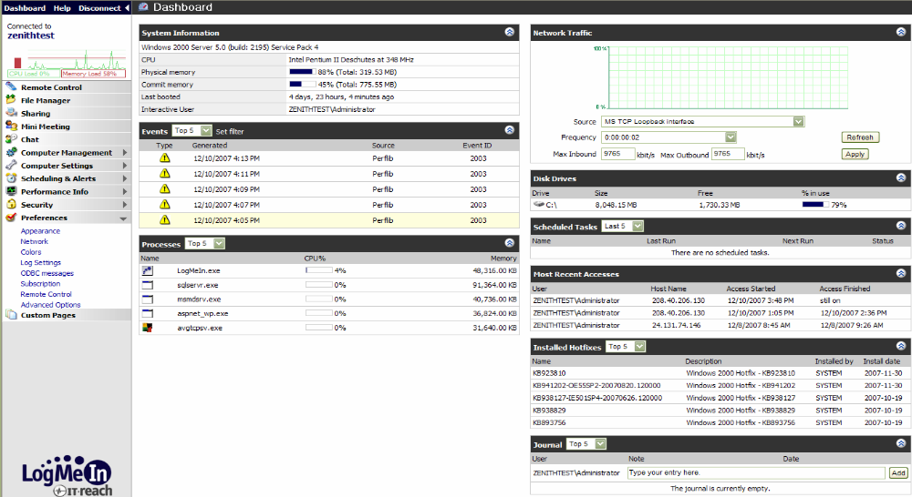
- Discuss what can be done with remote control (file transfer, etc) –the user can carry out any operation using remote control, as they would if they were at the actual machine. The system also allows the user to print documents store on the remote pc, to a local printer; conduct file transfer from the remote pc, to the local pc; Share files on the remote system over the web; conduct chat session, and mini meetings (end client feature where clients can invite a guest to attend a remote session on their computer). The user can also get PC performance information of the remote system through LogmeIn [10].
2.5.1.2 Auditing & Asset management
  - Discuss if researched solution has built in auditing & asset management ability- The SAAZ agent has an auditing feature built into its structure which automatically conducts an audit of the system, upon being installed on any system.
  - Discuss how auditing is accomplished- With the SAAZ Agent installed system information is captured weekly or on-demand. This information is used for system monitoring but is also reported back to the asset database so you can review system information or run prefabricated asset reports or create your own custom asset report [11].
  - Discuss what can and cannot be audited- The client, in taking inventory, doesn’t check for license compliance.
  - Discuss what asset information can and cannot be attained-users can run prefabricated reports against multiple site. The user may also create custom hardware asset reports for end clients.
2.5.1.3 Monitoring
- Discuss if researched solution has built in monitoring ability-
Monitoring is available only for servers at this time.
  - Diagrams showing the Server monitoring interface:
  - Shows a list of systems being monitored on the system 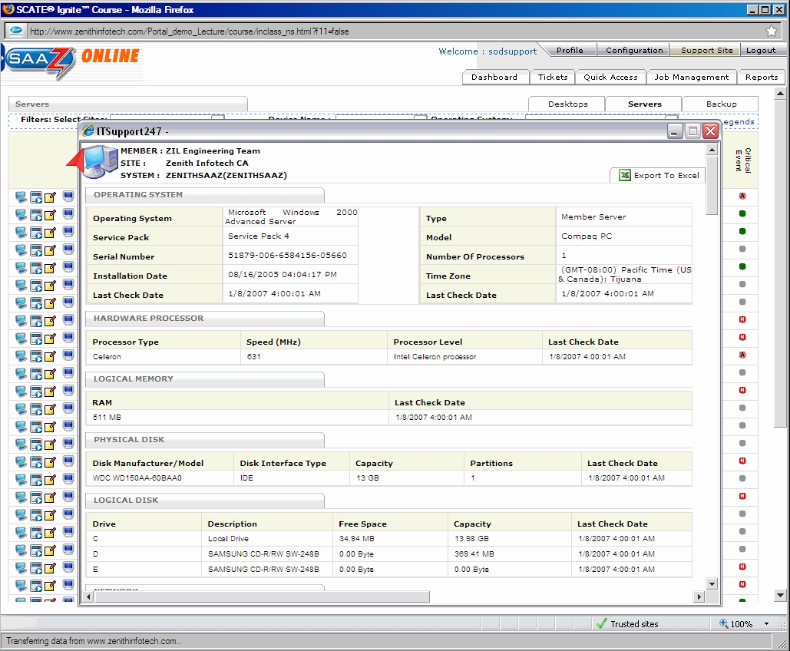

  - Error report displayed for the CPU 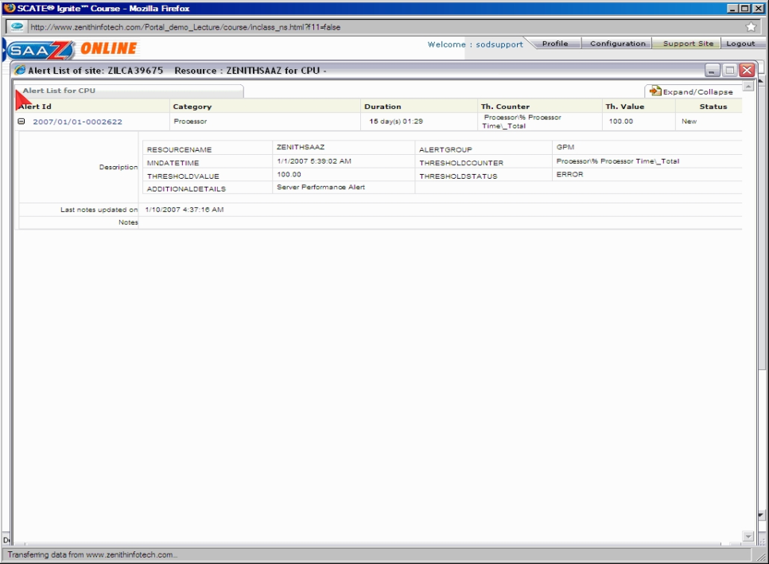

  - Shows performance data regarding server system .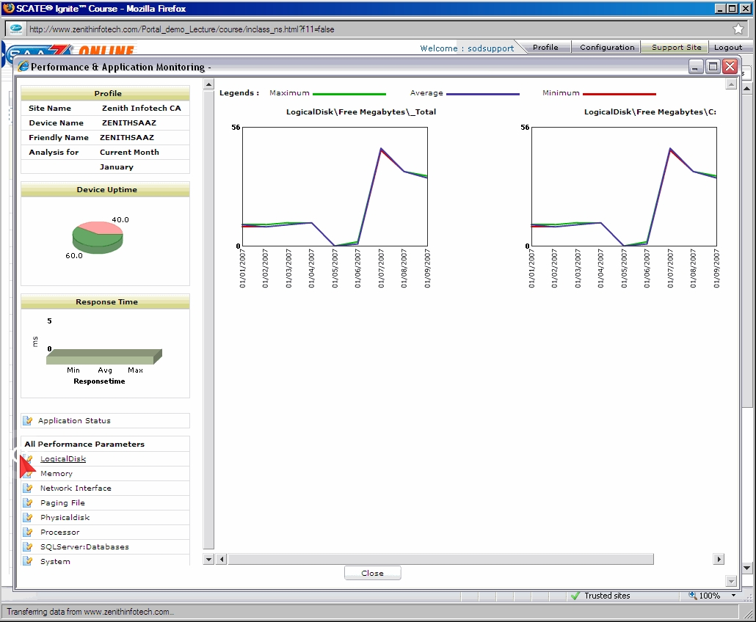

  - Displays the performance of the systems, and highlights items that need to be addressed immediately in red. 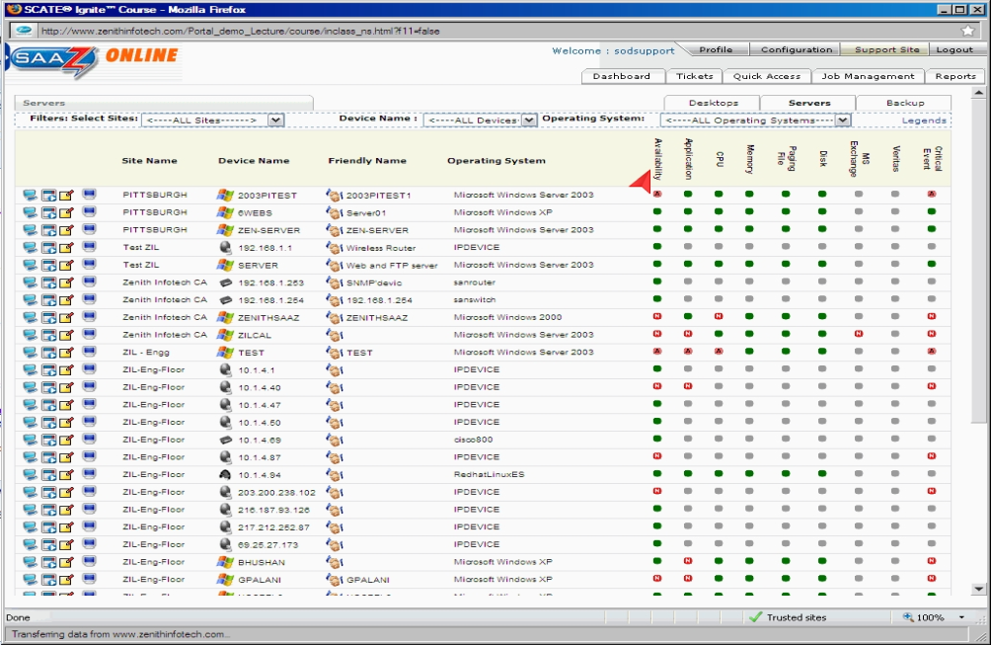
- Discuss how monitoring is accomplished- Monitoring is done through the SAAZ agent, which produces a monitoring a report based on pre-fabricated settings, or customized user settings.
- Discuss what can and cannot be monitored- The system can monitor hardware and software performance. Hardware monitoring tracks how much of the hardware resources are being used and what software processes are using them at this time. It cannot
  - Discuss what monitoring information can and cannot be attained- monitoring checks the system status of the server (hard drive space, temperature, ram usage, network traffic, etc...), and sends alerts to the user, by way of the SAAZ end client portal. Alerts can be customized to suit the administrators preferences
2.5.1.4 Patch Management
  - Discuss if researched solution has built in patch management ability- Zenith has a patch deployment system that runs alongside their Advanced Scripting Engine.
  - Discuss how patch management is accomplished- Utilizes Microsoft update for patch deployment. Users most turn of automatic update on their systems in order for patch management to be done more effectively by the system.
  - Discuss what can and cannot be patched-Any and all Microsoft system files can be patched. The patch deployment system doesn’t provide updates for other software systems. Custom patches cannot be pushed by the user through the SAAZ system. The user would need to contact Zenith for a custom patch to be developed and deployed for any other software/system.
  - The Diagram shows how the patch deployment/Advanced Scripting Engine system works 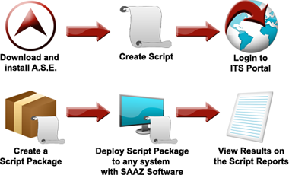
  - Discuss what patch management information can and cannot be attained- Patch deployment will provide log files, event logs, WMI counters, performance counters, etc. and have alerts sent via an e-mail to either a person or directly into ConnectWise [12].
2.5.1.5 Backup & Disaster Recovery
  - Discuss if researched solution has built in backup & disaster recovery ability- The Zenith SAAZ management system tool doesn’t have a built in Backup and Disaster Recovery system. They however, have a separate solution offered by the company.
  - Discuss how backup & disaster recovery is accomplished- known as BDR the system uses On Track power tools to enhance their BDR product, and provide a full backup of the servers in question. An incremental backup is then conducted every 15 minutes.
  - Discuss what can and cannot be backup and recovered- In the event that a server(s) go down, a fully virtualized server can be up and running in minutes, getting a system back up and running in no time at all. The system can also do bare metal (no OS) installations of a server system, files and policies. The system can also store company e-mail. All data stored on site is also sent to the Zenith data warehouses in Colorado, and Maryland, in the event of a disaster.
  - Discuss what backup & disaster recovery information can and cannot be attained- the most recent incremental backup, along the first initial full backup would be available.

  - Diagram showing what would occur should the BDR storage system be destroyed [13].
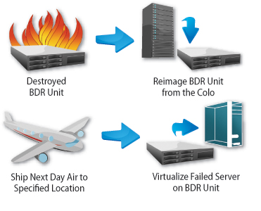
2.5.1.6 Endpoint Security
  - Discuss if researched solution has built in endpoint security ability- Endpoint security is provided through software products which are incorporated into the system.
  - Discuss how endpoint security is accomplished Security measures are put in place through patch management, anti-virus and anti-malware packages.
  - Discuss what can and cannot be secured via endpoint security-through patch deployment and scripting, any back walls that existed within Microsoft products would be sealed. Systems and provided further security through anti-viral/anti-malware software, which prevents malicious software from corrupting the system files, and slowing down the system. However, in the event that a patch file or definition file for the patch deployment/anti-virus/anti-malware system not exist, the system will be in jeopardy.
  - Discuss what endpoint security information can and cannot be attained- information on what patches need to be installed, update notifications for Windows/anti-virus/anti-malware system, and the viruses/malware which are detected on the system are provided to the user.
2.5.1.7 User State Management
  - Discuss if researched solution has built in user state management ability- Zenith doesn’t have this feature incorporated in its package.

2.5.1.8 Help Desk
  - Discuss if researched solution has built in help desk ability- This is a separate service provided by Zenith under their Virtual Service Desk System. The system is not designed for enterprise level companies, as the services assigns 7-8 employees per company to assist with troubleshooting matters. There isn’t a direct end-client support. This service costs $16 per user/per month.
  - Discuss how help desk is accomplished- This is accomplished through remote assistance, a 24 hour phone system, and through e-mail communication. There is no field technician support at this time.
  - Discuss what help desk information can and cannot be attained- The help desk can provide assistance with any, and all system support issues regarding any windows system (2000, XP, Vista) and Zenith SAAZ/BDR. The system doesn’t provide support for Mac, UNIX, or Other OS systems at this time.
  - Diagrams showing the Ticketing System used to report issues to the help desk:
  - 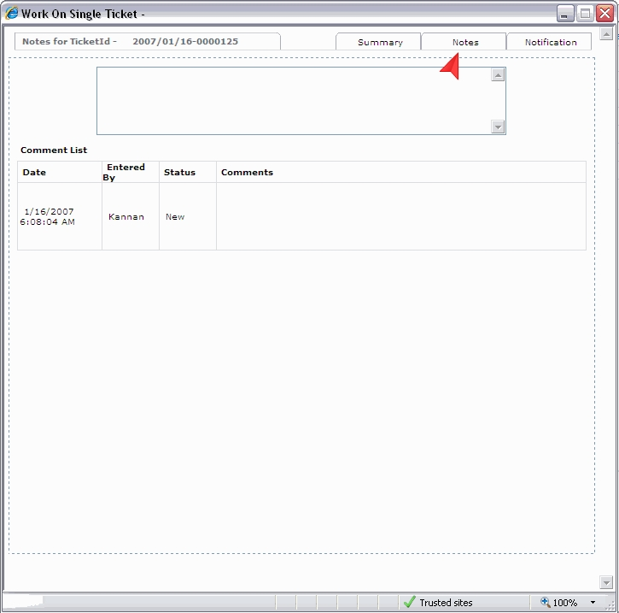 The above displays the ticket form used to request support for any particular system.

  - The below image displays the ticketing system as seen by the help desk staff/systems administrators. 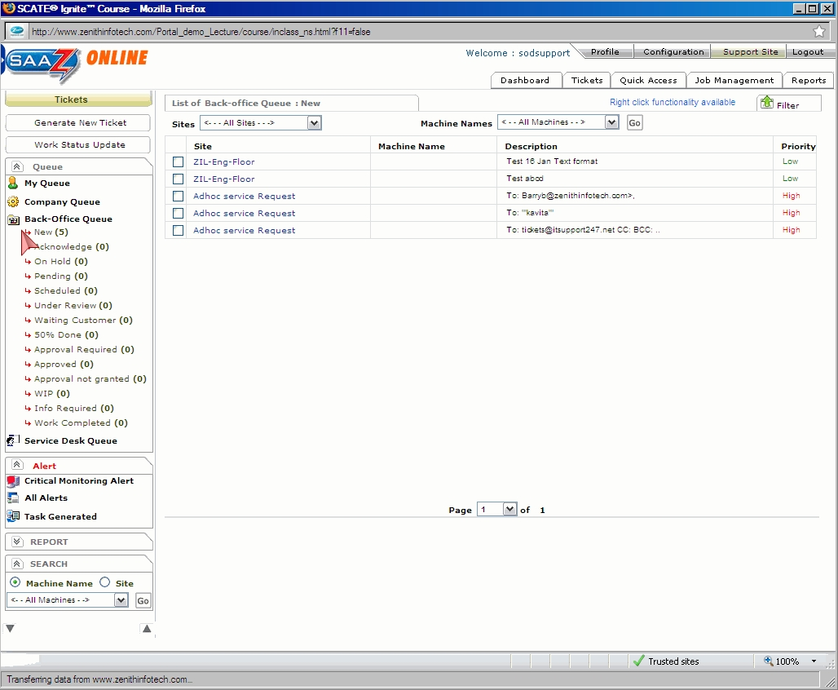
2.5.2 Usability
- Zenith has a graphically pleasing user interface, which seems to allow the user to seamlessly perform tasks on their system. However the system has, in the past, has been difficult to use with new users, due to lack of training. However, this has been rectified through the introduction of their support site [8].

2.5.3 Reliability
- Based on user reviews, the SAAZ and BDR systems provide very reliable system use. Remote access to systems/system files, getting automated error reports, and up to the minute server/desktop audits and server monitoring, the user is always up to speed with any development that may arise.

2.5.2 Performance
- Although a trial of the SAAZ software was not available for testing up to the final write up of this document, there have few complaints made about the functionality, and performance of the Zenith SAAZ, or for the BDR system. While there are some issues with the instantiation of certain features of SAAZ (i.e. anti-virus, patch deployment, etc…), and an initial system slow down when the agents are installed, once started, network system performance is typically maximized by the product.

2.5.2 Supportability
- While system support is limited by and large to the Windows operating system, it provides small business (which typically only uses windows) the support they need to keep their system up and running. When combined with other Zenith services (i.e. Backup and Disaster Recovery, Virtual Service Desk) there is virtually no system downtime.
The below table shows a comparison of the products provided by Zenith [14]:
 | Remote Server Watch | Proactive Server Care | Remote Server Care | Total Desktop Care | Virtual Service Desk
SAAZ Platform
Server & Device Monitoring | X | X | X
Asset & Inventory Reporting | X | X | X | X | X
Advanced Scripting Engine | X | X | X | X | X
Desktop Preventative Maintenance |  |  |  | X | X
Service Teams
Product Support Team | X | X | X | X | X
24x7 Critical Monitoring Team | X | X | X
24x7 Remote Support Team |  | X | X
24x7 Service Request Team |  |  | X
Virtual Service Desk |  |  |  |  | X
Technical Account Managers | X | X | X | X | X
Management Portal
ITS Portal | X | X | X | X | X
Partner Support Portal | X | X | X | X | X
End Client Portal | X | X | X | X | X
Technology Partners
Remote Connection Software | X | X | X | X | X
Spyware | X | X | X | X | X
PSA Integration | X | X | X | X | X

