Chapter 12 Review Exercise Solutions

R12.1
The software life cycle comprises all activities between the initial conception of a software product and its final retirement.

R12.2
This book recommends the following object-oriented development process:
- Discover classes
- Determine the responsibilities of each class
- Determine the relationships between the classes

R12.3
Classes correspond to nouns in the task description.

R12.4
Methods correspond to verbs in the task description.

R12.5
In an object-oriented programming language such as Java, a method must belong to a class, namely the class that is responsible for the method.

R12.6
- University–Student: aggregation; a university has students
- Student–TeachingAssistant: inheritance; a teaching assistant is a student
- Student–Freshman: inheritance: a freshman is a student
- Student–Professor: no relationship
- Car–Door: aggregation; a car has doors
- Truck–Vehicle: inheritance; a truck is a vehicle
- Traffic–TrafficSign: no relationship
- TrafficSign–Color; no relationship. (Color is an attribute)

R12.7
The class BMW can inherit from the class Vehicle–every BMW is a vehicle. However, the BMW company (which is different from the class of all BMWs) is an object of the class VehicleManufacturer. Inheritance is not appropriate for describing the relationship between an object and a class.

R12.8
The Circle.setLocation method needs to move the center of the circle; the radius is not affected. That is exactly what Point.setLocation does, so the method can be inherited.
However, a circle isn't-a point, so it doesn't make conceptual sense to use inheritance.
The other way around, it makes some conceptual sense. A point is a circle with radius 0. But then it becomes difficult to construct a circle from a point and a radius, since a point is then only defined in terms of a circle. It makes more sense to define a class Point and then a separate class Circle.

R12.9
Coin
get value
get name

CashRegister
record purchase | Coin
enter payment
give change

R12.10
BankAccount
deposit
withdraw
get balance

Bank
add account | BankAccount
get total balance
count
find
get maximum

R12.11
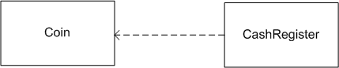

R12.12
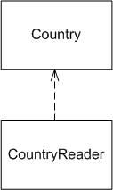
Country.html
CountryReader.html

R12.13
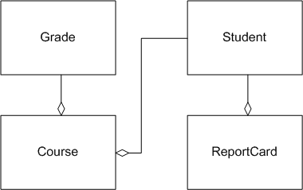
Student.html
Course.html
ReportCard.html
Grade.html

R12.14
